**BPM-015 Appendix G**

**MISO Inverter-Based Resource (IBR) Modeling Requirements**

**June 2025**

**DRAFT**

**v0.1**

# Revision History

|  |  |  |
| --- | --- | --- |
| **No.** | **Description** | **Date** |
| 0.1 | First Draft for stakeholder review | 6/3/2025 |
| 0.2 |  |  |
| 0.3 |  |  |

**Table of Contents**

Revision History 2

1 Scope and Applicability 4

2 Model Submittal Process Flow 5

3 Definitions 7

4 Model Requirements 7

4.1 General Requirements for All Models 7

4.2 Requirements for Standard Library Models 9

4.3 Requirements for PSS®E UDMs 10

4.4 Requirements for TSAT™ UDMs 10

4.5 Requirements for PSCAD™ Models 11

5 Model Quality and Performance Tests 12

5.1 Quality and Performance Tests for All Models 13

5.1.1 Initialization Tests 14

5.1.2 Balanced Fault Ride-Through Tests 15

5.1.3 Small Voltage Disturbance (SVD) Tests 16

5.1.4 Small Frequency Disturbance (SFD) Tests 17

5.1.5 High-Voltage Ride-Through (HVRT) Tests 18

5.1.6 Low-Voltage Ride-Through (LVRT) Tests 19

5.1.7 High-Frequency Ride-Through (HFRT) Tests 20

5.1.8 Low-Frequency Ride-Through (LFRT) Tests 21

5.1.9 Protection Verification Tests 22

5.1.10 Short Circuit Ratio (SCR) Tests 28

5.2 Quality and Performance Tests for PSCAD™ Models Only 29

5.2.1 Phase Angle Change Tests 29

6 References 30

# Scope and Applicability

Midcontinent Independent System Operator (MISO) requires submission of the following four simulation models for all inverter-based resources (IBRs) connecting to the MISO system to comply with FERC Order 2023 [1] and North American Electric Reliability Corporation (NERC) Reliability Standards [2]:

1. Standard library (“generic”) dynamic models (used in both PSS®E and TSAT™)
2. PSS®E user-written (aka, user-defined) models (PSS®E UDM)
3. TSAT™ user-defined models (TSAT™ UDM)
4. PSCAD™ models

This document describes the model requirements, model quality checks, simulation test procedures, and pass/fail criteria of testing these models. These model requirements are applicable to all IBRs, including solar photovoltaic (PV), battery energy storage system (BESS), type III and IV wind plants, as well as co-located and hybrid plants comprised of combinations of these resource types (e.g., solar PV plus BESS or wind plus BESS).[1] The requirements in this document are specific to models used to analyze fault ride-through capability, fault ride-through performance, and converter-driven stability [4]. Other specialized analyses may necessitate additional model features.[2]

To fulfill the model submittal requirements, an interconnection customer shall submit the following:

* The four required types of site-specific models (i.e., PSS®E standard library model, PSS®E UDM, TSAT™ UDM, and PSCAD™ model) including all required files and documentations that comply with model requirements listed in Section 4.
* One test report summarizing results of model quality and performance tests listed in Section 5, including benchmarking between model types.

Understanding MISO IBR performance requirements [3] and IEEE 2800-2022 [5] is essential for the application of this document. The requirements listed in this document shall be met prior to the interconnection.

# Model Submittal Process Flow

Figure 1 depicts modeling milestones that shall be met as a prerequisite to entering each phase of the process. Each milestone includes the models that shall be submitted, required updates to the models (if applicable), and the model quality and performance test report . Changes to a model shall require a new submission of the modeling package and an accompanying model quality and performance test report. Key milestones include:

* **Interconnection Request:** The interconnection customer shall submit a dynamic model package that includes all four model types (PSS®E standard library model, PSS®E UDM, TSATTM UDM, and PSCADTM). All models shall meet applicable modeling requirements as defined in Section 4. The models shall be accompanied by a model quality and performance test report as defined in Sections 4 and 5, that adequately demonstrates the models and proposed IBR plant meet the necessary quality and performance requirements.
* **Definitive Planning Process Decision Points 1 and 2:** The interconnection customer shall submit updated models, if necessary, based on any changes to the IBR plant design, equipment selection, protection and control changes, etc. Any change to the IBR plant that affects the electrical output of the IBR plant requires an updated set of models and a new model quality and performance test report. In general, any change that results in a Material Modification request or Qualified Change review will trigger a new model submission. The specific changes should be noted in the documentation (e.g., redline revisions). The interconnection customer should inform MISO of any IBR plant changes immediately for re-evaluation and determination of effects on the Definitive Planning Process (DPP) system impact studies. The changes shall not degrade the IBR plant performance for any tests listed in Section 5.
* **Signed Generator Interconnection Agreement:** Prior to execution of the signed Generator Interconnection Agreement (GIA), the interconnection customer shall submit all final models and an accompanying model quality and performance test report. Updated site information for short circuit ratio (SCR) and X/R ratio shall be used in this stage and subsequent stages, when known. Any deviations between the models and test report submitted at this phase and prior models and test reports used during the DPP study process require re-evaluation by MISO and may require additional consideration in subsequent queue system impact cluster studies. The final submitted models establish a baseline performance expectation of how the IBR plant should be designed.
* **Commercial Operation Date:** Within 60 days prior to the commercial operation date (COD), the interconnection customer shall submit documentation that demonstrates that the as-built equipment and parameterization matches the dynamic models used during the study process (i.e., *model verification*). This may include, but is not limited to, the following: screenshots, photos, inverter or power plant controller (PPC) control mode and protection settings, nameplate data, etc. If any equipment does not match the models submitted at signing the GIA, the interconnection customer shall submit an updated set of models and an updated model quality and performance test report.
* **Surplus and Replacement Interconnection Requests:** The requirements listed above are applicable to Surplus and Replacement interconnection requests at the time of Interconnection Request, Generator Interconnection Agreement signing, and Commercial Operation Date.

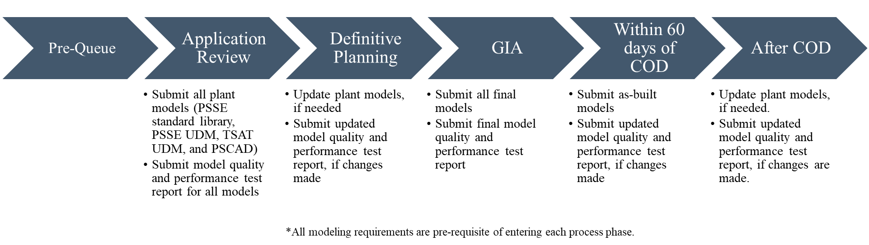

Figure 1: IBR Interconnection Modeling Requirements Process Flowchart

Any proposed changes that affect the electrical behavior, performance, or output of the IBR plant require updated models and an updated model quality and performance test report. In general, any change that results in a Material Modification request or Qualified Change review will trigger a new model package submission. The specific changes should be noted in the documentation (e.g., redline revisions). Within 30 days of changes made to the IBR plant, the Generator Owner (GO) shall submit an as-left verification report that verifies that the changes made in the field match the models submitted. If the as-left changes differ from those submitted to MISO and the TO, the GO will be subject to corrective actions outlined in the MISO Tariff and applicable contractual agreements.

# Definitions

The definitions in Clause 3.1 of IEEE Std 2800-2022 are applicable unless otherwise defined in this document.

* **Equipment-Specific Models –** Models that represent the make, model, type, and version of the installed (or planned) equipment. Equipment-specific IBR unit models and plant-controller models are typically provided by the original equipment manufacturer.
* **Site-Specific Models –** Equipment-specific models that also include the parameters and settings of the installed (or planned) equipment in the field.
* **Model Verification –** The process of confirming that model structure and parameter values represent the equipment or facility design and settings by reviewing equipment or facility design and settings documentation [6].
* **Model Validation –** The process of comparing measurements with simulation results to assess how closely a model’s behavior matches the measured behavior [6].

# Model Requirements

## General Requirements for All Models

The model requirements listed in this section are applicable to all four model types (i.e., standard library, PSS®E/TSAT™ UDM, and PSCAD™ models). Model-specific requirements for standard library, PSS®E/TSAT™ UDM, and PSCAD™ models are listed in the next subsections.

1. The models shall be configured to match the installed (or planned) equipment in the field and include all controls and protections (both software and hardware) that could affect the electrical output of the IBR plant to the extent possible.
2. Submitted models shall be provided in standalone packages (i.e., one folder for each model type containing all the necessary files), ready for simulations, and shall represent the project at requested service level at the POI (i.e., maximum active power output). The control mode and the parameters shall be set as specified in applicable interconnection requests and contractual agreements.
3. The models shall have the capability to change the control mode to any control mode possible in the actual power plant (e.g., voltage droop control, reactive power control, or power factor control, etc.) with accessible and modifiable reference setpoints.
4. All IBR units of the same type (identical design) shall be combined into a single equivalent aggregated unit. All IBR unit transformers of the same type (identical design) shall be combined into a single equivalent aggregated IBR unit transformer. Figure 2 shows a simplified single-line diagram of an aggregated[3] IBR plant for reference.

Figure 2. Simplified single-line diagram of an aggregated IBR plant.

1. The collector system model shall be an equivalent representation of the collector system. The preferred equivalencing method of the collector circuits, IBR unit transformers, and IBR units is detailed in [7].
2. All main power transformers and shunt compensation devices connected to the medium voltage collector bus(es) shall be explicitly modeled (i.e., no equivalencing).
3. The models shall include site-specific component and control models for the following, as applicable:
   1. IBR units,
   2. IBR unit transformers,
   3. Collector system,
   4. Mechanically switched reactive power devices,[4]
   5. Station service load,
   6. Flexible ac transmission systems (FACTS) devices,[5]
   7. Power plant controller,
   8. IBR main transformer(s), and
   9. Interconnection tie line.
4. The PPC model shall include control of all devices that are controlled by the PPC (e.g., batteries, different inverter manufacturers, switchable shunts, D-STATCOM, etc.), if applicable.
5. The controls of mechanically-switched reactive devices shall be modeled if the equipment dynamically responds to a disturbance within 10 seconds.
6. The controls of main power transformer on-load tap changers (OLTC/ULTC) shall be modeled if the equipment dynamically responds to a disturbance within 10 seconds.
7. All components of the model shall be verified that they represent the installed (or planned) equipment and settings. Attestations from the original equipment manufacturers that the models represent the planned or installed equipment, based on the available information at the time of submission, are required for the IBR unit and the PPC. Additional examples of acceptable approaches for model verification include, but are not limited to, the following:
   1. Mapping of controller’s code firmware version to the model version for real-code models.
   2. Evidence that the model parameters represent the as-built (or planned) control and protection settings (e.g., nameplate pictures of IBR unit and main transformers in the field, screenshots or equivalent of their tap settings, screenshots of PPC and inverter controls settings from the field, main breaker test report, etc.).
8. The IBR unit models shall be validated to ensure that they represent the installed (or planned) equipment and settings. This includes type test, factory acceptance test, or hardware-in-the-loop (HIL) test results demonstrating a comparison of the IBR unit’s response and the IBR unit’s model response for large-signal disturbances and is typically provided by the original equipment manufacturer. This is different from the plant level model validation that will be performed after the commissioning of the plant.
9. Each set of models shall include documentations that:
   1. Describe the applicability, functional use, and capabilities of the model.
   2. Describe any known limitations of the models (e.g., minimum SCR, model bandwidth, protection functions that are not included, control features that are not modeled, etc.).
   3. Identify a list of the files provided and their purpose (e.g., .obj, .dll, etc.).
   4. Describe which PSS®E, TSAT™, and PSCAD™ versions are supported (including Fortran Compiler for PSCAD™ models) and the minimum and maximum simulation time steps and other relevant simulation parameters.
   5. Provide an explanation of the control strategy of the PPC and the IBR unit controllers together with the corresponding control block diagrams.
   6. Define and describe parameters within the model that correspond to 1) frequency droop, 2) frequency deadband, 3) voltage reactive power droop, and 4) fault ride-through and protection settings.
10. All models shall be developed for a system with 60 Hz base frequency.

## Requirements for Standard Library Models

The following requirements are applicable to only standard library models:

1. The models shall be compatible with PSS®E and TSAT™ versions specified by MISO.
2. Only standard library models not listed as unacceptable by NERC [8], MISO, or the Eastern Interconnection Reliability Assessment Group (ERAG) Acceptable Model Working Group (AMWG) shall be used.
3. Any bus numbering larger than 1000 can be selected.

## Requirements for PSS®E UDMs

The following requirements are applicable to only PSS®E UDMs:

1. The models and Dynamic Link Libraries (DLLs) shall be provided for PSS®E versions specified by MISO.
2. The minimum timestep allowed is a quarter-cycle (i.e., 0.00416667 s).
3. Any bus numbering larger than 1000 can be selected.
4. Only table-driven models are acceptable (i.e., no CONEC and CONET subroutines).
5. All modes within PSS®E UDM shall be accurately modeled including data reporting mode (DOCU), data checking mode, data saving mode (DYDA).
6. The models shall be initialized at any feasible operating point without initial condition suspect errors and without additional manual adjustments.
7. The models shall be dispatchable at any feasible operating point within equipment capabilities.
8. The model shall allow multiple instantiations (i.e., several elements of the same type shall be able to use the same DLL, where applicable).
9. The models shall allow “enabling headroom availability” for low frequency events. This is different from dispatchability at different power levels.
10. Accompanying model documentation shall include:
    1. A control block diagram representation of the model.
    2. A full list of ICONs, CONs, STATEs and VARs and other relevant parameters with descriptions.
    3. A description of how to parametrize the dynamic model in case of power flow changes (e.g., bus number, ID, etc.).
    4. A description of how to enable headroom availability and its setpoint.

## Requirements for TSAT™ UDMs

The following requirements are applicable to only TSAT™ UDMs:

1. A TSAT case (*.tsa) including power flow and dynamic files) and library files (*.dll and *.tudm files) shall be provided for TSAT™ versions specified by MISO.
   1. The TSAT *.tudm file should only define the structure of the model and shall not include any project-specific information.
   2. The TSAT *.dyr file should interoperate with the PSS®E *.dyr file.
2. The minimum timestep allowed is a quarter-cycle (i.e., 0.00416667 s).
3. Any bus numbering larger than 1000 can be selected.
4. The models shall be initialized at any feasible operating point without initial condition suspect errors and warning messages.
5. The models shall be dispatchable at any feasible operating point within equipment capabilities.
6. The models shall allow “enabling headroom availability” for low frequency events. This is different from dispatchability at different power levels.
7. The models’ documentation shall include:
   1. A control block diagram representation of the model.
   2. A full list of parameters with descriptions.
   3. A description of how to parametrize the dynamic model in case of bus number changes.
   4. A description of how to enable headroom availability and its setpoint.

## Requirements for PSCAD™ Models

The following requirements are applicable to only PSCAD™ models:

1. The model shall include:
   1. Grounding transformer(s), if used.
   2. Over-voltage protection devices (e.g., surge arrestors) and filters, where applicable.
2. The IBR unit model shall:
   1. Utilize the actual hardware control code, if possible.[6]
   2. Represent the full detailed inner control loops of the power electronics.
   3. Include the primary energy source (PES) model.
   4. Include dc side dynamics, control, and protection of the converter.
   5. Include a full power electronic switching device representation or an averaged model representation of the converter.
3. The PPC model shall:
   1. Utilize the actual hardware control code, if possible.6
   2. Include all measurement, signal conditioning, communication delays, and controller cycling delays, to the extent practical.
4. IBR unit transformer and IBR main transformer models shall include the saturation characteristic of the core. This includes the per unit air core reactance, the per unit knee voltage, and the per unit magnetizing current.
5. Interconnection tie lines less than 3 miles may be modeled as a PI section. A Bergeron model or a frequency dependent model shall be used for longer interconnection tie lines.
6. The model shall [10]:
   1. Be compatible with PSCAD™ version 5.0.0 and higher.
   2. Be compatible with Intel Fortran 32-bit and 64-bit compiler version 15 and higher.
   3. Be compatible with Visual Studio 2015 and newer.
   4. Not require a simulation integration time step less than 10 μs.
   5. Not require a specific simulation integration time step.
   6. Be capable of reaching its ordered initial condition in less than 5 seconds (simulation time).
   7. Support the PSCAD™ “snapshot” feature.
   8. Support the PSCAD™ “multiple run” feature.
   9. Allow replication in different PSCAD™ cases or libraries through the “copy” or “copy transfer” features.
   10. Not use global variables in the PSCAD™ environment.
   11. Not utilize multiple layers in the PSCAD™ environment, including “disabled” layers.
7. The model should have pertinent control or hardware options[7] accessible to the user. Diagnostic flags[8] should be accessible to facilitate analysis and should identify why a model trips during simulations.
8. The PPC shall include accessibility of parameters that typically require site-specific tuning.[9]
9. The site-specific model shall be included in an example test case that initializes properly. The case shall include all equipment up to the POI. An ideal voltage source behind an impedance may be used to represent the system equivalent for the SCR at the POI.

# Model Quality and Performance Tests

The following requirements apply:

* A single-machine-infinite bus (SMIB) system shall be used for all tests, where the IBR plant is connected to a Thevenin equivalent system. The SCR and value of Thevenin voltage source of the equivalent system are defined for each test.
  + Where applicable and as defined in grid initial conditions, an SCR of 2.5 and an X/R ratio of 5 shall be used for model quality tests associated with the initial interconnection request. This may differ from the interconnection study SCR and X/R assumptions which are based on actual system location. The model quality tests at signed GIA and COD should use the site-specific SCR and X/R, as available.
  + A value listed as “variable” indicates that any value may be used.
* IBR generation plants (i.e., not storage) reactive power dispatch assumptions Qmin and Qmax should be zero and 32.87% of the IBR continuous rating, respectively. Battery energy storage system IBR plants Qmin and Qmax should be -32.87% of the IBR continuous rating and 32.87% of the IBR continuous rating, respectively.
* All tests shall be run for a minimum simulation duration of 30 seconds and the results shall be plotted for the time from 0 to 30 seconds.
* Frequency, voltage, active power, and reactive power shall be plotted at the point of measurement (POM) in separate figures for each test (i.e., four figures for each test). Relevant Trip control signals shall be included in the related plot (e.g., frequency tripping shown on frequency plot).

## Quality and Performance Tests for All Models

The simulation tests described in this section shall be performed for the four models (i.e., standard library models, PSS®E UDM, TSAT™ UDM, and PSCAD™ models). The following requirements also apply:

* The results of each test for all the four models (i.e., standard library model, PSS®E UDM, TSAT™ UDM, and PSCAD™ model) shall be overlaid on the same plot axis to facilitate comparison between different models (i.e., maximum of four curves on each figure).
* Any major discrepancies between the results obtained from different models for each figure shall be explained and justified otherwise they will be rejected by MISO.

### Initialization Tests

|  |  |  |  |  |  |  |  |
| --- | --- | --- | --- | --- | --- | --- | --- |
| **Test No.** | **Disturbance** | **IBR Plant Initial Condition** | | | **Grid Initial Condition** | | **Pass/Fail** |
| **Active Power at the POM** | **Reactive Power at the POM** | **Voltage at the POM (pu)** | **Infinite Bus Voltage** | **SCR** |
| 5.1.1-1 | No disturbance | Pmax | Qmax | 1.0 | Variable | 2.5 |  |
| 5.1.1-2 | No disturbance | Pmax | Qmin | 1.0 | Variable | 2.5 |  |
| 5.1.1-3 | No disturbance | Pmin[10] | Qmax | 1.0 | Variable | 2.5 |  |
| 5.1.1-4 | No disturbance | Pmin10 | Qmin | 1.0 | Variable | 2.5 |  |

**Pass/Fail Criteria**

The models pass these tests if all the following conditions are met for each test:

* 1. PSS®E and TSAT™ models initialize without any initial suspect error and the results remain flat during the simulation run.
  2. PSCAD™ models shall reach a steady state in less than 5 seconds and remain flat during the remainder of the simulation run.
  3. Active, reactive, and voltage values shall reasonably match between standard library, PSS®E/TSAT™ UDM, and PSCAD™ models at the POM.

### Balanced Fault Ride-Through Tests

|  |  |  |  |  |  |  |  |
| --- | --- | --- | --- | --- | --- | --- | --- |
| **Test No.** | **Disturbance** | **IBR Plant Initial Condition** | | | **Grid Initial Condition** | | **Pass/Fail** |
| **Active Power at the POM** | **Reactive Power at the POM** | **Voltage at the POM (pu)** | **Infinite Bus Voltage** | **SCR** |
| 5.1.2-1 | Bolted 3LG fault | Pmax | Qmax | 1.0 | Variable | 2.5 |  |

**Disturbance**

* Bolted 3LG fault: A three-phase-to-ground fault with zero fault impedance is applied at the POM at t=10 seconds and cleared after 10 cycles (i.e., 0.167 seconds).

**Pass/Fail Criteria**

The models pass these tests if all the following conditions are met:

The plant shall not trip and shall have a stable and well-damped response. An acceptable damping ratio is 0.3 or greater [5].

* 1. If the plant enters momentary cessation (current blocking) mode, it shall resume current injection in no less than 5 cycles following voltage recovery.
  2. After fault clearing and voltage recovery within the normal range, the active power recovery time to the pre-fault value shall be within 1.0 second.
  3. Appropriate reactive current response shall be observed based on control settings.
  4. Active, reactive, and voltage values shall reasonably match between standard library, PSS®E/TSAT™ UDM, and PSCAD™ models at the POM.

### Small Voltage Disturbance (SVD) Tests

|  |  |  |  |  |  |  |  |
| --- | --- | --- | --- | --- | --- | --- | --- |
| **Test No.** | **Disturbance** | **IBR Plant Initial Condition** | | | **Grid Initial Condition** | | **Pass/Fail** |
| **Active Power at the POM** | **Reactive Power at the POM** | **Voltage at the POM (pu)** | **Infinite Bus Voltage** | **SCR** |
| 5.1.3-1 | Small voltage disturbance | Pmax | 0 | Figure 3 | N/A | N/A |  |

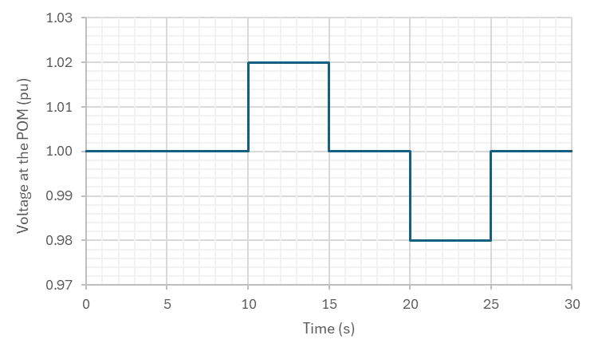

Figure 3: Voltage profile at the POM for the SVD tests.

**Grid Initial Condition**

Assume an ideal voltage source at the POM to represent the grid and apply the voltage profile shown in Figure 3 (i.e., use the playback model in PSS®E/TSAT™ and controllable voltage source in PSCAD™ at the POM).

**Pass/Fail Criteria**

The models pass these tests if all the following conditions are met:

* 1. The plant shall not trip.
  2. The plant shall have a stable and well-damped response. An acceptable damping ratio is 0.3 or greater [5].
  3. The plant shall not enter momentary cessation (current blocking) mode.
  4. Appropriate reactive power response shall be observed based on control settings.
  5. Active, reactive, and voltage values shall reasonably match between standard library, PSS®E/TSAT™ UDM, and PSCAD™ models at the POM.

### Small Frequency Disturbance (SFD) Tests

|  |  |  |  |  |  |  |  |
| --- | --- | --- | --- | --- | --- | --- | --- |
| **Test No.** | **Disturbance** | **IBR Plant Initial Condition** | | | **Grid Initial Condition** | | **Pass/Fail** |
| **Active Power at the POM** | **Reactive Power at the POM** | **Voltage at the POM (pu)** | **Infinite Bus Voltage** | **SCR** |
| 5.1.4-1 | Small frequency disturbance | 50% Pmax | 0 | Figure 4 (a) | N/A | N/A |  |
| 5.1.4-2 | Small frequency disturbance | 50% Pmax + no headroom[11] | 0 | Figure 4 (b) | N/A | N/A |  |
| 5.1.4-3 | Small frequency disturbance | 50% Pmax + headroom (50% of Pmax)[12] | 0 | Figure 4 (b) | N/A | N/A |  |

|  |  |
| --- | --- |
| 1. High frequency | 1. Low frequency |

Figure 4: Frequency profile at the POM for the SFD tests.

**Grid Initial Condition**

Assume an ideal voltage source at the POM to represent the grid and apply the frequency profile shown in Figure 4 (i.e., use the playback model in PSS®E/TSAT™ and controllable voltage source in PSCAD™ at the POM).

**Pass/Fail Criteria**

The models pass these tests if all the following conditions are met:

* 1. The plant shall not trip and shall have a stable and well-damped response. An acceptable damping ratio is 0.3 or greater [5].
  2. Appropriate active power response shall be observed based on control settings, including droop and deadbands.
  3. Active, reactive, and voltage values shall reasonably match between standard library, PSS®E/TSAT™ UDM, and PSCAD™ models at the POM.

### High-Voltage Ride-Through (HVRT) Tests

|  |  |  |  |  |  |  |  |
| --- | --- | --- | --- | --- | --- | --- | --- |
| **Test No.** | **Disturbance** | **IBR Plant Initial Condition** | | | **Grid Initial Condition** | | **Pass/Fail** |
| **Active Power at the POM** | **Reactive Power at the POM** | **Voltage at the POM (pu)** | **Infinite Bus Voltage** | **SCR** |
| 5.1.5-1 | High voltage | Pmax | Qmin | Figure 5 | N/A | N/A |  |

**Disturbance**

Voltage at the POM is stepped from 1.0 pu to 1.19 pu at t=10 seconds and return to 1.0 pu after 1 second (i.e., at t=11 seconds), as shown in Figure 5.

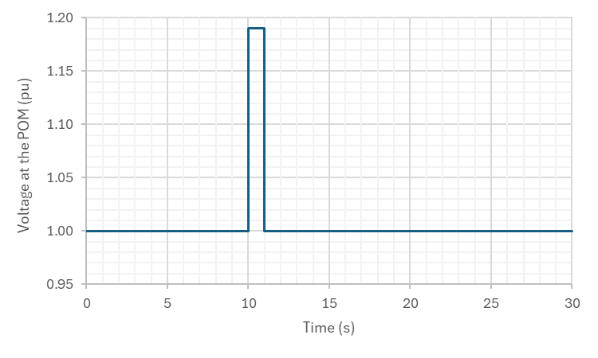

Figure 5: High voltage profile at the POM for the HVRT tests.

**Grid Initial Condition**

Assume an ideal voltage source at the POM to represent the grid and apply the voltage profile shown in Figure 5 (i.e., use the playback model in PSS®E/TSAT™ and controllable voltage source in PSCAD™ at the POM).

**Pass/Fail Criteria**

The models pass these tests if all the following conditions are met:

* 1. The plant shall not trip and shall have a stable and well-damped response. An acceptable damping ratio is 0.3 or greater [5].
  2. The plant shall not enter momentary cessation (current blocking) mode.
  3. If active power is reduced, it should recover to the pre-disturbance value within 1.0 second after the disturbance.
  4. Appropriate reactive current response shall be observed based on control objectives.
  5. Active, reactive, and voltage values shall reasonably match between standard library, PSS®E/TSAT™ UDM, and PSCAD™ models at the POM.

### Low-Voltage Ride-Through (LVRT) Tests

|  |  |  |  |  |  |  |  |
| --- | --- | --- | --- | --- | --- | --- | --- |
| **Test No.** | **Disturbance** | **IBR Plant Initial Condition** | | | **Grid Initial Condition** | | **Pass/Fail** |
| **Active Power at the POM** | **Reactive Power at the POM** | **Voltage at the POM (pu)** | **Infinite Bus Voltage** | **SCR** |
| 5.1.6-1 | Low voltage | Pmax | Qmax | Figure 6 | N/A | N/A |  |

|  |  |
| --- | --- |
| **Time Duration (s)** | **Voltage Level at the POM (pu)** |
| 0.32 | 0.00 |
| 1.20 | 0.25 |
| 3.00 | 0.50 |
| 6.00 | 0.70 |

Figure 6: Low voltage profile at the POM for the LVRT tests.

**Grid Initial Condition**

Assume an ideal voltage source at the POM to represent the grid and apply the voltage profile shown in Figure 6 (i.e., use the playback model in PSS®E/TSAT™ and controllable voltage source in PSCAD™ at the POM).

**Pass/Fail Criteria**

The models pass these tests if all the following conditions are met:

* 1. The plant shall not trip and shall have a stable and well-damped response. An acceptable damping ratio is 0.3 or greater [5].
  2. The plant shall not enter momentary cessation (current blocking) mode.
  3. If active power is reduced, it should recover to the pre-disturbance value within 1.0 second after the disturbance.
  4. Appropriate reactive current response shall be observed based on control settings.[13]
  5. Active, reactive, and voltage values shall reasonably match between standard library, PSS®E/TSAT™ UDM, and PSCAD™ models at the POM.

### High-Frequency Ride-Through (HFRT) Tests

|  |  |  |  |  |  |  |  |
| --- | --- | --- | --- | --- | --- | --- | --- |
| **Test No.** | **Disturbance** | **IBR Plant Initial Condition** | | | **Grid Initial Condition** | | **Pass/Fail** |
| **Active Power at the POM** | **Reactive Power at the POM** | **Voltage at the POM (pu)** | **Infinite Bus Voltage** | **SCR** |
| 5.1.7-1 | High frequency | Pmax | 0 | 1.0 | N/A | N/A |  |

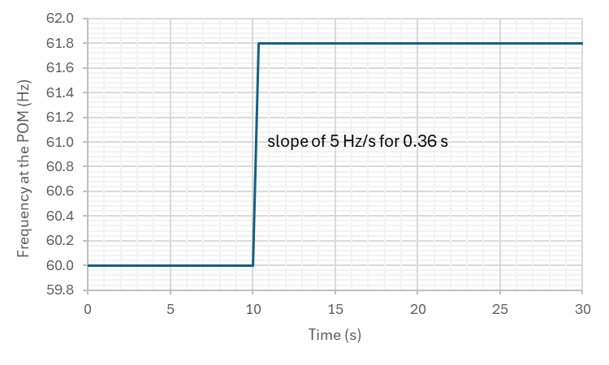

Figure 7: High frequency profile at the POM for the HFRT tests.

**Grid Initial Condition**

Assume an ideal voltage source at the POM to represent the grid and apply the frequency profile shown in Figure 7 (i.e., use the playback model in PSS®E/TSAT™ and controllable voltage source in PSCAD™ at the POM).

**Pass/Fail Criteria**

The models pass these tests if all the following conditions are met:

* 1. The plant shall not trip and shall have a stable and well-damped response. An acceptable damping ratio is 0.3 or greater [5].
  2. Appropriate active power response shall be observed based on control settings.
  3. Active, reactive, and voltage values shall reasonably match between standard library, PSS®E/TSAT™ UDM, and PSCAD™ models at the POM.

### Low-Frequency Ride-Through (LFRT) Tests

|  |  |  |  |  |  |  |  |
| --- | --- | --- | --- | --- | --- | --- | --- |
| **Test No.** | **Disturbance** | **IBR Plant Initial Condition** | | | **Grid Initial Condition** | | **Pass/Fail** |
| **Active Power at the POM** | **Reactive Power at the POM** | **Voltage at the POM (pu)** | **Infinite Bus Voltage** | **SCR** |
| 5.1.8-1 | Low frequency | 50% Pmax | 0 | 1.0 | N/A | N/A |  |

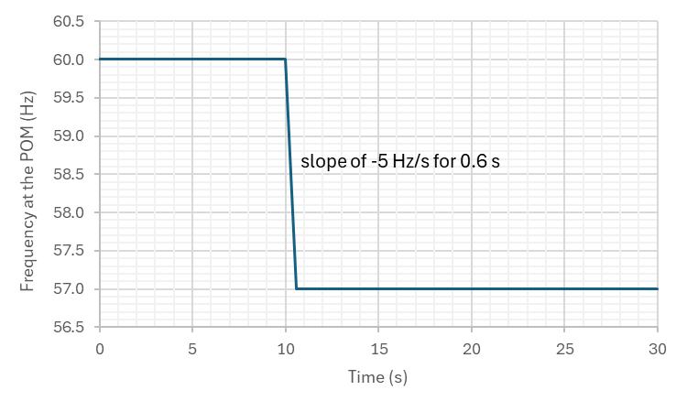

Figure 8: Low frequency profile at the POM for the LFRT tests.

**Grid Initial Condition**

Assume an ideal voltage source at the POM to represent the grid and apply the frequency profile shown in Figure 8 (i.e., use the playback model in PSS®E/TSAT™ and controllable voltage source in PSCAD™ at the POM).

**Pass/Fail Criteria**

The models pass these tests if all the following conditions are met:

* 1. The plant shall not trip and shall have a stable and well-damped response. An acceptable damping ratio is 0.3 or greater [5].
  2. Appropriate active power response shall be observed based on control settings.
  3. Active, reactive, and voltage values shall reasonably match between standard library, PSS®E/TSAT™ UDM, and PSCAD™ models at the POM.

### Protection Verification Tests

|  |  |  |  |  |  |  |  |
| --- | --- | --- | --- | --- | --- | --- | --- |
| **Test No.** | **Disturbance** | **IBR Plant Initial Condition** | | | **Grid Initial Condition** | | **Pass/Fail** |
| **Active Power at the POM** | **Reactive Power at the POM** | **Voltage at the POM (pu)** | **Infinite Bus Voltage** | **SCR** |
| 5.1.9-1 | High voltage | Pmax | 0 | Disturbances   * Voltage at the POM is stepped from 1.0 pu to 1.5 pu at t=10 seconds and then returns to 1.0 pu at t=15 seconds. See Figure 9(a). * Voltage at the POM is stepped from 1.0 pu to 0 pu at t=10 seconds and then returns to 1.0 pu at t=15 seconds. See Figure 9(b). * Frequency at the POM is stepped from 60 Hz to 70 Hz at t=10 seconds and then returns to 60 Hz at t=15 seconds. See Figure 9(c). * Frequency at the POM is stepped from 60 Hz to 50 Hz at t=10 seconds and then returns to 60 Hz at t=15 seconds. See Figure 9(c).  |  |  | | --- | --- | | A graph with a line  Description automatically generated   1. High voltage | A graph with a line  Description automatically generated   1. Low voltage | | A graph with a line  Description automatically generated   1. High frequency | A graph with a line  Description automatically generated   1. Low frequency |   Figure 9 (a) | N/A | N/A |  |
| 5.1.9-2 | Low voltage | Pmax | 0 | Disturbances   * Voltage at the POM is stepped from 1.0 pu to 1.5 pu at t=10 seconds and then returns to 1.0 pu at t=15 seconds. See Figure 9(a). * Voltage at the POM is stepped from 1.0 pu to 0 pu at t=10 seconds and then returns to 1.0 pu at t=15 seconds. See Figure 9(b). * Frequency at the POM is stepped from 60 Hz to 70 Hz at t=10 seconds and then returns to 60 Hz at t=15 seconds. See Figure 9(c). * Frequency at the POM is stepped from 60 Hz to 50 Hz at t=10 seconds and then returns to 60 Hz at t=15 seconds. See Figure 9(c).  |  |  | | --- | --- | | A graph with a line  Description automatically generated   1. High voltage | A graph with a line  Description automatically generated   1. Low voltage | | A graph with a line  Description automatically generated   1. High frequency | A graph with a line  Description automatically generated   1. Low frequency |   Figure 9 (b) | N/A | N/A |  |
| 5.1.9-3 | High frequency | Pmax | 0 | Disturbances   * Voltage at the POM is stepped from 1.0 pu to 1.5 pu at t=10 seconds and then returns to 1.0 pu at t=15 seconds. See Figure 9(a). * Voltage at the POM is stepped from 1.0 pu to 0 pu at t=10 seconds and then returns to 1.0 pu at t=15 seconds. See Figure 9(b). * Frequency at the POM is stepped from 60 Hz to 70 Hz at t=10 seconds and then returns to 60 Hz at t=15 seconds. See Figure 9(c). * Frequency at the POM is stepped from 60 Hz to 50 Hz at t=10 seconds and then returns to 60 Hz at t=15 seconds. See Figure 9(c).  |  |  | | --- | --- | | A graph with a line  Description automatically generated   1. High voltage | A graph with a line  Description automatically generated   1. Low voltage | | A graph with a line  Description automatically generated   1. High frequency | A graph with a line  Description automatically generated   1. Low frequency |   Figure 9 (c) | N/A | N/A |  |
| 5.1.9-4 | Low frequency | Pmax | 0 | Disturbances   * Voltage at the POM is stepped from 1.0 pu to 1.5 pu at t=10 seconds and then returns to 1.0 pu at t=15 seconds. See Figure 9(a). * Voltage at the POM is stepped from 1.0 pu to 0 pu at t=10 seconds and then returns to 1.0 pu at t=15 seconds. See Figure 9(b). * Frequency at the POM is stepped from 60 Hz to 70 Hz at t=10 seconds and then returns to 60 Hz at t=15 seconds. See Figure 9(c). * Frequency at the POM is stepped from 60 Hz to 50 Hz at t=10 seconds and then returns to 60 Hz at t=15 seconds. See Figure 9(c).  |  |  | | --- | --- | | A graph with a line  Description automatically generated   1. High voltage | A graph with a line  Description automatically generated   1. Low voltage | | A graph with a line  Description automatically generated   1. High frequency | A graph with a line  Description automatically generated   1. Low frequency |   Figure 9 (d) | N/A | N/A |  |

**Disturbances**

* Voltage at the POM is stepped from 1.0 pu to 1.5 pu at t=10 seconds and then returns to 1.0 pu at t=15 seconds. See Figure 9(a).
* Voltage at the POM is stepped from 1.0 pu to 0 pu at t=10 seconds and then returns to 1.0 pu at t=15 seconds. See Figure 9(b).
* Frequency at the POM is stepped from 60 Hz to 70 Hz at t=10 seconds and then returns to 60 Hz at t=15 seconds. See Figure 9(c).
* Frequency at the POM is stepped from 60 Hz to 50 Hz at t=10 seconds and then returns to 60 Hz at t=15 seconds. See Figure 9(c).

|  |  |
| --- | --- |
| A graph with a line  Description automatically generated   1. High voltage | A graph with a line  Description automatically generated   1. Low voltage |
| A graph with a line  Description automatically generated   1. High frequency | A graph with a line  Description automatically generated   1. Low frequency |

Figure 9: Voltage and frequency profiles at the POM for the protection verification tests.

**Grid Initial Condition**

Assume an ideal voltage source at the POM to represent the grid and apply the voltage and frequency profiles shown in

Disturbances

* Voltage at the POM is stepped from 1.0 pu to 1.5 pu at t=10 seconds and then returns to 1.0 pu at t=15 seconds. See Figure 9(a).
* Voltage at the POM is stepped from 1.0 pu to 0 pu at t=10 seconds and then returns to 1.0 pu at t=15 seconds. See Figure 9(b).
* Frequency at the POM is stepped from 60 Hz to 70 Hz at t=10 seconds and then returns to 60 Hz at t=15 seconds. See Figure 9(c).
* Frequency at the POM is stepped from 60 Hz to 50 Hz at t=10 seconds and then returns to 60 Hz at t=15 seconds. See Figure 9(c).

|  |  |
| --- | --- |
| A graph with a line  Description automatically generated   1. High voltage | A graph with a line  Description automatically generated   1. Low voltage |
| A graph with a line  Description automatically generated   1. High frequency | A graph with a line  Description automatically generated   1. Low frequency |

Figure 9 (i.e., use the playback model in PSS®E/TSAT™ and controllable voltage source in PSCAD™ at the POM).

**Pass/Fail Criteria**

The models pass these tests if all the following conditions are met:

* 1. The plant is generally expected to trip unless inverter, PPC, and plant relays are proven to be set outside these operating conditions.
  2. Active, reactive, and voltage values shall reasonably match between standard library, PSS®E/TSAT™ UDM, and PSCAD™ models at the POM.

### Short Circuit Ratio (SCR) Tests

|  |  |  |  |  |  |  |  |
| --- | --- | --- | --- | --- | --- | --- | --- |
| **Test No.** | **Disturbance** | **IBR Plant Initial Condition** | | | **Grid Initial Condition** | | **Pass/Fail** |
| **Active Power at the POM** | **Reactive Power at the POM** | **Voltage at the POM (pu)** | **Infinite Bus Voltage** | **SCR** |
| 5.1.10-1 | SCR change + Bolted 3LG fault | Pmax | 0 | 1.0 | Variable | Figure 10 |  |

**Disturbance**

Change the SCR of the grid, as shown in Figure 10. At the beginning of each transition to the next SCR value, apply a three-phase-to-ground fault with zero fault impedance at the POM and clear the fault after 6 cycles (i.e., 0.1 seconds).



Figure 10: Short circuit ratio profile of the grid for SCR tests.

**Grid Initial Condition**

Assume an ideal voltage source at the POM to represent the grid and change the SCR as shown in Figure 10.

**Pass/Fail Criteria**

The models pass these tests if all the following conditions are met:

* 1. The plant shall not trip and shall have a stable and well-damped response until at least SCR=2.5 (i.e., time 30 seconds in Figure 10). An acceptable damping ratio is 0.3 or greater [5].
  2. Active, reactive, and voltage values shall reasonably match between PSS®E standard library, PSS®E UDM, and PSCAD™ models at the POM.

## Quality and Performance Tests for PSCAD™ Models Only

The simulation tests described in this section shall be performed for PSCAD™ models only.

### Phase Angle Change Tests

|  |  |  |  |  |  |  |  |
| --- | --- | --- | --- | --- | --- | --- | --- |
| **Test No.** | **Disturbance** | **IBR Plant Initial Condition** | | | **Grid Initial Condition** | | **Pass/Fail** |
| **Active Power at the POM** | **Reactive Power at the POM** | **Voltage at the POM (pu)** | **Infinite Bus Voltage** | **SCR** |
| 5.2.1-1 | Phase angle ±25° change | Pmax | 0 | 1.0 | Variable | 2.5 |  |

**Disturbance**

Run the simulation for t=10 seconds. Apply the corresponding phase angle change (i.e., ±25 degrees) in the positive sequence phase angle of system voltage at t=10 seconds and continue the simulation run until t=30 seconds.

**Pass/Fail Criteria**

The models pass these tests if all the following conditions are met:

* 1. The plant shall not trip and shall have a stable and well-damped response. An acceptable damping ratio is 0.3 or greater [5].
  2. The plant shall not enter momentary cessation (current blocking) mode.

# References

[1] FERC, “Order 2023 – Improvements to Generator Interconnection Procedures and Agreements,” July 28, 2023. Available: <https://www.ferc.gov/media/e-1-order-2023-rm22-14-000>.

[2] NERC, “Reliability Standards for the Bulk Electric Systems of North America,” online: <https://www.nerc.com/pa/Stand/Pages/ReliabilityStandards.aspx>

[3] MISO, “Attachment X: Appendix 6 to Generator Interconnection Agreement (GIA)” 103.0.0, Effective On: November 14, 2024.

[4] Power System Dynamic Performance Committee, “Stability definitions and characterization of dynamic behavior in systems with high penetration of power electronic interfaced technologies,” Technical Report (PES-TR77) April 2020. [Online]. Available: <https://resourcecenter.ieee-pes.org/publications/technical-reports/PES_TP_TR77_PSDP_stability_051320.html>.

[5] “IEEE Standard for Interconnection and Interoperability of Inverter-Based Resources (IBRs) Interconnecting with Associated Transmission Electric Power Systems,” in IEEE Std 2800-2022, vol., no., pp.1-180, 22 April 2022, doi: 10.1109/IEEESTD.2022.9762253.

[6] NERC Project 2020-06 Verifications of Models and Data for Generators. Available: <https://www.nerc.com/pa/Stand/Pages/Project-2020_06-Verifications-of-Models-and-Data-for-Generators.aspx>

[7] E. Muljadi, A. Ellis, et al, “Equivalencing the Collector System of a Large Wind Power Plant”, IEEE Power Engineering Society Annual Conference, Montreal, Quebec, June 12-16, 2006.

[8] NERC, “Dynamic Modeling Recommendations – Recommended Modeling Practices and List of Unacceptable Models,” July 2023. Available: <https://www.nerc.com/pa/RAPA/ModelAssessment/Documents/Dynamic%20Modeling%20Recommendations.pdf>.

[9] WECC Meeting, “IEEE/Cigre Power System DLL Models/Standard,” April 5, 2019. Available: <https://www.electranix.com/wp-content/uploads/2019/04/Use-of-Real-Code-in-EMT-Models-for-WECC.pdf>.

[10] Electranix, “PSCAD Model Requirements Rev. 12,” September 19, 2022. Available: <http://www.electranix.com/wp-content/uploads/2022/09/PSCAD-Model-Requirements-Rev.-12-Sept-2022.pdf>

1. This excludes standalone high-voltage direct current (HVDC) systems. HVDC systems that are deployed for the sole purpose of interconnecting an IBR plant are included.
2. For example, analysis of harmonics.
3. Aggregation should be used for identical designs and shall be avoided for differing types/designs. For example, if a PV plant uses two different solar inverters, one equivalent aggregated unit shall be used for each type of inverter.
4. E.g., shunt capacitor banks, shunt reactor banks, and harmonic filter banks.
5. E.g., STATCOM and SVC.
6. Models that used the actual control code are commonly referred to as “Real Code” models [9].
7. E.g., adjustable protection thresholds or real power recovery ramp rates.
8. E.g., flags to show control mode changes or which protection has been activated.
9. E.g., voltage controller gains.
10. Applicable only to BESS plants. Pmin implies the maximum allowable charging (absorption) active power level.
11. Please refer to item 9 in Section 4.3for the description of enabling headroom in the models.
12. This implies the available power equals Pmax.
13. By default, the IBR unit shall operate in reactive current priority mode during high- and low-voltage ride-through events [5].