Manual No. 011

Business Practices Manual
RESOURCE ADEQUACY

Disclaimer
This document is prepared for informational purposes only, to support the application of the provisions of the Tariff and the services provided thereunder. MISO may revise or terminate this document at any time at its discretion without notice. While every effort will be made by MISO to update this document and inform its users of changes as soon as practicable, it is the responsibility of the user to ensure use of the most recent version of this document in conjunction with the Tariff and other applicable documents, including, but not limited to, the applicable NERC Standards. Nothing in this document shall be interpreted to contradict, amend, or supersede the Tariff. MISO is not responsible for any reliance on this document by others, or for any errors or omissions or misleading information contained herein. In the event of a conflict between this document, including any definitions, and either the Tariff, NERC Standards, or NERC Glossary, the Tariff, NERC Standards, or NERC Glossary shall prevail. In the event of a conflict between the Tariff and the NERC Standards, or NERC Glossary, the Tariff shall prevail until or unless the Federal Energy Regulatory Commission (“FERC”) orders otherwise. Any perceived conflicts or questions should be directed to the Legal Department.

Revision History
Doc Number | Description | Revised by: | Effective Date
BPM-011-r31 | Included language related to Final PRMR allocation process in Section 5.6 and other editorial changes  Updated PRA Formulations in Appendix M | MISO Staff | FEB-21-2025
BPM-011-r30 | Annual Review Complete including UCAP/ISAC ratio related process improvement, GADS events/performance submission, timeline change for multiple process such as state notifying MISO on utilizing their own PRM, full responsibility transactions, confirm/convert SAC etc, edits for RBDC (MRI/RBDC curve development, RBDC opt out process, PRMR determinations for PRA and settlements etc) | MISO Staff | OCT-01-2024
BPM-011-r29 | Annual Review Complete. Edits include GVTC test extension updates, 31-day rule and ZRC replacement updates, LMR and ER registration updates, OY CIL CEL removal Appendix K timeline updates and Attachment Y updates to schedule 53 resources and the UCAP/ISAC ratio process and timeline. | N. Przybilla | OCT-01-2023
BPM-011-r28 | Clarify and add additional context surrounding ZRC replacement and the 31-day outage rule in section 6.4 while ensuring language is consistent with Module E-1 of the MISO Tariff. | N. Przybilla | May-31-2023
BPM-011-r27 | Updates to all sections to facilitate the implementation of seasonal auctions & seasonal accreditation (FERC Docket No. ER22-495). Includes updates from annual BPM review | MISO Staff | October-31-2022
BPM-011 r26 | Replacement of 4.2.12 Battery Storage Accreditation with Electric Storage Resource. Add Electric Storage Resource to section 4.2.8. BTMG Qualification Requirements. Update Appx K. Correct Appendix N – Demand and Energy Forecast Characteristics. | M. Guerriero | AUG-15-2022
BPM-011-r25 | 2021 Annual review complete. Edits include: Hybrid resources, detail added to States establishing PRM, detail for 90/120 day outages, clarification for BTMG wind UCAP, Updated to reference new DSRI tool instead of MCS, updated RAN related LMR accreditation (ER20-1846), new DR Test Deferral process, Battery Storage accreditation, reorganized Appx I XEFORd, added Process Load reporting section, updated App K Timeline. | MISO Staff | JUL-01-2021
BPM-011-r24 | 2020 Annual review complete. Edits include new Appendix W (DR LOLE), Deliverable ICAP (ER20-1942, ER20-2005), GVTC testing clarification, ZDB example, and other minor clarifications. | G. Alexander | DEC-15-2020
BPM-011-r23 | Revisions to address treatment of resources on long term outage which FERC approved under Dock No. ER20-129-000. | T. Bachus | MAR-31-2020
BPM-011-r22 | 2019 Annual Review Complete. Edits include: general clean up, ER19-2559 (PRA Process Timeline) & ER18-2363 (Locational Filing), web links, ER UCAP intermittent qualification, Appx R CONE calculation, removing Att W (ER19-650 RAN Phase 1 LMR filing) by imbedding language into applicable LMR sections. | E. Thoms | OCT-1-2019
BPM-011-r21 | Added LMR Registration FAQ to address ER19-650-000 | E. Thoms | FEB-20-2019
BPM-011-r20 | Multiple updates. Revisions supporting changes to the out-year transfer study process. Additional revisions to support the Module E-1, Locational Tariff update which created External Resource Zones and several other changes. | M. Sutton | NOV-01-2018
BPM-011-r19 | Revisions to Section 4.2.8 clarifying language when a Qualifying Facility participates as a BTMG. Addition of SER Type II resource. Annual Review completed. | J. Harmon | SEP-28-2018
BPM-011-r18 | Annual Review Complete  Includes revisions to Section 4.2.8.5 clarifying deliverability options for BTMG. | J. Harmon | JAN-22-2018
BPM-011-r17 | Annual Review Complete | J. Harmon | AUG-25-2017
BPM-011-r16 | Several updates. Updated Wind UCAP values; added section regarding Solar capacity credit; Revised provisions for Zonal Deliverability Benefit; Inclusion of Suspended resources in the PRA; Retail Choice coincident load forecast reporting process. Annual Review completed. | J. Harmon | JUL-15-2016
BPM-011-r15 | Annual Review completed. Included Inter-zonal replacement, sub regional constraints in PRA, PRMR and LCR relationship, external resource and host BA qualification requirements, GVTC deferral, and refueling versus repowering.  Additions to section 5.2.1 for Local Resource Zone reevaluation process and Generation Limited Transfers | J. Milli /  M. Sutton /  S. Quadri /  J. Cole /  R. Westphal | SEP-01-2015
BPM-011-r14 | Annual Review completed. Remove netting of Demand Response. Update SFT and Transfer Analysis provisions. | J. Milli | SEP-01-2014
BPM-011-r13 | Updated LRZ map, timeline, and added catastrophic outage provisions | C. Clark | JAN-01-2014
BPM-011-r12 | Annual review and updated to reflect Tariff orders | C. Clark | AUG-01-2013
BPM-011-r11 | Updated to reflect Module E-1-1 Tariff | C. Clark | OCT-01-2012
BPM-011-r10 | Updated GVTC language for Hydro and ROR. | C. Clark | SEP-28-2012
BPM-011-r9 | Annual Review completed and Updated Registration tables and added new section for qualifying PPAs. | C. Clark | APR-15-2012
BPM-011-r8 | MISO Rebranding Changes JUL-19-2011 | G. Krebsbach | JUN-13-2011
BPM-011-r8 | Annual Review and added Dispatchable Intermittent Resource, minor clarifications | C. Clark | JUN-13-2011
BPM-011-r7 | Updated UCAP calculations for plan year 2011/2012, undated must offer provisions, updated External Resources cross-border deliverability provisions, updated minor clarifications | M. Heraeus / C. Clark | Dec-1-2010
BPM-011-r6 | Corrected errors and added “must offer” language and Units with Low Service Hours | M. Heraeus / C. Clark | JUN-1-2010
BPM-011-r5 | Corrected errors and inadvertent omissions | M. Heraeus | MAR-3-2010
BPM-011-r4 | Resource Adequacy Improvements Tariff Filing updates. Changed numbering to BPM -011 | K. Larson | DEC-21-2009
TP-BPM-003-r3 | Removed stakeholder comments from section 6.4 that were provided during drafting of TP-BPM-003-r2. Amended section 4.4.3.14.4.3.1. | T. Hillman | JUN-01-2009
TP-BPM-003-r2 | Revised to reflect the December 28th, 2007 (ER08-394) filing and subsequent Commission required compliance filings through May 2009 to revise Module E-1 to comprehensively address long-term Resource Adequacy Requirements | T. Hillman | JUN-01-2009
TP-BPM-003-r1 | Revised to reflect Open Access Transmission, Energy and Operating Reserve Markets Tariff for the Midwest ISO, Inc. (Tariff) relating to implementation of the Day-Ahead and Real-Time Energy and Ancillary Services Markets and to integrate proposed changes to the Balancing Authority Agreement. | J Moser | JAN-06-2009
TP-BPM-003 | Updated template | J. Moser | APR-01-2008
N/A | Section 3.2.1 Determination of Requirements – Non-valid statements were removed.  Section 3.2.3 Default Requirements – Minor revisions were made for clarification.  Section 3.2.4 Compliance with the Midwest ISO Requirements – Paragraph on after-the-fact ECAR “must offer” compliance was removed.  Section 4.1 Commercial Pricing Node Load Forecast – Minor revisions were made for clarification.  Section 5.2.1 Procedure for Designating a Network Resource for Resource Adequacy Purposes – LD Contracts bullet updated to reflect FERC Order 890.  Section 5.2.3 Designating Network Resources External to the Midwest ISO – The second bullet point was revised for clarification.  Section 5.3 Determination of Compliance with Network Resource Requirements – This section was deleted.  Section 5.4 (5.3) Network Resource Must Offer Requirement – Paragraph on after-the-fact ECAR “must offer” compliance was removed.  Section 5.5 Financial Transmission Rights – This section was deleted.  Section 5.6 (5.4) Updating Network Resource Designations – RE references have been updated to reflect the current NERC Regions.  Section 6.1.3 Liquidated Damage and Similar Contracts – Entire section updated to reflect FERC Order 890.  Section 6.1.4 Hubbing Transactions – This section was deleted.  Section 8 Data Requirements – Entire section updated to reflect  FERC order 890 |  | DEC-12-2007

Contents
1 Introduction 12
1.1 Purpose of the MISO Business Practices Manuals 12
1.2 Purpose of this Business Practices Manual 12
1.3 References 13
2 Overview of Resource Adequacy 14
2.1 Planning Reserve Margin Requirement Overview 14
2.2 Planning Resources Overview 14
2.3 Resource Adequacy Requirements Overview 15
2.4 Settlements/Performance Requirements Overview 16
3 Establishing Initial Seasonal Planning Reserve Marign Requirements 17
3.1 Overview 17
3.1.1 Agency Contracts Supporting Resource Adequacy Requirements 17
3.1.2 Validation of Firm Transmission Service for Load 18
3.2 Demand and Energy Forecasts 18
3.2.1 Non-Coincident Peak Demand and Energy for Load Forecasts 19
3.2.2 Coincident Peak Demand Forecast 20
3.2.3 Forecast Reporting 21
3.2.4 Wholesale Load Customers 22
3.2.5 Review of CPD Forecasts 22
3.3 Full Responsibility Transactions 23
3.4 Planning Reserve Margin 25
3.4.1 Determination of Seasonal Planning Reserve Margin 25
3.4.2 LOLE Analysis 26
3.4.3 Loss of Load Expectation (LOLE Working Group) 27
3.4.4 Generator Outage Data for LOLE Study 27
3.4.5 State Authority to Set PRM 28
4 Qualify and Quantifying Planning Resources 29
4.1 Overview 29
4.2 Planning Resources 30
4.2.1 Generation Resource, but not Dispatchable Intermittent Resource or Intermittent Generation 30
4.2.2 Use Limited Resources 38
4.2.3 External Resources 39
4.2.4 DRR Type I and Type II – Qualification Requirements 49
4.2.5 Load Modifying Resource Obligations and Penalties 50
4.2.6 BTMG Qualification Requirements 56
4.2.7 Demand Resource (DR) – Qualification Requirements 62
4.2.8 Energy Efficiency Resources 70
4.2.9 Electric Storage Resource 72
4.2.10 Qualifying Facilities (QF) 74
4.2.11 Hybrid and Co-Located Resources 75
4.3 Confirmation and Conversion of SAC MW 75
4.4 ZRC Transactions 75
4.4.1 Transfer of ZRCs 75
4.5 ICAP Deferral 76
4.5.1 Summary 76
4.5.2 Requirements and Timeline 77
4.5.3 Uncleared ZRCs with ICAP Deferrals 78
4.5.4 ICAP Deferral Non-Compliance Charge 78
5 Resource Adequacy Requirements 80
5.1 Overview 80
5.2 Local Resource Zones 80
5.2.1 Change in LRZ Configuration 81
5.2.2 Local Requirements and Transfer Capability 87
5.3 Pre-PRA arrangement of capacity scheduling 97
5.3.1 Fixed Resource Adequacy Plan (“FRAP”) 97
5.3.2 RBDC Opt Out 97
5.3.3 LSE’s Local Clearing Requirement for LSE’s Using a FRAP or RBDC Opt Out 99
5.4 Hedges and Zonal Deliverability Benefit 102
5.4.1 Zonal Deliverability Benefit 102
5.4.2 Historical Unit Considerations (HUCs) 104
5.4.3 Zonal Deliverability Charge Hedge 105
5.5 Planning Resource Auction (PRA) 106
5.5.1 Timing of Auctions 106
5.5.2 Amount of Capacity Cleared in Each Auction 106
5.5.3 Conduct of the PRA 106
5.5.4 Market Monitoring 108
5.5.5 Target Reliability Value 109
5.5.6 Resource Offers 109
5.5.7 Seasonal Simultaneous Feasibility Test (SFT) 110
5.5.8 Auction Results Posting 113
5.6 Final PRMR Allocation Process 114
5.7 Retail and Wholesale Load 120
5.7.1 Retail Load Switching 120
5.7.2 Wholesale (Non-Retail) Load Switching 121
5.7.3 Peak Load Contribution (PLC) 121
5.7.4 Settlements of Wholesale and Retail Switching 122
5.8 Capacity Deficiency Charge 122
6 Performance Requirements 124
6.1 Must Offer Requirement 124
6.1.1 Generation Resource but not Dispatchable Intermittent Resource or Intermittent Generation 124
6.1.2 Dispatchable Intermittent Resource and Intermittent Generation 125
6.1.3 Use Limited Resources 126
6.1.4 External Resources 127
6.1.5 DRR Type I and Type II 128
6.2 Must Offer Monitoring 128
6.3 Annual Calculation of CONE 129
6.4 Replacement Resources 130
6.4.1 Maximum Outage & Derate Threshold (Greater than 31 day rule) 130
6.4.2 Attachment Y Retirement or Suspend Status 131
6.4.3 Transfer of Resource Adequacy Requirement and Performance Requirements through ZRC Replacement 131
6.4.4 ZRC Replacement Transactions 132
6.4.5 On Ramping New Resources Mid-Planning Year for ZRC Replacement 133
6.4.6 MECT ZRC Replacement Calculator 133
6.4.7 Capacity Replacement Non-Compliance Charge and Distribution 135
6.5 LMR Performance 136
6.5.1 BTMG Performance 136
6.5.2 DR Performance 137
7 Integration of New LSEs 140
8 Testing Procedures and Requirements 141
8.1 Generator Real Power Verification Testing Procedures 141
9 Appendices 142
Appendix A Wind Capacity Credit 142
Appendix B GADS Events Outside Management Control (OMC Codes) 149
Appendix C Registration of Energy Efficiency Resources 151
Appendix D Registration of Demand Resources 152
Appendix E BTMG Registration 155
Appendix F External Resources 158
Appendix G Reliability Based Demand Curve 161
Appendix H Non-Schedule 53 Seasonal Accredited Capacity (SAC) Calculations for Planning Resources 168
Appendix I XEFORd Calculation 178
Appendix J GVTC Testing Requirements 185
Appendix K Resource Adequacy Timeline for activities for the Planning Year 2025 – 2026 194
Appendix L Transmission Loss Calculation 201
Appendix M Auction Formulation 202
Appendix N Seasonal Demand and Energy Forecast Characteristics 224
Appendix O Parties Responsible for Reporting Seasonal Demand and Energy Forecasts 225
Appendix P Zonal Deliverability Benefit Pro Rata Allocation 227
Appendix Q Fleet XEFORd Calculation 231
Appendix R Annual CONE Calculation 232
Appendix S Example Scenarios of “Excess BTMG" 235
Appendix T ICAP Deferral Notice 239
Appendix U ICAP Deferral Examples 241
Appendix V Solar and Run-of-River Hydro Accreditation 243
Appendix X Hybrid and Co-Located Resource Accreditation 248
Appendix Y SAC Calculations for Schedule 53 Resources 250

Introduction
This introduction to the Midcontinent Independent System Operator, Inc. (MISO) Business Practices Manual (BPM) for Resource Adequacy Requirements includes basic information about this BPM and the other MISO BPMs. The first section (Section 1.1) of this Introduction provides information about the MISO BPMs. The second section (Section 1.2) is an introduction to this BPM. The third section (Section 1.3) identifies other documents in addition to the BPMs, which can be used by the reader as references when reading this BPM.

Purpose of the MISO Business Practices Manuals
The BPMs developed by MISO provide background information, guidelines, business rules, and processes established by MISO for the operation and administration of the MISO markets, provisions of transmission reliability services, and compliance with the MISO settlements, billing, and accounting requirements. A complete list of MISO BPMs is available for reference through MISO’s website.

Purpose of this Business Practices Manual
This Resource Adequacy Business Practices Manual describes MISO’s and other entities’ roles and responsibilities related to maintaining Resource Adequacy, which is ensuring that Load Serving Entities (LSE) serving Load in the MISO Region have sufficient Planning Resources to meet their anticipated peak Demand requirements plus an appropriate reserve margin.

The Resource Adequacy BPM will conform and comply with MISO’s Energy Markets Tariff, NERC operating policies, and the applicable Regional Entity (RE) reliability principles, guidelines, and standards to facilitate administration of efficient Energy Markets.

This document benefits readers who want answers to the following questions regarding the Resource Adequacy Requirements (RAR).
- How is Resource Adequacy determined?
- How do the multiple state jurisdictions relate regarding Resource Adequacy Requirements (RAR)?
- What are the responsibilities of the different entities regarding Resource Adequacy?
- How are specific resources identified and qualified, including contracted resources, for Resource Adequacy purposes?
- What is a Zonal Resource Credit (ZRC) and how can it be used to comply with RAR?
- What are the deliverability requirements for Planning Resources?
- How are Demand Response Resources (DRR Type I and Type II) incorporated in the Resource Adequacy process?
- How does an LSE comply with its obligations under the changes to Module E-1 of the Tariff?
- What are the procedures for participating in Planning Resource Auctions?
- What are the settlement provisions for the Planning Resource Auctions?
- What are the procedures for tracking and settling retail and wholesale customer switches?

This document provides the necessary detail to aid a MISO Market Participant’s (MP) understanding of its primary responsibilities and obligations to the reliable operation of MISO’s Balancing Authority Footprint, as a result of MISO’s Resource Adequacy Requirements.

References
Other reference information related to this document includes:
- MISO BPMs
- MISO’s Open Access Transmission, Energy and Operating Reserve Markets Tariff
- NERC – Resource and Transmission Adequacy Recommendations, dated June 15, 2004
- Federal Energy Regulatory Commission (FERC) Order Nos. 890, Order 890 - A, and Order 890 - B.
- Module E Capacity Tracking (MECT) tool Users Guide
- LOLE Study Reports
- Wind & Solar Capacity Credit Report
- PowerGADS User’s Manual
- CIL/CEL Study Reports

Overview of Resource Adequacy
Achieving reliability in bulk electric systems requires, among other things, that the amount of resources exceeds customer Demand by an adequate margin. The margins necessary to promote Resource Adequacy needs to be assessed on both a near-term operational basis and on a longer-term planning basis.

The focus of Resource Adequacy is on the longer-term planning margins that are used to provide sufficient resources to reliably serve Load on a forward-looking basis. In the real-time operational environment, resources committed through the Resource Adequacy Requirements have a capacity obligation to be available to meet real-time customer Demand and contingencies. Therefore, Planning Reserve Margins (PRMs) must be sufficient to cover:
- Planned maintenance
- Unplanned or forced outages of generating equipment
- Deratings in the capability of Generation Resources and Demand Response Resources
- System effects due to reasonably anticipated variations in weather
- Load Forecast Uncertainty

Planning Reserve Margin Requirement Overview
Each LSE’s total obligation will be referred to as the Planning Reserve Margin Requirement (PRMR). Coincident Peak Demand forecasts are submitted by LSEs using a 50%/50% forecast (50% probability the forecast will be over, and 50% probability the forecast will be under, the projected peak Demand) which will include distribution losses. An LSE’s Initial Planning Reserve Margin Requirement (Initial PRMR) is described in Section 3 (Establishing Initial Planning Reserve Margin Requirements) of this BPM.

Planning Resources Overview
The resources used to achieve long-term Resource Adequacy are called Planning Resources, and consist of Capacity Resources, Load Modifying Resources and Energy Efficiency Resources. The relationships and key attributes of the Planning Resource types are as follows:
- Capacity Resources consist of electrical generating units, stations known as Generation Resources, External Resources (if located outside of the MISO Balancing Authority Area), Electric Storage Resources (ESR), Hybrid Resources, and resources that can be dispatched to reduce Demand known as Demand Response Resources that participate in the Energy and Operating Reserves Market and are available during Emergencies. Thermal Generation Resources are accredited based on the methodology described in Appendix Y (Schedule 53 Resources). Wind Resources will be accredited based on the ELCC study that MISO conducts. Non-wind intermittent generation resources will be accredited based on historical performance during the critical hours within each Season, where new resources will receive the class average for that resource type until enough historical data is accrued. Non-Schedule 53 Capacity Resources that report to GADS are quantified by applying seasonal forced outage rates to Installed Capacity (ICAP) values to calculate the Seasonal Accredited Capacity (SAC) for the resource.
- Load Modifying Resources (LMR) include Behind-the-Meter Generation (BTMG) and Demand Resources (DR) which are available during capacity and transmission Emergencies declared by MISO if used to meet Module E-1 requirements.
- Energy Efficiency Resources include installed measures on retail customer facilities that achieve a permanent reduction in electric Energy usage while maintaining a comparable quality of service.

A Market Participant (MP) can use Capacity Resources, LMRs, and Energy Efficiency Resources, up to their SAC values, to comply with their Resource Adequacy Requirements via a Fixed Resource Adequacy Plan or Reliability Based Demand Curve Opt Out (RBDC Opt Out) as described in Section 5.3 Pre-PRA arrangement of capacity scheduling of this BPM, or through self-scheduling their Zonal Resource Credits in the Planning Resource Auction(s) (PRA) as detailed in Section 5.5.6 (Resource Offers) of this BPM. A Market Participant can also sell ZRCs from Capacity Resources, LMRs, and Energy Efficiency Resources bilaterally before the Planning Resource Auction(s) or offer them in the Planning Resource Auction(s) as described in Section 5.5 (Planning Resource Auction) of this BPM.

MISO will determine Seasonal Accredited Capacity (SAC) values for all qualified Capacity Resources, Load Modifying Resources and for all Energy Efficiency Resources for each Season within the Planning Year.

Resource Adequacy Requirements Overview
Planning Resources that clear the Planning Resource Auction(s) (PRA) or that are designated in a Fixed Resource Adequacy Plan (FRAP) or RBDC Opt Out will be obligated to provide capacity in the Day-Ahead and Real Time Markets (DA/RT) for each Season cleared within the Planning Year unless replaced by another Planning Resource, as per Module E-1 Section 69A.3.1.h. Capacity Replacement Non-Compliance Charge(s) (CRNCC) may be applicable as per Module E-1 Section 69A.3.1h. Load Serving Entities (LSEs) that serve Load during the Planning Year will be obligated to pay for capacity from Planning Resources in the PRA pursuant to the relevant Auction Clearing Price (ACP) for the Local Resource Zone (LRZ) where the Load is located unless the Planning Resource was designated in a FRAP or RBDC Opt Out.

LSEs that have a Planning Reserve Margin Requirement (PRMR) will be obligated to procure capacity equal to their Final PRMR pursuant to the relevant ACP for the LRZ where they have PRMR unless, and to the extent that the LSE meets its Final PRMR via a FRAP or RBDC Opt Out per Section 5.3 of this BPM, or unless and to the extent that the LSE chooses to reduce its Final PRMR that is cleared in a given auction(s) by electing to pay the Capacity Deficiency Charge per Section 5.7 of this BPM.

Settlements/Performance Requirements Overview
The seasonal Planning Reserve Margin Requirement (PRMR) obligations of LSEs will be established for each Season of the Planning Year and will be settled based upon the applicable Planning Resource Auction(s) (PRA) clearing price for an LSE’s Final Planning Reserve Margin Requirement, unless covered by a FRAP or RBDC Opt Out, or unless the LSE elects to pay the Capacity Deficiency Charge. Once each planning period begins, LSEs and MPs will have the corresponding charges and credits from each applicable PRA included on their daily settlement statements for all loads and Planning Resources cleared in a PRA as documented in further detail in the Market Settlements BPM.

LMRs with ZRCs that either cleared the PRA or were used in a FRAP or RBDC Opt Out will have a performance obligation to be available during system Emergencies per section 4.2.7 (Demand Resource Qualification Requirements) of this BPM.

Establishing Initial Seasonal Planning Reserve Marign Requirements

Overview
The Initial seasonal Planning Reserve Margin Requirement (PRMR) is the number of MWs in ZRCs required to meet an LSE’s Resource Adequacy Requirements (RAR). The RAR is established to ensure that LSEs have enough Planning Resources to reliably serve load for the applicable Seasons.

The Initial seasonal PRMR is expressed in the following equation per Load Serving Entity (LSE) per Local Resource Zone (LRZ)

${Initial PRMR}_{LRZ}= \sum_{LBA}{[\left({CPDf}_{LBA}-{FRP}_{LBA}+{FRS}_{LBA}\right)×\left(1+{TL}_{LBA}\%\right)×\left(1+{PRM}_{RTO}\right)]}$

Where attributes are seasonal for the following:
Initial PRMR_{LRZ} = Initial Planning Reserve Margin Requirement per LRZ
CPDf_{LBA} = Coincident Peak Demand forecast per LBA
FRP_{LBA} = Full Responsibility Purchase per LBA
FRS_{LBA} = Full Responsibility Sale per LBA
TL_{LBA}% = Transmission Loss Percentage of LBA
PRM _{RTO} = Planning Reserve Margin in Unforced Capacity set by LOLE Studies

Agency Contracts Supporting Resource Adequacy Requirements
An LSE may contract with other entities to comply with RAR. The contracted entity may perform functions on behalf of the applicable LSE including, but not limited to, submitting the LSE’s forecasted CPD forecast or share of CPD forecast.

Each individual LSE is ultimately responsible for conformance with the RAR, even if the LSE enters a contract with a third party acting on its behalf. If requested by MISO, each LSE that contracts with another entity to comply with any part of the Resource Adequacy Requirements must notify MISO of the arrangement. The LSE must provide MISO with the name of the organization representing them, primary and alternate contact information for the individuals representing them, and the scope of responsibilities the contracted entity will provide.

Validation of Firm Transmission Service for Load
Each LSE shall document, as described in Module B – Transmission Service, to MISO that the LSE has obtained sufficient firm Transmission Service to serve its load for each Season in the Planning Year. Load not served by Network Integrated Transmission Service (NITS) must have Firm Point-to-Point Transmission Service or a firm Grandfathered Agreement (GFA), when applicable—however, Demand does not require firm MISO Transmission Service when the LSE meets its Initial PRMR using its own Behind-the-Meter Generation (BTMGs), Demand Resources (DRs), and Energy Efficiency Resources, and does not use the MISO Transmission System to serve such Demand.

Additionally, Energy Resource Interconnection Service (ERIS) requires a completed firm Transmission Service Request (TSR) submitted through OASIS OATI that has been approved by the Generation and Interchange team at MISO in order to be considered towards deliverability that is used to convert Seasonal Accredited Capacity (SAC) to Zonal Resource Credits (ZRCs). This information will be entered into the MECT on the Convert SAC screen by Market Participants (and in the Registrations screen, if applicable).

Demand and Energy Forecasts
MISO collects a variety of load forecasts for Resource Adequacy and other planning processes via the MECT tool. This section describes each of these forecasts and what entity is responsible for providing them. Please See Appendix O for the list of parties responsible for reporting Demand and Energy forecasts.

Demand and Energy forecasts that are not subject to retail choice load switching should be reported by the respective LSE. Demand and Energy forecasts that are subject to retail choice load switching should be reported by the respective Electric Distribution Company (EDC). The EDC calculates a Peak Load Contribution (PLC) MW value for each retail choice LSE that represents a share of the EDC’s Initial PRMR. If an LSE disagrees with their PLC value calculated by their EDC, the LSE will work with its EDC to revise the PLC prior to the final EDC forecast submission deadline. See Appendix K for all Demand and Energy forecast deadlines.

All Demand (Energy) forecasts must reflect a 50% probability that the Demand (Energy) will not exceed the forecasted Demand (Energy) for the relevant time period. Any manual or ex-post adjustments to the forecasts derived from the LSE’s chosen forecasting method that are offered due to catastrophic event impacts (such as COVID-19) must be supported analytically and quantitatively.

For a detailed description of each forecast’s characteristics refer to Appendix N.

Non-Coincident Peak Demand and Energy for Load Forecasts
Non-Coincident Peak Demand and Energy for Load forecasts are collected for the purposes of facilitating FERC Form 714 and NERC Modeling Data and Analysis (MOD) Standards reporting along with other planning processes at MISO.

The MISO FTR Administration team uses the Non-Coincident Peak forecast value for the upcoming Planning Year in the annual Auction Revenue Rights (ARR) allocation process. This forecast should not include transmission losses or Grandfathered Agreements (GFAs) but should include Demand Resources and Behind-The-Meter-Generation (BTMG). Load served by GFAs is reported separately via the same MECT section.

Please refer to NERC’s Reliability MOD Standards for a complete definition for the non-Coincident Peak Demand forecast and FERC’s Form 714 for the Energy for Load forecast. Below are general guidelines; if a conflict should arise between the guidelines below and the respective NERC standards documents, defer to the latter.

The Non-Coincident Peak Demand and Energy for Load forecasts are reported on a monthly basis for forecast years 1 and 2 and on a seasonal basis for forecast years 3 through 10.

Seasons for the purposes of these forecasts are defined as shown below:
Summer: June through August
Fall: September through November
Winter: December through February
Spring: March through May

For seasonal reporting of the Non-Coincident Peak Demand forecast, the single highest peak hour during the Season should be reported in MW. The ARR allocation section of the Non-Coincident Peak Demand Forecast submission screen should be calculated and submitted on an annual peak for a given Planning Year for use in the FTR annual Auction Revenue Rights process. For Energy for Load forecasts, the summation of each month or season’s Energy for load (GWh) should be reported as appropriate.

For all forecasts submitted, each LSE shall ensure that it counts its customer Demand once and only once.

Non-Coincident Peak Demand and Energy for Load forecast must be reported in the MECT by 11:59 pm EST on November 1 prior to the Planning Year.

For a detailed description of each forecast’s characteristics refer to Appendix N.

Coincident Peak Demand Forecast
The seasonal Coincident Peak Demand forecasts (CPD forecast) are used as the basis for determining each LSE’s seasonal obligation. The seasonal CPD forecasts shall be based upon considerations including, but not limited to, average historical weather conditions, economic conditions and expected Load changes (addition or subtraction of Demand).

For a detailed description of each forecast’s characteristics refer to Appendix N.

A document describing the desired approach to be used by LSEs in preparing the seasonal CPD forecasts, the information required in each annual filing, and the process used in reviewing the CPD Forecasts can be found on MISO’s website: Peak Forecasting Methodology Review Whitepaper. This document was written for when LSEs submitted an annual Coincident Peak Forecast, but the same methodology described in the paper can be performed at a seasonal level.

The seasonal CPD forecasts must be provided for each Asset Owner/LBA combination. Providing the CPD forecasts by Asset Owner is required by MISO’s settlements process. Reporting by LBA allows MISO to apply the appropriate seasonal Transmission Losses towards the Initial PRMR and Final PRMR calculation. Seasonal Transmission Losses will be made available on the public website by MISO for each LBA. For more information on Transmission Losses see Appendix L.

The CPD forecasts must be reported via the MECT tool by 11:59 EST on November 1 prior to the Planning Year.

The CPD forecasts are reported differently in non-retail choice and retail choice areas as described in the following subsections.

Forecast Reporting
LSEs with Demand and Energy that are not subject to retail choice load switching are required to provide MISO with Demand and Energy forecasts no later than 11:59 p.m. EST on November 1 each year, for the following Planning Year. The seasonal CPD forecasts must be reported for each Asset Owner by LBA.

LSEs with Demand and Energy that is subject to retail choice load switching are not required to provide MISO with Demand and Energy forecasts. Electric Distribution Companies (EDCs) are responsible for submitting forecasts in areas that have Demand and Energy that is subject to retail choice load switching.

EDCs are defined as the company that distributes electricity to retail customers through distribution substations and/or lines owned by the company. The EDC of a retail choice area provides MISO with a seasonal peak forecasted Demand coincident with MISO’s seasonal peak and must provide this data no later than 11:59 p.m. EST on November 1 prior to the Planning Year.

EDCs must provide both MISO and the respective retail choice LSEs with each retail customer’s initial seasonal Peak Load Contribution (PLC) in the EDC’s service territory no later than 11:59 p.m. EST on December 15 prior to the Planning Year.

All new EDCs are required to work with the MISO Client Services and Readiness department (https://help.misoenergy.org/) to set up access to the MECT tool and identify the relationships between the EDC and the LSEs in the EDC area. A Help Center ticket will need to be created to detail the access and relationship additions for the new EDC. The MISO Client Services and Readiness team will provide the new EDC with the required registration forms. Once the EDC setup is completed, all MPs with commercial pricing nodes participating in the retail choice load switching program are required to provide the name of the EDC where the commercial pricing node is located.

Provider of Last Resort
The Provider of Last Resort (POLR) will be responsible for meeting any Initial PRMR from Demand left unclaimed by retail choice LSEs in the EDC service territory. The Transmission Provider will work with the POLR and EDC to ensure that the POLR will serve any remaining Demand that is not allocated to LSEs.

Wholesale Load Customers
To ensure wholesale customers are accounted for, LSEs serving wholesale customers during the prompt Planning Year must include the Demand and Energy attributed to those wholesale customers in their Demand and Energy forecasts by 11:59 p.m. EST on November 1 prior to the Planning Year via the MECT tool.

An LSE that has previously served a wholesale customer and does not intend on serving that customer for the prompt Planning Year may or may not be required to report that customer in their forecasts.

Case 1: LSE knows the entity that will serve the wholesale customer next Planning Year:
In this case, the existing LSE is not responsible for submitting the Energy or Demand attributed to the wholesale customer in their forecasts. However, they must state the entity responsible for serving the customer in their supporting documentation.

Case 2: LSE does not know who will serve the wholesale customer next Planning Year:
In this case, the existing LSE is responsible for submitting the Energy or Demand attributed to the wholesale customer in their forecasts.

MISO will work with the wholesale customer regarding their forecasts and contact the wholesale customer to determine who the responsible LSE is. Once the responsible LSE is identified, MISO will transfer the Demand from the old LSE to the new LSE prior to the Planning Resource Auction.

Review of CPD Forecasts
Starting November 1, MISO will begin reviewing all forecasts and a randomly chosen set of supporting documentation submitted by LSEs and EDCs in order to give all parties adequate time to resolve any identified forecasting issues with MISO. The review will focus on whether the forecast methodology adequately and reasonably forecasts peak Demand, Energy, and/or Demand reduction capability of the submitting entity. The forecast review process will be completed no later than March 1 of each year prior to the annual PRA. If necessary, MISO may develop the required seasonal CPD forecasts for any Market Participants serving Load in the Transmission Provider Region or serving Load on behalf of a Load Serving Entity or other Market Participants that do not submit CPD forecasts and supporting documentation by the November 1 deadline.

Full Responsibility Transactions
Full Responsibility Transactions (FRT) are referenced differently depending on which side of the transaction is being addressed. The sale side of an FRT is called a Full Responsibility Sale (FRS) and the purchase side is called a Full Responsibility Purchase (FRP). Both the FRS and FRP are a transfer of Demand. As a result, the seasonal obligation (Initial PRMR and Final PRMR) calculation will reflect the associated transfer of transmission losses and PRM. FRTs may only be entered for Demand that is not subject to retail choice load switching.

The FRS results in an increase in Demand and FRP results in a decrease in Demand. This can be interpreted as the purchaser paying the seller to take on Demand and its associated seasonal Initial PRMR. This transfer of Demand also results in a transfer of the associated transmission losses and PRM.
- The seller of an FRS is contractually obligated to deliver power and Energy to the purchaser with the same degree of reliability as provided to the seller’s own native load. With Full Responsibility Service to an LSE within MISO’s Region, sellers are responsible for all of that LSE’s Initial PRMR associated with the sale.

Example:

Asset Owner MM1:
Seasonal CPDf = 10 MW
Seasonal PRM = 6.2%
Seasonal Transmission Loss % = 2%
Asset Owner MM1 is the Buyer of the FRT for the total amount of 5 MW
MM1’s Initial PRMR = (10 – 5) * (1 + 0.062) * (1 + 0.02) = 5.4 MW

Asset Owner SS2:
Seasonal CPDf = 20 MW
Seasonal PRM = 6.2%
Seasonal Transmission Loss % = 2%
Asset Owner SS2 is the Seller of the FRT for the total amount of 10 MW
SS2’s Initial PRMR = (20 + 10) * (1 + 0.062) * (1 + 0.02) = 32.5 MW

Asset Owner BB3:
Seasonal CPDf = 50 MW
Seasonal PRM = 6.2%
Seasonal Transmission Loss % = 2%
Asset Owner BB3 is the Buyer of the FRT for the total amount of 5 MW
Asset Owner BB3 is the Seller of the FRT for the total amount of 10 MW
BB3’s Initial PRMR = (50 – 5 + 10) * (1 + 0.062) * (1 + 0.02) = 59.6 MW

The LSE (purchaser) may contract with other entities (sellers) to be responsible for capacity payments based upon the ACP for all or part of its load delivered to the purchaser through an FRP/FRS agreement. Each purchaser and seller must agree on which of their transactions are to be reported as an FRP/FRS. If the purchaser and seller cannot agree upon whether a particular transaction is an FRP/FRS agreement, then either party may invoke the dispute resolution procedures in the Tariff. FRP/FRS agreements are treated effectively like a transfer of forecasted Demand and the associated Initial PRMR from one LSE to another. An LSE with an FRP agreement is required to input the forecasted Coincident Peak Demand information for the transferred Demand into the MECT. An MP with a FRS agreement is required to meet the RAR obligation derived from the Demand as though it was their load, as described in Section 3. If the seller under an FRP/FRS agreement is not an LSE subject to the MISO Tariff, then the purchaser under an FRP/FRS agreement will remain responsible for any capacity payments associated with the FRP/FRS agreement.

If the seller under an FRS/FRP agreement is not an LSE subject to the MISO Tariff (“non-jurisdictional”), then the purchaser who is responsible for any RAR deficiencies may coordinate with the non-jurisdictional party to ensure that any RAR obligations associated with transferred Demand are met. A purchaser may request that the seller communicate the proper validations and confirmations to the purchaser or confirm validation of RAR obligations in the MECT to the purchaser. Such purchaser also can request that MISO coordinate with the non-jurisdictional party to intermediate the exchange of information from the seller to the purchaser. Such coordination will not relieve the purchaser from their responsibility for any RAR deficiencies associated with the FRP/FRS agreement.

The LSE with the FRS is responsible for compliance with LSE requirements. The obligation to serve the load is shifted but the obligation to forecast the Demand remains with the original LSE (purchaser). Both the purchasing and selling parties will be required to enter and verify the FRT into the MECT Full Responsibility Transaction screen. The parties must enter an FRT into the MECT along with documentation detailing their contract between the purchasing and selling parties to enable MISO to track the load and capacity obligations shift. This must be done by the fifth business day of February and the settlement will be between LSEs for all FRTs.

The Initial PRMR cannot be a negative number as a result of the FRT.

Planning Reserve Margin
This section describes the Loss of Load Expectation (LOLE) study process used by MISO to establish the Planning Reserve Margin (PRM) for each Season of the prompt MISO Planning Year. A MISO Planning Year runs from June 1 through May 31.

Determination of Seasonal Planning Reserve Margin
MISO will perform probabilistic analyses annually to establish the system-wide seasonal PRMs. This probabilistic analysis will utilize a Loss of Load Expectation (LOLE) study which assumes that there are no internal transmission limitations. Additionally, MISO will perform probabilistic analyses to establish the seasonal Local Reliability Requirements (LRRs) for each Local Resource Zone. MISO will publish the results by November 1 preceding the applicable Planning Year.

The LOLE study shall be consistent with Good Utility Practice, the reliability requirements of the Regional Entities (RE), and applicable states in the MISO Region. The PRM analyses shall consider factors including, but not limited to: the Generator Forced Outage rates of Capacity Resources, Generator Planned Outages, expected performance of Load Modifying Resources (LMRs), Intermittent Resources, Energy Efficiency Resources, load forecast uncertainty, and the Transmission System’s import and export capabilities with external systems. The seasonal PRMs that are calculated in the LOLE probabilistic modeling software are determined on an ICAP and UCAP basis. The preliminary PRMR_{ICAP} values are the sum of the ICAP ratings of the resources utilized in the simulation to achieve the reliability criteria. Similarly, the sum of the UCAP ratings of these same resources utilized in the simulation to achieve the reliability criteria is the total UCAP-rated MW needed, or the preliminary PRMR_{UCAP} Values. PRMR values are finalized after MISO has received the updated LSE-submitted load forecasts on November 1 and validated the load forecasts.

MISO will calculate and publish on its website the estimated seasonal PRM for each of the nine subsequent Planning Years, to provide information for long-term resource planning, without establishing any enforceable specific resource planning reserve requirements.
See the Resource Adequacy page on MISO’s public website for current and previous LOLE study reports.

LOLE Analysis
MISO will determine the appropriate PRM for each Season of the applicable Planning Year based on the probabilistic analyses of being able to reliably serve MISO’s forecasted seasonal Coincident Peak Demand. This probabilistic analysis will utilize a LOLE study which assumes that there are no internal transmission limitations.

MISO’s LOLE study will first calculate the annual PRM such that the summation of LOLE across the year is one (1) day in ten (10) years, or 0.1 day per year. The minimum PRM requirement will be determined through LOLE analyses by either adding a negative output unit with no outage rates, or by adding increments of a positive output combustion turbine (CT) Planning Resource with nominal capacity values that correspond with the most recent annual calculation of Cost of New Entry (CONE) as described in Section 6.3 and that have class average outage rates, until a 0.1 day per year solution is reached.

A minimum of 0.01 day per Season LOLE will be used to calculate the seasonal PRMs and LRRs in Seasons with less than 0.01 day per year LOLE risk upon the annual summation of LOLE reaching the 0.1 day per year reliability criteria.

The LOLE model will initially be run with no adjustments to the capacity. If the LOLE in a given Season is less than the reliability criteria day per year for that Season, a negative output unit with no outage rates will be added until the LOLE reaches the reliability criteria for that Season. This is comparable to adding Coincident Peak Demand. If the LOLE is greater than the reliability criteria, proxy units based on a unit of typical size and outage rates will be added to the model until the LOLE reaches the reliability criteria.

MISO will also determine the Local Reliability Requirement (LRR) for each LRZ consistent with the LOLE achieving 0.1 day per year for each LRZ. The minimum amount of capacity above seasonal Coincident Peak Demand required to meet the reliability criteria of a 0.1 day per year LOLE value will be utilized to establish the system-wide seasonal PRMs. The minimum amount of capacity above the seasonal Zonal Coincident Peak Demand required to meet the reliability criteria of a 0.1 day per year LOLE value will be utilized to establish the seasonal LRR for each LRZ. When determining LRRs, risk-deficient Seasons will have a minimum reliability criteria of 0.01 LOLE per Season.

Loss of Load Expectation (LOLE Working Group)
MISO establishes seasonal Unforced Capacity requirements applicable in the Planning Resource Auction (PRA) based on LOLE probabilistic analyses conducted by MISO Resource Adequacy and in coordination with members of the LOLE Working Group (LOLEWG). The duties of the working group are to help guide MISO in implementing the study methods outlined in this section. The analyses will conform to the Electric Reliability Organization (ERO) standards, including those established by applicable Regional Entities for reliability and resource adequacy. The LOLEWG will review and provide recommendations to MISO on the methodology and input assumptions to be used in performing the LOLE analyses, as well as reviewing the results of the LOLE analyses and related sensitivity cases. MISO will be the entity ultimately responsible for conducting the LOLE study and determining the seasonal PRMs, except as set forth in Section 3.4.5.

Generator Outage Data for LOLE Study
The probabilistic study will use a LOLE model capable of sequential Monte Carlo simulation. Primary inputs are the generation data submitted to MISO through the PowerGADS tool and forecasted Demands provided as described above in this Section 3. If applicable to the generator type, Asset Owners are obligated to report outage event data as well as Generator Verification Test Capacity (GVTC) for Generation Resources and External Resources through the PowerGADS tool in the MISO Market Portal. Annualized planned outage rates and seasonal forced outage rates are developed for each applicable resource from the submitted outage event data and, together with the capabilities of each resource, are the key generator inputs to the LOLE model. Outage parameters for the LOLE model are established using outage event data from the past five calendar years, as submitted to PowerGADS.

The LOLE study will account for all system-wide forced outage causes captured in the EFORd metric. The EFORd term is defined as:

Equivalent Forced Outage Rate while in Demand (EFORd): A measure of the probability that a generating unit will not be available for the applicable Season due to forced outages or forced deratings when there is Demand on the unit to generate.

More information on EFORd calculations can be found in Appendix I of this BPM.

State Authority to Set PRM
The only entity other than MISO that may establish a PRM for any Season during the Planning Year is a state regulatory authority regarding those regulated entities under their jurisdiction. If a state regulatory authority establishes a minimum seasonal PRM for the LSEs under their jurisdiction, then that state-set seasonal PRM would be adopted by MISO for jurisdictional LSEs in such state. Other entities, such as reserve sharing groups or NERC regional entities, do not have the authority to establish a seasonal PRM under Module E-1. MISO will translate any state-set seasonal PRM into the same terms as MISO’s seasonal PRM (e.g., utilizing a UCAP basis) to facilitate comparison and compliance with PRMR.

MISO will perform the Loss of Load Expectation (LOLE) study to establish the seasonal PRM and publish the results by November 1 preceding the Planning Year. State regulatory authorities choosing to instead elect a state set seasonal PRM must notify MISO in writing by December 1 for the upcoming PRA. The notice shall be from an authorized representative of the state regulatory authority and include the seasonal PRMs, a list of those LSEs to which the seasonal PRMs apply, and a statement that the entities to which the seasonal PRM applies have been duly notified. In scenarios where an LSE crosses state boundaries and one of the states opts to set its own seasonal PRM, the state regulatory authority must work with the impacted LSEs to submit to MISO the pro-rata distribution of seasonal Coincident Peak Forecasts and seasonal Zonal Coincident Peak Forecasts among the states.
Any disputes regarding the applicability of the seasonal PRM information submitted by a state regulatory authority and an affected entity shall be resolved in accordance with applicable dispute resolution measures established by the state regulatory authority. If the state regulatory authority makes any changes to information initially submitted to MISO as a result of such a dispute, the changed information shall be submitted to MISO by the state regulatory authority on or before December 31. If no such changes are submitted, the original information submitted by the state regulatory authority will be used by MISO.
MISO shall update the MECT with the state-set seasonal PRM by January 31.

Qualify and Quantifying Planning Resources

Overview
This section identifies the qualification requirements for each type of Planning Resource.

All Planning Resources that qualify will have a SAC value determined by MISO. The benefits of SAC include:

- Fair recognition of the contribution each unit provides towards Resource Adequacy;
- Market signals that will promote generating unit availability performance; and in turn, the improved system availability will promote improved regional Resource Adequacy; and
- Supporting bilateral trades by recognizing the SAC value of each resource, while shifting the resource performance risk to owners of Planning Resources, where such risk more properly belongs.

Planning Resources consist of Capacity Resources, Load Modifying Resources, and Energy Efficiency Resources. Capacity Resources consist of Generation Resources, Electric Storage Resources, External Resources, and Demand Response Resources. Load Modifying Resources consist of Behind the Meter Generation and Demand Resources. Energy Efficiency Resources are resources registered with MISO that permanently reduce electricity Demand. A Hybrid Resource may also qualify as a Planning Resource to the extent that such Hybrid Resource is a Generation Resource or Capacity Resource.

Capacity Resources backed by behind the meter generation that have met all requirements to supply capacity in the MISO Resource Adequacy construct will have SAC MWs calculated based on data submitted by the Asset Owner, as described in the Appendix H - Non-Schedule 53 Seasonal Accredited Capacity (SAC) Calculations for Planning Resources - of this document. BTMG, DR, Energy Efficiency Resources, and External Resources must follow the registration procedures documented in the applicable subsections of this document to be eligible to supply capacity in the MISO Resource Adequacy construct.

Generation Resources backed by behind-the-meter-generation that have not provided at least one Season of historical performance data will have their SAC calculated for them after they are registered in MISO’s Commercial Model, provided that the Resource meets the Capacity Resource Module E-1 requirements. Planning Resources that are pseudo-tied between MISO Local Balancing Areas will be modeled in the Local Resource Zone based on the LBA in which they are physically located. The following table outlines the relationship and key attributes of the Planning Resource types that are committed to providing capacity.

 | Planning Resource
 | Capacity Resource |  | Load Modifying Resource |  | Energy Efficiency  Resource
 | Generation, ESR, and External | Demand Response Resources | BTMG | Demand Resource | Energy Efficiency  Resource
Capacity Verification | X | X | X | X | X
Must Offer | X | X
GADS Data Entry | X | X | X
Must Respond to Emergency Operating Procedures | X | X | X | X

Planning Resources

Generation Resource, but not Dispatchable Intermittent Resource or Intermittent Generation

Qualification Requirements
Generation Resources may qualify as Capacity Resources provided that:
- They are registered with MISO as documented in the Market Registration BPM.
- Generation Resources must be deliverable to Load within MISO’s Region. The deliverability of Generation Resources to Network Load within MISO’s Region shall be determined by System Impact Studies pursuant to the Tariff that are conducted by MISO, which consider, among other factors, the deliverability of aggregate resources of Network Customers to the aggregate of Network Load. Generation Resources that pass the deliverability test receive Network Resource Interconnection Service.
- Generation Resources that do not pass the deliverability test may procure firm Transmission Service (or utilize a GFA) in conjunction with Energy Resource Interconnection Service (ERIS) to meet the deliverability requirements.
  - Firm Transmission Service must either be a Firm Point-to-Point (PTP) Transmission Service Request (TSR) or a Firm Network Integration Transmission Service (NITS) Scheduling Right (SR).
    - NITS SRs should reference the OASIS NITS Application number and Resource Name used in the SR.
  - Firm transmission service (PTP TSR or NITS SR) must cover the entire applicable Season within the Planning Year in total or in aggregate and be submitted in the MECT. The resource is only deliverable to the LBA identified in the Firm Transmission study that grants the NITS SR or PTP TSR.
- Generation Resources with ERIS may participate in MISO’s Interim Deliverability Study process as described in BPM-015. The following generic parameters apply for the Interim Deliverability Study:
  - MISO may grant conditional NRIS applicable for the next Planning Year
  - MISO may grant conditional ERIS applicable for the next Planning Year
  - MISO may grant conditional External-NRIS (E-NRIS) applicable for the next Planning Year.
  - MISO may implement a Quarterly Operating Limit (QOL) on a portion of a Generation Resource due to transmission study overloads. MW amount subject to QOL can qualify as capacity in the PRA. The MW amount subject to QOL is not required to procure replacement capacity if the QOL is reduced in a subsequent MISO quarterly study.
- Generation Resources with a Provisional Interconnection Agreement are not qualified to participate in the PRA.
- Generation Resources that were accepted by the Transmission Provider and confirmed by a Network Customer as a designated Network Resource under the OASIS reservation process in place prior to either the initial effective date of the Energy Market in 2005 or that Transmission Owner’s integration date are considered as deliverable.
  - This may include Generation Resources that were issued ‘local’ NRIS through a Generator Interconnection Agreement consistent with Module E-1 Section 69.3.1.g paragraph v. In such instances, ‘local’ NRIS is processed in similar fashion as ERIS for the purposes of demonstrating deliverability for participation in the Planning Resource Auction. As with resources with ERIS, firm Transmission Service must be demonstrated to cover the entire auction period for the level of participation desired in order to qualify for participation in the PRA.
- Internal purchase power agreements (PPAs) will not be qualified by MISO.
- Generation Resources greater than or equal to 10 MW (based on Generation Verification Tested Capacity (GVTC)) must submit their Generator Availability Data System (GADS) data (including, but not limited to, NERC GADS) into the MISO PowerGADS database through the MISO Market Portal. Quarterly GADS Event and Performance Data must be submitted by the end of the month following the quarter (April for Q1, July for Q2, October for Q3, and January for Q4). The submitted data must have passed Level 2 Validation without any errors. Units that fail to submit Level 2 Validated quarterly GADS data will be disqualified for participation in the PRA.
- Generation Resources less than 10 MW based upon GVTC are not required to report their GADS data.
- Generation Resources less than 10 MW based upon GVTC that begin reporting GADS data must continue to report GADS data each Planning Year.
- The seasonal XEFORd for new Generation Resources in service less than one full Season will be the seasonal EFORd class average for the resource type. A Generation Resource will use the class average value until 3 consecutive seasonal months of data is available. Forced outage rates are used for the capacity accreditation of non-Schedule 53 Generation Resources.
- Generation Resources that have been retired prior to the Planning Year will not qualify as a Planning Resource.
- Generation Resources that are in approved “Suspension” status qualify as a Planning Resource through the ICAP Deferral process.
- If Generation Resources used to meet Resource Adequacy Requirements retire or suspend during the Planning Year, they must be replaced effective with their change of status date. Generation Resources with approved “Suspension” status must participate as a Planning Resource in the next Planning Year subject to provisions regarding physical withholding in Module D of the Tariff.
- Generation Resources that plan to retire during the Planning Year will be subject to test for Physical Withholding.
- Generation Resources that are or plan to be suspended will be subject to test for Physical Withholding.
- Generation Resources that have been designated as a System Support Resource (SSR) may participate in the PRA.
- Generation Resources must demonstrate capability on an annual basis as described below.
- Generation Resources undergoing conversion to natural gas are not required to submit GVTC prior to returning. Changes in performance will be reflected in the resource’s rolling XEFORd.

When to Perform and Submit a Generation Verification Test Capacity (GVTC)
- Generation Resources, External Resources, ESR, Demand Response Resources backed by behind the meter generation, or Behind the Meter Generation (BTMG) that qualified as Planning Resources for the current Planning Year must submit their GVTC no later than October 31 in order to qualify as a Planning Resource for the upcoming Planning Year. GVTC can be completed by completing a real power test or based on operational data. The GVTC must be completed during the test period of September 1 through August 31 prior to the upcoming Planning Year.
- A real power test is required to demonstrate a modification that increases the rated capacity of a unit, and a revised GVTC should be submitted to MISO no later than March 1 prior to the Planning Year. The initial GVTC, even if a Planning Resource is unable to test and the GVTC is 0, must be submitted by October 31 prior to the Planning Year.
- A real power test is required when returning from a suspended state and the GVTC must be submitted to MISO. A real power test is required when any unit returns to service in MISO after an absence (including but not limited to, catastrophic events, or a period during which it was not qualified as a Planning Resource under Module E-1).
- A real power test is required for Planning Resources in an approved “Suspension” status. If a Planning Resource is unable to complete a real power test, the MP responsible for that Planning Resource must include this item, including timing and cost requirements, when requesting a facility specific reference level.
The GVTC for a new or returning Non-Intermittent Generation resource is due by March 1 prior to the Planning Year unless the GVTC has been deferred via the ICAP Deferral process as described in Section 4.5. See Appendix J – GVTC Testing Requirements.
GVTC Test Extension Request
A Market Participant for a Generation Resource required to submit GVTC results must use Reasonable Efforts to submit GVTC results by October 31 prior to the upcoming Planning Year. If circumstances prevent the Market Participant from submitting the GVTC results for the Generation Resource by October 31, the Market Participant must notify the Transmission Provider no later than five (5) Business Days after October 31 and request an extension. The extension request must include a reasonable explanation and justification for missing the deadline, estimated seasonally corrected GVTC values, and an expected completion date prior to the upcoming Planning Year. An extension may also be requested for re-testing and submitting after the October 31 deadline. The estimated seasonally corrected GVTC values are only an estimate to be used in initial SAC posting and the actual test results will be used for the final SAC posting. The Transmission Provider will review each extension request on a case-by-case basis to determine whether to approve or deny the request to extend the GVTC deadline. Denial of an extension will not preclude the Market Participant for the Generation Resource from utilizing the ICAP Deferral process. Test results for Approved GVTC Test Extension Requests must be submitted by January 15 prior to the upcoming Planning Year.

Reporting is accomplished through MISO’s PowerGADS reporting system as described in the Net Capability Verification Test User Manual.

SAC Determination
The SAC values for a Generation Resource are based on an evaluation of the type and volume of interconnection service, GVTC values, the XEFORd value of non-Schedule 53 Generation Resources as described in Appendix H – Non-Schedule 53 Seasonal Accredited Capacity (SAC) Calculations for Planning Resources and Appendix I – XEFORd Calculation, and SAC value for Schedule 53 Resources as applicable and described in Appendix Y – SAC Calculations for Schedule 53 Resources.

Generation Resources relying either fully or in part on Energy Resource Interconnection Service (ERIS), coupled with firm Transmission Service to demonstrate deliverability must procure firm Transmission Service up to the Resource’s ICAP level in order to receive their full SAC allocation.

If a Generation Resource’s procured firm Transmission Service coupled with ERIS is less than the Generation Resource’s ICAP value, the SAC allocation would be pro-rated based on Tariff Module E-1 Section 69A.4.5.

The SAC methodology is implemented to address the fact that not all Generation Resources contribute equally to Resource Adequacy. By adjusting the capacity rating of a unit based on its availability, SAC provides a means to recognize the relative contribution that each resource makes towards Resource Adequacy. When the PRM requirement is similarly adjusted by the weighted average EFORd of all the pooled resources, the generating units with better than average availability will reflect higher values than units with below average availability.

In order for a Generation Resource to convert its entire calculated Total SAC into Zonal Resource Credits, the Generation Resource must be fully deliverable up to its ICAP. Deliverability is determined by any combination as outlined in Module E-1 Section 69A.3.1.g of the Tariff.

If a Generation Resource is not fully deliverable up to its ICAP, the resource will be eligible to convert a value less than the Total SAC into Zonal Resource Credits as outlined in Appendix H – Non-Schedule 53 Seasonal Accredited Capacity (SAC) Calculations for Planning Resources, as well as in Appendix Y – SAC Calculations for Schedule 53 Resources.

Intermittent Generation and Dispatchable Intermittent Resources – Qualification Requirements
Intermittent Generation and Dispatchable Intermittent Resources are subclasses of Generation Resources and may qualify as Capacity Resources if they meet the same qualification requirements in Sec. 4.2.1.1 Qualification Requirements and the alternate GADS reporting procedure as described below:

For existing Intermittent Generation and Dispatchable Intermittent Resources (eg. run-of-river hydro, solar, biomass), Market Participants must supply MISO with a minimum of one entire Planning Year of hourly net output data for each season in which the resource would be accredited.

For existing Intermittent Generation and Dispatchable Intermittent Resources not classified as run-of-river hydro or wind, Market Participants may submit up to three (3) Planning Years of hourly net output data, for a total of 9 months considered for each seasonal lookback period, during typical seasonal peak hours, where the typical seasonal peak hours are hours ending in 15, 16, and 17 EST for the Summer, Fall and Spring Seasons, and hours ending in 8, 9, 19, and 20 EST for the Winter Season. Seasonal accreditation for existing Intermittent Generation and Dispatchable Intermittent Resources not classified as run-of-river hydro or wind is determined as an average of the hourly net output.

For Intermittent Generation and Dispatchable Intermittent Resources classified as run-of-river hydro, Market Participants may submit up to fifteen (15) Planning Years of hourly net output data, for a total of 45 months considered for each seasonal lookback period, during typical seasonal peak hours, where the typical seasonal peak hours are hours ending in 15, 16 and 17 EST for the Summer, Fall and Spring Seasons, and hours ending in 8, 9, 19 and 20 EST for the Winter Season. Seasonal accreditation for fun-of-river hydro resources is determined as a median of the provided hourly net output.

For resources on qualified extended outage where data does not exist for some or all of the previous historical seasonal months, a minimum of 30 consecutive days’ worth of historical net output data during the relevant typical seasonal peak hours, must be provided prior to participating in the PRA.

New Intermittent Generation or Dispatchable Intermittent Resources that do not have a minimum of 30 consecutive days’ worth of seasonal historical operating data during the typical seasonal peak hours may participate in the PRA and will receive class average accreditation values if the resource will be in operation by the start of a Season in the applicable Planning Year.

Dispatchable Intermittent Resources and Intermittent Generation Resources – Sac Determination
The Seasonal Accredited Capacity (SAC) for Intermittent Generation and Dispatchable Intermittent Resources will be determined by MISO based on historical performance, availability, and type and volume of Interconnection Service. Examples of SAC calculations for these resources can be found in Appendix V – Solar and Run-of-River Hydro Capacity Credit.

Intermittent Generation and Dispatchable Intermittent Resources that are powered solely by wind will have their SAC values determined based on Interconnection Service volumes and their respective wind capacity credit established via seasonal Effective Load Carry Capacity (ELCC) analyses as described in Appendix A – Wind Capacity Credit.

Wind Capacity Credit
MISO calculates specific wind capacity credit (%) for each wind resource and applies it to its registered maximum capability (MW) in the Commercial Model or its registered Capacity (MW) through the LMR or External Resource registration process. MISO uses historical wind availability information to calculate a seasonal Effective Load Carrying Capacity (ELCC) to determine a wind capacity credit. Wind capacity credits are determined for each individual wind resource based on its average capacity factor during MISO’s top eight (8) coincident peaks that occurred during the Season for the previous three Planning Years.

A new wind resource with no commercial operation history during the Season will receive a wind capacity credit equivalent to the MISO system wide wind capacity credit from the seasonal Effective Load Carrying Capacity (ELCC) analyses for their initial Planning Year, and thereafter metered data will be used to calculate its future resource-specific wind capacity credit.

If an existing wind resource has no historical metered data available, or was inoperable for a Season, then the existing wind resource will receive a seasonal capacity credit of 0%.

An increase in unit capacity for Intermittent Generation and Dispatchable Intermittent Resources that are solely powered by wind after the SAC values have been established will require written notification from the Market Participant to a member of the Resource Adequacy department to update the values. This notification is due by March 1 prior to the applicable Planning Year.

BTMG wind will have their SAC values determined from their historical net output during periods of MISO system peak Demand for the three Planning Years prior.

For more information regarding the methodology for calculating wind capacity credits, see Appendix A – Wind Capacity Credit of this BPM and MISO’s website (misoenergy.org / Planning / Resource Adequacy / PRA Documents / select the appropriate Planning Year) for the Wind and Solar Capacity Credit Report. Additionally, Appendix H – Seasonal Accredited Capacity (SAC) Calculations for Planning Resources details the determination of convertible SAC using the deliverability-adjusted capacity factor.

Solar Capacity Credit
Solar resources will have their SAC values determined based on the three (3) most recent Planning Years of historical average net output during typical seasonal peak hours, where the typical seasonal peak hours are hours ending in 15, 16, and 17 EST for the Summer, Fall and Spring Seasons, and hours ending in 8, 9, 19 and 20 EST for the Winter Season.
Solar resources that have been upgraded or returning from extended outages shall submit all operating data for the prior Season with a minimum of 30 consecutive days to have their capacity registered with MISO.

Solar resources with less than 30 days of metered values would receive seasonal class accreditation for their initial Planning Year in operation. Seasonal class accreditation for a new solar resource in the Summer, Fall, and Spring Seasons is 50% and 5% for the Winter Season. Refer to Appendix V - Solar and Run-of-River Hydro Capacity Credit for additional examples and determination of convertible SAC.

Use Limited Resources

Use Limited Resources – Qualification Requirements
Use Limited Resources are defined as Generation Resources or External Resource(s), that due to design considerations, environmental restrictions on operations, cyclical requirements (such as the need to recharge or refill), or for other non-economic reasons, are unable to operate continuously, but are able to operate for a minimum set of consecutive operating hours. A Capacity Resource may be defined as a Use Limited Resource if it:
- Is capable of providing the Energy equivalent of its claimed Capacity for a minimum of at least four (4) continuous hours each day across MISO’s peak;
- Notifies MISO of any outage (including partial outages) and the expected return date from the outage;
- Demonstrates GVTC and submits the results to MISO;
- Is a dispatchable resource(s) in which the unit(s) have physical limitations;
- Identifies the resource as use limited when registering the asset, subject to MISO approval.
  - MISO will review the conditions of the asset or PPA to determine if the resource qualifies as a Use Limited Resource.
  - MISO will consider how the resource has historically operated and any proposed changes in its operation to determine if the resource qualifies as a Use Limited Resource.

Use Limited Resources are a subclass of Generation Resources and may qualify as Capacity Resources if they meet the same qualification requirements in Section 4.2.1.1 Qualification Requirements.
- MISO may qualify a resource classified as a Diversity Contract as a Use Limited Resource seasonally provided the resource meets all of the requirements of both an External and Use Limited Resource.
- Use Limited Resources must demonstrate GVTC on an annual basis as described in Section 4.2.1.1 Qualification Requirements. See Appendix J – GVTC Testing Requirements for additional details.
- Use Limited Resources with any new or untested additional capacity are eligible for the ICAP Deferral Process as described in Section 4.5 ICAP Deferral.

Use Limited Resources – SAC Determination
The SAC values for a Use Limited Resource are based on an evaluation of the resource type and volume of Interconnection Service, GVTC value, and XEFORd value of such Use Limited Resource as described in Appendix H – Non-Schedule 53 Seasonal Accredited Capacity (SAC) Calculations for Planning Resources.

In addition, a Use Limited Resource with contract provisions that prevent the resource from meeting its must offer requirement will have a decrease in the SAC calculation to the extent that the contract provisions are less than the required must offer requirement of 4 hours across the forecasted peak for each day during the registered Season. Use Limited Resources unable to meet the must offer requirements will have their SAC prorated relative to the percentage of hours meeting the Must Offer requirement and to the must offer hours for the Season.

External Resources
MPs may register an External Resource by providing the information listed below to MISO Resource Adequacy to qualify such resources as Capacity Resources. External Resources are registered through the MECT tool for each Planning Resource Auction and reviewed and approved by MISO Resource Adequacy staff. An MP that owns an External Resource or contracts for an External Resource through a power purchase agreement (PPA) may register its External Resources. An MP must denote within the registration if the External Resource being registered is a Use Limited Resource. External Resources that are also Use Limited Resources must meet all requirements in Section 4.2.2.1 “Use Limited Resources – Qualification Requirements” and be approved by MISO Resource Adequacy.

An MP must submit the completed registration form for existing External Resources in the MECT by February 1 prior to the upcoming Planning Year. New External Resource registrations or existing registrations with increased capacity are to be submitted in the MECT by March 1 prior to the upcoming Planning Year. Existing registrations with increased capacity are required to submit the original GVTC by October 31 prior to the upcoming Planning Year. The completed registration form requires the MP to certify that the registration information is accurate and that the qualifying MWs from External Resources are not being registered by another party. MISO will notify the MP within 15 days after a completed registration form is received regarding accreditation of the External Resource. MISO will review the External Resource registration form for completeness and accuracy, and will notify the MP when it has been determined whether or not the External Resource qualifies for the applicable Planning Resource Auction, or whether there are any outstanding deficiencies in the registration.

External Balancing Authority Qualification Options
MISO has established host/external Balancing Authority qualification criteria that applies to Balancing Authorities that could impact Energy schedules associated with qualifying External Resources. The Balancing Authority qualification criteria ensures that Energy schedules corresponding to the qualifying External Resources will only be interrupted in a manner that provides consistency, transparency, and reliability.

An executed PPA or External Resource owned prior to April 3, 2014 will continue to qualify as a Planning Resource for the initial full term of the PPA or ownership of the resource, if it is only interruptible as a last resort under Requirement 2 of NERC Standard EOP-011. A Diversity Contract executed prior to April 3, 2014 will continue to qualify as a Planning Resource, if it is only interruptible as a last resort under Requirement 2 of the NERC Standard EOP-011 between June 1 and September 30.

Resources or PPAs that are submitted to MISO for qualification as External Resources must have their corresponding Energy schedules flow through host/external Balancing Authorities that comply with one of the three options outlined below to qualify.

A. Scheduled Interruption Linked to Performance of a Specific Generator in the External Balancing Authority
In the case of unit specific sales, if the MISO Balancing Authority Area is experiencing an Energy Emergency, the external Balancing Authority will not interrupt the schedule from the External Resource unless the generator being used to serve a unit-specific sale has a forced or planned outage.

This type of External Resource would be treated similarly to internal generation because those internal resources constitute Capacity Resources, even when they can be interrupted for forced or planned outages. This provision ensures that the generator delivering the Energy in support of the PPA can be specifically identified.

B. Slice-of-System Curtailed Pro-Rata with Load in the Source Balancing Authority when Source Balancing Authority is in Emergency Procedures
PPA or External Resource fleets in this category will qualify as Planning Resources, so long as the associated capacity schedule only will be curtailed pro-rata, along with load in the source Balancing Authority, and only when the source Balancing Authority is operating under Emergency Procedures.

Under this situation and as an example, a PPA with a 1,000 MW export schedule from an external Balancing Authority with a 3,000 MW load will be curtailed pro-rata along with the load when the external Balancing Authority is operating under Emergency Procedures. That is, curtailment would take place three-quarters to firm load and one quarter to the firm schedule. This pro-rata treatment is triggered when MISO experiences emergency conditions at the same time as the external Balancing Authority.

C. Slice-of-System in a Balancing Authority that Coordinates Planning Reserve Qualifications and Shares Emergency Responsibilities with MISO’s Balancing Authority
In addition to the slice-of-system treatment noted in category B above, a slice-of-system PPA or External Resource fleet can qualify as External Resources under this category, and MISO and the external Balancing Authority will share Load Shedding on a pro-rata basis in proportion to the load in the area under the Capacity Emergency, so long as the requirements of this category are met. This qualification category has several requirements for the host Balancing Authority:
- It must be in MISO’s Reliability Coordination Area.
- It must share Operating Reserves with the MISO Balancing Authority.
- It must have a Seams Operating Agreement with MISO containing several features. The Seams Operating Agreement must:
  - Ensure that the host Balancing Authority has established planning reserve processes and criteria similar to MISO.
  - Specify the actions that will be taken by both entities, MISO and the host Balancing Authority, during Emergency Procedures prior to implementing Load Shedding.
  - Specify that the host Balancing Authority will submit load estimates to MISO in a similar manner as submitted by other Load Serving Entities under Module E-1, provide generator testing data for all resources used to serve firm requirements of the host Balancing Authority, and provide transparency to such resource plans in the form of a FRAP or RBDC Opt Out, pursuant to Module E-1.

With these requirements in place, when both Balancing Authorities have exhausted other emergency operating actions and are in a firm load shedding event, load shedding is shared on a pro-rata basis in proportion to the load in the area under the capacity emergency.

For example, if the load of an external Balancing Authority in capacity emergency is 3,000 MW, and the load of the area in MISO in capacity emergency is 17,000 MW, then pro-rata load shed is 3/20 of the total for the external Balancing Authority and 17/20 for the area in MISO in the capacity emergency.

External Resources – Qualification Requirements
The following information will be required to register an External Resource:
- Demonstration of firm Transmission Service from the External Resource to the MISO border, and that;
- Firm Transmission Service has been obtained within MISO to deliver the Capacity Resource MWs seeking to be qualified from the External Resource(s) to the Load Zone CPNode within MISO. The Load Zone CPNode will be interpreted as the Local Balancing Authority (LBA) that MISO’s OASIS reservation sinks in for Network Customers, or either;
  - The External Resource has Network Resource Interconnection Service under Attachment X.
  - The External Resource was accepted by the Transmission Provider and confirmed by a Network Customer as a designated Network Resource under the OASIS reservation process in place prior to either the initial effective date of the Energy Market in 2005 or that Transmission Owner’s integration date.
- External Resources may procure firm Transmission Service (or utilize a Grandfathered Agreement) to meet the deliverability requirements.
  - Firm Transmission Service must either be in the form of a firm Point-to-Point (PTP) Transmission Service Request (TSR) or firm Network Integration Transmission Service (NITS) Scheduling Rights (SR).
    - NITS Scheduling Rights should reference the OASIS NITS Application Reference number or Assignment Reference number, and Resource Name of the Scheduling Right.
  - Firm Transmission Service (PTP TSR or NITS SR) must cover the entire applicable Season within the Planning Year in aggregate and be submitted in the MECT once approved. The resource is only deliverable to the LBA identified in the firm transmission study that grants the NITS SR or PTP TSR.
- Demonstrates that any External Resources or portions of External Resources being registered as Capacity Resources to serve the Load of the LSE are not otherwise being used as capacity resources in any other RTO/ISO or in another state resource adequacy program, is available in the event of an Emergency, and performs an annual GVTC test and reports the data via MISO’s PowerGADS (or alternatively, submits a populated Non-GADS Performance Template to the MECT) by October 31 for returning resources and March 1st for new resources.
- External Resources that have been retired prior to the applicable Planning Year will not qualify as a Planning Resource.
- If External Resources used to meet Resource Adequacy Requirements retire or suspend during the Planning Year, they must be replaced effective with their change of status date.
- External Resources greater than or equal to 10 MW based on their GVTC must submit generator availability data to PowerGADS through the MISO Market Portal. This 10 MW threshold applies to individual generator sizes and not to contracted capacity values in PPAs and does not apply to Intermittent Resources or Intermittent Generation. Quarterly GADS Event and Performance Data must be submitted by the end of the month following the quarter (April for Q1, July for Q2, October for Q3, and January for Q4). The submitted data must pass Level 2 Validation without any errors. Units that fail to submit Level 2 Validated quarterly GADS data will be disqualified for participation in the PRA.
- External Resources less than 10 MW based upon GVTC that begin reporting GADS data must continue to report such information.
- Border External Resources and Coordinating Owner External Resources will be modeled, for LOLE and PRA purposes, in the LRZ where their firm Transmission Service crosses the MISO border. All remaining External Resources will be modeled in an External Resource Zone based on their associated External Balancing Authority.
- A PPA may qualify as a Planning Resource if it is valid for the entire Season or is unavailable for no greater than thirty-one (31) days in total for each Season it is being used. If an amended PPA or interim operating plan exists for the Season in which the MP seeks capacity credit, this will be used in calculating the capacity value provided the PPA or interim operating plan contains a capacity amount.
- For a PPA to qualify as a Capacity Resource, it must demonstrate that it complies with the requirements found in Section 69A.3.1.c of the Tariff.
- External Resources that are in service and registering as a Planning Resource for the first time must submit GVTC, and if greater than or equal to 10 MW based on GVTC must submit GADS data (if applicable) prior to being approved as a Capacity Resource.
- An External Resource registration needs to point to a Load Zone CPNode. Along with firm Transmission Service, this acts as verification of deliverability to the load being served by the External Resource.
- All External Resources being used as a Planning Resource are required to perform a real power test according to MISO’s Generator Test Requirements and submit the GVTC data to MISO’s PowerGADS no later than October 31 to qualify as a Planning Resource. The test shall be performed between September 1 and August 31 of the prior Planning Year and be corrected to the average temperature of the date and times of MISO’s coincident seasonal peaks, measured at or near the generator’s location, for the last 5 years, or provide past operational data that meets these requirements to determine its GVTC and submit its GVTC data to MISO’s PowerGADS.
  - Resources that do not submit real power tests through GADS must submit a populated Non-GADS Performance Template via MECT as substitute. Existing resources must do this by October 31, while new resources should submit this template by March 1.
- External Resources undergoing gas conversion are not required to submit GVTC prior to returning.
- MPs who register a slice-of-system External Resource are responsible for ensuring proper outage and GVTC data is submitted to MISO through PowerGADS, unless a populated Non-GADS Performance Template is submitted via MECT for the External Resource. This information is due no later than October 31 of the prior Planning Year to qualify as a Planning Resource.
When to Perform and Submit a Generation Verification Test Capacity (GVTC)
- External Resources that qualified as Planning Resources for the current Planning Year shall submit their GVTC data no later than October 31 in order to qualify as a Planning Resource for the upcoming Planning Year. GVTC can be met by a real power test or past operational data must be provided during the test period between September 1 and August 31 prior to the upcoming Planning Year.
- A real power test is required to demonstrate a modification that increases the rated capacity of a unit, and then submit the revised GVTC to MISO by March 1. The initial GVTC should be submitted by October 31 prior to the Planning Year.
- A real power test is required when returning from a suspended state and the results of the GVTC should be submitted to MISO via the PowerGADS system.
- A real power test is required when any unit returns to MISO after an absence (including but not limited to, catastrophic events, or not qualified as a Planning Resource under Module E-1) or being qualified as a Planning Resource for the first time and must be submitted to MISO no later than March 1 prior to the Planning Year.
- The GVTC for a new External Resource is due before a Market Participant registers the new External Resource in the MECT and must be submitted by March 1 prior to the upcoming Planning Year.
- See Appendix J – GVTC Testing Requirements.
- External Resources with any new or untested additional capacity are eligible for the ICAP Deferral process as described in Section 4.5 ICAP Deferral.
- Reporting is accomplished through MISO’s PowerGADS reporting system as described in MISO’s Capacity Verification Manual, which is located on MISO’s PowerGADS > Tools > Guide.

Submission of new External Resource Registrations
A Market Participant must register their new External Resource via the Registrations screen in the MECT by March 1 prior to the Planning Year. To guarantee new resources can be used in an LSE’s FRAP or RBDC Opt Out, registrations must be submitted no later than February 15 prior to the Planning Year. The registering entity must be a Market Participant prior to registering an External Resource. Any entity that is not a Market Participant, but desires to register an External Resource, must contact the Client Services and Readiness team at MISO Help Center (https://help.misoenergy.org/) to become a Market Participant. The resource information submitted through the Registrations screen will require the Market Participant to certify that the registration information is accurate, complete, and that the qualified MWs from the External Resource are not being registered by another party or used in another Balancing Area for capacity purposes. Appendix F, External Resources, contains the information that must be submitted by an MP through the MECT on the Registrations screen.

Amendments to Accredited External Resource Registration Data
The Market Participant can amend the registration for an External Resource for an upcoming Planning Year by providing MISO notification no later than March 1 if the original registration was submitted by the deadline.

Renewal of External Resource for Subsequent Planning Years
Renewed External Resource registrations must be submitted by February 1 prior to the upcoming Planning Year. MISO will review the renewed External Resource registration information for completeness and accuracy and ensure it complies with the qualification requirements for an External Resource. MISO will notify the Market Participant within 15 days after the renewed registration form has been submitted as to whether or not the External Resource has been accredited as an External Resource, or whether there are any deficiencies within the registration that must be corrected. If the External Resource is accredited as an External Resource, it will be given a unique name for tracking purposes and made available in the MECT for use by the MP during the applicable Planning Year.

Review of Power Purchase Agreements
Market Participants that have entered into power purchase agreement(s) for future Planning Years must provide to MISO the documentation that demonstrates the active power purchase agreement and MISO will make a preliminary determination of whether the agreement(s) would qualify as External Resources from power purchase agreement(s) as set forth in sections 69A.3.1.c.(i) through 69A.3.1.c.(v) of the Tariff. PPAs meeting these requirements are considered conforming. Market Participants must submit this documentation as part of the External Resource registration process and will be reviewed by MISO Resource Adequacy staff.

MISO Resource Adequacy and Legal staff will review the submitted agreement(s) and respond within 60 days of receipt of the request. MISO will provide written confirmation as to whether the contract meets the current Tariff requirements. Any such determination is based upon the existing version of the Tariff, which may be modified from time to time subject to the acceptance of such modifications by the Federal Energy Regulatory Commission. The Market Participant requesting an advanced review of their agreements will need to follow the procedures applicable to the planning period for which such External Resource is intended to be relied upon to meet capacity requirements. This includes the provision of the appropriate GVTC and GADS data and other requirements then in effect for registering an External Resource as set forth in the Tariff and in Section 4.2.3 External Resources, to have the External Resource modeled in the MECT and qualified as a Capacity Resource. Any subsequent modifications to the PPA will be subject to a new confirmation determined by MISO regarding the portion of the term.

PPAs that do not meet the requirements of Section 69A.3.1.c (i) through (v) of the Tariff are considered non-conforming and must provide MISO with all the following information in order to qualify as a Capacity Resource:
a) The PPA was executed prior to October 20, 2008;
b) NERC regional entity has accredited the PPA to satisfy resource adequacy requirement provisions;
c) The PPA has provided reliable capacity to the Transmission Provider Region;
d) The supplier(s) of capacity in the PPA commit(s) to provide the capacity to an LSE in the Transmission Provider Region in a defined amount at a defined location based upon the supplier(s)’ portfolio of generation assets;
e) Energy from the PPA cannot be interrupted for economic reasons and will only be interrupted for force majeure type conditions as a last resort during Emergency conditions;
f) Either the purchaser(s) or the supplier(s) of capacity in the PPA has committed to offer energy into the Day-Ahead Energy and Operating Reserves Market and all pre-Day-Ahead and the first post Day-Ahead Reliability Assessment Commitment processes for all periods for which Energy is available under the PPA, consistent with the must offer provisions in Section 69A.5;
g) The physical resource(s) backing the PPA are identified by the supplier of the PPA;
h) The portion of the physical resources backing the PPA has not otherwise been registered by any other entity as Capacity Resources in the MISO Region or as capacity resources in any other region; and
i) If the PPA is renewed, the PPA will be modified to comply with the terms of Section 69A.3.1.c (i) through (v) and (vii).

External Resources – SAC Determination
The Seasonal Accredited Capacity (SAC) for External Resources will be accredited based on seasonal GVTC values and seasonal Transmission Service, and seasonal XEFORd_{d} (where applicable) values of such External Resources, are based on the methodology documented in Appendix H – Non-Schedule 53 Seasonal Accredited Capacity (SAC) Calculations for Planning Resources. MISO will determine SAC values for External Resources that are Intermittent Generation as described in Section 4.2.1.4 – Dispatchable Intermittent Resources and Intermittent Generation Resource – SAC Determination. External Resources, from PPAs, with varying monthly capacity values will be credited with the monthly capacity value of the contract that corresponds with the seasonal peak Demand month, unless the resource(s) supporting the PPA are considered Intermittent Generation.

Dually Connected Border External Resources
Border External Resources can have interconnection facilities which connect to multiple LRZs. In those instances, these resources would be modeled in a single Local Resource Zone with which the resource has the greatest connectivity. Connectivity is measured using shift factor analysis that evaluates the generator’s impact on flows on the Transmission System. The analysis is performed based on the latest models and input files used in support for the upcoming PRA. The study model is created by ramping the resource up and sinking the output to the MISO footprint. Line loadings in the connected LRZs are compared with those of the base model to determine the impact of the unit. The study will include consideration of tie line flow, impact on historical constraints, and impacts on the connected LRZs as a whole. Results of the analysis will be posted on MISO’s website prior to the Planning Resource Auction. Details regarding the resource’s impact on individual transmission lines will not be published.

SAC Determination – Fixed Capacity PPA
Market Participants may register External Resources where the supplier has guaranteed delivery of a fixed MW value of capacity. Market Participants must contact MISO Resource Adequacy for a review of this type of PPA. Subsequent approval of such contracts by MISO results in an accreditation of XEFORd and the SAC will be set equal to the ICAP of the External Resource registered. PPAs backed by an Intermittent Resource do not qualify as this type of PPA.

SAC Determination – Full Requirements PPA
Market Participants may register External Resources to model a full requirements power purchase agreement with a counterparty. This results in the ICAP of the External Resource being increased for the Planning Reserve Margin, applicable Transmission Losses, and the Forced Outage rating. This adjusted ICAP will be used in the External Resource’s SAC and Must Offer calculations. Market Participants must contact MISO Resource Adequacy for a review of these types of contracts.

$${ICAP}_{Adjusted}=\sum_{GADS Resources}{\left(\frac{{ICAP}_{i} x {(1+PRM}_{LRZ}) x (1+{TL}_{LBA})}{(1- {XEFORd}_{i})}\right)}$$

Where:
ICAP_{adjusted}: PPA Percent x Resource ICAP or amount owned by MP
XEFORd_{i}: XEFORd of selected GADS resource
PRM_{LRZ}: Planning Reserve Margin Requirement for the Local Resource Zone that the External Resource will be serving Load in
TL_{LBA}: Transmission Losses for the LBA that the External Resource will be serving load in

DRR Type I and Type II – Qualification Requirements
Demand Response Resources (DRR) Type I and Type II may qualify as Capacity Resources provided that the following criteria are met. (All references to generation availability and testing in this section pertain to DRRs backed by generation.):
- DRR Type I and Type II backed by behind the meter generation (that are not Intermittent Generation and Dispatchable Intermittent Resources) must submit generator availability data (including, but not limited to, NERC GADS) into the PowerGADS tool through the Market Portal.
- DRR Type I and Type II must demonstrate seasonal capability on an annual basis. Verification of DRR Type I and Type II capability will be in accordance with the guidelines established by the applicable Regional Entity, unless superseded by specific verification guidelines set by the applicable state authorities.
- DRRs may qualify as Capacity Resources if they meet the same qualification requirements in Section 4.2.1.1 Qualification Requirements.
- DRRs must demonstrate seasonal corrected GVTC on an annual basis as described in Section 4.2.1.1 Qualification Requirements. See Appendix J – GVTC Testing Requirements for additional details.
- DRRs with any new or untested additional capacity are eligible for the ICAP Deferral Process as described in Section 4.5 ICAP Deferral.

DRR Type I and Type II – SAC Determination
MISO will determine the SAC value for each Demand Response Resources backed by behind the meter generation based on an evaluation of GVTC value and XEFORd values of such generator. If such behind the meter generation facility is interconnected to the Transmission System, MISO will consider the type and volume of the interconnection service when determining the Unforced Capacity. If GADS data is not required to be submitted by the MP, then a class average EFORd of the resource type will be used to calculate the forced outage rate (XEFORd) for the resource.

A DRR that interrupts or controls load but is not backed by behind the meter generation will be accredited identically as a Demand Resource participating as an LMR.

SAC MW options for units with derates prior to the GVTC test date is further explained in Appendix J.4 – Generation Verification Test Capacity During a Derate.

Load Modifying Resource Obligations and Penalties
Load Modifying Resources (LMRs) consist of Demand Resources (DR) and Behind the Meter Generation (BTMG). A Demand Resource shall mean a resource registered with MISO defined as Interruptible Load or Direct Load Control Management and other resources that result in additional and verifiable reductions in end-use customer Demand during an Emergency.

Behind the Meter Generation is defined as a generation resource used to serve wholesale or retail load that is located behind a Load Zone CPNode. BTMG is not included in MISO’s Setpoint Instructions. An LMR that exclusively relies only on a generator to accomplish the load reduction and remains synchronously connected to the grid, or injects onto the grid, must register as a BTMG. In scenarios where LMRs represent an interruptible program that disconnects the load from the grid and activates a local backup generator to provide power on an asynchronous island, independent from the grid, a DR registration may be used.

BTMG and DR requirements to qualify as an LMR are covered in Sections 4.2.6 - BTMG Qualification Requirements and 4.2.7 - Demand Resource (DR) Qualification Requirements of this BPM.

LMRs differ from Capacity Resources in that they do not have a must offer requirement; however, they must be available for use within MISO as defined in this BPM during Emergency events (including capacity and transmission events) declared by MISO unless unavailable because of maintenance, Force Majeure or other reasons outlined in this BPM. LMRs communicate to MISO their availability through the Demand Side Resource Interface (DSRI). MPs with LMR assets must provide updates to availability specific to each LMR that is listed in the DSRI. The DSRI is populated with the monthly Demand Reduction Capability Forecast values provided at the time of the LMR registration. If the LMR partially clears, the value in the DSRI will be adjusted by the % of the total seasonal ZRCs a resource clears in a Planning Resource Auction (PRA) or used in a Fixed Resource Adequacy Plan (FRAP) or RBDC Opt Out times the Demand Reduction Capability Forecast. If the LMR only partially clears the PRA, MISO will grant an opportunity to adjust the monthly MW values to account for the cleared LMR ZRCs. It is critical that LMR availability always be current as the Scheduling Instructions (dispatch directives) and ultimately performance and availability review will utilize the information in the DSRI at the time the Scheduling Instruction is issued and how the Market Participant responds to the Scheduling Instruction. If the LMR is on any type of derate, outage or otherwise not available, the LMR availability should be adjusted by decrementing the availability in the DSRI by reducing the “MWs available for MISO” for the affected LMR. The following are two examples of a 40 MW BTMG LMR derated by 25 MWs, and a 25 MW DR LMR derated by the full 25 MWs and is completely in outage:
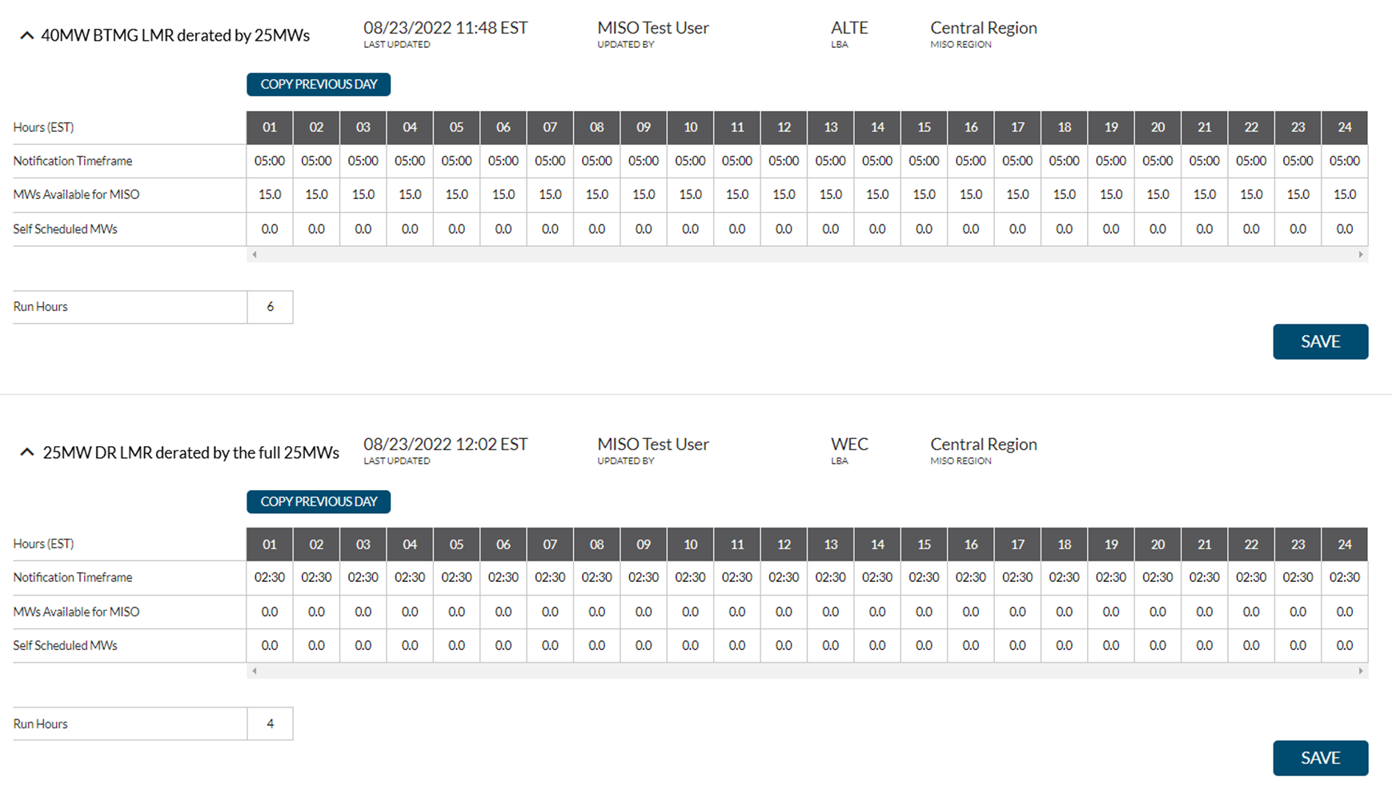
If a BTMG is scheduled to be deployed by the MP, the “Self Scheduled MWs” section in the DSRI should be increased for LMR MWs that are scheduled to be deployed and the “MWs available for MISO” amount should be reduced to reflect the remaining MWs available for additional MISO deployment. If a DR is scheduled to be deployed by the MP, or it simply has reduced load for the end-use at the facility, then the “Self Scheduled MWs” section in the DSRI should be increased for LMR MWs that are scheduled to be deployed or has been already reduced, and the “MWs available for MISO” amount should be reduced to reflect the remaining MWs available for additional MISO deployment. Derates and outages that occur where load is not reduced should not be entered as “MWs available for MISO” or “Self Scheduled MWs”. The following are two examples of a 40 MW BTMG LMR coming online for a test between 0600 – 2100, and a 25 MW DR LMR available for only 5 MWs for MISO because there is reduced load at the facility:
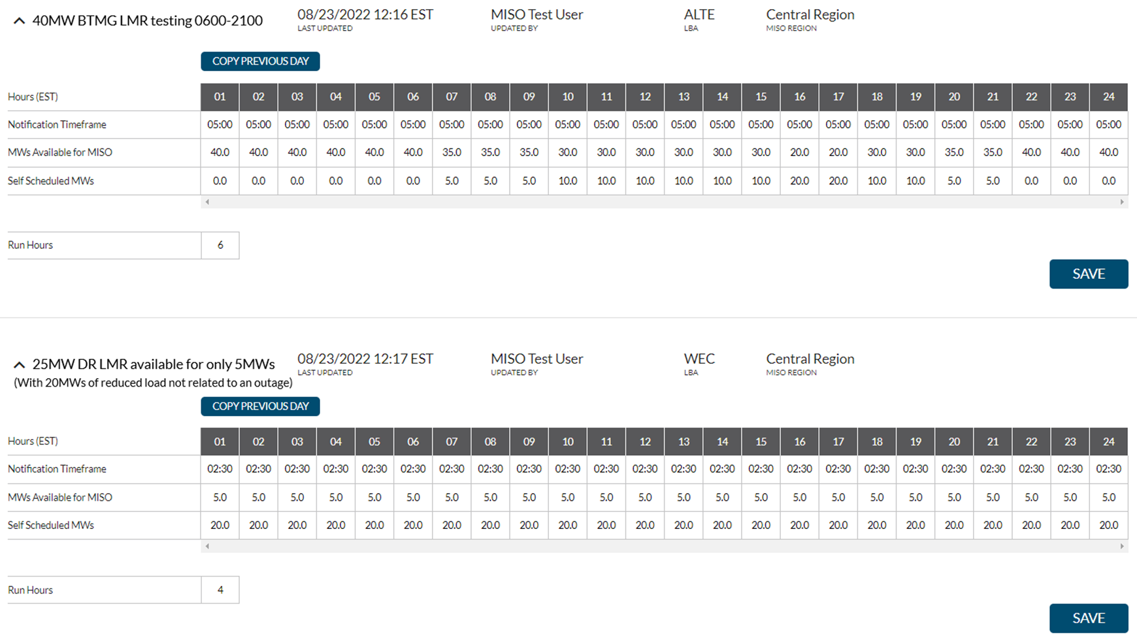

For specifics on DSRI functionality, please see the MP LMR Users Guide located in the Learning Center.

If an Emergency is declared by MISO that requires LMR deployment, MISO will issue Scheduling Instructions in the DSRI using the LMR availability information (“MWs available for MISO” and “Self Scheduled MWs”) provided by MPs. Self Scheduled MWs are included in a Scheduling Instruction to ensure that the MW deployed voluntarily by an MP continue to be deployed if required during an Emergency. Self Scheduled MWs are not subject to notification times because they are already planned to be performing at those levels, as decided by the MP; however, MWs available for MISO are subject to notification times whenever Scheduling Instructions are created. The LBA and the MP will receive a notification of the Scheduling Instructions via a MISO Communications System (MCS) message (LMR Implementation MCS message type). MPs will also receive a Scheduling Instructions event banner within the DSRI application as shown below (with audible alerts until acknowledged).

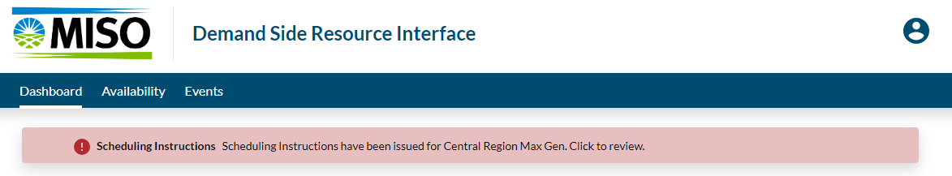

Market Participants with LMRs must have personnel operating on a 24x7 basis that can receive and respond to MCS messages, Operator Interface Declarations and Messages, and LMR Scheduling Instructions events in the DSRI. The MP will need to acknowledge receipt of the Scheduling Instruction and update the remaining availability, if any, of the LMR(s) being used to meet the Scheduling Instruction in DSRI to reflect the MW amount available in the specified time(s). This update and acknowledgement should be done within one (1) hour of receiving the Scheduling Instruction from MISO. Also, before the Emergency deployment, the MP that registered the LMR(s) should submit the specific designation of LMRs and associated MWs used to meet the total MWs contained in the Scheduling Instruction via the Resource Deployment tab of the LMR Scheduling Instruction Event in the DSRI.

MPs that report LMR availability (including self-scheduled MWs) in the DSRI that is less than the performance obligation based on the MW value that is being used to meet RAR, may be requested to provide documentation and/or metering data to MISO for the dates and hours that MISO declared an Emergency. Meter data for the LMRs used to meet the MWs requested in the Scheduling Instruction must be uploaded in the Demand Response Tool within 103 days of the Emergency event or as requested by MISO.

MISO will not violate registration parameters (e.g., notification time) and real time availability updates provided by MPs when issuing a Scheduling Instruction. MISO does, however, rely on real time availability updates provided by MPs when issuing a Scheduling Instruction.

LMRs with Dual Registration
Market Participants that register LMRs are eligible to also register in the Energy market as Emergency Demand Resources and/or Demand Response Resources.

LMRs that have some capability registered as Emergency Demand Response (EDR) or Demand Response Resource (DRR) should adjust their availability in DSRI to reflect net LMR MWs available to MISO (e.g. decrement total LMR capability by EDR offer amount and DRR cleared Day-Ahead or pending Real Time offer). It is the responsibility of the Market Participant to ensure no double counting of MWs offered across the dual registration types. Double counted MWs may be subject to underperformance penalties.

LMRs also Dual Registered as Demand Response Resources (DRR)
DRR Type I and Type II that have converted SAC to ZRCs which were used to meet seasonal Resource Adequacy Requirements (RAR) are categorized as Capacity Resources under Module E-1 (Section 69A.3.1.b) and therefore are not LMRs. However, a DRR that does not convert all its associated SAC may also register the remaining SAC of the resource as an LMR. In this case, the SAC converted and used to meet RAR under the LMR designation would follow the respective LMR requirements and likewise the DRR SAC if converted and used to meet RAR would carry the must offer requirement. The combined SAC converted to ZRCs between the DRR designation and the LMR designation cannot exceed the assigned SAC value of the singular resource.

LMRs also Dual Registered as an Emergency Demand Resource (EDR)
A resource may qualify as an Emergency Demand Response (EDR) under Schedule 30 to participate in the Energy market regardless of whether it qualifies as an LMR under Module E-1. An LMR may also dually register and qualify as an EDR. In the case of a dual LMR / EDR registration, the resource may be dispatched as an EDR when there is a pending EDR offer (EDR offers are made daily). If the resource is not dispatched as an EDR, it maintains its LMR obligations, and its performance will be evaluated as such. Being dual registered requires the resource to meet the most stringent of the two designations’ requirements. Also, the tolerance band allowed for an EDR does not apply when dual registered. MISO will not assign LMR penalties to Emergency Demand Response (EDR) resources that have already been assessed penalties under Schedule 30 of the Tariff.

For more information regarding the dual registration of LMRs as EDRs, please see Section 6.4 of BPM-026 Demand Response.

LMR Performance Obligations
The registered capacity of accredited LMRs that has been converted to ZRCs and has cleared in the PRA must be available as outlined above for use in the event of an Emergency declared by MISO. MISO will populate the DSRI with the monthly Demand Reduction Capability Forecast values provided at the time of the LMR registration. If the LMR partially clears, the value in the DSRI will be adjusted by the % of the total seasonal ZRCs a resource clears times the Demand Reduction Capability Forecast. MPs should keep these values up to date to ensure the availability is accurate as Scheduling Instructions will be based on the LMR Availability in the DSRI. The Available MWs for MISO should be consistent with the availability indicated in the LMR’s registration. A Market Participant utilizing LMRs to meet Resource Adequacy Requirements will be subject to the penalties described in Section 69A.3.9 of the Tariff if the LMR is included in the Market Participant’s response to Scheduling Instructions and the LMR fails to respond.

A Demand Resource (DR) must respond with an amount greater than or equal to the target level of load reduction or reduce Demand at or below the registered firm service level. DRs that registered with a Firm Service Level Measurement & Verification methodology that partially clear, will have the uncleared portion of the resource added to their registered firm service level (FSL) when evaluating performance. A BTMG must provide the target level of generation increase as indicated on the Market Participant’s Resource Deployment tab of the LMR Scheduling Instruction Event in the DSRI when responding to Scheduling Instructions Combined, the Market Participant’s DR and BTMG responses must meet the total MWs contained in their Scheduling Instruction.

This “target” level MW is indicated by the MP via the DSRI’s Resource Deployment tab of the LMR Scheduling Instruction Event which outlines which LMRs were utilized and the associated MW levels to meet the total MWs contained in the Market Participant’s Scheduling Instruction. An LSE shall be assessed the costs that were otherwise incurred to replace the Energy deficiency at the time the LMR was dispatched.

MISO will not assign LMR penalties to Emergency Demand Response (EDR) resources that have already been assessed penalties under Schedule 30 of the Tariff. LMR values entered in the DSRI availability will also be considered when evaluating whether target levels of generation increase, or Load reduction have been met. For more information regarding the performance assessment of an LMR, please see BPM-026 Section 6.2.

The operators of LMRs that improperly report to MISO that an LMR is unavailable in the DSRI prior to receiving a Scheduling Instruction or the LMR does not respond when included in a Market Participant’s response to Scheduling Instructions will have an opportunity to provide documentation of the specific circumstances that would justify exemption from such penalties. A penalty will not be assessed for any portion of the target level of Load reduction for a DR, or target level of generation increase for a BTMG, which had already been accomplished for other reasons (i.e., for economic considerations, self-scheduling at or above the amount of BTMG committed in a Planning Resource Auction, or local reliability concerns) and properly reflected in the hourly availability in the DSRI for each resource. Likewise, for certain LMRs that are temperature dependent (e.g., a Demand Resource program involving air conditioning load), the target level of Load reduction or target level of generation increase may be adjusted and the hourly availability in the DSRI should be updated to properly reflect the anticipated capability of the resource.

BTMG Qualification Requirements
MPs with BTMGs can qualify as LMRs by:
- Submitting monthly availability (in megawatts) and notification time (in hours) for the upcoming Planning Year.
- Intermittent BTMG (e.g., solar, wind, run-of-river hydro, etc.) are exempt from submitting the additional documentation for monthly availability and notification time as they are not dispatched via the DSRI.
- Confirming through the registration process such BTMG can be available to provide Energy with no more than 6 Hours advance notice from MISO or the LBA and sustain Energy production for a minimum of four (4) consecutive Hours.
- Confirming through the registration process that the BTMG is capable of being interrupted and available at least the first (5) times as needed during the Summer and Winter and at least the first (3) times as needed during the Spring and Fall by MISO or the LBA for emergency event purposes, consistent with the registration information of the physical capability of the BTMG.
- Confirming that the BTMG is equal to or greater than 100 kW (an aggregation of smaller resources that can produce Energy may qualify in meeting this requirement if located in the same LRZ).
- Behind the Meter Generation must demonstrate GVTC on an annual basis as described in Sec. 4.2.1.1 Qualification Requirements. See Appendix J – GVTC Testing Requirements for additional details.
- Behind the Meter Generation with any new or untested additional capacity are eligible for the ICAP Deferral Process as described in Sec. 4.5 ICAP Deferral.
- Submitting generator availability data (including, but not limited to, NERC GADS) into a database through the Market Portal for non-intermittent BTMG greater than or equal to 10 MW based on GVTC. Non-intermittent BTMG less than 10 MW based upon GVTC that begin reporting generator availability data must continue to report such information. Behind the Meter Generation that is an intermittent resource must submit information in accordance with Section 4.2.1.3 Intermittent Generation and Dispatchable Intermittent Resources - Qualification Requirements. Quarterly GADS Event and Performance Data must be submitted by the end of the month following the quarter (April for Q1, July for Q2, October for Q3, and January for Q4). The submitted data must have passed Level 2 Validation without any errors. Units that fail to submit Level 2 Validated quarterly GADS data will be disqualified for participation in the PRA.
- For wind resources being registered as BTMG, the following information is required:
  - Resources with commercial operation history of metered values during at least one Season would submit metered values in MW terms for all Hours in the test period.
  - Resources with no commercial operation history of metered values during the Season would receive class average for each Season within the Initial Planning Year.
- For solar resources being registered as BTMG, the following information is required:
  - Resources with at least 30 consecutive days of metered values for that Season would submit metered values in MW terms for all hours in the test period.
  - Resources with less than 30 consecutive seasonal days of metered values would receive class average for the Seasons within the Initial Planning Year.
- For storage resources that do not report to GADS (including but not limited to, batteries, flywheels, compressed air, and pumped storage) being registered as BTMG, the following information is required:
  - Resources with commercial operation history of metered values during no less than 30 consecutive days in a specific Season would submit historic availability for the top 8 coincident system peak hours for a minimum of one and a maximum of three of the most recent applicable Planning Years for each Season.
  - Resources with less than 30 consecutive days of metered values during a Season would receive class average accreditation for the Initial Planning Year.
- Internal purchase power agreements (PPAs) will not be qualified by MISO.
- BTMGs that have been retired prior to the Season will not qualify as a Planning Resource.
- If BTMGs used to meet Resource Adequacy Requirements retire or suspend during the Planning Year, they must be replaced effective with their change of status date.

Submission of New BTMG Registrations
An MP must register its new BTMG via the Registration screen in the MECT by March 1 prior to the Planning Year. The registering entity must be an MP prior to registering a BTMG. In order to guarantee new Resources can be used in an LSE’s FRAP or RBDC Opt Out, registrations should be submitted no later than February 15 prior to the Planning Year. An entity that is not a MP, but desires to register a BTMG, must contact the Customer Registration team at register@misoenergy.org MISO Help Center (https://help.misoenergy.org/) to become a MP. During the registration process the MP will be required to certify that the registration information is accurate, complete, and that the qualified MWs from the BTMG are not being registered by another party. Appendix E contains the information that must be submitted by an MP through the MECT registration screens. MISO will review the BTMG registration information for completeness and accuracy and ensure it complies with the qualification requirements for BTMG. MISO will endeavor to notify the MP within 15 days after the registration form was submitted regarding whether the BTMG has been accredited as an LMR, or whether there are any deficiencies that must be corrected. If the BTMG is accredited as an LMR, it will be given a unique name for tracking purposes and made available in the MECT screens for use by the MP.

Termination of BTMG Accredited as LMR
Because BTMGs need to be accredited seasonally, the “Effective Stop Date” will default to the last day of the applicable Season.

Amendments to Accredited BTMG Registration Data
The Market Participant can amend the registration for a BTMG for an upcoming Planning Year by providing MISO notification no later than March 1 if the original registration was submitted by February 1.

The Market Participant may modify any of the non-end date information submitted in the registration, which may affect the BTMG’s qualification, including, but not limited to, a change in operation, or either an increase or decrease in MW capability. The Market Participant shall submit new or amended registration information in the MECT by March 1 prior to a Planning Year for MISO to determine whether the resource still qualifies as a BTMG. The Market Participant will still need to provide MISO with a GVTC by the original test date as outlined in the BPM. Any modifications in the capability of an existing BTMG must have updated test and registration information submitted to MISO via the MECT by March 1.

Renewal of BTMG for subsequent Planning Years
BTMG must be reviewed for accreditation as an LMR on an annual basis. An MP can request renewal of BTMG accreditation for subsequent Planning Years through the MECT registration screens. Renewal of BTMG must be requested by February 1^{sr} prior to the Planning Year.

NOTE: BTMGs must submit GVTC and/or operational data by the October 31 deadline, per Section 4.3, to have SAC values determined. MISO will review the revised BTMG registration information for completeness and accuracy and ensure it complies with the qualification requirements for BTMG. MISO will endeavor to review the registration for approval within 15 days after the revised registration form was submitted to determine whether the BTMG has been accredited as an LMR, or whether there are any deficiencies that must be corrected. If the BTMG is accredited as an LMR, then it will be given a unique name for tracking purposes and be made available in the MECT screens for use by the MP during the applicable Planning Year.

Behind the Meter Generation (BTMG) – SAC Determination
The SAC value for a BTMG is based on an evaluation of the applicable type and volume of interconnection service, GVTC (or historical output at peak if intermittent), line losses if not interconnected to MISO, and XEFORd value of such BTMG.

BTMG that are intermittent resources will have their SAC determined consistent with the methodology described for similar resource fuel types as described in Section 4.2.1.3, Intermittent Generation and Dispatchable Intermittent Resources – Qualification Requirements, through 4.2.1.7, Other Intermittent Generation and Dispatchable Intermittent Resources.

BTMG Deliverability
Each BTMG resource owner must coordinate with their Distribution Provider (DP) to ensure local distribution service for the BTMG resource to qualify as an LMR type Planning Resource for participation in the PRA. The majority of BTMG is interconnected at distribution-level voltage; however, it is possible for BTMG to be interconnected at transmission-level voltage. Additionally, MPs with BTMG must coordinate with their LSE, DP, and Transmission Owner (TO) to determine eligibility to participate in the PRA. This section will outline the roles and responsibilities of an LSE, DP, TO, and MISO for an individual BTMG to participate in the PRA including specific methodologies available to the BTMG MP to demonstrate deliverability. Responsibilities of an entity may differ depending if the Point of Interconnection is on the distribution system or transmission system and will be noted.

Roles and Responsibilities to Determine Eligibility for PRA Participation
Additional descriptions of the role and responsibility of each entity is below. The MP owning a BTMG is responsible for providing an attestation to MISO that proper coordination has occurred with each entity.

Load Serving Entity (LSE): Collaborate with BTMG MP to establish eligibility for a BTMG to participate in the wholesale market (e.g., PRA) in accordance with the relevant state regulatory framework.

Distribution Provider (DP): Ensure reliability of distribution system and assess access to the transmission system. Typically, the DP completes an interconnection study to assess the reliability impacts on the distribution system. The DP is responsible for determining engineering studies, facility upgrades, and/or agreements required to permit access of a BTMG to the transmission system.

Transmission Owner (TO): Determine when the transmission system is utilized by a BTMG to serve load and coordinate with the DP and MISO on engineering and facility studies as appropriate. The TO typically ensures studies are completed, per their direction, to ensure transmission facilities (including other interconnected generators) are not impacted by an additional injection of Energy from a BTMG onto the transmission system. Studies will vary depending on the specific Point of Interconnection.

MISO: Accountable for ensuring BTMG has demonstrated deliverability for use in the PRA (additional details below) and ensuring the BTMG MP has provided attestation of coordination with the LSE, DP, and TO.

Definition of “Excess BTMG”
Deliverability of BTMG is established relative to the portfolio of total BTMG assets owned or under contract by an LSE in a singular LBA. A BTMG that utilizes the transmission system or a volume of BTMG exceeding an LSE’s “net PRMR” in a singular LBA is considered “Excess BTMG” and will need to demonstrate deliverability utilizing an option described in Sec. 4.2.6.5.3 – Options for BTMG to Demonstrate Deliverability. It is possible for the volume of “Excess BTMG” SAC to be less than the SAC of a singular BTMG. In this instance, the MP is eligible to demonstrate deliverability for a portion of a generator or multiple generators. MISO will collaborate with the BTMG MP to establish the specific Point of Injection onto the Transmission System.

The term “net PRMR” is utilized rather than Initial PRMR because it is possible for an LSE to have a portfolio of ZRCs that include registered Demand Resources (DR) and Demand backed Demand Response Resources (DRR_{demand}) that reduce the expected peak Demand by an LSE and result in a net injection onto the Transmission System. Net injection onto the Transmission System is “Excess BTMG” as represented by the figure below.

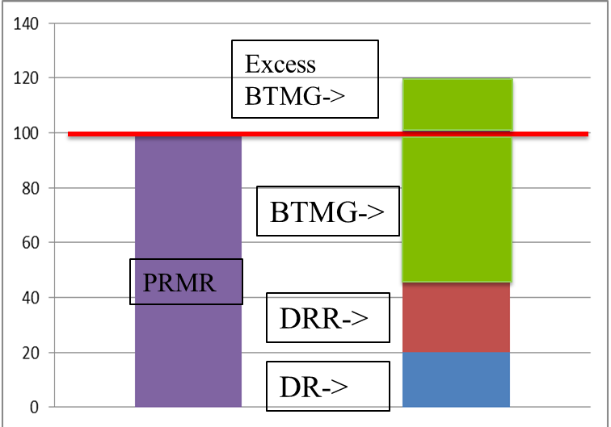

Options for BTMG to Demonstrate Deliverability
Below are the multiple options for a MP with BTMG to demonstrate deliverability:

Option 1: BTMG utilizing the distribution system to offset Initial PRMR. BTMG used to offset an LSE’s load utilizing only the distribution system is considered deliverable up to the volume of “net PRMR” of an LSE in a singular LBA. No additional studies are required.

Option 2: Firm Transmission Service. The MP of the BTMG can apply for Point-to-Point or Network Integration Transmission Service using a type of “Monthly” or “Yearly” depending on the Point of Interconnection (POI). A BTMG with a POI on the distribution system can utilize “Yearly” type firm Transmission Service to facilitate a system impact study, if required. A BTMG with a POI on the Transmission System can use “Monthly” or “Yearly” type of firm Transmission Service since an ERIS study would have been completed. A Network Customer may designate a BTMG as a Network Resource through OATI OASIS utilizing firm Transmission Service.

Option 3: Interconnection Service of NRIS or External NRIS (E-NRIS). The MP of the BTMG can enter the Generator Interconnection Queue and apply for NRIS or E-NRIS. An MP can apply for E-NRIS with a BTMG that has a POI on the distribution system. A BTMG with a POI on the Transmission System is eligible for NRIS. The BTMG would be part of a MISO Definitive Planning Phase (DPP) study and required to submit an application and deposits as appropriate. Refer to BPM-015 Generation Interconnection for additional details.

Option 4: Historical determination of deliverability. BTMG used to offset an LSE’s Initial PRMR located in the same LBA and historically demonstrated deliverability prior to integration with MISO, as accepted by MISO or a Transmission Owner, is considered deliverable. Individual BTMGs may have demonstrated deliverability by confirmation by a Network Customer as a designated Network Resource or completion of a Market Transition Deliverability test prior to an LSE joining MISO.

Measurement and Verification of BTMG
See Attachment TT of the Tariff and BPM-026 Demand Response.

Demand Resource (DR)

Demand Resource Qualification Requirements
MPs qualify a Demand Resource as an LMR by:
- Confirming exclusive rights to represent the Demand Resource and that the Market Participant has the authority to reduce Demand using the Demand Resource for the entire season in which the LMR is registered. In the case of an ARC registering a DR, this would include uploading into the MECT registration, any contractual documentation including signature pages or confirmations from the end-use customer that establishes an active relationship for the seasons in which the DR is registered. Additional documentation may be provided (or requested) to confirm contractual rights between all MPs and the end use customers, including full contracts, and retail rate tariffs or riders.
- Confirming through the registration process such DR can be available to reduce Demand with no more than six (6) hours advance notice from MISO or the LBA and sustain the reduction in Demand for a minimum of four (4) consecutive hours.
  - A Market Participant registering a Demand Resource that performed a real-power test may not register the Demand Resource with a notification time less than that documented by the real-power test
  - A Market Participant registering a Demand Resource utilizing the waiver provision must provide documentation supporting the ability to reduce Demand within the registered total notification time as set forth in sub-section 4.2.7.1.1 – End-Use Customer Documentation Requirements.
  - A Market Participant must provide documentation supporting the ability to hold the Demand reduction for a minimum of four (4) consecutive hours as set forth in sub - section 4.2.7.1.1 – End-Use Customer Documentation Requirements.
- Residential programs for which Demand reduction is achieved by curtailing for shorter intervals and rotating through residents may qualify, provided the total Demand reduction remains at or above the amount of Demand reduction identified in real-time.
  - For example, a program may register 10,000 residents to provide 5 MW of Demand reduction, with the expectation that only 5,000 residents will be curtailed at a time.
  - If a program rotates through residential customers, it must document such rotation at the time of registration.
- Confirming through the registration process that the total DR Load reduction is not exclusively accomplished and dependent on the dispatch of a BTMG capable of injecting onto the Transmission System or distribution system.
- Confirming through the registration process that the DR is equal to or greater than 100 kW. An aggregation of smaller resources within an LBA that can reduce Demand may qualify in meeting this requirement if they are within the same Load Zone CPNode.
- Confirming through the registration process that the DR is capable of being interrupted at least the first (5) times during the Summer and Winter and at least (3) times as needed during the Spring and Fall as needed by MISO or the LBA for Emergency purposes, consistent with the registration information of the physical capability of the DR.
- DR that retired prior to the Planning Year will not qualify as a Planning Resource.

- Documenting in the MECT the DR’s capability to reduce Demand by a targeted Demand reduction level or to a firm service level at the MISO seasonal Coincident Peak.
  - If a DR being registered elects to perform a real power test, the details regarding the requirements of such test are located in section 4.2.7.8 – Demand Resource Testing Requirements below.
  - If a DR being registered elects to use the waiver provision in lieu of performing a real power test to demonstrate Demand reduction documentation must be provided as set forth in section 4.2.7.8.1 – Real Power Test Waiver documentation. A Market Participant may elect to waive the requirements of a real power test by satisfying one of the following criteria:

    - Provide documentation of participation in a retail program approved by any applicable regulatory authority that explicitly precludes or explicitly waives the requirement to perform a real power test.

    - For the 2026 / 2027 Planning Year only, a
    - Market Participant may waive the requirement to perform a real power test for a resource participating in a retail program overseen by a regulatory authority. If the DR opts out of demonstrating Demand reduction capability under this waiver provision, then the DR will be subject to three (3) times the underperformance penalties during a MISO Emergency event. Specifically, undelivered MWs will be penalized at a rate of LMP times three (3), rather than LMP. The RSG component of the penalty will not be multiplied times three (3), nor will any capacity penalties or lost capacity revenue. A Market Participant seeking such a waiver must post credit by March 1, 2026 totaling the total registered amount of Demand (ICAP value registered) registered but not tested multiplied by $12,000/MW, where $12,000/MW is the product of 3 * 4 * $1,000 to account for the three (3) times penalty assumed under the waiver, the four (4) hours of LMR requirements, and a $1,000 LMP as a proxy for pricing under Emergency conditions.
    - A Demand Resource that has responded to at least one Scheduling Instruction during the three-year period beginning on January 1 of the Year that is three Years prior to the start of the applicable Planning Year, has fully met the performance requirements of all Scheduling Instructions it was issued, and fully met its availability requirement as set forth in Section 69A.3.5.e may qualify for a waiver if:
- For a Demand Resource that is not a residential aggregation, the Demand Resource has not experienced a significant change in the operations of any component comprising the Demand Resource. For the purposes of this language, a significant change in the operations is defined as any change in the operational characteristics of an asset, such as the expansion of the facility, operation of additional production lines, or a change in the method by which Demand reduction is achieved. An aggregation may disaggregate (an) asset(s) without needing to retest provided the Demand Resource meets the waiver criteria with the asset(s) being disaggregated. An aggregation that adds additional assets is not eligible under this waiver provision.
- For a Demand Resource that is a residential aggregation, the Demand Resource may qualify for this waiver provided that the number of households in the program has not grown by no more than twenty percent (25%) and at least half (50%) of the households within the aggregation have been enrolled since the last real power test.
- A Demand Resource utilizing this waiver provision will have its registered capacity set to the same value established under the original real power tests. A Market Participant wishing to increase the amount of Demand Response registered must provide a real power test.

- Documenting in the MECT the Measurement and Verification (M&V) protocol that will be used to determine if such DR performed when called upon by MISO or the LBA during Emergencies.

Demand Resource Registration Process
A Market Participant can register a Demand Resource to be used as a Planning Resource and receive SAC MW for said Demand Resource that can be converted to ZRCs by providing the documentation set forth below at the time of registration and all information set forth in Appendix D – Registration of Demand Resources. An MP registering a Demand Resource must provide the documentation set forth below prior to March 1 prior to the start of the Planning Year. A resource for which the Market Participant fails to provide the documentation set forth below will be prohibited from registering in the Planning Resource Auction.

End-Use Customer Documentation Requirements
At the time of registration, a Market Participant must provide, for each non-residential resource, the following documentation provided on end-use customer stationary or through email from the end-use customer. If registering a residential program, the Market Participant assumes the responsibilities of the end-user customer documentation requirements. For a residential program being registered that is administered through an intermediate party, such as an Aggregator of Retail Customers registering end-use customers for whom service is provided by an intermediate party, the intermediate party assumes all of the obligations set forth below. Failure to provide this information may lead to a resource being disqualified from participating in the Planning Resource Auction.
- A list of interruptible load(s) that the customer(s) will curtail when called upon during an Emergency. This requirement is not required for resources using the firm service level baseline.
- The operating procedures used by the customer(s) to facilitate the Demand reduction.
  - This information must include:
    - The method the Market Participant will use to communicate with the customer; and
    - The procedures used by the customer to curtail the load(s); and
    - The expected time required to provide curtailment. This time must be less than or equal to the registered notification time.
    - Confirmation that the end-use customer is capable of maintaining Demand reduction for a minimum of four (4) consecutive Hours.
- Load that is not subject to curtailment. This information is only required of Demand Resources utilizing the firm service level Measurement and Verification methodology.
- Verification that the load expected to be curtailed was curtailed during the real power test.
  - Additional load may also be curtailed but will not count towards the amount of Demand reduction achieved during the real power test.
- Any additional documentation requested by MISO at the time of registration to validate the Demand Resource’s ability to meet the obligations required of LMRs.
Additionally, the Market Participant must provide, upon request, contact information for the customer to permit MISO or the IMM to verify the information submitted. A Market Participant needs only to provide this information upon request by MISO or the IMM as part of the verification of the Demand Resource. MISO will not reach out to the customer directly to curtail Demand.

Market Participant Documentation Requirements
In addition to the Demand Resource qualification requirements set forth above and the requirements set forth in Appendix D – Registration of a Demand Resource, a Market Participant must provide the following information to MISO at the time of registration. Failure to provide this information may lead to a resource being disqualified from participating in the Planning Resource Auction.
- All Market Participants must submit an estimation of the amount of Demand reduction achievable by the load(s) being curtailed by the end-use customer(s) of the assets comprising the Demand Resource.
  - This information should be itemized by program, for example lighting, HVAC, etc. MISO may adjust these estimates if a comparison to similar programs demonstrates significantly different values. For example, if a Market Participant submits a program with 10,000 households claiming 15 MW of Demand reduction while most other household programs claim only 10 MW for such a program, MISO will require additional evidence of the ability of these households to provide 15 MW of Demand reduction and may reduce this value to 10 MW.
- All Market Participants must provide evidence supporting the registered firm service level.
  - Supporting documentation may include load processes for which curtailment is not a requirement and an estimation of the maximum Demand used by the process; or
  - Contractual restrictions with the Load Servicing Entity or Electric Distribution Company specifying a minimum service guarantee.
- All Market Participants must provide Hourly meter data spanning the most recent Season for which hourly meter data is available for every Day of the Season. For example, for a Demand Resource registering after January 1, 2026 this requires data spanning either September 1, 2024 through August 31, 2025 or data spanning December 1, 2024 through November 30, 2025.
  - For Demand Resources for which data is not available due to the resource being a new resource, as much data as can be provided must be provided.
- Documentation supporting the real power test and accredited values must be provided as set forth below.

Submission of new DR Registrations
A Market Participant may register a new Demand Resource via the Registration screen in the MECT by March 1 prior to the Planning Year. To guarantee new Planning Resources can be used in an LSE’s FRAP or RBDC Opt Out, registrations of a DR intended to be used in a FRAP or RBDC Opt Out should be submitted no later than February 15 prior to the Planning Year. The registering entity must be an MP prior to registering a DR. Any entity that is not a MP, but desires to register a DR, should contact the Customer Registration team at MISO Help Center (https://help.misoenergy.org/) to become a MP. The MP will be required to certify that the registration information is accurate, complete, and that the qualified MWs from the DR are not being registered by another party. Appendix D – Registration of a Demand Resource contains the information that must be submitted by an MP through the MECT Registrations screen. MISO will review the DR registration information for completeness, accuracy, and ensure it complies with the qualification requirements for DR. MISO will endeavor to review the registration within 15 days after the registration was submitted to determine whether the DR has been accredited as an LMR, or whether there are any deficiencies that must be corrected. If the DR is accredited as an LMR, it will be given a unique name for tracking purposes and made available in the MECT screens for use by the MP.

Submission of ARC (Aggregator of Retail Customers) LMR Registrations

The LBA and LSE will verify the following:
- LBA name
- LSE name
- RERRA name
- CPNode name
- End use customer account number
- Meter identification number(s)
- Maximum level of participation (MWs)
  - The maximum level of participation shall be determined for an ARC as set forth below.
  - The LSE must provide to MISO verification that the LMR is included in the Load obligation of the LSE as set forth below.
- Address of the assets in the ARC registration.

If during registration review, the LBA or LSE is identified to be incorrect for assets in a registration, the registration will be rejected. The Market Participant can submit a new registration once the Market Participant has identified the correct LBA or LSE. This will restart the review timeline for MISO, the LBA, the LSE, and RERRA.

Any modification to the assets during the review will restart the review timeline for MISO, the LBA, the LSE, and RERRA.

Instances where the ARC LMR’s customer changes LSEs:
- The LSE identified by the ARC LMR should be correct at the time of the ARC LMR’s registration submitted to the Module E Capacity Tracking (MECT) tool. Otherwise, the ARC LMR Registration will be rejected.
- If the ARC LMR’s LSE changes during the registration process, the ARC LMR registration can be revised. The date the registration was submitted will be sent along to the LSE for their review.
  - It is the responsibility of the ARC LMR’s customers and the ARC to identify LSE changes.
  - It is the responsibility of the ARC LMR to notify MISO, the old LSE, and the new LSE when changes to the ARC LMR’s customer’s LSE occur.
Where more than one ARC submits the same account, both ARCs will be notified of the other’s submission and need to determine among themselves who has the rights to the account. If no decision is reached by March 15, the ARC that submitted the account first will receive credit for the account.

Maximum Level of Participation (MWs) of a Demand Resource registered by an ARC

The maximum level of participation for each Demand Resource registered by an ARC using a Measurement and Verification methodology that is not the firm service level shall be no greater than that Demand Resource’s Demand as evaluated by the LBA or LSE and no less than the accredited value registered by the ARC.

For an ARC registering an asset that is using the firm service level baseline, the asset’s contribution to the Coincident Peak Demand forecast for each Season in the period from September 1 through August 31 prior to the Planning Year shall be equal to the average maximum Demand consumed by the asset in the five-hour window centered at the time of the MISO Coincident Peak, for the five (5) Business Days prior to the Day of the MISO Coincident Peak, the Day of the MISO Coincident Peak, and the five (5) Business Days after the Day of the MISO Coincident Peak, less the firm service level.

An ARC wishing to increase the accredited value of a Demand Resource to reflect an upward adjustment due to a deployment as a DRR, as an LMR, or under a retail program, must provide documentation for such increase to MISO and the LSE responsible for the asset no later than February 1 prior to the Planning Year. Any asset registered after this date will not be permitted to adjust its contribution to the Coincident Peak Demand forecast and will use the LSE/EDC submitted Coincident Peak Demand forecasted value for the asset in accreditation.

Table 1. Example of calculation of a Demand Resource using the firm service level load obligation calculation.
In Table 1., August 26, 2024 HE 17 is the Hour with the Coincident Peak Demand. The five (5) hour window centered on HE 17 is used for the 5 Business Days prior to August 26th, the five (5) Business Days after August 26th, and August 26th itself. MISO and the LSE should calculate the peak Demand for each 5-hour window on each Day, then average these values to determine the accredited value of the resource, in this case resulting in a value of 116.7 MW.

Termination of a Demand Resource Accredited as LMR
Because DRs need to be registered annually, the “Effective Stop Date” will default to the last day of the applicable Planning Year.

Amendments to Accredited DR Registration Data
The Market Participant can amend the registration for a DR for an existing upcoming Planning Year by providing MISO notification no later than March 1, if the original registration was submitted by February 1.

The MP may modify any of the non-end date information submitted in the registration, which may affect the DR’s qualification, including, but not limited to, a change in operation, number of interruptions, advisory notice period, maximum duration, or accreditation amount as either an increase or decrease in either its targeted MW level or firm service level. The accreditation amount may not be greater than the LMRs contribution to the LSE/EDC’s Coincident Peak Demand forecast.

Renewal of DR for subsequent Planning Years
A DR must be reviewed annually for accreditation as an LMR. An MP can request renewal of DR accreditation for subsequent Planning Years through the MECT Registrations screen. Renewal of DR must be requested by February 1 prior to the Planning Year. MISO will review the renewed DR registration information for completeness and accuracy and ensure it complies with the qualification requirements for DR. MISO will endeavor to notify the MP within 15 days after the renewed registration form was submitted regarding whether the DR has been accredited as an LMR, or whether there are any deficiencies that must be corrected. If the DR is accredited as an LMR, it will be given a unique name for tracking purposes and made available in MECT for use by the MP during the applicable Planning Year. All rules in this section 4.2.7 Demand Resources also apply to renewed DRs in subsequent Planning Years.

Demand Resources – SAC Determination
A Demand Resource will be accredited based upon the type of Measurement and Verification it selects. A Market Participant may always request accreditation to a lesser amount than provided for in Section 69A.4.2.

Demand Resources not using a firm service level baseline
A Market Participant registering a Demand Resource not using a firm service level baseline that has performed a real power test will have its accreditation set equal to the amount of Demand reduction achieved during the real power test. The real power test may be scaled upwards by no more than 25% for temperature sensitive loads to conditions consistent with the MISO Coincident Peak. Documentation must be provided supporting the adjustment that includes:
- A detailed description of the temperature sensitive load process.
- Justification for the adjustment, such as a test being performed when it was 95° F while the Coincident Peak occurred at 103° F.
- An evaluation supporting the increase by the amount requested of the real power test.
A Market Participant registering a household aggregation may increase the registered amount of Demand Reduction by up to an additional 25% if it can provide evidence of the number of households in the aggregation at the time of the real power test. MISO must approve of the adjustment.
If a Market Participant waives the requirements to perform a real power test under the provisions set forth in Section 69A.3.5.j.1or 69A.3.5.j.2, the Demand Resource shall have an accredited amount equal to the amount of Demand reduction achievable as documented by the Market Participant under the provisions set forth in section 4.2.7.2.2 – Market Participant Documentation Requirements.
For the 2026 / 2027 and 2027 / 2028 Planning Years, a Market Participant electing to waive the requirements of a real power test under the provisions set forth in Section 69A.3.5.j.3 shall have an accredited amount equal to the accredited Demand reduction achievable in the prior Planning Year, less any reduction from the contribution of a resource that has been disaggregated.

Demand Resources using a firm service level baseline
For a Demand Resource that is using the firm service level baseline, the Seasonal Accredited Capacity will be equal to the Demand Resource’s contribution to the Coincident Peak Demand of the appropriate LSE/EDC less the firm service level. The Demand Resource’s contribution to the Coincident Peak Demand shall be determined using the appropriate Coincident Peak Demand forecast methodologies for non-ARCs, and the procedure set forth in section 4.2.7.2.4.1 – Maximum Level of Participation (MWs) of a Demand Resource registered by an ARC.

Demand Resource Deliverability
The owner of ZRCs converted from DR may use them as part of a FRAP or RBDC Opt Out or offer them into the PRA. The DR ZRCs are considered deliverable regardless of the LRZ where the DR physically resides.

Measurement and Verification of Demand Resources
See Attachment TT of the Tariff for Demand Resources using a targeted Demand reduction program and BPM-026 Demand Response for Demand Resources using a firm service level baseline. A Demand Resource may nominate one Measurement and Verification methodology for each Demand Resource regardless of its dual-registration status.

Demand Resource – Testing Requirements
The testing period for a DR to demonstrate Demand reduction capability begins January 1 in the Year prior to the start of the Planning Year. A real power test may be performed at any time up until registration, provided the Market Participant can provide meter data demonstrating performance of the real power test. A Market Participant with a resource that has commenced operations prior to March 1 may submit a Demand Response Deferral Notice pursuant to Section 69A.3.5.m of the Tariff and further detailed below in section 4.2.7.10.
A Demand Resource shall demonstrate seasonal Demand reduction capability for a minimum of a 15-minute duration using the guidelines set forth below. The Market Participant must provide interval meter data demonstrating the Demand reduction maintained for at least two intervals. For example, if a Demand Resource wishes to submit 15-minute interval data, it must provide two consecutive 15-minute intervals, each demonstrating the requisite Demand reduction. As another example, a resource wishing to curtail for only 15-minutes must submit three intervals of 5-minute meter data, two 10-minute intervals, or any other combination of intervals such that the Demand reduction is demonstrated for the minimum of 15-minutes. A Market Participant need not increase load after a test. Results should be submitted in accordance with LMR registration deadlines and attached to the LMR registration.
A Market Participant submitting a real power test may elect any interval that demonstrates the required Demand reduction within the registered notification time, even if the shut-down was performed as part of the normal operations of the facility.
Results of a real power test may be uploaded to the documentation section of the LMR registration in MECT. When testing a DR, accurate availability should be reflected in the DSRI by showing the DR as self-scheduled. If an MP plans to test DR greater than 20 MW, the MP should notify MISO operations two (2) Business Days prior to conducting a test by submitting the DR Testing Notification Template to the MISO ITOC (ITNOCRequests@misoenergy.org). The DR Testing Notification Template should include: (1) LMR name, (2) MP, (3) Load Zone CP Node, (4) expected MW reduction, (5) expected reduction date and hour(s), (6) notification time, and (7) operator contact information in case MISO Operations has questions. New DR and DR that did not clear the PRA will not be able to update the DSRI, however, these DR should still notify MISO by utilizing the DR Testing Notification Template.
Test Requirements for Demand Resources Not Using a Firm Service Level Baseline
A Demand Resource that achieves demand reduction by a targeted Demand reduction amount must meet the following requirements:
- For a Demand Resource that is not an aggregation, the Demand reduction achieved must use all equipment that may be curtailed when called during a Scheduling Instruction. There is no requirement that all of this equipment be operating when issued a Scheduling Instruction; however, to qualify for capacity payments the real power test must demonstrate the equipment was curtailed.
- For a Demand Resource that is part of an aggregation, the Demand reduction must be performed simultaneously for all resources within the aggregation. The Demand reduction need not start simultaneously, but all resources within the program must have curtailed load by the same set of intervals used to identify the Demand reduction.
  - For tests performed prior to July 15, 2025 a Demand Resource may be tested individually and aggregated without requiring a re-test or being required to test simultaneously as all other resources in the aggregation.
- For non-residential programs, the Demand reduction is measured starting from the Demand at the start of the test period to the interval the reduction is achieved by. When evaluating performance when issued a Setpoint Instruction or Scheduling Instruction, the appropriate Measurement and Verification methodology will be applied.
- For residential programs, the Demand reduction is measured using the registered Measurement and Verification methodology.
Table 2. Example of the accreditation of three resources, each with different response times, that all achieve the full demand reduction by 1900 and hold it for 2 intervals. Here, the starting point is 23 MW, while the ending point is 6 MW as reflected at 1900. Resource C reduced by an additional MW, however this is not included in the Demand reduction achieved. The resource must register with at least four (4) hours notification time to reflect the 1500 starting point for Resource B. This example highlights the resources that may begin the test from different points in time but must all achieve the Demand reduction by the same time.
Test Requirements for Demand Resources Using a Firm Service Level Baseline
Conceptually, a Demand Resource using the firm service level baseline is required to demonstrate the ability to reduce Demand from any point of Demand consumption to the registered firm service level. This is achieved by meeting one of the following test requirements:
      - A test demonstrating the ability to reduce Demand when starting from a point at the beginning of the test that is at least 80% of the maximum Hourly metered Demand and ending at a point at or below the firm service level. When determining the maximum hourly Demand consumed to verify the real power test data submitted by a Market Participant, the Transmission Provider will exclude Hours with Demand that is at least two (2) standard deviations above the mean Demand consumed in a Season.; or
      - A test demonstrating the ability to reduce Demand when starting from a point at least as great as the maximum Demand consumed during expected Resource Adequacy Hours, as set forth in the Resource Adequacy Business Practices Manual, and ending at a point at or below the firm service level.
        - For example, if the load process consumes 80 MW between 9pm and 5am daily and 30 MW otherwise but can achieve a firm service level of 10 MW, then the resource may test from any point greater than 30 MW to satisfy this requirement, provided the resource never consumes more than 30 MW between 5am and 9pm.
        - Expected Resource Adequacy Hours are determined by using each Hour of the Day that has experienced at least 5% of the total Resource Adequacy Hours from the three (3) Planning Years in a Season for which all Seasons have assigned Resource Adequacy Hours by March 1 prior to the start of the Planning Year, aggregating Resource Adequacy Hours from the North Sub-Region and South Sub-Region. For the 2026 / 2027 PY these are determined from PY 2022 / 2023 PY, 2023 / 2024 PY, and 2024 / 2025 PY.
          - Summer: HE 14 – HE 20
          - Fall: HE 14 – HE 20
          - Winter HE 8 – HE 12 and HE 19 – HE 22
          - Spring: HE 14 – HE 21.
      - A test must be performed to satisfy the requirements for each Season for the most recent period spanning September 1 through August 31. A single annual test that satisfies the criteria for each Season shall satisfy this requirement.
      - An aggregation of firm service level resources may test individually, at different times, to ensure the ability of each firm service level resource to achieve its firm service level as set forth above.
      - A Demand Resource using the firm service level baseline may not use the Demand reduction achieved by the load process identified by the end-use customer that will remain in operation when the resource is called upon to reduce Demand as part of the real power test.
        - For example, if a 15 MW resource has a firm service level of 5 MW, the load process consuming 5 MW of Demand will not count towards the demand reduction for the purposes of identifying if the Demand Resource could reduce to this level of consumption.
        - A Demand Resource using the firm service level may curtail to 0 MW as part of a valid test, however the load process identified as consuming Demand when operating above the firm service level will not be included in the determination of whether the resource achieved its firm service level.
        - The above rules mean if a 15 MW resource with a 5 MW firm service level, of which the firm service level load process is 5 MW and the remaining load is comprise of four 2.5 MW processes, decreases its Demand from 12 MW to 2 MW by curtailing two 2.5 MW processes and the 5 MW process will not be considered to have passed the test.
      - MISO will perform an outlier test by calculating the mean load during each Season and removing from consideration all Hours during which Demand was greater than two (2) standard deviations above the Mean using a two-tailed test. For example, if Demand is, on average, 10 MW in the Summer with a standard deviation of 6 MW, MISO will not include Demand that is greater than 22 MW above the mean.
      - If MISO determines a resource that has not satisfied this testing criteria, it will be treated as a non-firm service level resource. Specifically, its Measurement and Verification will use another baseline of the Market Participants choosing, subject to approval of MISO, and the resource’s Demand reduction test will be used to accredit the resource pursuant to tests of non-firm service level Demand Resources.

Demand Response Deferral Notice
The MP must provide written notification to MISO (https://help.misoenergy.org) of their intention to defer Demand response testing by February 1 prior to the upcoming Planning Year. This Demand Response Deferral Notice must be from an officer of the company and include the following information:
- Company Name
- NERC ID of Company
- Planning Resource Name
- Local Balancing Authority (LBA) or External Balancing Authority (BA) where located
- Expected DR test value (MW)
- Estimated completion date of the Demand response test

Once the Demand response test is completed, information pertaining to it must be submitted via written notification to MISO (https://help.misoenergy.org).
A Demand Resource providing such notice must satisfy credit requirements by March 1 prior to the Planning Year totaling the ICAP value registered, but not tested, multiplied by $12,000/MW, where $12,000 is the product of 3 * 4 * $1,000 to account for the three (3) times Energy penalty assumed under the waiver, the four (4) hours of LMR requirements, and a $1,000 LMP as a proxy for pricing under emergency conditions.
If the Market Participant submits the real power test results on or before the last Business Day of the Month prior to the Season the Demand Resource was used in a FRAP or RBDC Opt Out or cleared the auction within the Planning Year that are equal to or greater than the expected Demand response test value, then the Transmission Provider will adjust the Market Participant’s credit requirement to account for these changes within twenty (20) Business Days after that real power test is submitted.
If SAC associated with a Planning Resource for which Demand response testing has been successfully deferred are unconverted to ZRCs, the Market Participant may provide notice to the Transmission Provider that it wishes to forfeit the deferred Demand response value, in which case the Transmission Provider will adjust the Market Participant’s Demand response value and credit requirement within twenty (20) Business Days.
A Market Participant that provides a Demand Response Deferral Notice and that either (1) has not submitted any real power test result for such Demand Resource by the last Business Day of the Month prior to the Season the Demand Resource was used in a FRAP or RBDC Opt Out or cleared the auction within the Planning Year, or (2) has submitted a real power test result by the last Business Day of the Month prior to the Season the Demand Resource was used in a FRAP or RBDC Opt Out or cleared the auction within the Planning Year that demonstrates fewer megawatts are available than the expected Demand response test value submitted in the Demand Response Deferral Notice, shall be subject to a penalty equal to three (3) times the Hourly Real-Time Ex Post LMP at the Load CPNode for any such deficiency and distributed pursuant to the Market Participants representing the LSEs in the Local Balancing Authority Area(s) that experienced the Emergency that required the use of an LMR. Such revenues shall be distributed on a Load Ratio Share basis. In addition, such Market Participant shall not have their credit released until a real power test result demonstrating the availability of all megawatts submitted in the Demand Response Deferral Notice is submitted and verified by the Transmission Provider, or the end of the Planning Year, whichever is earlier.

Energy Efficiency Resources
Energy Efficiency (EE ) Resources are installed measures on retail customer facilities that achieve a permanent reduction in electric Energy usage while maintaining a comparable quality of service. The EE Resource must achieve a permanent, continuous reduction in electric Energy consumption (during the defined EE Performance Hours) that is not reflected in the peak load forecasts used for the PRA for the Planning Year for which the EE Resource is proposed. The EE Resource must be fully implemented at all times during the Season within the Planning Year, without any requirement of notice, dispatch, or operator intervention. Examples of EE Resources are efficient lighting, appliance, or air conditioning installations; building insulation or process improvements; and permanent load shifts that are not dispatched based on price or other factors.

The reduction in electric Energy consumption due to existing EE programs that is reflected in the CPD forecast cannot qualify as an EE Resource. All the requirements to offer or commit an EE Resource in MISO’s capacity planning market are detailed in the sections below. One of the major requirements includes the measurement and verification of the EE Resource’s Nominated EE Value for a Season within the Planning Year. The Nominated EE Value is the expected average Demand (MW) reduction, excluding transmission losses, during the defined EE Performance Hours in each Season of the Planning Year. The EE Performance Hours are between the hour ending 13:00 Eastern Prevailing Time (EPT) and the hour ending 19:00 EPT during all days of the applicable Season the EE Resource is seeking capacity accreditation, inclusive, of such Planning Year, that are not a weekend or federal holiday.

A Measurement & Verification (M&V) plan describes the methods and procedures for determining the Nominated EE Value of an EE Resource and confirming that the Nominated EE Value is achieved. The EE Resource provider must submit an initial Measurement & Verification plan for the EE Resource by February 1 prior to the PRA in which the EE Resource is to be initially offered. The EE Resource provider must submit an updated Measurement & Verification plan for the EE Resource by February 1 prior to the next PRA in which the EE Resource is to be subsequently offered. Post-installation of the EE Resource, the EE Resource provider must submit an initial Post-Installation M&V Report for the EE Resource by March 1 prior to the first Planning Year that the EE Resource is committed to PRA. The EE Resource Provider must submit updated Post-Installation M&V Reports by March 1 prior to each subsequent Planning Year that the resource is committed. Failure to submit an updated Post-Installation M&V Report by March 1 prior to a subsequent Planning Year or failure to demonstrate that post-installation
M&V activities were performed in accordance with the timeline in the approved M&V Plan will result in a Nominated EE Value equal to zero MWs of seasonal ZRCs for the Planning Year.

The last Post-Installation M&V Report submitted and approved by MISO prior to the Planning Year that the EE Resource is committed will establish the Nominated EE Value that is used to measure PRA commitment compliance during the Planning Year. Details regarding seasonal PRA commitment compliance and the associated penalty for failure to deliver the unforced value of a seasonal PRA capacity commitment are detailed below.

MISO reserves the right to audit the results presented in an initial or updated Post-Installation M&V Report. The M&V Audit may be conducted at any time, including during the defined EE Performance Hours. If the M&V Audit is performed and results finalized prior to the start of a Planning Year, the Nominated EE Value confirmed by the Audit becomes the Nominated EE Value that is used to measure seasonal PRA commitment compliance during the Planning Year. If the M&V Audit is performed and results are finalized after the start of a Planning Year, the Nominated EE Value confirmed by the M&V Audit becomes the Nominated EE Value prospectively for the remainder of that Planning Year.

Energy Efficiency installations that are installed prior to any given Planning Year are eligible to participate in seasonal PRAs or be used in a FRAP or RBDC Opt Out for that Planning Year and three subsequent Planning Years. For example, an EE Resource installed and qualified prior to June 1, 2013, could participate in the seasonal PRAs or be used in a FRAP or RBDC Opt Out for 2013/14, 2014/15, 2015/16, and 2016/17 Planning Years provided the EE Resource registers and meets the qualification requirements for each Planning Year. After four years, the EE Resource could no longer be used as a Planning Resource but would continue to be included as a reduction in the Demand forecast.

Energy Efficiency Resource – Measurement and Verification
See Attachment UU of the Tariff.

Electric Storage Resource
An Electric Storage Resource (ESR) is a resource capable of receiving electric Energy from the grid and storing it for later injection of Energy back to the grid. The ESR includes all technologies and/or storage mediums, including but not limited to, batteries, flywheels, compressed air, and pumped storage. The location of an ESR may be at any point of grid interconnection, on either the Transmission System or a local distribution system. An ESR must:
- be capable of injecting a minimum of 100 kW;
- be capable of complying with MISO’s Setpoint instructions;
- have the appropriate metering equipment installed; and
- be physically located within the MISO Balancing Authority Area.

Electric Storage Resource – Qualification Requirements
An ESR may qualify as a Capacity Resource for the Planning Resource Auction (PRA) provided the resource is a Use Limited Resource that is able to continuously discharge for a minimum of 4 hours across the expected peak hour each Operating Day and meets the following criteria:
- An ESR must demonstrate discharge capability during each of the seasonal auctions the ESR will be used to meet RAR.
- Verification of capability will be based on the power (MW) and the Energy rating (MWh) via data included in a populated Non-GADS Performance Template and submitted to MISO through the MECT.
- For an upcoming PRA, the following data for the ESR must be submitted to the MECT by October 31 to qualify for the PRA using the Non-GADS Performance Template: Nameplate Capacity, Net Energy Rating (MWh), and Hourly Equivalent Discharge Amount (MW) from the ESR testing (minimum of 1 hour and a maximum of 4 hours).
An ESR must demonstrate deliverability in order to qualify as a Capacity Resource for participating in the PRA. If an ESR is interconnected to the MISO Transmission System, the Resource can either obtain Network Resource Interconnection Service (NRIS) under Attachment X or procure Firm Transmission Service in conjunction with Energy Resource Interconnection Service (ERIS). If an ESR is interconnected to the Distribution System, the Resource will be subject to coordination with Distribution Provider, Transmission Owner, and MISO Transmission Service. For more information, see section "4.2.8.5.1 - Roles and Responsibilities to Determine Eligibility for PRA Participation."

Electric Storage Resource – Hourly Equivalent Discharge Amount (MW)
The Hourly Equivalent Discharge Amount (MW) of an ESR will be calculated as:

$$\frac{Total Net Energy(MWh)}{Total Hours tested}$$

where The Total Net Energy Rating (MWh) and the Total Hours tested are based on the data submitted to MISO through a populated Non-GADS Performance Template.

Reporting Historical Data
Market Participants will use MISO’s Non-GADS Performance Template found on the Resource Adequacy page of the MISO website to submit the appropriate unit and operational data for the upcoming Planning Year. A populated Non-GADS Performance Template must be submitted to MISO by October 31 of each year via the Module E Capacity Tracking (MECT) tool to be eligible for accreditation in the Planning Resource Auction applicable to the following Planning Year.
Reporting availability data for an ESR is not required if the ESR has less than 10 MW of nameplate capacity and the Market Participant has never provided such data for the ESR.

ESR Capacity Accredited Value Determination
MISO will determine the accreditation for each ESR based upon an evaluation of its demonstrated capability, resource availability, and Interconnection Service if applicable. ESRs must demonstrate deliverability prior to participating in the PRA. Deliverability will be demonstrated by the Market Participant and verified by MISO depending upon the Point of Interconnection of the resource. A class average unavailability rate will be applied to an ESR to determine a default class average capacity accreditation value prior to being in service long enough to calculate a unit-specific forced outage rate. A 5% unavailability rate will be assumed until sufficient ESRs exist (30 or more individual units) to come up with an average value. The accreditation of an ESR with sufficient historical data is calculated through the Non-GADS Performance Template.

Qualifying Facilities (QF)
Certain generators may be recognized as a Qualifying Facility under PURPA. MISO offers three modeling options that facilitate market participation for QF generators. Each of the options, described below, are reflected differently in the PRA. Each QF should coordinate with its LSE to determine eligibility.

Gross Modeling: Load and generation associated with a QF are modeled separately in the PRA. Load associated with the QF would be included in the LSE’s Demand forecast submitted to MISO and generation is modeled as a Generation Resource with a CPNode. QF generators utilizing this option are required to meet the accreditation requirements for testing and deliverability as described in Section 4.2.1 Generation Resource but not Dispatchable Intermittent Resource or Intermittent Generation.

Hybrid Modeling: When QF generation exceeds the associated QF load, both load and generation may be modeled as a single Generation Resource CPNode. The expected net injection onto the transmission system (e.g., QF generation – process load served by QF generation) is modeled as the GVTC. QF generators utilizing this option are required to meet the accreditation requirements for testing and deliverability as described in Section 4.2.1 Generation Resource but not Dispatchable Intermittent Resource or Intermittent Generation.

BTMG Modeling: Load and generation associated with a QF are modeled separately in the PRA. Load associated with the QF would be included in the LSE’s Demand forecast submitted to MISO and generation is modeled as a BTMG. QF generators utilizing this option are required to meet the accreditation requirements for testing and deliverability as described in Section 4.2.6 BTMG Qualification Requirements.

Hybrid and Co-Located Resources
For purposes of accreditation, Hybrid Resources and Co-Located Resources will be accredited in two phases: Phase I – Sum of Parts accreditation and Phase II – Availability-based accreditation. Phase I applies in the initial service life of a Hybrid Resource or Co-Located Resource before operating history is available. Phase II applies once a Hybrid Resource or Co-Located Resource has historical operating data. See Appendix X – Hybrid and Co-Located Resource Accreditation for details.

Confirmation and Conversion of SAC MW
A ZRC represents 1 MW-day of qualified Seasonal Accredited Capacity (SAC) from a Planning Resource for a specific Season of a Planning Year, tracked to the nearest tenth of a MW, pursuant to the applicable ZRC qualification procedures described herein. To create a ZRC, an MP must confirm the SAC MW and then convert SAC MW from each qualified Planning Resource to seasonal ZRCs through the Convert SAC screen in MECT. SAC confirmation and conversion must be completed per the timeline specified in appendix K.

When seasonal ZRCs are converted from SAC by the Asset Owner, the seasonal ZRCs are populated into the available ZRC account for that Asset Owner. MISO will keep track of how many ZRCs the MP has created, and how many remaining SAC MWs for each Planning Resource are available for conversion to ZRCs. Once created, MISO will track ZRCs back to the specific Planning Resources that they were created from to assist with establishing clearing requirements, the auction clearing process, and market mitigation monitoring.

ZRC Transactions

Transfer of ZRCs
Available ZRCs can be transferred between MPs using the MECT. This is accomplished in the ‘ZRC Transactions’ tab in the MECT. Both the ‘Buyer’ and ‘Seller’ are required to account for a ZRC transaction in the MECT. The ’Seller’ is required to submit the transaction in the MECT and the ’Buyer’ is required to confirm the transaction reported. Once the transaction has been submitted and confirmed by both parties, the ZRC transaction volumes will be subtracted from the seller’s available ZRC account and added to the buyer’s available ZRC account. ZRC transactions are from the transaction date to the end of that Season. In situations where the ZRC transaction is only intended for part of a Season, the ZRCs can be transferred back to the original MP and would be effective for the rest of the Season. The Market Participant that registered the Planning Resource is responsible for complying with all Tariff requirements. The MECT allows transactions based the ZRC balance in the Seller’s portfolio. ZRC transactions can occur throughout the PRA auction cycle, including during the Offer window. ZRC transactions can also be utilized during the Planning Year to facilitate ZRC replacement transactions.

ICAP Deferral

Summary
ICAP Deferrals allow Market Participants (MPs) to participate in the Planning Resource Auction (PRA) using Zonal Resource Credits (ZRCs) that have been credited to the following:

For Schedule 53 Resources:
- an untested new Planning Resource;
- new Schedule 53 Resources that have not or will not achieve the Commercial Operation Date (COD) by March 1 prior to the upcoming Planning Year, an existing Planning Resource that is returning to operation from a catastrophic outage or suspension; an existing Planning Resource where the Market Participant’s GVTC extension request was denied or the Market Participant missed the GVTC submittal deadline and failed to request an extension;
- an existing Planning Resource that is returning to the MISO market.
- For Non-Schedule 53 Resources:
- an untested new Planning Resource;
- new Non-Schedule 53 Resources that have not or will not achieve the Commercial Operation Date (COD) by March 1 prior to the upcoming Planning Year
- an existing Planning Resource that is returning to operation from a catastrophic outage or suspension;
- an existing Planning Resource increasing its capability through increases to GVTC or Interconnection Service (IS);
- an existing Planning Resource where the Market Participant’s GVTC extension request was denied or the Market Participant missed the GVTC submittal deadline and failed to request an extension;
- an existing Planning Resource that is returning to the MISO market.

Schedule 53 Resources that submit ICAP Deferral will get SAC class average for the deferred season(s) while non-Schedule 53 Resources will get the lesser of GVTC or IS, multiplied by (1- class average XEFORd).

Requirements and Timeline
The MP must provide written notification to MISO (https://help.misoenergy.org) of its intention to defer ICAP by February 15 prior to the upcoming Planning Year. This ICAP Deferral Notice should state that the Planning Resource will demonstrate deliverability, demonstrate commercial operation including filing a COD Notification (Appendix E to the GIA) with MISO Resource Integration (ResourceIntegration@misoenergy.org), have confirmed Transmission Service , and/or perform a real power test to submit its GVTC after March 1, but before the last Business Day, prior to the start of the deferred Season. The ICAP Deferral Notice can be found in Appendix T of this BPM. The ICAP Deferral Notice must be from an officer of the company and include the following information:
- Company Name
- NERC ID of Company
- Planning Resource Type
- Planning Resource Name/CPNode Name/Unit Number
- Local Resource Zone (LRZ) or External Resource Zone (ERZ) where Planning Resource is located
- Planning Resource Fuel Type
- Estimated ICAP Value in MW
- Estimated Completion Date of ICAP
- Reason for deferring (See Appendix U)Season(s) to be deferred
- Generator Interconnection Agreement (GIA) Number (only necessary if deferral includes upgrades to Interconnection Service)
- Expected NRIS and ERIS values
- GVTC / COD declaration for intermittent resources
- Commercial Operation Date
- TSR Number
- Other ICAP Type

Once the GVTC test is completed, information pertaining to it must be submitted via written notification to MISO (https://help.misoenergy.org/) by the last Business Day prior to a Seasons’ start date for all deferred ZRCs that cleared in the PRA or were included as part of a FRAP or RBDC Opt Out. For intermittent resources COD declaration is used to meet the GVTC submittal requirement. For intermittent BTMG an attestation of COD must be submitted to MISO.

New resources must have (i) an executed GIA or an unexecuted GIA accepted by FERC and (ii) be registered in the June Commercial Model prior to the upcoming Planning Year at the time of the ICAP Deferral request. For modeling SAC in the PRA, the resource must be modeled in the March model prior to the PRA in order to offer into the PRA accordingly. For example, the resource needs to be in the March 2025 Commercial Model to participate in the 2025-2026 Planning Resource Auction.

The MP requesting the ICAP Deferral must post 90 days of credit for the ICAP value of the untested ZRCs no later than March 1 prior to the upcoming Planning Year. The credit will be based on the 90 days of daily CONE for the LRZ in which the resource is located.

MISO will adjust the Market Participant’s credit requirements within ten (10) Business Days of the full ICAP being met and has been validated by MISO or when the MP provides written notification to MISO Resource Adequacy that a Planning Resource replacement has been completed.

Uncleared ZRCs with ICAP Deferrals
If the untested ZRCs will not be used in a FRAP or RBDC Opt Out or will not be offered into the PRA, the MP that registered the resource may provide notice to MISO by March 1 that it wishes to forfeit the deferred ICAP value. MISO will recalculate the resulting Seasonal Accredited Capacity (SAC) value and will adjust the credit requirements within ten (10) Business Days after receiving the notice. Furthermore, if the untested ZRCs do not clear the PRA, MISO will release credit back to the MP that submitted the ICAP Deferral Notice.

ICAP Deferral Non-Compliance Charge
The MP that submitted the ICAP Deferral request is responsible for completing ICAP or resource replacement by the last Business Day of prior to a Seasons’ start date for all deferred ZRCs that cleared in the PRA or were included as part of a FRAP or RBDC Opt Out. Any ICAP not completed or replaced by the last Business Day prior to a Seasons’ start date will be subject to the ICAP Deferral Non-Compliance Charge for each day the ICAP or the Planning Resource replacement is not completed.

The ICAP Deferral Non-Compliance Charge will be based on the sum of the applicable seasonal Auction Clearing Price (ACP) and daily CONE based on the LRZ or ERZ of the Planning Resource, multiplied by the number of ZRCs that have not been replaced or tested.

The distribution of ICAP Deferral Non-Compliance Charge will be allocated pro-rata based on each LSE’s share of the total seasonal Final Planning Reserve Margin Requirements (PRMR) in MISO.

Please refer to Appendix U for Examples of ICAP Deferrals.

Resource Adequacy Requirements

Overview
MISO’s Resource Adequacy construct ensures that adequate Planning Resources are maintained for each Local Resource Zone (LRZ) to meet the MISO footprint’s seasonal Final Planning Reserve Margin Requirement (Final PRMR). An LSE can meet its seasonal Final PRMR by any of the following ways:
- Self-scheduling of ZRCs
- Fixed Resource Adequacy Plan (FRAP)
- Participating in the Planning Resource Auction (PRA)
- Paying the Capacity Deficiency Charge (CDC)
- Reliability Based Demand Curve Opt Out (RBDC Opt Out)

Local Resource Zones
MISO developed Local Resource Zones (LRZ) to reflect the need for an adequate amount of Planning Resources to be in the appropriate physical locations within the MISO Region to reliably meet Demand and LOLE requirements. MISO will provide the details of each LRZ no later than September 1 of the year prior to a Planning Year. The geographic boundaries of each of the LRZs will be based upon analysis that considers: (1) the electrical boundaries of Local Balancing Authorities; (2) state boundaries; (3) the relative strength of transmission interconnections between Local Balancing Authorities; (4) the results of previous LOLE studies; (5) the relative size of LRZs; and (6) market seams compatibility. MISO may re-evaluate the boundaries of LRZs if there are changes within the MISO Region including, but not limited to, any of the preceding factors, significant changes in membership, the Transmission System and/or Resources.

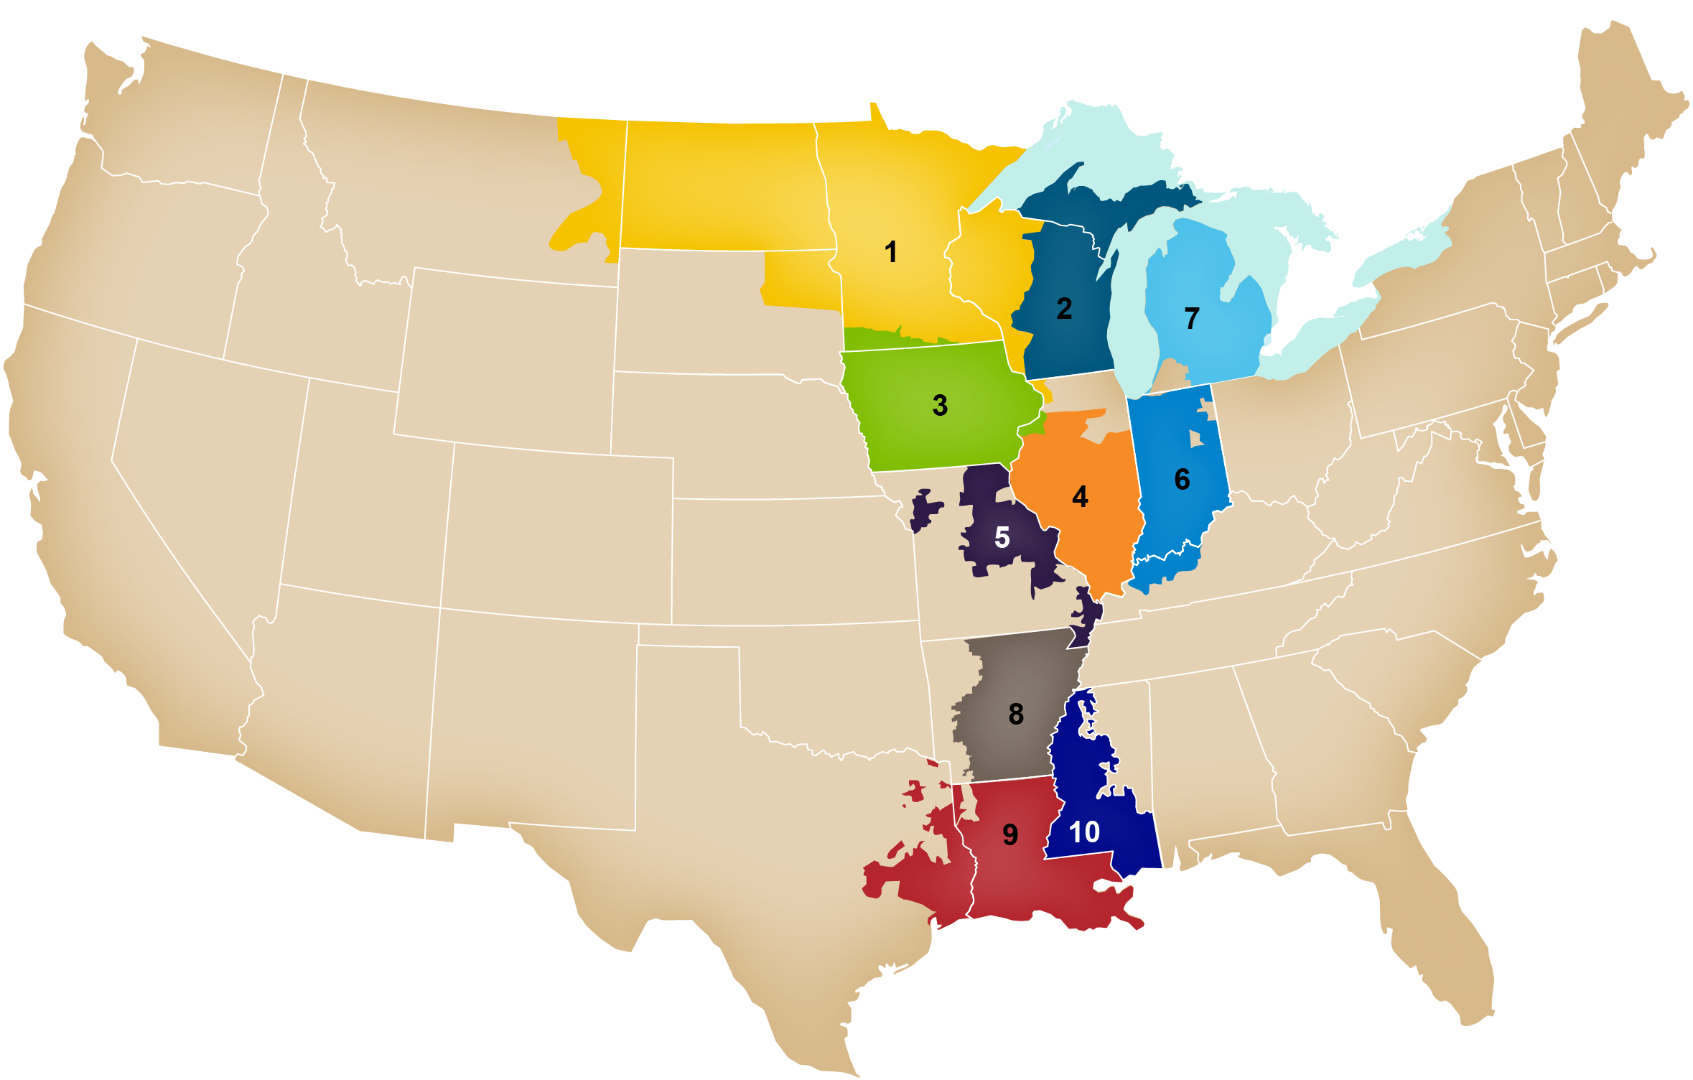
Figure 5: Local Resource Zones Map

Change in LRZ Configuration
MISO, after working with stakeholders and submitting a Tariff revision to Attachment VV that has been accepted by the Federal Energy Regulatory Commission, may change the configuration of the LRZs if a re-evaluation trigger has occurred and after consideration of the criteria outlined for consideration in setting LRZ boundaries. Changes to LRZ configuration will only be applicable to future Planning Years that have not already been cleared through the PRA. MISO will share any re-evaluation triggers and the results of the analysis documenting the impacts of the proposed LRZ boundary changes with stakeholders in an open and transparent manner prior to making any filings to change LRZ boundaries.

Once the boundaries of an LRZ have changed, its boundaries should stay constant for at least three years to provide stable future locational signals.

Re-evaluation Triggers
The Transmission Provider may re-evaluate the boundaries of LRZs if there are significant changes in the Transmission Provider Region. Such changes are called re-evaluation triggers, and they include, but are not limited to, the following:
- Significant changes in membership:
Re-evaluation may occur for LRZs where there are membership changes in the MISO system or for areas which neighbor the regions where there is a membership change. Re-evaluation may occur prior to or in the cycle immediately following the integration of new members into the MISO system.
- Significant changes in the Transmission System:
Transmission infrastructure must be on target to be in-service by June 1 of the year which would follow a filing for an LRZ boundary changes (i.e., the transmission must be in-service for the first summer where the zonal changes will go into effect). The changes to the transmission system should impact transmission constraints represented in the MISO Resource Adequacy construct for the zone(s) being reevaluated.
- Significant changes in Resources:
Changes to the resource mix may include the addition of significant new generation or the retirement of significant existing generation. The resource changes should be shown to modify the transmission system flows in the zone(s) being studied, impacting transmission constraints represented in the MISO Resource Adequacy construct.

The existence of a trigger will not guarantee that a zonal change will be implemented; the trigger will allow the analysis to proceed and will be considered as part of the final decision on whether or not to change zonal boundaries.

Re-evaluation Considerations
Once a re-evaluation trigger has been met, the geographic boundaries of the zone or zones may be re-evaluated. This re-evaluation will be based upon an analysis that considers the following factors.
- Electrical Boundaries of Local Balancing Authorities
- State boundaries
- Relative strength of transmission interconnection between Local Balancing Authorities
- Results of LOLE studies
- Relative Size of LRZs
- Natural geographic boundaries such as lakes and rivers

The electric boundaries of Local Balancing Authorities, state boundaries, and natural geographic boundaries will be considered by inspection. Additional information on the process used to analyze the other criteria is below.

Relative Strength of Transmission Interconnections between Local Balancing Authorities
Multiple aspects of the transmission system are considered in this portion of the evaluation. These aspects are first investigated individually, and the final assessment considers all of the factors. The assessment includes the following:
- Previously identified LOLE results (Capacity Import and Export Limit constraints)
- Constraint variation(s)
- Transmission projects
- Physical ties including post-contingency connectivity and transmission service

LOLE results identified for Capacity Import and Export Limit analysis before and after the boundary change is applied will be considered. Zonal transfer analysis yields a list of constraints. The most limiting constraint after redispatch determines a zone’s limit in the LOLE study. In the re-evaluation analysis, the less limiting constraints are also considered since reconfigurations impact the transfer level at which constraints are limiting. Also, while there can only be one limiting constraint, multiple constraints can be seen at similar transfer levels. For example, assume the most limiting constraint is at a transfer level of 100 MW. There are two additional constraints at 99 MW and one at 90 MW. Since these transfer levels are very close, all four are considered in this evaluation.

Constraint variation is caused by reconfiguration of Local Resource Zones. This variation is caused by changing the generation that is used to create the transfer. Zonal definitions determine which generators are used in the transfer analysis so any change in zonal definition may result in a difference in the impact the transfer has on the constraint. It is possible that a constraint has an impact above the threshold before reconfiguration and less than the threshold afterwards which is considered in this evaluation.

The impact of approved MTEP Appendix A and Target A transmission projects is considered. If a project mitigates a constraint and the project is expected to be in service prior to the Planning Year under consideration, then the impact of the transmission project to the LOLE results is considered.

MISO will consider the number of ties of any reconfigured zone. Generally, a reconfigured zone should have two or more ties with the rest of MISO. Two or more ties between the zones are optimal when planning for contingencies so the zones are still connected post-contingency. Any LBA being added to an existing LRZ should have two or more ties with an LBA in the new LRZ. Any other impacted LRZs should have contiguous LBAs with two or more ties. Further consideration is needed if an LBA leaving an LRZ results in an LRZ with unconnected LBAs. In addition, confirmed transmission service between zones may be considered when evaluating reconfigurations. Confirmed long-term transmission service indicates transmission capacity between the zones has been previously evaluated.

The Results of LOLE Studies
LOLE studies will be performed with the LRZ configuration being considered. The results of this analysis will be compared with the prevailing LRZ configuration. This LOLE analysis includes a MISO PRM model analysis (Section 3.5), LRZ LRR determination (Section 5.2.2.2), and capacity import and export limit analysis (Section 5.2.2.1) for the LRZ configuration being considered and for the prevailing LRZ configuration. The results of this analysis and comparison with the prevailing system results will be used as one factor in determining whether LRZ changes are warranted, in conjunction with the other LRZ considerations.

Relative size of LRZs
The relative size of an LRZ will contain no less than 2,000 MW of Demand.

Determination of LRZ Boundaries
Following the determination of an LRZ re-evaluation trigger, the conclusion of all analysis with consideration of stakeholder feedback will determine whether the LRZ boundaries will be changed. This determination will be based upon the benefits and/or risks that the LRZ boundary changes would present on the system. MISO’s final determination will be shared with stakeholders and the changes will be filed with FERC.

External Resource Zones
MISO developed External Resource Zones (ERZs) to reflect the physical location of External Resources and establish Auction Clearing Prices for such External Resources (other than Coordinating Owner and Border External Resources). An ERZ will be created for each External Balancing Authority adjacent to MISO with Planning Resources participating in the MISO PRA.
Current External Resource Zones:

ERZ | Area(s)
EZ20 | KCPL, OPPD, WAUE
EZ22 | PJM
EZ23 | OVEC
EZ24 | LGEE
EZ26 | AECI
EZ27 | SPA
EZ28 | TVA

External resources ZRCs are counted toward the MISO North/Central region and the MISO South region based on transmission shift factors that are calculated annually.

Establishing Sub-Regional Resource Zones (SRRZ)
MISO will also establish SRRZs applicable for each Planning Year. A SRRZ is a zone, comprised of an LRZ or combination of two or more LRZs, to administer constraints in accordance with applicable seams agreements, coordination agreements, or transmission service agreements.

Currently, MISO has two SRRZs: MISO South, defined as LRZs 8, 9 and 10, and MISO Midwest, defined as LRZs 1-7. These SRRZs are a result of the settlement agreement between MISO, SPP, and the other Joint Parties. This agreement established Regional Directional Transfer Limits (RDTL) that limit the amount of total transfer between these two SRRZs in the PRA. The RTDL from South to Midwest is 2,500 MW and the RTDL from the Midwest to South is 3,000 MW.

MISO shall establish the Sub-Regional Export Constraint (SREC) and Sub-Regional Import Constraint (SRIC) for each Season by March 1 prior to the Planning Year. The methodology for determining the SREC and SRIC for each SRRZ is described below.

Determination of Seasonal SREC and SRIC
The following steps describe the steps MISO will utilize to calculate the SREC and SRIC.
1. Begin with the Regional Directional Transfer Limits (RDTL) between the two SRRZs
2. Complete a feasibility analysis to review operational events from the previous seasonal peaks to determine if a further reduction to the Regional Directional Transfer Limit is warranted for reliability.
3. Decrement the initial RDTL (from step 1) based upon completed feasibility analysis
4. Subtract from the net RDTL (from step 3) the sum of Firm Reservations on MISO OASIS that utilize the contract path between South and Midwest and are exporting the MISO BA for the applicable Season of the Planning Year. This difference determines the SREC and SRIC to be utilized for that Season of the Planning Year.

Example from the 2016-2017 Planning Year
1. The RDTL from South to Midwest is 2,500 MW and from Midwest to South is 3,000 MW.
2. MISO’s feasibility analysis for the 2016-2017 Planning Year determined that no additional reduction of the RDTL was required; 0 MW.
3. The net RDTL for 2016-2017 is equal to the initial RDTL; South to Midwest is 2,500 MW and from Midwest to South is 3,000 MW.

4. The MISO OASIS Reservations, in each direction, that exported from the MISO BA for the 2016-2017 Planning Year were summed:
South to Midwest Direction: 1,624 MW
Midwest to South Direction: 206 MW

Final SREC and SRIC applied for the 2016-2017 Planning Year:
South SRRZ SREC: 876 MW
South SRRZ SRIC: 2,794 MW
North SRRZ SREC: 2,794 MW
North SRRZ SRIC: 876 MW

Regional Directional Transfer Limit Feasibility Analysis
On an annual basis, prior to administrating the PRA, MISO will review operational data from the previous seasonal peaks to determine if operational events experienced in the past and forecasted expected conditions for the applicable Planning Year Season warrant a reduction in the initial RDTL between the MISO South and Midwest Regions. MISO will review the results of the feasibility analysis with stakeholders prior to implementing in a PRA.

The following data sources are considered for the feasibility analysis:
  - Studies that assess MISO transfer capability between Regions
  - Studies that assess load diversity between Balancing Authorities
  - Transmission system constraints
  - Congestion history on relevant transmission constraints
  - Capacity or Transmission Emergency alerts, warnings, or events

Local Requirements and Transfer Capability

Calculation of Transfer Limits for the Planning Resource Auction(s)
MISO will determine the seasonal import and export limits for each LRZ by performing a transfer analysis study. The study produces Zonal Import Ability (ZIA) and Zonal Export Ability (ZEA) values which represent a zone’s ability to import and export capacity in every Season, respectively. The seasonal ZIA and ZEA values are adjusted by the amount of exports (Controllable Exports (CE)) to non-MISO load from the zone to determine a zone’s seasonal CIL and CEL. Seasonal CIL and CEL determine the maximum amount of ZRCs that can be imported or exported respectively to/from that zone in that Season. The seasonal ZIA is an input to the calculation of the seasonal Local Clearing Requirement (LCR) for each LRZ, as described in Section 5.2.2.3 (Establishment of Local Clearing Requirement). Seasonal LCR, CEL, and CIL are inputs to the Planning Resource Auction clearing process. Transfer analysis will be performed on seasonal Powerflow models appropriate for the upcoming Seasons in the next planning year.

Transfer analysis is not required to calculate an ERZ CEL; instead, MISO will determine the seasonal CEL of each ERZ by determining the volume of SAC for External Resources within that zone. The seasonal CEL will be set to the MW SAC in the ERZ no later than eight (8) business days before the last business day in March.

Transfer Analysis
Transfer capability is the measure of the ability of interconnected electric systems to reliably transfer power from one area to another under certain system conditions. The incremental amount of power that can be transferred will be determined through First Contingency Incremental Transfer Capability (FCITC) analysis. First Contingency Total Transfer Capability (FCTTC) indicates the total amount of power able to be transferred before a constraint is identified. FCTTC is the base power transfer plus the incremental transfer capability.

$$Total Transfer Capability \left(TTC\right)=Base Power Transfer+ FCITC$$

Linear FCITC analysis will identify limiting constraints with a minimum Distribution Factor (DF) cutoff of 3%, meaning the transfer and contingency must increase the loading on the overloaded element by 3% or more. In addition, facilities must have loadings 100% or more of the normal rating for system-intact conditions and loadings 100% or more of the emergency rating for N-1 contingencies.

Export and import capabilities of subsystems will be respected and machine limits are enforced. Exporting an LRZ’s available capacity will include offline units. A pro-rata dispatch is used which ensures all available generators will reach their max dispatch level at the same time. The pro-rata dispatch is based on the MW reserve available for each unit and the cumulative MW reserve available in the subsystem. The MW reserve is found by subtracting a unit’s base dispatch from its maximum dispatch, which reflects the available capacity of the unit. Refer to Table 2 and the equation below for an example of how one unit’s dispatch is set, given all machine data for the source subsystem.
Machine | Base Model Unit Dispatch  (MW) | Minimum Unit Dispatch  (MW) | Maximum Unit Dispatch  (MW) | Reserve MW (Max dispatch – Unit Dispatch)
1 | 20 | 20 | 100 | 80
2 | 50 | 10 | 150 | 100
3 | 20 | 20 | 100 | 80
4 | 450 | 0 | 500 | 50
5 | 500 | 100 | 500 | 0
Total Reserve |  |  |  | 310

Table 2: Example Subsystem

$$Machine 1 Post Transfer Dispatch=\frac{(Machine 1 Reserve MW)}{(Source Subsystem Reserve MW}×Transfer Level MW$$

$$Machine 1 Post Transfer Dispatch=\frac{80}{310}×100=25.8$$

$Machine 1 Post Transfer Dispatch$ = 25.8

General Assumptions
Power flow models and input files are required to determine the import and export limits of each LRZ in each Season. Input files (subsystem and contingency) from MTEP studies built for timeframes matching the effective period of the transfer limit study will be used. Single-element contingencies in MISO and seam areas are evaluated. Other than the power flow model, all other input files will be the same across all Seasons within the Planning Year.

Subsystem files will be modified to include required source and sink definitions, details are provided in the next two sections (Import and Export Limit Determination Sections). The monitored file will include all facilities under MISO functional control and Seam facilities 100 kV and above.

Power flow models will contain approved MISO MTEP Appendix A and Target A projects with effective dates on or before the effective date of the study model. Planning Resources, internal and external to MISO will be dispatched in the base model according to the Generator Modeling and Transactions/Interchanges sections of the Transmission Planning Business Practices Manual, or BPM-020. The following generators are excluded from the incremental transfer analysis dispatch:
- Nuclear
- Generators with negative dispatch
- Hydro
- Wind
- Solar

Wind and solar will be ramped down for transfers and will not be ramped up. Maximum wind output will be limited to base dispatch in the power flow model which is set by the wind capacity credit. MISO and external area interchange in the base case will be set to the net of the expected firm transactions with its neighbors.

If a Transmission Owner has identified a zonal import limit that is binding as a result of the exclusion of nuclear (headroom) or other resources in the sink of the transfer study, the TO may inform MISO of the limitation and MISO will evaluate the ZIA and update accordingly, at MISO’s sole discretion.

Seasonal Zonal Import Ability (ZIA) and Seasonal Capacity Import Limit (CIL) Determination
To determine an LRZ’s seasonal limits, a generation-to-generation transfer is modeled from a source subsystem to a sink subsystem. For import limits, the limit is determined for the sink subsystem. Import limits are found by increasing MISO generation resources in adjacent Local Balancing Authorities (LBAs) while decreasing generation inside the LRZ under study. LBAs that are interconnected with the LRZ under study are considered adjacent. Tiers are used to define the generation pool used for import studies and are comprised of the adjacent systems of the zone being studied.
- Tier 1 – Generation in the MISO LBAs adjacent to the LRZ under study
- Tier 2 – Tier 1 plus generation in MISO LBAs adjacent to Tier 1
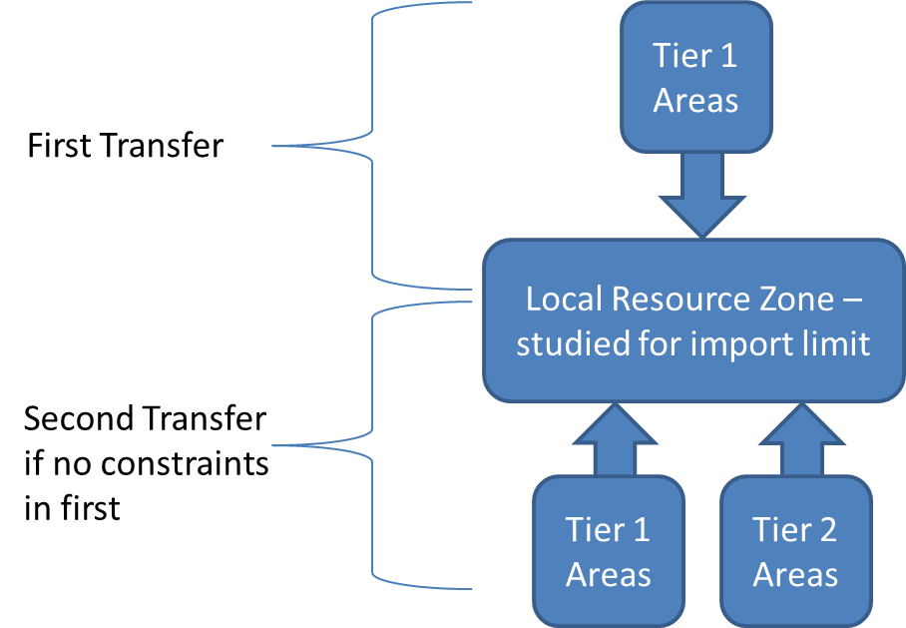
Figure 5.1: Tiered import illustration

Import limit studies are analyzed first using Tier 1 generation only. If no constraint is identified,
the source is expanded to include Tier 2 and the transfer is retested. If a constraint is identified, redispatch is tested. If redispatch mitigates the constraint completely and an additional constraint is not identified, the source is expanded to include Tier 2 and the transfer is retested. If constraints are identified using Tier 1 generation, Tier 2 generation is not needed to determine the zone’s import limit.

The results of the analysis produce the seasonal Zonal Import Ability. This value will be used to determine the seasonal CIL after accounting for exports to non-MISO load.

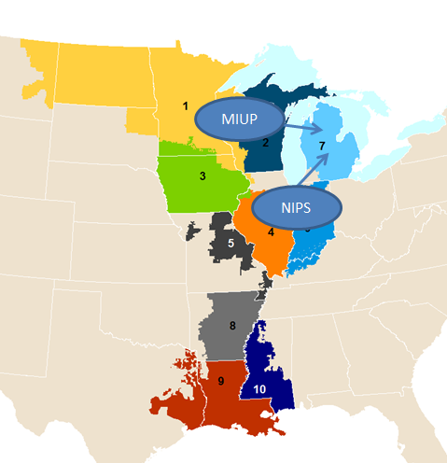
Figure 5.2: Example - MISO LBAs Used for First Test of LRZ 7 import limits

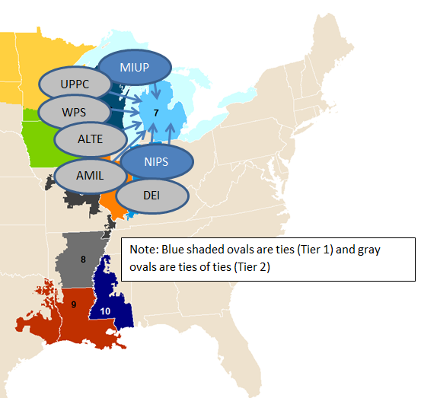
Figure 5.3: Example - MISO LBAs Used for Second Test of LRZ 7 import limits

Seasonal Zonal Export Ability (ZEA) and Seasonal Capacity Export Limit (CEL) Determination
The LRZ being studied for a seasonal export limit, is the source subsystem for the transfer. Available generation within the LBA(s) contained in that particular LRZ is increased proportionately while all generation dispatched, except for nuclear, wind and other intermittent resources, in all other MISO LBAs is decreased proportionately. This method produces the seasonal ZEA which is used to determine the seasonal CEL after accounting for exports to non-MISO load.
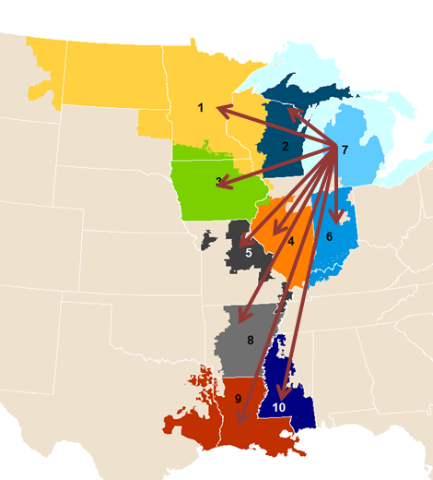
Figure 5.4: Example - MISO LBAs Used for LRZ 7 export limits

Redispatch
LOLE study redispatch is based on prior MTEP study methods. The base assumptions are as follows:
- No more than 10 conventional plants or wind plants will be used
- Redispatch limited to 2,000 MW total (1,000 MW up and 1,000 MW down)
- Nuclear units are excluded
- Wind and other intermittent resources can only be ramped down

For import redispatch scenarios, all generation resources in the zone being studied and adjacent systems (Tier 1 or Tiers 1 & 2) used for the transfer will be eligible to be ramped up. All MISO generation resources will be eligible to be ramped down. If the limiting constraint is a Reciprocal Coordinated Flowgate (RCF), MISO will work with the Seam entity to determine if an adjustment to external dispatch is appropriate and impactful.

For export redispatch scenarios, only MISO generation resources within the zone being studied are eligible to be ramped up. All MISO generation resources are eligible to be ramped down. As with import redispatch, if the limiting constraint is a Reciprocal Coordinated Flowgate (RCF), MISO will work with the Seam entity to determine if an adjustment to external dispatch is appropriate and impactful.

Adjustment for Exports to Non-MISO Load
FERC issued an order on December 31, 2015 which required studies to be neutral to units within MISO areas that are exporting to non-MISO load. MISO identifies and removes the impact of these exporting units on zonal area interchange. These adjustments result in an increase to CIL and decrease to CEL for zones with exports to non-MISO load.

Generation Limited Transfer
When conducting transfer analysis, the source subsystem might run out of generation to dispatch before identifying a constraint caused by a transmission limit. MISO has developed a process referred to as Generation Limited Transfer, or GLT, to identify transmission constraints in these situations.

After running the FCITC analysis to determine import and export limits for each LRZ, MISO will determine whether a zone is experiencing a GLT. If the LRZ is experiencing a GLT, MISO will adjust the base model dependent on whether the analysis is an import or export study and re-run the transfer analysis.

For an export study, when a transmission constraint has not been identified after dispatching all generation within the exporting system (LBAs under study) MISO will decrease load and generation dispatch in the study zone. The objective of the adjustment is to create additional capacity to export from the zone. After the adjustments are complete, MISO will perform transfer analysis on the adjusted model to be in line with section 5.2.2.1 (Calculation of Transfer Limits for the PRA). If a GLT is observed again, further adjustments will be made to the load and generation of the study zone.
For an import study, when a transmission constraint has not been identified after (a) decreasing all generation within the LRZ under study, (b) or dispatching all generation within Tiers 1 & 2, MISO will adjust load and generation in the source subsystem, Tiers 1 & 2. This will increase the capacity available to import into the study zone. After the adjustments are complete, the transfer analysis will be completed on the adjusted model to be in line with section 5.2.2.1. If a GLT is observed again, further adjustments to the model would be made to the load and generation in Tiers 1 & 2.

FCITC could result in the transmission system supporting large thermal transfers for some zones which might result in some additional considerations. First, large GLT adjustments for export limits could result in reactive-power issues in the zone. Additionally, any load scaling beyond 50% of the zone’s load in the base model could result in unrealistic modeling for a summer peak scenario and could lead to unreliable limits and constraints. Therefore, load scaling for both import and export studies will be limited to 50% of the zone’s load.

If the GLT does not produce a limit for a zone(s), whether due to a valid constraint not being identified or due to other considerations as listed in the prior paragraph or in the case of a Zone where no valid limit is found in a particular Season, then the seasonal CIL or seasonal CEL will use the following equation where Capacity is the amount available to export or import from Tier 1 & 2 LBA’s in the Base Case and where Base Case Flows is the Area Interchange for the study LRZ in the base Powerflow model.

ZIA/ZEA = Capacity + Base Case Flows

MISO shall report that LRZ as having no seasonal CIL/CEL limit and ensure that the transfer amount in the PRA will not bind in the first iteration of the Simultaneous Feasibility Test (SFT).

Voltage Limited Transfer for import studies
Zonal imports may be limited by voltage constraints due to a decrease in the generation dispatch in the zone being studied. Voltage constraints might occur at lower transfer levels than thermal limits that are determined by linear FCITC. As such, LOLE studies may include evaluation of Power-Voltage curves for major disturbances for LRZs with known voltage-based transfer limitations. Known transfer limitations will be identified through existing MISO or member Transmission Owner studies. Additionally, a study could be considered if an LRZ’s import reaches a level where the majority of the zone’s load would be served using imports from non-zonal resources. MISO will coordinate with stakeholders as these scenarios are encountered.

Processing and Reporting Results
The transfer analysis results for each LRZ consist of a list of constraints and their corresponding FCITC and FCTTC values up to the requested transfer level. The constraint with the smallest FCTTC will be used to determine each Seasons’ ZIA, ZEA, CIL and CEL. The limits are the total transfer capability of the corresponding limiting constraint. Refer to Section 5.2.2.3 Establishment of Local Clearing Requirement regarding how the seasonal ZIA impacts the seasonal Local Clearing Requirement (LCR) calculation. Stakeholder review of the constraints will occur through the LOLE working group.

If a zone’s seasonal Local Clearing Requirement (LCR) is greater than the zone’s seasonal Initial Planning Reserve Margin Requirement (PRMR) and an existing MTEP project is not expected to increase the seasonal ZIA, MISO will follow the process outlined in section 4.5.1 of the Transmission Planning BPM to identify a project to increase the zone’s seasonal CIL.

Timeline and Posting of Results
Posting of power flow models and input files will be completed before analysis begins, if stakeholders have feedback for the models, it should be provided to MISO in a timely manner. The models and associated input files will be made available to the same location where MTEP Powerflow models are shared (https://misoenergy.sharefile.com/).

The outcome of this process will identify a ZIA, ZEA, CEL and CIL for each of the LRZs for each Season within the next Planning Year. MISO will publish the values for each LRZ by November 1 preceding the applicable Planning Year.

Establishment of Local Reliability Requirement
Each LRZ’s seasonal Local Reliability Requirement (LRR) is the amount of SAC MWs required, located within the specific LRZ, to yield a 0.1-day-per-year LOLE at the load level for the LRZ at the time of the LRZ peak, without assistance from resources outside the respective LRZ (other than Border External Resources and Coordinating Owner External Resources modeled in the zone as described in section 4.2.3.2 (External Resource Qualification Requirements)). The LOLE study process is further described in the annual LOLE Study report posted on MISO’s website.

Each Seasons’ LRR will be established using the following iterative process:
- Use the LOLE model to determine the resources required in the LRZ to maintain 1 day in 10 years LOLE, representing the LRZ as isolated from the rest of MISO with no transmission ties to the outside world.
- Each LRZ contains the same load and internal resources from the PRM Analysis.
- For each LRZ, the model will initially be run with no adjustments to the capacity. If the LOLE is less than 0.1 day per year, a perfect negative unit with zero forced outage rate will be added until the LOLE reaches 0.1 day per year for the LRZ. This is comparable to adding Coincident Peak seasonal Demand. If the LOLE is greater than 0.1 day per year, proxy units based on a unit of typical size and forced outage rate will be added to the LRZ until the LOLE reaches 0.1 day per year for the LRZ.
- After solving for 0.1 day per year on an annual basis, risk-deficient Seasons will have a minimum reliability criteria set to 0.01 LOLE and adjustments to capacity in the model will be made until the LOLE reaches 0.01 day per Season.

The minimum amount of capacity above the zonal seasonal Coincident Peak Demand required to meet the reliability criterion of a 0.1 day per year LOLE value will be utilized to establish the Local Reliability Requirement (LRR) for each Local Resource Zone for each Season within the Planning Year. The LRR study utilizes the Year 2 zonal seasonal Coincident Peak Demand supplied by LSEs in the prior Planning Year PRA cycle. The per-unit LRR values are annually calculated by MISO and reviewed with stakeholders through the Loss of Load Expectation Working Group. The zonal per-unit seasonal LRR values are multiplied by the total zonal seasonal Coincident Peak Demand forecast (which is the sum of all CPD forecasts submitted by LSEs in each LRZ) for the prompt Planning Year PRA(s), inclusive of transmission losses, to calculate each Local Resources Zone’s Local Reliability Requirement that will be enforced in each annual and Transitional Planning Resource Auction.

Establishment of Local Clearing Requirement
The final steps in calculating an LRZ’s seasonal LCR is to account for the external transmission ties and controllable exports to non-MISO systems, by reducing the seasonal LRR by the seasonal ZIA determined in accordance with Section 5.2.2.1 (Calculation of Transfer Limits for the PRA) and by controllable exports. Controllable exports are firm capacity commitments from MISO units to non-MISO load and may be committed and dispatched by MISO during emergencies. All 10 LRZs have LCRs for each season and they must be met by resources internal to the zone, or by Border External Resources. For example, an LSE with Initial PRMR in LRZ 1, must meet that with ZRCs originated in LRZ1 to meet LRZ1’s Local Clearing Requirement. ZRCs from other zones can be used to meet the incremental PRMR greater than LCR up to that zone’s Initial PRMR subject to CIL/ CEL and SRIC / SREC.

The formula for determining the seasonal LCR is as follows:
Seasonal LCR_{z1} = Seasonal LRR_{z1} –Seasonal ZIA_{z1} – controllable exports _{z1}

MISO will publish preliminary seasonal LCR determinations as part of the preliminary PRA data. These values will be updated no later than mid-March with final, updated controllable export values and seasonal ZIAs.

Pre-PRA arrangement of capacity scheduling

Fixed Resource Adequacy Plan (“FRAP”)
The FRAP will identify resources for which an LSE has ownership or contractual rights that will be relied upon to meet the LSE’s Planning Reserve Margin Requirement while also conforming to the Local Clearing Requirement (“LCR”) in each LRZ where the LSE has a Initial PRMR in each Season within the Planning Year. An LSE must submit its FRAP for applicable Season(s) via the MECT by the 7th business day of March prior to each Planning Year. MISO will review the FRAP and endeavor to notify the LSE of any issues by March 15. LSEs will have until the PRA(s) offer window opens to resolve any issues identified by MISO.

An LSE can designate its seasonal ZRCs in the FRAP up to the LSE’s seasonal Initial PRMR. The seasonal ZRCs used in a FRAP will be deducted from the available seasonal ZRC balance of Planning Resources in the MECT. Any portion of an LSE’s seasonal Initial PRMR not covered by the FRAP (or met through paying the Capacity Deficiency Charge) will be cleared in the seasonal PRA.

An LSE submitting a FRAP may be subject to a Zonal Deliverability Charge (ZDC). The ZDC is the difference between the seasonal ACP in the LRZ where the LSE has Initial PRMR obligation and the ACP in the LRZ or ERZ where the ZRC associated with the FRAP is physically located multiplied by the volume of the ZRC associated with the FRAP. An LSE can obtain a ZDC Hedge as a hedge against zonal price differences in each Season within the Planning Year.

Seasonal ZRCs and seasonal obligation included in a FRAP will be modeled in the PRA for the applicable Season.

RBDC Opt Out
An LSE may elect to use the RBDC Opt Out for the upcoming and the next two years’ PRAs with an obligation (Final PRMR) that is calculated as shown in section 3.1, and with the RBDC Opt Out Adder determined at the first year of RBDC Opt-Out utilizing the following formula:

${Final PRMR}_{LSE}= \sum_{LBA}{[\left({CPDf}_{LBA}-{FRP}_{LBA}+{FRS}_{LBA}\right)×\left(1+{TL}_{LBA}\%\right)×\left(1+{PRM}_{RTO}+{Adder}_{RBDC Opt Out}\right)]}$

Where attributes are seasonal for the following:
Final PRMR_{LRZ} = Final Planning Reserve Margin Requirement per LSE
CPDf_{LBA} = Coincident Peak Demand forecast per LBA
FRP_{LBA} = Full Responsibility Purchase per LBA
FRS_{LBA} = Full Responsibility Sale per LBA
TL_{LBA}% = Transmission Loss Percentage of LBA
PRM _{RTO} = Planning Reserve Margin in Unforced Capacity set by LOLE Studies
Adder_{RBDC Opt Out}= RBDC Opt Out Adder (Defined in Module A 72.0.0)

In MECT, the LSE’s choice of RBDC Opt Out is administrated at the granularity of Asset Owners that have load obligations.

Establishment of RBDC Opt Out Adder
MISO will use the systemwide and regional RBDCs, and historical market clearing data (e.g., last three Planning Years’s market data) to determine the initial RBDC Opt Out Adder that will be applicable to LSEs that elect the RBDC Opt Out starting with Planning Year 2025-2026. MISO will post the determination of the RBDC Opt Out Adder on the MISO website per the timeline defined in Appendix K.

Request for RBDC Opt Out and ZRC designation
A Market Participant representing an LSE that plans to use the RBDC Opt Out must submit its initial intent to do so through the MECT. Such request must include the name and contact information of the RERRA(s) (email, phone number), where its load is subject to jurisdiction, and must be submitted no later than January 15 prior to the upcoming Planning Year. Market Participants representing the LSE need to contact MISO if there are complexities regarding the RERRA-LSE relationship (e.g., an LSE is subject to the jurisdiction of multiple RERRAs). MISO will verify the information and notify the RERRA(s) within five (5) business days following deadline of the LSEs initial submission. The RERRA(s) has up to twenty (20) Business Days to notify MISO whether the requested RBDC Opt Out has been authorized, on or before timeline listed in Appendix K.
If the RERRA(s) notifies MISO that the LSE is not authorized to use the RBDC Opt Out in the upcoming PRA, MISO will deny the LSE’s initial submission in MECT. If the LSE is subject to the jurisdiction of more than one RERRA, MISO will deny the LSE’s initial submission proposing to use the RBDC Opt Out if any one RERRA indicates that the LSE is not authorized to use the RBDC Opt Out. The LSE may withdraw its initial submission even if it receives authorization from RERRA(s). Otherwise, the LSE must submit its final confirmation to use the RBDC Opt Out in the MECT and must demonstrate that the LSE has designated ZRCs for each Season to meet the LSE’s Final PRMR, and its share of LCR, by the 7th business day of March prior to each Planning Year. An LSE that elects the RBDC Opt Out may not use any other options to participate in the PRA (e.g., self schedule, FRAP, participating auction) to meet its Final PRMR, but may offer any ZRCs in excess of its Final PRMR into the PRA that is consistent with Section 64.1.1.d of Module D.
MISO will notify the LSE prior to March 15th before the applicable Planning Year whether the ZRCs submitted for the RBDC Opt Out meets the LSE’s final PRMR and share of LCR for each LRZ requirement for each Season during the applicable Planning Year. An LSE that does not demonstrate sufficient ZRCs to meet its seasonal Final PRMR and share of LCR on LRZ basis before the PRA offer window opens will be subject to the Capacity Deficiency Charge based on the amount of shortfall in each Season.
An LSE that elects the RBDC Opt Out may be subject to a Zonal Deliverability Charge (ZDC). The ZDC is the difference between the seasonal ACP in the LRZ where the LSE has Final PRMR obligation and the ACP in the LRZ or ERZ where the ZRC associated with RBDC Opt Out is physically located, multiplied by the volume of the ZRC associated with the RBDC Opt Out. An LSE can obtain a ZDC Hedge as a hedge against zonal price differences in each Season within the Planning Year.
Seasonal ZRCs and associated seasonal obligations related to the RBDC Opt Out will be modeled in the PRA for the applicable Season.

LSE’s Local Clearing Requirement for LSE’s Using a FRAP or RBDC Opt Out
LSEs that choose to use a FRAP or RBDC Opt Out must designate a sufficient volume of Planning Resources located in the same LRZ to meet the LRZ’s LCR requirement in each Season individually. The amount of resources that must be sourced from within the LRZ to satisfy the LSE’s seasonal LCR share is equal to the load ratio share of the LSE multiplied by the total seasonal LCR for its LRZ. The following formula is used to determine each LSE’s FRAP or RBDC Opt Out LCR requirements for each Season.
$LSE LCR=\left[\frac{LSE PRMR'}{Zonal PRMR' } \right]* Zonal LCR$

$Minimum LSE ZONE =max⁡(0,\left[\frac{LSE LCR* LSE NON ZONE }{\left(LSE PRMR'-LSE LCR\right)} \right])$
for the given LSE NON ZONE

$$Maximum LSE NON ZONE =max⁡(0,\left[\frac{LSE ZONE* \left(LSE PRMR' - LSE LCR\right)}{LSE LCR} \right])$$
for the given LSE ZONE

Where:
LSE LCR: Amount of ZRCs that must be supplied from the same LRZ where the LSE’s Initial PRMR is located
LSE ZONE: ZRCs that are in the same LRZ as the Initial PRMR that is being met through a FRAP or RBDC Opt Out by the LSE
LSE NON ZONE: ZRCs from an ERZ or that are not in the same LRZ as the Initial PRMR that is being met through a FRAP or RBDC Opt Out by the LSE
LSE PRMR’: Total Initial PRMR the LSE has in the LRZ
ZONAL PRMR’: Total Initial PRMR for all LSEs in the LRZ
Zonal LCR: The minimum amount of ZRCs that are located within an LRZ that is required to meet the LOLE while fully using the Capacity Import Limit for such LRZ.
EXAMPLE :

All LSE Initial PRMR in following example is calculated based on the MISO-established PRM, even if the LSE is subject to the jurisdiction of a state that has established its own PRM

LSE Initial PRMR = 100 MW in LRZ 1
LSE LCR = 80 MW in LRZ 1

To apply ZRCs from other LRZs or an ERZ in the FRAP (or RBDC Opt Out), the following condition must be satisfied when the LSE LCR≤ LSE Initial PRMR:

$$\left[\frac{(LSE ZONE+ LSE NON ZONE) }{LSE PRMR} \right]≤ \left[\frac{LSE ZONE }{LSE LCR}\right]$$

When the LSE LCR>LSE Initial PRMR, the LSE should only use ZRCs inside the resource zone to meet its Initial PRMR:
$$LSE NON ZONE=0$$
Substituting the value for LSE LCR from above, the above formula can be rearranged and rewritten as:
$$min⁡(1,\left[\frac{Zonal LCR }{Zonal PRMR} \right])≤ \left[\frac{LSE ZONE }{\left(LSE ZONE+LSE NON ZONE \right)}\right]$$

Where LSE Total is simply the sum of the FRAP from within and outside of the zone. To state more simply, an LSE must maintain a balance of FRAP (or RBDC Opt Out) in zone to total FRAP (Or RBDC Opt Out) greater than or equal to the ratio of the zone’s LCR and Initial PRMR.

Case 1: LSE ZONE = 40MW in LRZ 1
LSE NON ZONE = 10 MW from LRZ 2

$$\left[\frac{(40+10) }{100} \right]≤ \left[\frac{40}{80} \right]Þ\left[\frac{1}{2} \right]≤ \left[\frac{1}{2} \right]Þ Pass: 10 MW of ZRCs from other LRZ is allowed$$
for the given LSE NON ZONE of 10 MW,

$$Minimum LSE ZONE =\left[\frac{80* 10}{(100-80)} \right]=40 MW$$

NOTE: 40 MW represents the minimum amount of FRAP (or RBDC Opt Out) that must be fulfilled by the ZRCs in LRZ 1 in this case.

Case 2: LSE ZONE = 60 MW
LSE NON ZONE = 20 MW

$$\left[\frac{(60+20) }{100} \right]≤ \left[\frac{60}{80} \right]Þ\left[\frac{4}{5} \right]≤ \left[\frac{3}{2} \right]ÞFail: 20 MW of ZRCs from other LRZ is not allowed$$

for given LSE ZONE of 40 MW,

$$Maximum LSE NON ZONE =\left[\frac{60* \left(100-80\right)}{80} \right]=15 MW$$
NOTE: 15 MW represents the maximum amount of ZRCs from other zones which can be used to FRAP or RBDC Opt Out LSE’s Initial PRMR in LRZ 1 in this case.

Hedges and Zonal Deliverability Benefit

Zonal Deliverability Benefit
Price separation between Local Resource Zones (LRZs), External Resource Zones (ERZs), or groupings of LRZs, including Sub-Regional Resource Zone (SRRZs) occurs due to constraints binding in the Planning Resource Auction(s) (PRA). Zonal Resource Credits (ZRC) will receive the Auction Clearing Price (ACP) based upon the LRZ or ERZ where the Planning Resource underlying the ZRC is physically located for each Season within the Planning Year.

As a result of price separation, the Transmission Provider may collect more debits from LSEs than it credits the owners of the seasonal ZRCs. Excess amounts will be distributed as follows:
- Historical Unit Considerations (HUCs) and Zonal Deliverability Charge (ZDC) Hedges owed payment.
- Any remaining excess revenue shall be distributed on a pro rata basis to Deliverability Benefit Zones (DBZs). A DBZ is a group of one or more LRZs with equal ACPs driven by the same auction constraint.

Zonal Deliverability Benefit Pro Rata Allocation Methodology
The pro rata distribution is applied to each applicable Season and is based upon the LSE’s eligible Adjusted Final PRMR. Adjusted Final PRMR is the Final PRMR minus HUCs and ZDC Hedges.

MPs with Fixed Resource Adequacy Plans or RBDC Opt Out are eligible to receive ZDB.

The pro rata methodology to allocate ZDB uses a weighted average approach to calculate the benefit, in dollars, to importing DBZs of all exports within MISO – a weighted average exporting ACP. This weighted average pool of dollars is then allocated to importing DBZs within MISO on a pro rata methodology based upon the difference between the importing DBZ ACP and the weighted average exporting ACP and the MW amount of imports into a DBZ. The ACP for each LRZ within an importing DBZ is adjusted by dividing the benefit dollars allocated to the DBZ by the total PRMR of all LRZs within a specific DBZ. The specific steps to allocate ZDB are described below.
- Subtract Final PRMR and ZRCs associated with HUCs and ZDB Hedges to derive an adjusted Final PRMR (Adjusted Final PRMR) and ZRC (Adjusted ZRC).
- Create a DBZ for each group of LRZs that have equal ACPs which result from the same auction constraint.
- For each DBZ, subtract the sum of Adjusted Final PRMR for each LRZ within the DBZ from the sum of Adjusted ZRCs for each LRZ within the DBZ. A DBZ will be considered a net importing DBZ if the sum of Adjusted Final PRMR is greater than the sum of Adjusted ZRCs. A DBZ will be considered a net exporting DBZ if the sum of the Adjusted Final PRMR is less than the sum of Adjusted ZRCs. A net exporting DBZ shall not receive any ZDB credit. A net importing DBZ shall receive a ZDB credit allocation based upon this weighted average approach.
- Calculate the weighted average ACP of all net exporting DBZs (Weighted Average Export ACP) to determine a financial value of export capacity within the Transmission Provider region per the formula below:
$Weighted Average Export ACP=\frac{\sum{{(Net Export}_{j}×{ACP}_{j})}}{\sum{{Net Export}_{j}}}$$Weighted Average Export ACP=\frac{\sum{{(Net Export}_{j}×{ACP}_{j})}}{\sum{{Net Export}_{j}}}$$Weighted Average Export ACP=\frac{\sum{{(Net Export}_{j}×{ACP}_{j})}}{\sum{{Net Export}_{j}}}$
$\sum{\frac{Net Exports_{j}*ACP_{j}}{\sum{Net Exports_{j}} }}$Where j = Each net exporting DBZ
- Calculate the ZDB credit allocation, in dollars, for each net importing DBZ:
${ZDB Credit}_{k}={Net Import}_{k}×\left({ACP}_{k}-Weighted Average Export ACP\right)$${ZDB Credit}_{k}={Net Import}_{k}×\left({ACP}_{k}-Weighted Average Export ACP\right)$
Where k = Each net importing DBZs
- Distribute the ZDB credit in each DBZk by dividing the ZDB credit by the sum of Adjusted Final PRMR of the LRZs within each DBZk. Subtract this amount from the initial ACP calculated for each LRZ from the PRA.

FRAP or RBDC Opt Out Contribution to ZDB
Furthermore, ZDB includes credits collected from FRAPs or RBDC Opt Out that contain ZRCs located in LRZs that have a greater ACP than the respective PRMR’s LRZ. This ZDB will be allocated on a pro rata basis by Adjusted Final PRMR to all LSEs within the DBZ where the ZRC associated with the FRAP or RBDC Opt Out is physically located.

Allocation of Zonal Deliverability Charge (“ZDC”)
A FRAP will be subject to a ZDC if the ACP of the LRZ where the ZRC is physically located is less than the ACP of the LRZ where the Final PRMR associated with the FRAP or RBDC Opt Out is physically located. ZDC collected by the Transmission Provider that is not associated with a ZDC Hedge will be allocated on a pro rata basis by Adjusted Final PRMR to all LSEs within the DBZ where the Final PRMR associated with the FRAP or RBDC Opt Out is physically located.

A detailed example of ZDB pro rata allocation methodology is in Appendix P.

Historical Unit Considerations (HUCs)
A HUC is a financial hedge against ACP differentials between LRZs or between an LRZ and an ERZ. HUCs for existing capacity agreements hold LSEs harmless from price separation to the extent that excess auction funds are sufficient. HUCs for existing LSEs will be eligible until the end of the original term of the arrangement, not including any evergreen extensions, or for two years – whichever is longer.

The following criteria must be satisfied for HUC approval:
- LSE must have ownership or contractual rights to the resource
- Must have resource and load located in two different LRZs or a resource located in an ERZ
- Must have either NRIS or firm transmission service from the resource LRZ to the load LRZ
- Contracts and its associated NRIS or firm transmission service must be valid through the entire Planning Year
- Contracts must be a) Grandfathered Agreements, b) arrangements executed and in place on or before July 20, 2011, or c) arrangements that predate March 26, 2018 and pertain to External Resource represented in External Resource Zones
- For both new and existing LSEs, HUCs will expire at the end of the contract term, unit ownership change or unit retirement date, whichever is sooner. Contracts expiring during the upcoming Planning Year are not eligible for a HUC covering the planning year. Contracts that have been renewed by evergreen contract provisions are only valid for two Planning Years from the date of the HUC registration
- A HUC must be registered in the MECT by November 1 prior to each Planning Year. HUC Registrations will need to have all information populated except for the Planning Resource, Asset Owner, Resource Zone and TSR and/or NITS identification number(s). Once the SAC MW for Planning Resources is published, MISO will allow Market Participants to update the Planning Resource, Asset Owner, Resource Zone, and TSR and/or NITS ID number information only. Updates will need to be completed by February 1 prior to the Planning Year
- A separate HUC registration is required for each Planning Resource and load within each LRZ or a resource located in an ERZ
  - One Planning Resource in a registration can only select one LRZ or ERZ
- The MW in HUC registrations that are paid will not exceed the LSE’s seasonal Final PRMR minus their LCR.
- If there are more HUCs than a DBZ’s Final PRMR minus its LCR, then HUC payments will be pro-rated by multiplying the difference between Final PRMR and LCR divided by the total HUCs.
- If Market Participants enter a seasonal ZRC transaction to fulfill contracts that meet the criteria for a hedge, MISO must be able to determine the source of the ZRCs in order to apply the HUC financial hedge to the auction results
  - ZRCs transacted to fulfill existing contracts will need to have specific unit identifiers from aggregate deliverable generators
- Based on the ZRCs transacted, MISO will work with the MP that qualified the HUC to determine in which LRZ or ERZ the Planning Resource is located

If a Load is in an LRZ with a higher ACP than the LRZ or ERZ where the Resource is located, the MP serving the Load will pay an amount equal to the difference of the ACPs between the LRZ and the LRZ or ERZ where the Resource is located, multiplied by the amount of the unhedged load if a HUC Hedge does not exist. This distribution will be limited by the excess auction revenue collected in a given PRA.

A combination of capacity agreements that require the delivery of capacity throughout the Planning Year will qualify for treatment as HUCs, provided that the agreements otherwise satisfy the criteria.

Facilities under construction on or before July 20, 2011 that subsequently become Planning Resources will be eligible for the HUC Hedge provided that the HUC criteria is satisfied.

Firm resources that meet HUC Hedge criteria may be included as part of a FRAP or RBDC Opt Out or offered into the annual auction. Any MWs of ZRCs in a FRAP or RBDC Opt Out that are qualified under a HUC will not be subject to a Zonal Deliverability Charge assessment and will not receive a HUC payment.

Zonal Deliverability Charge Hedge
LSE can obtain a ZDC Hedge as described herein as a financial protection from zonal price differences. Market Participants will be eligible for a hedge against congestion in the auction if the LSE invests in new or upgraded transmission to serve the LSE’s load if located in a different LRZ. Network upgrades made for interconnection service (NRIS/ERIS) do not qualify for a ZDC Hedge. Also, any cost shared upgrades would not be eligible for a ZDC Hedge. The participant that funds the upgrades and submits the transmission service request is the participant who is eligible for the ZDC Hedge. However, Network upgrades associated with a Transmission Service Reservation (TSR) from the new resource to load located in a different LRZ would qualify. The volume of a ZDC Hedge will be the incremental increase in the CIL that resulted from the Network Upgrades identified in the approved firm transmission service request. Market Participants must register the ZDC Hedge and provide supporting documentation in the MECT by November 1 prior to the Planning Year to demonstrate eligibility. ZDC Hedges will be granted only to LSEs that have Planning Resources that cleared in a PRA.

Planning Resource Auction (PRA)

Timing of Auctions
Seasonal Planning Resource Auctions will be conducted in the first 20 business days of April, with results posted near the end of April which is approximately one month before the beginning of the first Season of the associated Planning Year (PY). All four seasonal (Summer, Fall, Winter and Spring) PRA’s will be conducted in April prior to the PY.

Amount of Capacity Cleared in Each Auction
The seasonal PRA(s) and Transitional PRA shall clear seasonal ZRC offers in order to satisfy 100% of the seasonal Final PRMR for each LSE, less the amount of seasonal Initial PRMR associated with the Capacity Deficiency Charge and inclusive of any resources used in a seasonal FRAP or RBDC Opt Out, in each LRZ. For a Season, if the total volume of seasonal ZRC offers is less than total seasonal Final PRMR, MISO will clear the total volume of offered ZRCs for that Season respecting established CIL, CEL, SRIC and SREC.
For LSEs not selecting the RBDC Opt Out, the Final PRMR is established as a result of the PRA clearing using RBDCs. For LSEs selecting the RBDC Opt Out, Final PRMR is the same as Initial PRMR, which is based on the sum of the applicable PRM plus the applicable RBDC Opt Out Adder, as demonstrated in section 3.1. LSEs under state jurisdiction where the state has elected to establish its own planning reserve margin will have a Final PRMR based on the planning reserve margin established by the state.

Conduct of the PRA
The seasonal Planning Resource Auctions shall be sealed bid auctions, which will determine the seasonal Auction Clearing Prices (ACP) for each Local Resource Zone (LRZ) and External Resource Zone (ERZ) modeled in that auction. The auction shall determine the outcome of all seasonal ZRC offers accepted during the qualification process and submitted during the auction offer window.

Step 1: Compilation of Offers
Offers for each of the seasonal auctions must be submitted in the MECT’s Submit Offer screen for each specific seasonal auction during the auction offer window period. The offer window for the auction will be opened during the last four business days in the month of March prior to the start of the new Planning Year. Owners of jointly owned facilities can individually offer their share of any such resources into the seasonal PRAs, either as self-schedule price takers or with specific offers or use their share of such resources as part of a seasonal FRAP or RBDC Opt Out.

MISO shall compile all of the offers for each Season, as follows: The MP acting on behalf of any Planning Resource accepted in the qualification process for participation in the auction may submit an offer consisting of price and quantity pairs, indicating the minimum acceptable price and the associated quantity of seasonal ZRCs that the MP would commit to provide from the Resource in the associated modeled LRZ and/or ERZ during the Season within the Planning Year. An offer shall be defined by the submission of up to five price and quantity pairs, each having a strictly greater price than the previous price in the submission. Each price shall be expressed in dollars per megawatt-day, and each quantity shall be expressed in 0.1 MWs. The MW/Price pairs must be monotonically increasing for each price. Each segment of each offer is separately evaluated.

Step 2: Determination of the Outcome
MISO shall use the seasonal ZRC offers to determine the aggregate supply curves for each MISO modeled LRZ and/or ERZ. MISO will use the seasonal offers in conjunction with the seasonal import and export constraints, seasonal local clearing requirements, and other inputs to determine the least cost set of offers that respects the various constraints expressed as described in the Tariff. The Transmission Provider will clear offers based on the needs of the LRZ and not the size of a Resource (i.e., if an LRZ needs 50 MW, but a Market Participant has a 100 MW Resource; only 50 MW will clear). At any non-zero clearing price, a pro-rated clearing from tied bids will be applied in conjunction with need, location of resources subjected to tied bids, and import and export limits of respective LRZs. At a zero-clearing price, all zero-price and price-taking offers will be accepted.

Inadequate Supply
While the auction process will endeavor to select seasonal ZRC offers sufficient to meet the seasonal requirements of each LRZ, it is possible that sufficient resources are not available in the LRZ and the LRZ would thus be short of Planning Resources for that Season within the Planning Year. In such cases, the auction will clear all seasonal ZRC offers in the LRZ for that Season and, if the LRZ is short ZRC’s to meet the seasonal requirements, the entire LRZ will clear at the LRZ’s seasonal CONE value. If the LRZ is short of ZRC’s to meet the requirements for more than one Season within the Planning Year, then the ACP for such Seasons will be determined as described in section 69A.7.1 of Tariff Module E-1.

Market Monitoring
All participation by Market Participants is subject to the market power mitigation rules regarding physical and economic withholding of capacity as described in Module D of MISO’s Open Access Transmission Tariff and Market Monitoring BPM-009. All Planning Resources except for External Resources, Load Modifying Resources, and Energy Efficiency Resources are subject to physical and economic withholding monitoring. Below are additional details regarding the application of these market monitoring provisions. In addition to these details, please refer to Module D and BPM-009 Market Monitoring and Mitigation for additional details.

Physical Withholding
Sec. 64.1.1.d of Module D describes the Physical Withholding Provisions in the PRA. The IMM has established a Physical Withholding Threshold Limit of 50 MW per LRZ that is applied as a sum to a Market Participant (MP) and its Affiliates. Thus, there is a total of 50 MW of deliverable SAC (ZRCs) whose rights are owned by an MP and its Affiliates in each LRZ that are not required to submit an offer into the PRA or be part of a FRAP or RBDC Opt Out. If the sum of deliverable SAC MW withheld exceeds the Physical Withholding Threshold Limit, the MP and its Affiliates would fail for conduct (Conduct Test) for physical withholding and be subject to the Impact Test described in Module D.

Economic Withholding
Sec. 64.1.2.d of Module D describes the Economic Withholding Provisions in the PRA. By default, each Planning Resource subject to economic withholding has an initial Reference Level for their PRA offer of $0/MW-Day. A Conduct Threshold equal to 10% of the LRZ Daily CONE (Daily CONE = LRZ CONE / 365) is allowed for a PRA offer without failing conduct (Conduct Test) for economic withholding and be subject to the Impact Test described in Module D.

An MP may submit a request for a Facility Specific Reference Level (FSRL) to the IMM. The request must be accompanied by evidence and documentation of Going Forward Costs (operating and capital) to operate the Planning Resource for the next Planning Year. Going Forward Costs must be sufficient detail to specify costs specific to suspension or retirement. Refer to BPM-009 Market Monitoring and Mitigation for additional details.

Market Participants have the option to use Default Technology Specific Avoidable Costs (DTSAC) calculated by the IMM as specified in Module D for operating cost recovery in lieu of submitting their own documentation for operating costs. The DTSAC values in Module D are broken down by different generator classifications for suspension and retirement requests. Refer to BPM-009 Market Monitoring and Mitigation for additional details.

Target Reliability Value
The resultant target reliability value for each Season for each LRZ will be the greater of the system-wide seasonal Planning Reserve Margin Requirement based on MISO’s seasonal PRM or the seasonal LCR value. The sum of these seasonal LRZ target reliability values will be the system’s target seasonal reliability value, that is, the amount of SAC MW that must be obtained, if available, from the auction.

Resource Offers
Any seasonal ZRCs that were not used in a FRAP or RBDC Opt Out can be offered into the seasonal PRA during the auction window period. The following business rules are applied to the seasonal ZRC offers for the seasonal PRA:
- Offer cannot be changed or withdrawn after the auction window is closed.
- Smallest Offer MW = 0.1 MW.
- Offer Segment defined as a price-quantity pair.
- Up to 5 Offer Segments per Planning Resource.
- Lowest Offer price is $0.00/MW-Day.
- Highest Offer Price for each Season and zones (LRZ and ERZ) is the annual LRZ/ERZ CONE divided by the total number of days in the Season.
- The Transmission Provider will clear offers based on the needs of the LRZ and not the size of a Resource (i.e., LRZ needs 50 MW, but Market Participant has a 100 MW Resource; only 50 MW will clear). At a zero-clearing price, all zero-price and price-taking offers will be accepted.

Self-Scheduling
LSEs that “self-schedule” ZRCs by submitting offers into the PRA(s) with a price of $0.00 will always clear the auction.

Sub-Regional Constraints
The Sub Regional Import Constraint (SRIC) and the Sub Regional Export Constraint (SREC) for each Sub Regional Resource Zone (SRRZ) are the transmission constraint parameters which must be respected, in addition to CILs and CELs for each LRZ, when conducting the PRA or in the Resource Replacement process. A SRRZ consists of more than one LRZ. The North/Central SRRZ consists of LRZs 1-7, and the South SRRZ consists of LRZ 8-10.

The Transmission Provider will establish and publish, on the Transmission Provider’s public website, SRRZs, seasonal SRECs and seasonal SRICs as soon as practical but no later than the first business day of March for the following Planning Year.

Seasonal Simultaneous Feasibility Test (SFT)
Background
The test identifies transmission constraints resulting from power transfers between LRZs and imports to the MISO system from ERZs. To the extent transmission constraints cannot otherwise be mitigated via redispatch of seasonal Planning Resources while holding LRZ imports and exports constant, new seasonal CIL and CEL values (as applicable) are established. Resulting transfers in the auction will be simultaneously reliable and feasible. The seasonal SFT is completed after the seasonal auction clears and is driven by section 69A.7.1 of Tariff Module E-1.

Base Model
Base modeling represents the transmission topology and associated transmission ratings, Demand, and anticipated net interchange for the associated Season: summer, fall, winter, and spring. This is accomplished by the following modeling assumptions:
- Base model
  - Latest available MISO model with expected generation and transmission topology for the effective date of each Season within the Planning Year
- Transmission Topology
  - Includes Appendix A and other Model On Demand projects in-service by the effective date of the specific Season within the Planning Year
- Load
  - Final PRMR cleared through seasonal auction
  - LMRs are modeled as reduction of seasonal Final PRMR where LMRs are physically located
- Dispatch
  - Seasonal FRAP
  - Seasonal RBDC Opt Out
  - Seasonal ZRC offers cleared through the auction

- External representation
  - Latest Eastern Interconnection Reliability Assessment Group Multiregional Modeling Working Group series model matching Planning Year timeframe for each Season where applicable within the Planning Year

The latest seasonal models from the annual MISO series model build provides the best representation of the system and is a better representation than the one-year-old LOLE model used to establish the seasonal CIL and CEL limits. The latest model contains up-to-date topology and has gone through more recent stakeholder review.

Interchange Detail
External units that clear the auction are accounted for by Balancing Authority Area and then the interchange between MISO and the Balancing Authority Areas with cleared units is adjusted to represent the cleared amount. Units within MISO with an external capacity commitment will be dispatched to external load. Interchange will be adjusted to reflect the transaction.

Topology Validation
Model checks are performed prior to the SFTs and PRAs. First, the ratings of facilities found to be limiting in the LOLE study are checked for rating changes. If the facility ratings are updated, the impact on seasonal CEL, CIL and/or ZIA must be determined and included as inputs to the PRAs. Transmission projects included in the LOLE models that were supposed to be in service by the effective date of the model, are validated and updated accordingly if a project’s in-service date changes.

Power flow Analysis
The only controllable elements of the auction are the seasonal CIL and CEL. The seasonal SFT determines if any changes to CIL and CEL are required. The initial limits are determined in the annual LOLE study where seasonal CIL and CEL limits are established. These limits are an input to the initial auction clearing process. The SFT process is outlined in Figure 5.5 below.


Performed for each LRZ

Figure 5.5: SFT Process Flow

Seasonal CIL and CEL may be modified when the dispatch of Planning Resources within that Season outside the LRZ is the only action to mitigate constraints. To determine if changes are required, it must first be determined if the LRZ is an exporter or importer from the auction results of that Season. If the LRZ is an exporter within the seasonal CEL bounds, no change to limits should cause the LRZ to export more. Similarly, no change to limits should cause an importing LRZ to import more. The changes to limits that are impactful for exporters and importers are outlined as:
- Potential change if Planning Resources outside an LRZ is the only mitigation identified
- Decrease export or import limit if Planning Resources outside LRZ can be ramped up or down respectively to mitigate the constraint
- Decrease limit by MW amount needed to mitigate constraint

The Tariff allows for up to three iterations of the auction clearing process. The first iteration uses the seasonal CIL and CEL values from the LOLE study while the second and third iteration use any updated CIL and CEL values as determined by the seasonal SFT. The second and third iterations are performed only if needed. The clearing iterations are outlined as:

1st Pass
- Inputs to the auction clearing process are seasonal CILs and CELs from LOLE study, seasonal LCR, seasonal SRECs, and seasonal SRICs as applicable
- If all LRZs pass the SFT in that Season, auction results are final and the 2nd and 3rd iteration of auction clearing is not required.
2nd Pass
- Inputs to the auction clearing process are updated. Seasonal CILs and CELs from the 1st Pass and
- If all LRZs pass the SFT, results are final.
3rd Pass
- Inputs to the seasonal auction clearing process are updated. Seasonal CILs and CELs from the 2nd Pass if all zones pass the SFT, results are final. If at least one LRZ does not pass the SFT, the iteration with the fewest MWs of network violations will be deemed as the final auction result.

Auction Results Posting
MISO will post the summary of the Planning Resource Auction results on its website twenty (20) Business Days after the auction offer window is closed. The summary includes the following information for MISO system wide and each LRZ for each Season within the Planning Year: Final PRMR, Total Offer + FRAP + RBDC Opt Out, Offer Cleared + FRAP + RBDC Opt Out, LCR, Import Limit (CIL), Export Limit (CEL), Import/Export amount, ACP, deficient amount, and Total Offer Cleared volume for the system.

One month following the completion of any PRA, MISO will post the ZRC Offers in price/quantity pairs on its website without revealing the names of the Market Participants submitting such offers and the names of the Planning Resources offered.

Resource Adequacy Settlement
Transmission Provider will settle each PRA using the following steps:
- Determine the ACP for ZRCs within each LRZ for every Season.
- Determine each LSE’s Final PRMR. For details see Error! Reference source not found..
- Provide HUC credits equal to the zonal ACP differential to Load subject to HUCs in every Season in the Planning Year.
- Provide ZDC Hedge credits equal to the zonal Auction Clearing Price differential to ZDC Hedge Load amounts in every Season in the Planning Year.
- Provide ZDB credits to all remaining Final PRMR in the LRZ. The ZDB is a credit against the ACP paid by LSEs with Final PRMR in each LRZ in every Season in the Planning Year.

Settlement calculations for each Season in the PRA will be conducted on a daily basis and the results will be shown under the Real Time Settlements statement. Please refer to the Market Settlements BPM for further details. Below are charge types under the PRA(s) Settlement:
- PRA Charge
- Distribution of PRA Charge
- Zonal Deliverability Charge (ZDC) (*Only applies to the FRAP or RBDC Opt Out)
- Distribution of ZDC
- Capacity Deficiency Charge (Covered outside of the daily settlements)

Cleared seasonal ZRCs from Diversity Contracts that are not self-scheduled or in the LSE’s seasonal FRAP or RBDC Opt Out will receive reduced payment based on the total number of days the external resource identified in the Diversity Contract are dedicated to MISO load when an LSE clears more seasonal ZRC in the PRA than its seasonal Final PRMR. The LSEs that converted SAC MW to seasonal ZRCs will receive the seasonal auction clearing price for the entire Season for those seasonal ZRCs that cleared in the seasonal PRA.

Final PRMR Allocation Process
The Final PRMR of an LSE is determined based on RBDC clearing and the LSE’s participation option (such as RBDC Opt Out, market participation, etc.) in the PRA. The RBDC cleared MWs determined during the PRA clearing process will be allocated to determine LSE’s Final PRMR using the steps outlined below (Figure 5.6).

Figure 5.6: Overview of Final PRMR allocation process

Step 1: Accounting for RBDC Opt Out
First, determine cumulative MWs corresponding to PRMR obligation of LSEs choosing the RBDC Opt Out option as per Section 5.3.2. Then, deduct this cumulative MWs from the total cleared MW from the PRA clearing. Remaining cleared MWs, if any, are then passed on to step 2.
Step 2: Accounting for State-set PRM
Then, the Final PRMR for LSEs who are under State jurisdiction with the State defined PRM is determined. For such LSEs, their Final PRMR is calculated based on the PRM defined by the respective State. Then, the sum of Final PRMR of LSEs who are under State jurisdiction with the State defined PRM is deducted from the remaining cleared MWs that were calculated in step 1. At the end of step 2, remaining cleared MWs, if any, are determined and then passed on to step 3.
Step3: Determine Final PRMR for other LSEs (Neither RBDC Opt Out nor under State-set PRM)
If the remaining cleared MWs after step 2 of the Final PRMR allocation process are greater than zero, then step 3 of the Final PRMR allocation process will be executed. In this step, remaining cleared MWs, determined in step 2 of the Final PRMR allocation process, will be distributed across remaining LSE’s not covered under step 1 or step 2 on a pro-rata basis with respect to their Coincident Peak Load Forecast including transmission losses.
For LSEs participating using FRAP provisions, the quantity that is covered through FRAP provisions will be considered after step 3 of the Final PRMR allocation process. Any additional ZRCs that such LSEs need to procure from the market to meet their share of Final PRMR, will be charged the applicable ACP.
Example 1: RBDC Out Out, No State setting PRM, & Final PRMR higher than Initial PRMR
Consider a system with three LSEs (LSE A, LSE B, and LSE C) and a system peak demand of 100 MW (accounting for the CPD forecast plus transmission losses).
PRA Participation:
- LSE A has a 15MW load and participates in the PRA using RBDC Opt Out provisions.
- LSE B has 50 MW load, and
- LSE C has 35 MW load.
Assumptions:
- No State has defined PRM for its jurisdictional entities
- MISO defined PRM to be 9%
- RBDC Opt Out Adder to be 4%
- Systemwide RBDC clearing in the PRA to be 112 MW (indicating RBDC clearing at 12% above load forecast)
- No SRIC/SREC binding
Final PRMR allocation calculation:
Step 1: Accounting for RBDC Opt Out
In this example, LSE A has 15 MW of load participating in the PRA using RBDC Opt Out provisions. Given a PRM of 9% and an RBDC Opt-Out Adder of 4%, the final PRMR for LSE A will be 16.95 MW, calculated as 15 * (1 + 9% + 4%). After this allocation, 95.05 MW of cleared RBDC capacity will remain (112 MW - 16.95 MW) for further distribution in the following steps.
Step 2: Accounting for State-set PRM
In this example, there is no load subjected to State defined PRM. Hence, no Final PRMR is allocated in this step and 95.05 MW of cleared RBDC capacity will still remain (112 MW - 16.95 MW) for further distribution in the following step.
Step 3: Determine Final PRMR for other LSEs (Neither RBDC Opt Out nor under State-set PRM)
In step 3, remaining RBDC cleared 95.05 MW, determined after step 2 of the Final PRMR allocation process, will be distributed across remaining load which is not covered under step 1 or step 2 on a pro-rata basis. In this example, the remaining load after step 1 and step 2 is 85 MW. Hence, the Final PRMR for LSE B will be 55.91 MW, calculated as 50 * (95.05/85), and the Final PRMR for LSE C will be 39.14 MW, calculated as 35 * (95.05/85). The effective PRM for load participating in the PRA outside of RBDC Opt Out and State defined PRM is 11.82%.
The example is graphically summarized ahead.

Example 2: RBDC Opt Out, State setting PRM, & Final PRMR higher than Initial PRMR
Consider a system with three LSEs (LSE A, LSE B, and LSE C) and a system peak demand of 100 MW (accounting for the CPD forecast plus transmission losses).
PRA Participation:
- LSE A has a 15 MW load and participates in the PRA using RBDC Opt Out provisions
- LSE B has 50 MW load and subjected to State defined PRM of 10%
- LSE C has 35 MW load
Assumptions:
- MISO defined PRM to be 9%
- RBDC Opt Out Adder to be 4%
- Systemwide RBDC clearing in the PRA to be 112 MW (indicating RBDC clearing at 12% above load forecast)
- No SRIC/SREC binding
Final PRMR allocation:
Step 1: Accounting for RBDC Opt Out
In this example, LSE A has 15 MW of load participating in the PRA using RBDC Opt Out provisions. Given a PRM of 9% and an RBDC Opt-Out Adder of 4%, the final PRMR for LSE A will be 16.95 MW, calculated as 15 * (1 + 9% + 4%). After this allocation, 95.05 MW of cleared RBDC capacity will remain (112 MW - 16.95 MW) for further distribution in the following steps.
Step 2: Accounting for State-set PRM
In this example, LSE B’s load is subjected to State defined PRM of 10%. Hence, the Final PRMR for LSE B is 55 MW, calculated as 50*(1 + 10%). After this allocation, 40.05 MW of cleared RBDC capacity will remain (95.05 MW – 55 MW) for further distribution in the following step.
Step 3: Determine Final PRMR for other LSEs (Neither RBDC Opt Out nor under State-set PRM)
In step 3, the remaining RBDC cleared 40.05 MW, determined after step 2, will be distributed across remaining load which is not covered under step 1 or step 2 on a pro-rata basis. In this example, the remaining load after step 1 and step 2 is 35 MW. Hence, the Final PRMR for LSE C will be 40.05 MW, calculated as 35 * (40.05/35). The effective PRM for load participating in the PRA outside of RBDC Opt Out and State defined PRM is 14.43%.
The example is graphically summarized ahead.

Example 3: RBDC Opt Out, State setting PRM, & Final PRMR lower than Initial PRMR
Consider a system with three LSEs (LSE A, LSE B, and LSE C) and a system peak demand of 100 MW (accounting for the CPD forecast plus transmission losses).
PRA Participation:
- LSE A has a 15 MW load and participates in the PRA using RBDC Opt Out provisions.
- LSE B has 50 MW load and subjected to State defined PRM of 10%.
- LSE C has 35 MW load.
Assumptions:
- MISO defined PRM to be 9%
- RBDC Opt Out Adder to be 4%
- Systemwide RBDC clearing in the PRA to be 108 MW (indicating RBDC clearing at 8% above load forecast, lower than PRM)
- No SRIC/SREC binding
Final PRMR allocation:
Step 1: Accounting for RBDC Opt Out
In this example, LSE A has 15 MW of load participating in the PRA using RBDC Opt Out provisions. Given a PRM of 9% and an RBDC Opt-Out Adder of 4%, the final PRMR for LSE A will be 16.95 MW, calculated as 15 * (1 + 9% + 4%). After this allocation, 91.05 MW of cleared RBDC capacity will remain (108 MW - 16.95 MW) for further distribution in the following steps.
Step 2: Accounting for State-set PRM
In this example, LSE B’s load is subjected to State defined PRM of 10%. Hence, the Final PRMR for LSE B is 55 MW, calculated as 50*(1 + 10%). After this allocation, 36.05 MW of cleared RBDC capacity will remain (91.05 MW – 55 MW) for further distribution in the following step.
Step 3: Determine Final PRMR for other LSEs (Neither RBDC Opt Out nor under State-set PRM)
In step 3, the remaining RBDC cleared 36.05 MW, determined after step 2 of the Final PRMR allocation process, will be distributed across remaining load which is not covered under step 1 or step 2 on a pro-rata basis. In this example, the remaining load after step 1 and step 2 is 35 MW. Hence, the Final PRMR for LSE C will be 36.05 MW, calculated as 35 * (36.05/35). The effective PRM for load participating in the PRA outside of RBDC Opt Out and State defined PRM is 3%.
The example is graphically summarized ahead.

Retail and Wholesale Load
Retail and Wholesale Load switching between LSEs can be tracked through the MECT after the start of the in each Season within the new Planning Year. As a result of load switching, the seasonal Final PRMR of the LSEs involved in the load switching will change. Switching of seasonal Retail load will not change an Electric Distribution Company’s (EDC) total area seasonal Final PRMR. Similarly, wholesale seasonal load transaction will not change the total MISO seasonal Final PRMR.

Retail Load Switching
By January 15 11:59 p.m. EST prior to the start of the new Planning Year, retail supplier LSEs will confirm their share (e.g. PLC) of the EDC’s area seasonal Initial PRMR. After the Planning Year starts, the Retail LSE’s seasonal Final PRMR will change during each Season within the Planning Year when the load from one LSE is switched to another LSE within the EDC area.

Market Participants with Demand in areas subject to retail choice are required to provide the name of the EDC and the CPNode names associated with the LSEs within the EDC area at the time of registration. The CPNode to EDC mapping information is important for determining LSEs’ retail load switching method.

EDCs are responsible for updating the seasonal Final PRMR associated with each retail choice LSE in the MECT. The Retail Load screen in the MECT is provided for EDCs in Retail Choice states to track the Retail LSE’s day-to-day migration of loads at the Asset Owner (AO) level.

Using the daily retail load switching information in the MECT, MISO Settlements calculates each retail choice LSE’s new seasonal Final PRMR. The LSEs’ PRMR are subject to resettlement calculations based on the resubmission of load switching information.

The daily retail load switching information includes:
- Name of the EDC
- Name of the LBA
- Operating Date of Retail load switching
- Season (Summer, Fall, Winter or Spring)
- Name of AO(s)
- AO’s new Retail MW (with granularity of tenth of a MW)

Wholesale (Non-Retail) Load Switching
A Wholesale Load obligation can be switched from one LSE to another using the Wholesale Load Switching screen in the MECT during each Season of the Planning Year. When Wholesale Load switching occurs, the daily capacity charges of the Wholesale Load will be transferred from the current LSE to the new LSE. The seasonal Final PRMR for affected LSEs will be decreased or increased, as appropriate, by the amount of the wholesale load plus the seasonal PRM. Procedures for billing, settlement, and credit requirements will be as specified in the appropriate BPMs. LSEs with wholesale contracts that change during the Season within the Planning Year may enter a Wholesale Load switching contract representing seasonal Final PRMR in the MECT.

For the case of Wholesale Load switching, the amount of the seasonal Final PRMR transferred via the wholesale load transaction process will transfer the Final PRMR of the current LSE to the new LSE starting with the effective date specified in the wholesale transaction for the applicable Season. The transaction must be confirmed in the MECT by both parties before the start of the effective date.

Peak Load Contribution (PLC)
The EDC calculates each retail LSE’s load ratio share of the retail LSEs peak Demand of the EDC’s peak Demand at the MISO seasonal Coincident Peak Load prior to the Planning Year. The aggregate PLCs will be set equal to the seasonal Initial PRMR of the EDC. Specific methods used by the EDC to calculate each Retail LSE’s PLC must be provided to both MISO and LSEs no later than December 15 prior to the upcoming Planning Year. LSEs will have until January 15 prior to the upcoming Planning Year to verify the seasonal EDC provided data in the MECT.

Settlements of Wholesale and Retail Switching
All confirmed load switching information submitted by the Settlements deadline (per the Market Settlements BPM) will be transferred to Market Settlements for settlement calculation purposes.

An LSE’s seasonal Final PRMR will change based on the information submitted in the MECT for both Wholesale and Retail Load Switching.

MISO will calculate the new charges and credits by applying the seasonal Auction Clearing Price (“ACP”) for the applicable LRZ to the new daily seasonal Final PRMR for each AO.

At the end of each weekly billing cycle, MISO will sum up the daily charges for each LSE for the weekly invoicing. The Market Settlements BPM provides more information regarding this process. An LSE’s seasonal Final PRMR will change if Retail Load switching information in the MECT or daily load data for Settlements is resubmitted per the Settlement’s rerun process (i.e., S55, S105). Please see Market Settlements BPM for the Market Settlements Timeline.

Capacity Deficiency Charge
LSEs are allowed to opt out all or a portion of their seasonal Initial PRMR from participating in the auction by paying the Capacity Deficiency Charge. This is achieved by making a voluntary entry into the “Capacity Deficient Amount (MW)” field of the MECT equal to the MW amount of seasonal Initial PRMR opting out of the seasonal auction before the auction window opens. The Capacity Deficiency Charge for an LSE is the MW amount in the “Capacity Deficient Amount (MW)” field multiplied by 2.748 times the seasonal Cost of New Entry (“CONE”) which is calculated by Annual CONE/365 multiplied by the days in the Season for the LRZ where the LSE’s seasonal Initial PRMR is located.

LSEs that choose the RBDC Opt Out must demonstrate sufficient ZRCs to meet their seasonal Final PRMR (equal to the Initial PRMR) before the PRA auction window opens. Otherwise, the shortfall is subject to the Capacity Deficiency Charge by multiplying 2.748 times the seasonal CONE price.
Capacity Deficiency Charge revenues received by the Transmission Provider will be distributed on a pro rata basis based upon the cleared MW of seasonal Final PRMR to other LSEs in the Transmission Provider’s footprint who did not opt to pay the Capacity Deficiency Charge. If the LRZ where the LSE opted to pay the Capacity Deficiency Charge failed to meet its seasonal LCR, then seasonal Capacity Deficiency Charge revenues will be allocated solely to LSEs within that LRZ that did not opt out of the seasonal auction by paying the seasonal Capacity Deficiency Charge. MISO will assess the seasonal Capacity Deficiency Charge on the first business day after the results of the seasonal PRA have been published.

Performance Requirements

Must Offer Requirement
The must offer requirement applies to any Market Participant who converts the SAC of a Capacity Resource to seasonal ZRCs, and those ZRCs are used in a seasonal FRAP or RBDC Opt Out or clear in a seasonal auction within the Planning Year. The must offer volume is the effective ICAP times the % of the total seasonal ZRCs a resource clears (for example, a unit eligible for 10 ZRCs that clears 5 will have a must offer of 50% of its ICAP), except for Intermittent Resources. The effective ICAP equals the lesser of GVTC or Interconnection Service (NRIS+ERIS) for each Season (e.g. effective ICAP = Min(GVTC, IS)). The must offer obligation for Intermittent Resources is based on the cleared seasonal ZRCs, or ZRCs used in a FRAP or RBDC Opt Out, divided by the seasonal Resource credit (e.g. wind capacity credit for a wind resource) as described in Section 4.2.1.5 – Wind and Solar Capacity Credit. Additionally, no must offer requirement will exceed the resource’s firm level of transmission service. LMRs do not have a must offer requirement, their obligations are covered in section 4.2.5 - Load Modifying Resource Obligations and Penalties.

Generation Resource but not Dispatchable Intermittent Resource or Intermittent Generation
MPs that own a Capacity Resource with ZRCs that clear in the PRA or are identified in a Fixed Resource Adequacy Plan (FRAP) or RBDC Opt Out must offer the ICAP equivalent of the cleared and FRAP or RBDC Opt Out ZRCs into the Day-Ahead Energy Market and the first post Day-Ahead Reliability Assessment Commitment (RAC) for every hour of every day, except to the extent that the Capacity Resource is unable to provide Energy, Contingency Reserve, or Short-Term Reserve due to a forced or planned outage or other physical operating restrictions consistent with MISO’s Tariff. Outages and derates must be reported in the MISO Outage Scheduler (CROW).

Compliance with “must offer” requirements will be evaluated by MISO on a non-discriminatory basis. MISO will analyze compliance with “must offer” requirements in both the Day-Ahead and RAC by considering information provided by the MISO Outage Scheduler (CROW) and operational limitations, including, but not limited to, those related to fuel limited, Energy output limited or Intermittent Generation and Dispatchable Intermittent Resources.

Dispatchable Intermittent Resource and Intermittent Generation
An MP that owns a Capacity Resource that has ZRCs identified as part of a Fixed Resource Adequacy Plan (FRAP) or RBDC Opt Out or ZRCs which clear in a PRA must submit the ICAP equivalent MW value of the cleared ZRCs into the Day-Ahead Energy Market, and each pre Day-Ahead and the first post Day-Ahead Reliability Assessment Commitment (RAC) for every hour of every day, except to the extent that the Intermittent Resource is unable to provide Energy, Contingency Reserve, or Short-Term Reserve due to a forced or planned outage or other physical operating restrictions consistent with MISO’s Tariff.

The must offer requirement applies to the effective ICAP of the Intermittent Generation and Dispatchable Intermittent Resources, and not to the SAC amount. The must offer obligation for Intermittent Resources is replaced with the forecast in the DA market based on the weather forecast and performance of Intermittent Resources.

For wind resources, the ICAP-equivalent must offer obligation is cleared ZRCs and/or ZRCs used in a Fixed Resource Adequacy Plan divided by the wind capacity credit. For non-wind Intermittent Generation and Dispatchable Intermittent Resources, the XEFORd will be set equal to the SAC divided by the ICAP, where the ICAP shall be the maximum value registered in the Commercial Model. For non-wind Intermittent Resources not modeled in the Commercial Model, the ICAP will be the nameplate capacity value as provided by the MP.

DA Reliability Forecast submissions for Intermittent Generation and Dispatchable Intermittent Resources received by the close of both the DA and Forward Reliability Assessment Commitment (FRAC) market offer periods will be used to monitor compliance with the must offer requirement when the unit’s availability is affected by non-mechanical and/or non-maintenance reasons. The must offer monitoring process for Intermittent Generation and Dispatchable Intermittent Resources that submit a DA Reliability Forecast by DA Market close and FRAC close will check that the offers submitted are greater than or equal to the volumes submitted via the DA Reliability Forecast. The same Intermittent Forecast data file used in Day-Ahead Must Offer compliance shall be utilized in FRAC if no further update is provided. If a DA Reliability Forecast is submitted on time and in the correct format, it replaces the cleared Installed Capacity as the must offer requirement. Intermittent Resource Generation cannot submit a DA Reliability Forecast if being registered as a Use Limited Resource.

When submitting data to the Intermittent Resource Forecast Update tool, a header row should be included at the beginning of the file in this format; Resource, Day, Hour Ending (HE), and MW. The must offer monitoring process for Intermittent Generation and Dispatchable Intermittent Resources that do not to provide the DA Reliability Forecast by the DA Market close and the FRAC close, will be based on offers submitted and outages or derates submitted in MISO’s Outage Scheduler (CROW). The must offer process will be based on the daily and hourly offers submitted by the Asset Owner. Additionally, maintenance and mechanical outages to Intermittent Forecasts will be based on the forecasts only. The thresholds established in Section 6.1 will not be used for Intermittent Generation and Dispatchable Intermittent Resources that provide the DA Reliability Forecast.

Use Limited Resources
An MP that commits a Capacity Resource that has ZRCs which clear in a Planning Resource Auction (PRA) or are used in a Fixed Resource Adequacy Plan must submit the ICAP value of ZRCs which either clear the PRA or is used in a Fixed Resource Adequacy Plan in the Day-Ahead Energy Market, each pre Day-Ahead, and the first post Day-Ahead Reliability Assessment Commitment (RAC) for every hour of every day, except to the extent that the Generation Resource is unable to provide Energy, Contingency Reserve, or Short-Term Reserve due to a forced or planned outage or other physical operating restrictions consistent with MISO’s Tariff.

A Use Limited Resource is required to submit into the Day-Ahead Market to satisfy the must offer requirement of at least four (4) continuous hours daily across MISO’s forecasted daily peak (including weekends). The must offer period of four (4) hours includes the two (2) hourly intervals prior to the forecasted peak hour, the peak hourly interval, and one (1) hourly interval after the forecasted peak load. This approach enables MISO to have an opportunity to schedule the Resource for the period in which the Use Limited Resource will not be recharging or replacing depleted resources. MISO’s peak period will be based on the forecast published one day prior to the operating day in the Market Report section of the MISO website:
https://www.misoenergy.org/markets-and-operations/real-time--market-data/market-reports >Select “Summary” under Navigator to find the latest reports.

All outages and derates for Use Limited Resources need to be reflected in MISO’s Outage Scheduler (CROW) or SDX. Thresholds for Use Limited Resources will only be applied during the four continuous hours across MISO’s peak. MISO will not call upon a Use Limited Resource during its recharge hours, except in the case of an Emergency.

External Resources
The maximum must offer requirement applies to the registered capacity of the External Resource.

An MP that owns a Capacity Resource that has ZRCs which are identified in a Fixed Resource Adequacy Plan (FRAP) or RBDC Opt Out or clear in a PRA must submit the ICAP-equivalent value of FRAP or RBDC Opt Out or cleared ZRCs as Energy offers into the Day-Ahead Energy Market for every hour of every day, except to the extent that the Generation Resource is unavailable due to a full or partial forced scheduled outage or the offers are from a Use Limited Resource. The must offer requirement will be capped at the resource’s ICAP value.

Offers in the Day-Ahead Energy Market can only be Normal Energy type, with the transaction type of either fixed or dynamic. Dispatchable and market type of Day-Ahead cleared schedules are accounted for in the first post Energy and Operating Reserve Market. In addition, the Normal Energy type with the transaction type of either Fixed or Dispatchable offers with market type of Real-Time Energy and Operating Reserve Market only will also be considered in Day-Ahead Forward Reliability Assessment Commitment (FRAC).

Therefore, the must offer requirement for External Resources in FRAC is met by being available for declared capacity emergencies via MISO Market Capacity Emergency SO-P-EOP-00-002.

The MP that has either identified ZRCs from a FRAP or RBDC Opt Out or cleared ZRCs in a Planning Resource Auction (PRA) from an External Resource shall ensure the resource operator is reporting its outages and derates with their respective reliability coordinator. External Resources must be available to schedule Energy into MISO during Emergencies if needed by MISO. MISO Market Capacity Emergency SO-P-EOP-00-002 includes a mechanism to schedule all External Resources into MISO’s Balancing Authority Area. BPM 007 Physical Scheduling Systems Section 15 explains how External Resources should be identified as Capacity Resources. External Resources should select “YES” in the Miscellaneous (MISC) field of the E-tag and the Token field must contain “MISOCR” in all capital letters with no spaces. In the Value field, the MP should list the Capacity Resource name that matches the Module E External Resource registration name in the MECT.

External Resources that are Use Limited Resources must follow the Day-Ahead must offer requirements for Use Limited Resources as documented in Section 4.2.2.1 of this BPM.

Compliance with must offer requirements will be evaluated by MISO on a non-discriminatory basis. MISO will analyze the compliance with must offers in both the Day-Ahead and RAC by considering information provided by MISO’s CROW Outage Scheduler, and operational limitations, including, but not limited to, those related to fuel limited, Energy output limited, or Intermittent Generation.

DRR Type I and Type II
The same must offer requirement described in Sec. 6.1 applies to the Installed Capacity of DRR Type I and Type II, (and not the SAC rating) used to meet Resource Adequacy Requirements. Installed Capacity refers to the amount of ZRCs cleared in an PRA and/or used in a Fixed Resource Adequacy Plan divided by (1 – XEFORd) of the Capacity Resource.

Must Offer Monitoring
MISO will monitor whether the offers submitted by the Asset Owner of each Capacity Resource in the Day-Ahead Energy and Operating Reserve Market, and first post Day-Ahead RAC process meets the seasonal must offer requirements. The must-offer requirements are in terms of Installed Capacity (ICAP) of the resource, where ICAP is the minimum of GVTC and Total Interconnection Service.

The offers should be greater than or equal to the seasonal must offer requirement minus approved outages or derates minus the applicable threshold as detailed in this section, but not to exceed the firm level of established Transmission Service. This excludes Capacity Resources that submit Intermittent Forecasts that have been accepted by MISO including DIR- registered Hybrid Resources.

[Firm Service] > [Offer] > [Offer requirement] – [Outage or Derate] – [tolerance threshold]

If the offer amount is greater than or equal to the must offer requirement minus the approved outage or derate in CROW minus the appropriate threshold, then the MP will have passed the must offer monitoring check. Otherwise, the MP will not pass the must offer monitoring check. MISO will notify MPs through a report published on the market portal of their must offer status.

Outages & Derates
If the Offers for Day-Ahead and first post Day-Ahead RAC are less than the must offer requirement, then MISO will compare the difference to approved outages or derates in MISO’s Outage Scheduler (CROW) for such resources. Approved outages, approved derates, and offers will be captured based on the information provided at both the Day-Ahead Energy Market close and first post Day-Ahead RAC close. DA Market close and first post Day-Ahead RAC close times are addressed in the Energy and Operating Reserve Markets BPM.

Tolerance Threshold
MISO will apply a tolerance threshold to all resources based on the must offer requirement listed in the MECT for the applicable Season. The thresholds were developed to recognize that data entry errors could occur when providing derate volumes through MISO’s Outage Scheduler (CROW). Importantly, this does not relieve the MP of the obligation to meet the overall seasonal must offer requirement. The tolerance threshold volume will be applied at the CPNode level except for those resources noted otherwise in this BPM. The thresholds are as follows:

- The lesser of 10 MW or 10% for Capacity Resources greater than or equal to 50 MW
- The greater of 1 MW or 10% for Capacity Resources less than 50 MW

Market Participant Review
If a Market Participant believes there is a discrepancy in their must offer report, the Market Participant can notify MISO via the MISO Help Center of the discrepancy and submit supporting documentation. Outage information should include all revisions from the outage submission to the completion of the outage.

MISO will review the information submitted and notify the Market Participant within seven (7) Business Days via email of the outcome of the review.

IMM Access
The IMM also has access to the reports published on the market portal and may contact Market Participants directly on any compliance issues.

Annual Calculation of CONE
MISO will work with the Independent Market Monitor (IMM) to recalculate the CONE value for each LRZ annually by September 1 of each year for the following Planning Year. The CONE value for each individual LRZ will be the same in every Season (Summer, Fall, Winter and Spring).

In calculating CONE values, the IMM and MISO will consider the following factors:
- Physical factors: type of resource, location, costs for fuel
- Financial factors: debt/equity ratio, cost of capital, ROE, taxes, interest, insurance
- Other factors: permitting, environmental, Operating and Maintenance costs, etc.

MISO and the IMM will not consider anticipated net revenues from the sale of capacity, Energy, or Ancillary Services as factors in the annual recalculation of the CONE.

Once the IMM and MISO have calculated the CONE for each LRZ, MISO will make a filing with the Commission under Section 205 of the Federal Power Act seeking approval from the Commission for the re-calculated CONE. CONE values approved by FERC are posted on the MISO website.

Net CONE will be determined as per Section 69A.8 of Tariff Module E-1.

Replacement Resources

Maximum Outage & Derate Threshold (Greater than 31 day rule)
If a Planning Resource for which a Market Participant converts Seasonal Accredited Capacity into ZRCs is unable to meet the applicable performance requirements for the cleared ZRCs as described in Section 69A.5 for greater than thirty-one (31) Days in total due to full or partial Generator Planned Outage during the Season of the Planning Year in which the ZRCs cleared, or for Planning Resources that are subject to Diversity Contracts or Power Purchase Agreements for greater than one (1) Month during any Season of the Planning Year in which the ZRCs cleared, such Market Participant must replace the cleared ZRCs with uncleared ZRCs or new resources per Section 6.4.5 (On Ramping New Resources Mid-Planning Year for ZRC Replacement) to transfer the performance requirements applicable to the planning Resource or pay the Capacity Replacement Non-Compliance Charge (Tariff Module E-1 Section 69A.3.1.h). The CRNCC charge will be calculated after the completion of the season in the timeliest manner by MISO and the IMM.

The Must Offer Monitoring threshold described in section 6.2 (Must Offer Monitoring) will not apply when evaluating charges and ZRC replacement regarding the 31-day outage rule. The performance obligation is in terms of effective ICAP and thus the amount of ZRCs needed to be replaced will back calculate to ZRC values.

For example, a wind resource that has a 100 MW ICAP and 20 MW SAC and clears 20 ZRCs in the market will have a must offer requirement of 100 MW. The forecasts submitted to the DA market will overwrite the 100 MW requirement based on projected wind performance on an hourly basis. If the wind resource undergoes planned maintenance or repowering and planned derates the facility to 80 MW ICAP for an entire Season, they will need to replace ZRCs when outages in a Season exceed 31 days since derate ICAP (must offer requirement – derates of facility 100-80=20MW) is greater than zero, and the amount of ZRCs to be replaced will be in SAC/ZRC terms. The original ICAP is 100 MW which resulted in 20 MW SAC, the resource is on a derate of 20 MW down to 80 MW, thus resulting in only 4 ZRCs needing replacement. 20 MW SAC / 100 MW ICAP = 20%, 20MW derate ICAP *20% = 4ZRCs. To complete the example, 80 MW ICAP*20% = 16 MW SAC. The cleared SAC obligation is 20 ZRCs, and the derate results in 16 ZRCs, therefore 4 ZRCs must be replaced, or charges assessed for any days over 31 in that Season.

$$\frac{ 20 ZRC}{100 ICAP}=20\% Original;20MW ICAP derate*20\%=4 ZRC$$

Similarly, for conventional resources the conversion process is the same. For example, a 100 MW ICAP thermal resource has 50 MW SAC, if they clear all 50 ZRCs in the auction for that Season the must offer obligation is still 100 MW. If the resource is derated to 80 MW, the ZRCs needing to be replaced will be: 80 MW *50% = 40 MW, with a 50 MW SAC obligation, so 10 ZRCs would need to be replaced or charges assessed when the outage exceeds 31 days within that Season.

For resources that are completely offline due to planned or reasonably known outages for greater than 31 days, the penalty would be assessed on the cleared ZRCs of that resource, regardless of resource type. The CRNCC would be charged to the asset owner who converted SAC to ZRCs.

Attachment Y Retirement or Suspend Status
A Planning Resource used to meet seasonal RAR must be replaced by the registering Market Participant prior to the effective date of a status change to ‘retired’ or ‘suspend’ via an Attachment Y filing.

Transfer of Resource Adequacy Requirement and Performance Requirements through ZRC Replacement
ZRC replacement is available for use by Planning Resources that cleared a Season in the Planning Year and that go on suspension, retirement, catastrophic outage, ICAP Deferral, or that experience a Generator Planned Outage or derate greater than 31 days in that Season. Planning Resources already on a forced outage or knowingly offline during the effective date, cannot be used for ZRC Replacement. ZRC replacements are not allowed for any other reason. In the event of such ZRC Replacement any performance requirements associated with the Resource that is being replaced (e.g., must offer obligation) will be transferred to the substituting Resource(s) for the duration of the ZRC Replacement period. ZRC Replacement is forward looking, MPs cannot replace ZRCs retroactively.

A Resource being used for ZRC replacement must not be on a full or partial Generator Planned Outage during the term of the ZRC replacement and must otherwise meet the applicable performance requirements set forth in section 69.A.3.1.h of Module E-1 of the Tariff.

ZRC Replacement Transactions
Replacement transactions in each Season can be entered at any time during the Planning Year and, unless otherwise modified, are valid through the end of the applicable Season within the Planning Year.

Replacement ZRCs may be sourced from any LRZ or ERZ subject to LCR, CIL, CEL, SREC, and SRIC constraints from the associated seasonal PRA. A replacement calculator is available in the MECT to check for any constraint violation. Planning Resource replacement transactions should be entered into the MECT tool at least seven (7) Calendar Days prior to effective date of replacement to ensure it has been entered and validated properly. This ensures adequate time for MPs and MISO staff to review and confirm accurate and proper entry of the ZRC replacement.

Replacement ZRCs can be from the Market Participant’s own Planning Resources or ZRCs procured through a bilateral transaction from another Market Participant in the same seasonal auction These ZRCs can be sourced from other LRZ’s provided they do not violate any LCR, CIL, CEL, SRIC or SREC. ZRC replacements from LRZs other than the original resource will be processed in accordance with the following parameters:
  - ZRC replacement shall be processed on a first come, first served basis.
  - The amount of cleared seasonal ZRCs in each LRZ at the time of a ZRC replacement shall be based upon the current amounts of cleared seasonal ZRCs, including any previous replacement transactions.

Replacement ZRCs should be input in the MECT with an intended effective date. The termination date of a Replacement ZRC transaction will be set as end of the Season by default. Market Participants can update the termination date to a different date before end of the Season, provided that replacement capacity must be designated for RAR until at least 95% of its ZRCs have been replaced.

ZRC replacement shall have no impact on settlements from the PRA and FRAPs and RBDC Opt Out. The “Replacement Calculator” option is available in the MECT which can be used for verifying if the Planning resource being used for the replacement will meet all of the required LRZ parameters including LCR, CIL and CEL, as well as ERZ CEL.

On Ramping New Resources Mid-Planning Year for ZRC Replacement
If a new resource is expected to be available at the start of a Season within the Planning Year, the preferred course for the Market Participant would be to enter the ICAP Deferral process.

However, if a new resource is unable to utilize the ICAP Deferral Process, the new resource may be eligible to receive uncleared Zonal Resource Credits (ZRCs) in the middle of the Planning Year and prior to the start of a Season only under the following conditions:
- Market Participant must coordinate with the IMM to obtain confirmation the new resource did not physically withhold capacity from a particular seasonal auction.
- The new resource must be in Commercial Model at time of request.
- The new resource must submit applicable testing (i.e. GVTC into MISO PowerGADS or Non-GADS Performance Template into MECT, DR tests, etc.).
- The new resource must become commercially operable as of date of replacement.
- Requests must be submitted at least 3 weeks prior to start of replacement.
- If the new resource is an LMR no part of the Behind-The-Meter Generation (BTMG) or Demand Response (DR) assets can have been previously registered for the Planning Resource Auction by the registering Market Participant.
- If the new resource is an ARC LMR the contract with the customer/asset must have been signed after the March 1 Registration deadline.

MECT ZRC Replacement Calculator
The Replacement Calculator screen in the MECT is used to help MPs assess whether the ZRCs being used for the replacement will meet all of the required parameters including seasonal LCR, CIL, CEL, SREC, and SRIC.

For each Local Resource Zone, the Replacement Calculator screen displays the seasonal Final PRMR, LCR, CIL, CEL, sum of cleared Offers, sum of FRAP and sum of RBDC Opt Out, Total Import and Total Export for each LRZ, and Total Export for each ERZ from the seasonal PRA. Import Available and Export Available numbers are updated each time the Resource Replacement process is completed.
- Import Available number represents the maximum ZRCs allowed to import into the LRZ without violating the CIL in that Season. Import Available for the LRZ is calculated as:
Seasonal Import Available = CIL – Total Import from PRA + (Sum of all Export* - Sum of all Imports*)
- LRZ Export Available number represents the maximum seasonal ZRCs allowed to export out of the LRZ without violating the CEL. Export Available for the LRZ is calculated as:
LRZ Export Available = CEL – Total Export from PRA + (Sum of all Import - Sum of all Exports*)
ERZ Export Available represents the maximum ZRCs allowed to export out of the ERZ without violating the CEL. It is calculated as: ERZ Export Available = ERZ CEL – ZRCs cleared, including FRAPs and RBDC Opt Out, in ERZ

Example:

LRZ 1 has an LCR of 15,070 MW; and Import Available of 4,628.7 MW
LRZ 2 has an Export Available of 1,023.7 MW
LRZ 3 has an Export Available of 1,759.4 MW
ERZ 1 has an Export Available of 1,000 MW

Total MW needing replacement in LRZ 1: = 200 MW (Original Resource = AAA1)

Replacement ZRCs from LRZ 1: Of that 200 MW, 100 MW will be replaced by other Planning Resources located in LRZ 1 (Substitution Resource = AAA2)

ZRCs in LRZ 1 (after same LRZ replacement): LRZ 1’s total ZRCs from LRZ 1 after replacement = Offers Cleared + FRAP +RBDC Opt Out - Total MW needing replacement + Replacement ZRCs from the same LRZ = 18,522.3 – 200 + 100 = 18,422.3

LCR Test: Since 18,422.3 > LRZ 1’s LCR of 15,070, the LCR Test result is “Pass”

Amount Exported: Remaining Replacement ZRCs of 100 MW are imported from LRZ 2 and LRZ 3:
o LRZ 2’s Exported ZRCs = 40 MW (Substitution Resource = BBB3)
o LRZ 3’s Exported ZRCs = 60 MW (Substitution Resource = CCC4)

Import Test: LRZ 1’s total Imported ZRCs = 100 MW (40 MW + 60 MW). Since 100 MW < Import Available of 4,628.7, the Import Test result is “Pass”

Export Test: Since LRZ 2’s Export of 40 MW < Export Available of 1,023.7 MW and LRZ 3’s Export of 60 MW < Export Available of 1,759.4 MW, the Export Test results for LRZ 2 and 3 are “Pass”.

This scenario will require the following 3 separate Resource Substitution Registrations to replace AAA1 for the full amount of 200 MW in LRZ 1:
o First 100 MW of AAA1: replaced by AAA2 for 100 MW from LRZ 1
o Second 40 MW of AAA1: replaced by BBB3 for 40 MW from LRZ 2
o Remaining 60 MW of AAA1: replaced by CCC4 60 MW from LRZ 3
o No change for ERZ 1

Capacity Replacement Non-Compliance Charge and Distribution
Any combination of cleared or replaced ZRCs that are on full or partial Generator Planned Outage for greater than thirty-one (31) Days in total during a Season, or for any other reason including full or partial Generation Outages that were not planned but were known or could have been reasonably anticipated at the time of the PRA, as set forth in the Market Monitoring and Mitigation Business Practices Manual, or unavailable because subject to a Diversity Contract that is not available for greater than one (1) Month during a Season, will be assessed a Capacity Replacement Non-Compliance Charge. The charges will be applied to the asset owner that converted the SAC to ZRCs for the resource. MISO’s Control Room Operations Window (CROW) includes the following 4 categories of out of service (OOS) and derates: Planned, Urgent, Emergency and Forced. For purposes of calculating CRNCCs, MISO will use CROW outages prioritized as Planned. In addition, all outages not prioritized as Planned in CROW, but that were: (1) known or reasonably known at the time of the PRA, or (2) were determined by the IMM to be incorrectly prioritized in CROW shall be included in calculation of the CRNCC. See BPM-008 and the CROW users guide for outage prioritization codes and definitions.
Capacity Non-Compliance Charge = [# days failure to comply with replacement ] * [ # ZRCs failed to be replaced ] * [Seasonal Zonal ACP + Daily Zonal CONE ]
The number of Days counted will be on an hourly basis (31 days x 24 hours = 744 hours) since outages may only cover a portion of some Days. The number of hours that failed to comply or replace will be determined by ranking generator performance across the Season and applying charges to hours with the least violations in the Season beyond 744 hours. The charges assessed will round down to the number of whole Days in excess of 31 Days. For example, 815 hours minus 744 hours and then divided by 24 hours = 2.96 Days. In this case, the penalty charged for will be for two days.
Capacity Replacement Non-Compliance Charge revenues received by the Transmission Provider will be distributed to Market Participants representing LSEs that have met their Final PRMR during the applicable Season of the Planning Year on a pro rata basis, based upon their respective LSEs’ share of total Final PRMR for the Transmission Provider Region.

LMR Performance

BTMG Performance
When a BTMG that either is used in a seasonal FRAP or RBDC Opt Out or cleared in a seasonal PRA fails to perform during an Emergency when included in a Market Participant’s Resource Deployment response to a Scheduling Instruction, the penalties are calculated for each hour in which a BTMG fails to respond in an amount greater than or equal to the target level of generation increase entered in the Resource Deployment screen of the LMR Scheduling Instruction Event in the DSRI as the sum of: (1) the product of (a) the amount of increased generation not achieved and (b) the LMP at the CPNode associated with the BTMG; and (2) applicable Revenue Sufficiency Guarantee (RSG) Charges. The amount of increased generation not achieved for BTMG is equal to the greater of: (1) the difference between (a) the target level of generation increases and (b) actual increased generation; and (2) zero. The applicable RSG Charges are equal to the product of: (1) the difference between (a) the target level of increased generation and (b) actual increased generation; and (2) the applicable RSG charges.

If advanced reporting is not entered in response to Scheduling Instructions into the Resource Deployment screen of the LMR Scheduling Instruction Event in the DSRI, then the full amount of Scheduling Instructions will be penalized.

The revenues from charges resulting from BTMGs that fail to respond in an amount greater than or equal to the MP responses to Scheduling Instructions shall be allocated, pro rata, to MPs representing LSEs in the LBA area(s) that experienced the Emergency, on a load ratio share basis.

For any situation where a BTMG does not increase generation in response to a Scheduling Instruction or where the resource is claimed to be unavailable as indicated in the DSRI as a result of maintenance requirements or for reasons of Force Majeure, MISO shall initiate an investigation into the cause of the BTMG not being available as needed during Emergency and may, if deemed appropriate, disqualify that resource from receiving ACP payments for that Planning Year. The BTMG may be called but not required to respond if the Emergency call is outside the resource’s registration limitations (i.e. less than the registered time to respond, the event lasts longer than the registered duration, is made outside the BTMG’s registered availability period; or the resource has reached its registered maximum number of deployments for that Season). However, should a BTMG resource indicate availability in the DSRI at any time in any Season of the Planning Year, it is considered available in the event of an Emergency during that Season and may receive Scheduling Instructions.

In the event the same BTMG does not sufficiently respond or is unavailable, except for reasons of Force Majeure or other acceptable reasons defined in the Tariff or in this BPM on a second occasion during a Season within the Planning Year (with a separation period of at least 24 hours), the MP that registered the BTMG will be subject to the penalties described herein (if that BTMG fails to increase generation to the level instructed). Such BTMG shall be assessed the same penalty as indicated above for its first performance failure, and the BTMG will no longer be eligible to receive ACP payments for the current Planning Year and for the next Planning Year.

If, in review of the BTMG’s measurement and verification data following an Emergency, MISO determines that the MP has committed fraud to receive excess payments or to avoid penalties, MISO will have the right to ban the MP or its customers from participation in the wholesale electricity markets, as well as, pursue other legal options at the sole discretion of MISO.

DR Performance
If a DR that either is used in a seasonal FRAP or RBDC Opt Out or cleared in the seasonal PRA fails to perform during an Emergency when included in a Market Participant’s Resource Deployment response to Scheduling Instructions, penalties will be calculated for each hour in which a DR fails to respond in an amount greater than or equal to the target level of Load reduction entered in the Resource Deployment screen of the LMR Scheduling Instruction Event in the DSRI as the sum of: (1) the product of (a) the amount of load reduction not achieved, including Load above the registered firm service level for those DR registered as such and (b) the LMP at the CPNode associated with the DR; and (2) applicable Revenue Sufficiency Guarantee (RSG) Charges. The amount of Load reduction not achieved for DRs is equal to the greater of: (1) the difference between (a) the target level of Load reduction and (b) actual Load reduction; and (2) zero. The RSG Charges are equal to the product of: (1) the difference between (a) the target level of Load reduction and (b) actual Load reduction; and (2) the applicable RSG charges.

If advanced reporting is not entered in response to Scheduling Instructions into the Resource Deployment screen of the LMR Scheduling Instruction Event in the DSRI, then the full amount of Scheduling Instructions will be penalized.

Unless already entered as Self Scheduled for the event, DRs registered with a firm service level must still show a load reduction. Advanced Reporting should reflect the best estimate of load reduction available (i.e. load above the firm service level) during the event. Penalties will still be measured as load above the registered firm service level.

The revenues from charges resulting from DRs that fail to respond in an amount greater than or equal to the MP responses to Scheduling Instructions shall be allocated, pro rata, to MPs representing LSEs in the LBA area(s) that experienced the Emergency, on a load ratio share basis.

For any situation where a DR does not respond in an amount greater than or equal to the target level of Load reduction or registered firm service level or the resource is unavailable, including those circumstances where the resource is unavailable for maintenance reasons or Force Majeure, MISO shall initiate an investigation into the cause of the DR not being available when called upon, and may, if deemed appropriate, disqualify that resource from ACP payments for that Planning Year. The DR may be called but not required to respond if the Emergency call is outside the resource’s registration limitations (i.e. less than the registered time to respond, the event lasts longer than the registered duration is made outside the DR’s registered availability period, or the resource has reached its registered maximum number of deployments for that Season). However, should a Demand Resource indicate availability in the DSRI at any time in a Season within the Planning Year, it is considered available in the event of an Emergency during that Season and may receive scheduling instructions.

In the event the same DR is not sufficiently responsive, including being unavailable, on a second occasion during a Season within the Planning Year (with a separation period of at least 24 hours) when included in a Market Participant’s response to Scheduling Instructions; except when unavailable due to maintenance reasons, Force Majeure or other acceptable reasons as outlined in the Tariff or this BPM, the MP that registered the DR that was used to meet Resource Adequacy Requirements will be subject to the penalties described herein. The MP using the DR shall be assessed the same penalty as indicated above for a first performance failure, and the DR will no longer be eligible to receive ACP payments for the remainder of the current Planning Year and for the next Planning Year (s).

If, in review of the DR’s measurement and verification data following an Emergency, MISO determines that the MP has committed fraud to receive excess payments or avoid penalties, MISO will have the right to ban the MP or its customers from participation in the wholesale electricity markets, as well as pursue other legal options at the sole discretion of MISO.

Integration of New LSEs
This section serves as a guide for those new Load Serving Entities (LSEs) integrating into MISO’s region between the time MISO has completed the PRA(s) and the next Planning Year starts.

Once the integration date is set, MISO will work with both existing and new LSEs to ensure that the newly integrating LSEs have sufficient Planning Resources to meet their anticipated Coincident Peak Load Forecast plus an appropriate planning reserve margin.

To ensure the PRMR for new LSEs is met, MISO may conduct a Transitional PRA following the same registration requirements and auction protocols as the PRA.

MISO may provide the following when integrating new LSEs for applicable Season(s):
- Define, as needed, new Local Resource Zone and their associated zonal parameters including:
- Calculate CONE for the LRZ
- Determine ZIA, ZEA, CIL and CEL
- LOLE Analysis (Section 3.4.2)
- Establishment of Local Reliability Requirement (Section 5.2.2.2)
- Calculate Seasonal Planning Reserve Margin and Transmission Losses for the new LBAs
- Determination of Seasonal Planning Reserve Margin (Section 3.4.1)
- Review of CPD Forecasts (Section 3.2.5)
- Conduct Transitional Planning Resource Auction
- Amount of Capacity Cleared in Each Auction (Section 5.5.2)
- Conduct of the PRA (Section 5.5.3)
- Auction Results Posting (Section 5.5.8)

MISO may coordinate the proper timing of the data collection effort with the new LSEs for the successful completion of the Transitional PRA. The Transitional PRA will ensure that sufficient Planning Resources are procured to meet the Final PRMR of the newly integrating MISO region for the applicable Seasons in the remaining Planning Year.

The Resource Adequacy Timeline for the seasonal PRAs is shown in Appendix K. MISO will determine the Resource Adequacy timeline for the Transitional PRA and will publish it on the Resource Adequacy webpage under the Planning Section of the MISO public website. The Resource Adequacy timeline for the Transitional PRA will be reviewed by stakeholders prior to publishing on the MISO public website.

Testing Procedures and Requirements

Generator Real Power Verification Testing Procedures
MISO has developed generator test standards as documented in Appendix J that apply for Planning Years 2011-2012 and beyond.

Appendices
- Wind Capacity Credit
The goal of establishing wind accreditation is to estimate the reliable output of wind as a percentage of the Installed Capacity (ICAP), for each Season, for the MISO system and by Commercial Pricing Node (CPNode). The data driving wind accreditation includes the following:
- The hourly load and the hourly wind output for the sampled peak load period for each Season. This concurrent load and wind data, along with the normal complement of generator data in an LOLE simulation, is essential for determining the system-wide seasonal Effective Load Carrying Capacity (ELCC) of the wind fleet.
- The hourly wind output for the top 8 seasonal MISO coincident daily peak hours for the most recent 3 years’ worth of operational data per Season, both for the MISO system and by individual wind CPNodes. The system-wide and individual CPNode performance and ICAP data is used to allocate the system-wide seasonal wind ELCC among the individual wind CPNodes currently in operation.
- The hourly amounts by which individual wind CPNodes are dispatched downward are part of Dispatchable Intermittent Resources (DIR) activity in the market. Non-DIR resources are not required to submit Day-Ahead Energy Market offers—subsequently, curtailments are only considered for DIR wind resources that do offer into the Day-Ahead Energy Market.

Since 2009, MISO has embarked on a process to determine the capacity value for the increasing fleet of wind generation in the system. The MISO wind accreditation process, as developed and vetted through the MISO stakeholder community, consists of a two-step method. The first step utilizes a probabilistic approach to calculate the MISO seasonal system-wide ELCC value for all wind resources in the MISO footprint. The second step employs a deterministic approach using unit-specific metrics to allocate the single seasonal system-wide ELCC value across all wind CPNodes in the MISO system, resulting in an individual wind capacity credit for each wind node in operation for the sampled peak load period for each Season.

As the geographical distance between wind generation increases, the correlation in the wind output decreases. This leads to a higher average output from wind for a more geographically diverse set of wind plants, relative to a closely clustered group of wind plants. Due to the increasing diversity and the inter-annual variability of wind generation over time, the process needs to be repeated annually to incorporate the most recent historical performance of wind resources into the analysis. For each upcoming Planning Year, the wind capacity credit values in MISO are updated to account for both the stochastic nature of wind generation and the increasing integration of new resources into the system. The sections of this appendix and current results illustrated here are broken down to provide an example detailing the two-step method adopted by MISO for determining wind accreditation from the 2012-13 Planning Year.

Step-1: MISO System-Wide Wind ELCC Analysis

Probabilistic Analytical Approach

The probabilistic measure of load not being served is known as Loss of Load Probability (LOLP) and when this probability is summed over a time frame, e.g. one year; it is known as Loss of Load Expectation (LOLE). The accepted industry standard for what has been considered a reliable system has been the “Less than 1 Day in 10 Years” criteria for LOLE. This measure is often expressed as 0.1 days/year, as one year is the period for which the LOLE index is calculated.

Effective Load Carrying Capability (ELCC) is defined as the amount of incremental load a resource, such as wind, can dependably and reliably serve, while considering the probabilistic nature of generation shortfalls and random forced outages as driving factors to load not being served. Using ELCC in the determination of capacity value for generation resources has been around for nearly half a century. In 1966, Garver demonstrated the use of loss-of-load probability mathematics in the calculation of ELCC [1].

To measure ELCC of a particular resource, the reliability effects need to be isolated for the resource in question, from those of all the other sources. This is accomplished by calculating the LOLE of two different cases: one “with” and one “without” the resource. Inherently, the case “with” the resource should be more reliable and consequently have fewer days per year of expected loss of load (smaller LOLE).

The new resource in the example shown in Fig. 1 made the system 0.07 days/year more reliable, but there is another way to express the reliability contribution of the new resource besides the change in LOLE. This way requires establishing a common baseline reliability level and then adjusting the load in each case “With” and “Without” the new resource to this common LOLE level. A common baseline that is chosen is the industry accepted reliability standard of 1 Day in 10 Years (0.1 days/year) annual LOLE criteria.
Base System
Base System
+ New Resource
(Wind)
LOLE = 0.15 day/year
(or 1½ days in 10 years)
LOLE = 0.08 day/year
(or 0.8 day in 10 years)
Figure 1: Example System “With” and “Without” New Resource

With each case being at the same reliability level, as shown in Fig. 2, the only difference between the two cases is that the load was adjusted. This difference is the amount of ELCC expressed in load or megawatts, which is 300 MW (100 minus -200) for the new resource in this example. This number may be divided by the ICAP of the new resource and then expressed in percentage form. ICAP for a wind resource is defined as the lesser of a wind resource’s Maximum Output as it is registered in the Commercial Model and its total Interconnection Service. The new resource in the ELCC example Fig. 2 has an ELCC of 30 percent of the resource’s nameplate capacity, assuming nameplate capacity is equivalent to ICAP.
1000 MW
Nameplate
Base System
Base System
+ New Resource
(Wind)
LOLE = 0.1 day/year
(or 1 day in 10 years)
LOLE = 0.1 day/year
(or 1 day in 10 years)
Decreased
Load
Load
Increased
-200 MW
+100 MW
Figure 2: ELCC Example System at the same LOLE

The same methodology illustrated in the simple example of Fig. 2 was utilized as the analytical approach for the determination of the seasonal system-wide ELCC of the wind resource in the much more complex MISO system. For each historic year studied, there were two types of cases analyzed: cases with and cases without the wind resources included in the model. Each case was adjusted to the same common baseline LOLE and the ELCC was measured off those load adjustments. [2]

LOLE Model Inputs & Assumptions

To apply the ELCC calculation methodology, MISO uses an LOLE model capable of sequential Monte Carlo simulation to calculate LOLE values with and without the wind resource modeled. This analysis primarily considers three major inputs:
- Generator Forced Outage Rates (EFORd)
- Actual Historic Hourly Load Values
- Actual Historic Hourly Wind Output Values

Forced outage rates are used for the conventional type of units in the LOLE model. These EFORd are calculated from the Generator Availability Data System (GADS) that MISO uses to collect historic operation performance data for all conventional types units in the MISO system.

To incorporate historical performance, the actual historical hourly concurrent load and wind output at the wind CPNodes is used to calculate the historic seasonal ELCC values for the wind generation in the MISO on a system-wide basis.

Step-2: Wind Capacity Credit by CPNode Calculation

Deterministic Analytical Technique

Since there are many wind CPNodes throughout the MISO system, a deterministic approach involving a historic-period metric is used to allocate the system-wide seasonal ELCC values of wind to all the registered and in-service wind CPNodes. While evaluation of all CPNodes captures the benefit of the geographic diversity, it is important to assign the capacity credit of wind at the individual CPNode locations, because location relates to deliverability due to possible congestion on the transmission system in the MISO market. Also, in a market it is important to convey the correct incentive signal regarding where wind resources are relatively more effective. The location and relative performance are valuable inputs in determining the tradeoffs between constructing wind facilities in high-capacity factor locations, that in the case of the MISO system are located in more remote locations far from load centers, and requiring more transmission investment versus locating wind generating facilities at less effective wind resource locations that may require less transmission build-out.

The fleet-wide wind ELCC value (%) for a particular Season multiplied by the total ICAP for registered and in-service wind resources results in the total seasonal fleet-wide allocatable wind accreditation (MW). The total seasonal fleet-wide wind accreditation is then allocated to the applicable wind CPNodes in the MISO system.

Allocation considers the historic output, both in terms of with and without curtailments, for each wind CPNode over the top 8 daily peak hours for each Season included in the analysis. A capacity factor for each CPNode during all historical daily peak hours is represented in the Wind CPNode Equations contained in this appendix by “PKmetric_{CPnode}” for a particular CPNode, which is also referred to as the peak performance capacity factor.

This peak capacity factor for each Season is calculated using two methods:
- one method includes (adds back in) megawatts of a wind resource that were curtailed
- a second method excludes (does not add back in) those same curtailed megawatts

The larger of the two methods above, for each individual resource, forms the basis for allocating the total seasonal fleet-wide wind accreditation to the CPNodes.

New wind CPNodes that do not have sufficient historic output data will receive the seasonal fleet-wide wind capacity credit percentages applied to their ICAP as their default seasonal capacity accreditation for their first year in operation.

Tracking the top 8 daily peak hours in a Season is sufficient to capture the peak load times that contribute to the annual LOLE of 0.1 days/year. For example, in the LOLE run for year 2011, all of the 0.1 days/year LOLE occurred in the month of July, but only 4 of the top 8 daily peaks occurred in the month of July. Therefore, no more than 4 of the top daily peaks contributed to the LOLE. Other years have LOLE contributions due to more than 4 days, however 8 days was found sufficient to capture the correlation between wind output and peak load times in all cases. If many more years of historical data were available, one could simply utilize the single peak hour from each year as the basis for determining the PKmetric_{CPnode} over multiple years.

Wind CPNode Equations

The relationship of the wind accreditation to a CPNode’s ICAP and Capacity Credit (%) is expressed as:
${\left(\text{Wind Capacity Rating}\right)}_{\text{CPNode n}}=\text{ICA}{\text{P}}_{\text{CPNode n}}×{\left(\text{Capacity Credit \%}\right)}_{\text{CPNode n}}$ (1)

Where ICAP_{CPnode n} = Installed Capacity of the wind facility at the CPNode level.

The right most term in equation (1) above, the (Capacity Credit %)_{CPNode n}, can be replaced by the expression (2):
${\left(\text{Capacity Credit \%}\right)}_{\text{CPNode n}}=K×({\text{PKmetric}}_{\text{CPNode n}}\%)$ (2)

Where “K” for was found by obtaining the PKmetric at each CPNode over the time period, and solving expression (3):
$\text{K}=\frac{\text{ELCC}}{\sum_{1}^{\text{n}}{({\text{ICAP}}_{\text{CPNode n}}×{\text{PKmetric}}_{\text{CPNode n}})}}$ (3)

This results in the sum of the Wind Capacity Rating (MW) calculated for the CPNodes approximately equal to the total fleet-wide seasonal wind ELCC.

References
- Garver, L.L.; "Effective Load Carrying Capability of Generating Units," Power Apparatus and Systems, IEEE Transactions on, vol. PAS-85, no. 8, pp. 910-919, Aug. 1966
- Keane, A.; Milligan, M.; Dent, C.J.; Hasche, B.; D'Annunzio, C.; Dragoon, K.; Holttinen, H.; Samaan, N.; Soder, L.; O'Malley, M.; "Capacity Value of Wind Power," Power Systems, IEEE Transactions on, vol. 26, no. 2, pp. 564-572, May 2011

- GADS Events Outside Management Control (OMC Codes)
There are a number of outage causes that may prevent the Energy coming from a power generating plant from reaching the customer. Some causes are due to the plant operation and equipment while others are outside plant management control. Such outages include (but are not limited to) ice storms, hurricanes, tornadoes, poor fuels, interruption of fuel supplies, etc.
A list of GADS causes and their cause codes for OMC events are listed on the following page. MISO has generated a list of OMC codes accepted by MISO for GADS purposes. For more detailed information regarding OMC outages and codes please refer to Appendix K of the NERC GADS Data Reporting Instructions.
The lists of GADS Cause Codes applicable to reporting outages to MISO are as follows:
GADS Cause Codes Outside Plant Management Control (OMC)
3600 Switchyard transformers and associated cooling systems – external
3611 Switchyard circuit breakers – external
3612 Switchyard system protection devices – external
3619 Other Switchyard equipment – external
3710 Transmission line (connected to powerhouse switchyard to 1st Substation)
3720 Transmission equipment at the 1st Substation (see code 9300 if applicable)
3730 Transmission equipment beyond the 1st Substation (see code 9300 if applicable)
9000 Flood
9001 Drought
9010 Fire, not related to a specific component
9015 Pandemic
9020 Lightning
9025 Geomagnetic disturbance
9030 Earthquake
9031 Tornado
9035 Hurricane
9036 Storms (ice, snow, etc.)
9040 Other catastrophe
9130 Lack of fuel (water from rivers or lakes, coal mines, gas lines, etc.) where the operator is not in control of contracts, supply lines, or delivery of fuels
9132 Wet Fuel – Biomass
9135 Lack of water
9139 Ground water or other water supply problems
9150 Labor strikes company-wide problems or strikes outside the company’s jurisdiction such as manufacturers (delaying repairs) or transportation (fuel supply) problems
9200 High ash content
9210 Low grindability
9220 High sulfur content
9230 High vanadium content
9240 High sodium content
9250 Low Btu coal due to low BTU vane of coal not expected (Outside Management Control)
9260 Low Btu oil
9270 Wet coal
9280 Frozen coal
9290 Other fuel quality problems
9300 Transmission system problems other than catastrophes (do not include switchyard problems in this category; see codes 3600 to 3629, 3720 to 3730)
9320 Other miscellaneous external problems
9500 Regulatory (nuclear) proceedings and hearings - regulatory agency initiative
9502 Regulatory (nuclear) proceedings and hearings - intervener initiated
9504 Regulatory (environmental) proceedings and hearings - regulatory agency initiated
9506 Regulatory (environmental) proceedings and hearings - intervener initiated
9510 Plant modifications strictly for compliance with new or changed regulatory requirements (scrubbers, cooling towers, etc.)
9520 Oil spill in Gulf of Mexico
9590 Miscellaneous regulatory (this code is primarily intended for use with event contribution code 2 to indicate that a regulatory-related factor contributed to the primary cause of the event)

- Registration of Energy Efficiency Resources
Energy Efficiency
Registration Requirements | Explanation
Name | Enter the name of the Energy Efficiency Resource
Plan Year | The Auction you are registering your Energy Efficiency Resource for displays in this field.
Description | Enter type of resources and additional names and sizes if registering more than one unit.
Asset Owner | Select the name of the entity that owns or has rights to this asset.
Local Resource Zone (LRZ) | The LRZ where this Energy Efficiency Resource is located displays once the Asset Owner and LBA is selected and the registration is saved.
Local Balancing Area (LBA) | Select the LBA where this Energy Efficiency Resource is located.
Documentation | Attach supporting documentation.
Program Information | Indicate if this is a new program or previously registered program.
Program Inception Auction | Select auction program began
Program Name | Name of program that is being registered.
Added Capability | Enter MW capability of program for given Auction
Total Capability | Total cumulative MW capability of program.
Eligible Capability | Sum of MW capability of 4 most recent Planning Years.
Forecast Capability | Total Capability minus Eligible Capability.
Energy Efficiency Capability at MISO Peak | MW value of program at MISO Peak.
Certify that registrant possesses ownership or equivalent contractual rights | Indicate whether registrant has all necessary rights to register this resource.
Comments | Submit any comments for this registration.

- Registration of Demand Resources
Demand Resource (DR)
Registration Requirements | Explanation
Auction | The Season(s) in the PY you are registering your DR for displays in this field.
Name | Enter Name of the DR.
Description | Enter type of resources, additional names, and sizes if registering more than one unit.
Asset Owner | Select the name of the entity that owns or has rights to this asset.
Local Resource Zone (LRZ) | The LRZ where this DR is located displays once the Asset Owner and LBA is selected and the registration is saved.
Local Balancing Area (LBA) | Select the LBA where this DR asset is located.
Load Zone CP Node | Enter the CP Node where the DR asset is located.
CP Node Override | Check box if the Load Zone CP Node and Asset Owner combination that is needed, is not in the dropdown. MECT would allow then any Load Zone CPNode to be selected for any Asset Owner, assigned to the MP.
Aggregate Retail Customer (ARC) | Check box if resource registered as an ARC and fill out appropriate account and address information.
Retail Choice | Check box if Resource is for Retail Choice and if yes, type in name of Retail Choice Customer.
Accreditation Method | Choose accreditation method and attach supporting documentation.
Demand Reduction Capability Forecast | Monthly values shall be provided for the first two years from the Effective Start Date. Provide monthly MW levels associated with the amount of MW you can reduce in a given month consistent with the actual physical availability of the resource limited by any relevant regulatory or contractual restrictions.  Seasonal values shall be provided beyond the 2-year monthly window. Provide seasonal (Summer and Winter) MW levels associated with the amount of MW you can reduce in a given month consistent with the actual physical availability of the resource, limited by any relevant regulatory or contractual restrictions.
Operator Contact Name | Enter who to contact for deployment of the DR. The contact should be available 24 x 7 for commitment by MISO or LBA.
Operator Contact Phone Number | Enter phone number for 24 x 7 operator.
Operator Contact Email | Enter email address for 24 x 7 operator.
M&V protocol to be applied to this DR | Select the protocol that should be applied. This is used for determination of whether the LMR performed if called on during a MISO Emergency. If other selected, please describe in box.
Exclude Season | Check this box to exclude the registration from participation in the specified Season.
Capability at MISO Peak | Enter MW capability being registered at MISO’s Seasonal Peak. This value cannot exceed the value calculated using Attachment Z.
DRR Registered | Check box if resource is registered as a DRR. If yes, select the name of the DRR CP Node.
Emergency Demand Response (EDR)? | Check box if DR registered as an EDR. If yes, select the name of the EDR resource.
Load Control Method | Select if load is direct control or interruptible load.
Max Interruptions | Select the max interruptions for the resource.
Max duration (hours) | Select the max duration for the resource.
Notification | Enter the notification time required for this DR. Notification time(s) must cover all hours and cannot be more than 6 hours and should be available 24 hours/Everyday (From 0000 to 2300 acceptable for 24 hours). Multiple notification times should start and stop with different hours (from 0000 to 0700, 0800 to 1600, 1700-2000, 2100 to 2300).
EP Node Details | Add an appropriate EP Node by clicking “Add EP Node” and upload documentation for details on the EP Node.  Note: This is an optional upload on DR Registration
Accept terms and conditions of the MISO Tariff | Indicate whether registrant accepts the terms and conditions of the MISO Tariff applicable to this resource
Certify that registrant holds all permits in place to operate resource | Indicate whether registrant has all necessary permits to operate this resource
Certify that registrant holds all rights in place to operate resource | Indicate whether registrant has all necessary rights to operate this resource
Comments | Submit any comments for this registration

- BTMG Registration
Behind the Meter Generation (BTMG)
Registration Requirements | Explanation
Auction | The Season(s) within the PY you are registering your BTMG for displays in this field.
Name | Enter Name of the BTMG.
Description | Enter type of resources and additional names and sizes if registering more than one unit.
Asset Owner | Enter the name of the entity that owns or has rights to this asset.
Local Resource Zone (LRZ) | The LRZ where this BTMG is located displays once the Asset Owner and LBA is selected, and the registration is saved.
Local Balancing Area (LBA) | Select the LBA where this BTMG asset is located.
Load Zone CP Node | Enter the CP Node where the BTMG asset is located.
Documentation | Add supporting documentation as necessary.
Demand Reduction Capability Forecast | Monthly values shall be provided for the first two years from the Effective Start Date. Provide monthly MW levels associated with the amount of MW you can inject in a given month consistent with the actual physical availability of the resource, limited by any relevant regulatory or contractual restrictions.  Summer and Winter values shall be provided beyond the 2-year monthly window for levels associated with the amount of MW you can inject in the given Summer and Winter Season consistent with the actual physical availability of the resource, limited by any relevant regulatory or contractual restrictions.
Operator Contact Name | Enter who to contact for deployment of DRBTMG. The contact should be available 24 x 7 for commitment by MISO or LBA.
Operator Contact Phone Number | Enter phone number for 24 x 7 operator.
Operator Contact Email | Enter email address for 24 x 7 operator.
M&V protocol to be applied to this BTMG | Select the protocol that should be applied. This is used for determination of whether the LMR performed if called on during a MISO declared Emergency. If other selected, please describe in box provided.
Exclude Season | Check this box to exclude the registration from participation in the specified Season
Generators | Select the name of the Generator(s)
Wind Capacity Factor % | If a wind unit is selected, the Wind Capacity Factor will be displayed.
Transmission Loss % | Indicates the Transmission Loss % to be applied to the UCAP calculation based on the LBA selected.
Capability at MISO Peak | Indicates the calculated MW value for the BTMG resource based on its GVTC
XEFORd | Displays the XEFORd to be applied in the UCAP calculation for the BTMG resource. If multiple Generators are selected, this field will display the weighted average XEFORd.
Emergency Demand Response (EDR)? | Check box if BTMG registered as an EDR and if yes, select the name of the EDR resource
Max Interruptions | Select the maximum interruptions for the resource
Max Duration (hours) | Select the maximum runtime hours for the resource
Startup notification time details (in hours) | Enter the notification time required to deploy this BTMG. Needs to be no more than 6 hours and cover all hours. Needs to be available 24 hours/Everyday (From 0000 to 2300 acceptable). Multiple notification times should start and stop with different hours (from 0000 to 0700, 0800 to 1600, 1700-2000, 2100 to 2300)
EP Node Details | Add an appropriate EP Node by clicking “Add EP Node” and upload documentation for details on the EP Node.  Note: This is an optional upload on BTMG Registration
Accept terms and conditions of the MISO Tariff | Indicate whether registrant accepts the terms and conditions of the MISO Tariff applicable to this resource
Certify that registrant holds all permits in place to operate resource | Indicate whether registrant has all necessary permits to operate this resource
Certify that registrant holds all rights in place to operate resource | Indicate whether registrant has all necessary rights to operate this resource
Comments | Submit any comments for this registration

- External Resources
External Resources
Registration Requirements | Explanation
Name | Enter name of the External Resource.
Description | Enter type of resources and additional names and sizes if registering more than one unit.
BER/COR | Indicate if this Resource is a Border External Resource or Coordinating Owner Resource by checking this box.
Auction | The Season(s) in the Planning Year you are registering the resource for displays in this field.
Asset Owner | Select the name of the entity that owns or has rights to this asset.
Load Zone CP Node | Select the required Load Zone CP Node where this Resource is serving load.
Local Balancing Area (LBA) | Select the LBA where the External Resource sinks within MISO.
Local Resource Zone (LRZ) | Indicates the Local Resource Zone where the load served by this resource is located.
Ownership | Indicate if the External Resource is directly owned or from a PPA.
Entitled Capacity | Enter MW value the Market Participant can register.
PPA Type | Select whether PPA MWs are defined in MISO ICAP or UCAP.
Generator | Select name of GADS or Non-GADS Generator.
Ownership Share Type | Select Megawatt or Percent to indicate how much capacity corresponds to the registration.
External Balance Area where Resource are located | Enter Balancing Authority where the resource is physically located.
Capacity at MISO Peak (Calculated) | The amount of seasonal capacity on a megawatt basis corresponding to the registration in terms of NRIS and ERIS.
Interface CPNode | Select Interface Load Zone CPNode.
XEFORd | The seasonal forced outage rate associated with the Generator(s) from GADS, excluding Outside Management Control (OMC) events. Can be overridden by the Market Participant.
NERC Regional Entity | Select NERC Regional Entity where the resource is located.
Use-Limited Resource Qualification | Indicate if this resource meets all Use Limited Resource qualification requirements.
Diversity Contract | Indicate whether this resource is part of a Diversity Contract exchange.
IDC Name | Indicate the IDC name used for entering outages via the SDX. List separate IDC name for each unit being registered. This is used for the must offer requirement.
Documentation | If Resource is not owned directly, attach supporting PPA or other pertinent documentation here.
Firm transmission to the MISO Border | Input effective date and OASIS reservation number and select Transmission Provider.
Firm transmission within the MISO Transmission System | Input effective date and OASIS Reservation number.
Have you accepted the terms and conditions of the MISO Tariff ? | Indicate whether registrant accepts the terms and conditions of the MISO Tariff applicable to this Resource.
Have you notified the host BA? | Indicate if you have contacted your host BA of this registration.
Will this External Resource be used exclusively as a Capacity Resource for MISO? | Indicate that you certify that this External Resource is being used as a Capacity Resource exclusively for MISO.
Is this External Resource available the entire auction? | Indicate if this External Resource is available for the entire Season within the upcoming Planning Year.
Have all other requirements been met? | Indicate if all other requirements have been met.
Resource Operator Contact Name (24x7) | Enter who to contact for deployment of External Resource. The contact should be available 24x7 for commitment by MISO or LBA.
Resource Operator Contact Phone Number (24x7) | Enter phone number for 24x7 operator.
Resource Operator Contact Email (24x7) | Enter email address for 24x7 operator.
Season(s) registration is being submitted for | Summer ☐ Fall ☐  Winter ☐ Spring☐
Comments | Submit any comments for this registration.

- Reliability Based Demand Curve
Overview
The key features of the Reliability Based Demand Curve include:
- Target point defined by: (a) x-axis centered on MISO’s reliability requirement at a loss of load expectation (LOLE) of 0.1 days per year; and (b) y-axis centered on the estimated Net CONE that would be needed to attract new resources. This target point reflects the central concept that price levels must be consistent with achieving system reliability objectives.
- Curve proportional to incremental reliability value, such that prices decline with increasing quantities of capacity, and such that pricing levels are rationalized against reliability risk across each of the four seasons.
- Price cap at 1 × Cost of New Entry (CONE, or Gross CONE) in each season, and 4 × CONE in total across the four seasons.
RBDCs are developed for the entire MISO system as well as for the two subregions (North/Central & South) of the MISO system, utilizing the same reliability-based concept. The demand curves for the subregions will reflect the additional reliability value that capacity resources can contribute by being located in a subregion with more acute reliability needs than the broader system. The total reliability value (and price) awarded to capacity in a particular subregion will reflect the sum of its contribution to avoiding system-wide reliability events (reflected in the system-wide RBDC) plus its contribution to avoiding additional reliability events that would occur in the subregion (reflected by the subregional RBDC).
In total, MISO utilizes twelve (12) RBDCs for any particular Planning Year: four (4) seasonal curves for the system-wide RBDC, four (4) seasonal curves for the North/Central subregion, and four (4) seasonal curves for the South subregion.
RBDCs are drawn in proportion to reliability value at each quantity point and are drawn through the target point at the reliability requirement and Net CONE.
System-wide Reliability Based Demand Curves
The system-wide RBDC is defined in proportion to system-wide Marginal Reliability Impact (MRI), which is measured as avoided Expected Unserved Energy (EUE), or the reductions to load shedding that would be achieved by adding one more MW of perfect capacity (or UCAP) to the system. This is derived from the seasonal Loss of Load Hours (LOLH) predicted at a specific quantity of supply, and the observation that 1 MW of perfectly-available UCAP supply would have avoided 1 MW-hour of outages across all of the simulated events. Mathematically, MRI is defined as:
MRI = Avoided EUE from Incremental Capacity = LOLH x 1 MW UCAP
Where:
- MRI (MWh per UCAP MW) is the incremental reliability value of adding 1 UCAP MW of capacity to the system.
- Avoided EUE (MWh per season) is the reduction in expected involuntary load shedding caused by adding incremental capacity.
- Incremental Capacity (UCAP MW) is the volume of perfectly-available capacity added.
- LOLH (hours per season) is the number of shortage hours predicted in reliability simulations across the season in question, in correlation with a specific quantity of UCAP MW available in that season.

To calculate MRI as a function of capacity, MISO utilizes the same resource adequacy model used in the determination of resource adequacy Requirements.
MRI curves are convex and monotonically downward-sloping, reflective of the declining marginal reliability value of capacity when supply is abundant, as well as the increasing marginal reliability value of capacity when supply is scarce. MRI is calculated above and below the reliability requirement by first establishing the supply quantity at which the system achieves the reliability target, and then adding/subtracting perfectly-available UCAP MW (in equal increments of no less than 50 MW and no more than 250 MW) to determine the marginal reliability value of the incremental capacity.
EUE is calculated at consistent variances in incremental and decremental amounts of capacity in the model for each season. The starting point for the seasonal MRI curves is the amount of capacity (in terms of UCAP) that results in the LOLE criteria corresponding with the demonstrated risk for each season. The Monte Carlo modeling for the system-wide MRI curve is copper plate, which assumes no internal transmission limitations within the MISO system.

Subregional Reliability Based Demand Curves

The development of subregional MRI curves follows the same process used for developing the system-wide curves—however, with the addition of bi-directional subregional transfer limits in the resource adequacy model that exists between the two subregions.

The starting point for each subregion’s MRI curve is the PRMR from the system-wide analysis. Decrease/increase capacity in one region and simultaneously increase/decrease capacity in the other by the same amount and record reliability metrics for each region individually and MISO as a whole.

Subregion-specific Net CONE values are used to calculate subregional scaling factors, which are multiplied by the subregional MRI curves in each season to calculate the subregional RBDCs. Subregional RBDCs reflect the additional reliability value associated with capacity that can avoid reliability events that occur only in that subregion due to import limits, but that are not experienced system-wide.

Beyond the import capability, only capacity located in that subregion can help to avoid those localized shortfall events, so the incremental reliability and pricing value awarded would only apply to local capacity resources. The subregional RBDCs are calculated considering only local outage events, not considering system-wide outage events that are driven by system-wide supply shortfalls. Therefore, the subregional RBDCs are defined as additive in nature to the system-wide RBDCs.

The role of the system-wide demand curve is to signal the value of adding more capacity in total in MISO, regardless of where it is located. The role of the subregional RBDCs is to signal where within the system capacity is most needed (and where additional capacity cannot be as effectively utilized).

The steps for calculating subregional RBDCs include:
  - Initialize the resource adequacy model with each subregion at a target of 0.1 days per year: Beginning with the system-wide resource adequacy model, apply subregional transfer limits. Then subtract capacity in each season until each subregion is at a minimum seasonal LOLE criteria of 0.01 days/season for seasons demonstrating minimal risk. This reliability target reflects the subregional interpretation resource adequacy criteria in the MISO Tariff used as the basis for setting starting points in the subregional RBDCs.
  - Calculate Subregional Seasonal resource adequacy metrics Across Reserve Margins for Each Subregion: From this starting point, add (or subtract) perfectly-available UCAP MW
capacity to the subregion in each season. Adding capacity to the system and the relevant subregion and observing the change in LOLE, LOLH, and EUE measures the incremental value of locating capacity in that region. When the subregion in question becomes highly import-dependent, events in that subregion will become large (even though the broader system will maintain similar levels of reliability). When the region becomes a large exporter of capacity, local events will drop to zero (even though system-wide events will not drop to zero given that the maximum capacity limit will be enforced more often and local excess supply will not be possible to export in all cases).
  - Calculate Seasonal Subregional MRI Curves: The subregional MRI curve has a somewhat different meaning as compared to the system-wide MRI curve, in that the subregional MRI curve aims to measure the additional value achieved by locating capacity within a particular import-constrained region (beyond the value already reflected by the system-wide curve). Subregional MRI will be positive when the region is import-constrained and zero when the subregion has excess capacity. Therefore, the MRI curve for each subregion is first calculated as the total MRI including both system-wide and subregional events (the direct model result), and then the share of system-wide events is subtracted out. The resulting MRI curve reflects subregional events only.
  - Calculate the Subregional Scaling Factor: Calculate the subregional scaling factor from the subregional Net CONE value, divided by the subregional MRI at a quantity consistent with the resource adequacy target LOLE of 0.1 days/year from Step 1.
  - Calculate Seasonal Subregional RBDCs: Calculate the RBDCs for capacity in each
subregion based on the MRI curve times the Subregional Scaling Factor from Step 4. The
resulting subregional RBDC will produce a positive price whenever the subregion is
anticipated to be import constrained during times of potential shortage, and incremental capacity in that subregion would help to alleviate the shortfall.

Translating MRI Curves to RBDC

Translating the MRI curves (in units of incremental EUE per MW) into a capacity demand curve (in units of dollars per MW-day) requires a system scaling factor. The system scaling factor is calculated so as to support annual average prices at annualized Net CONE when the system is at the annual LOLE requirement of 0.1 days/year. If more than one season shares a meaningful portion of the LOLE risk, the LOLE risk could be summed from the estimated values across 2–4 seasons. Mathematically, system scaling factor is defined as:
System Scaling Factor = Average System Annual Net CONE ÷ System MRI @ 0.1 LOLE
Where:
- System Scaling Factor ($/MWh) is the payment rate at which the system-wide Reliability Based Demand Curves would incentivize investment in additional supply.
- System Annual Net CONE ($/UCAP MW-year) is the administrative estimate of the net
annualized cost to develop new capacity resources (i.e., the long-run marginal
cost of supply) on a system-wide basis.
- System MRI @ 0.1 LOLE (MWh/UCAP MW-year) is the marginal impact of
additional capacity, as estimated on a system-wide copper-sheet basis (i.e.,
without considering transmission constraints) when the system is at the annual LOLE requirement of 0.1 days/year.

The prices on all the curves are derived by multiplying the MRI curves by the uniform system scaling factor (in $/MWh of EUE avoided) given by the annual break-even revenue requirement from the capacity market at the LOLH corresponding to a LOLE of 0.1 days/year.

Once the System Scaling Factor is calculated, the same value is utilized to calculate the RBDCs across all four seasons. The four RBDCs reflect a set of economic parameters that signal the relative value of capacity across each season. These four RBDCs will therefore support differentiated prices in each season that are always consistent with the level of events that are likely to be faced in each season given its respective supply-demand balance. The curves are all of a convex shape, reflective of the diminishing value of reliability at higher quantities but have different horizontal placements relative to peak load and different rates of diminishing return that reflect the unique system challenges faced across each season.

Summer has the highest peak load, so the curve is at the highest overall quantity in the
summer—however, the other seasons face more uncertainty in net load across weather years and so their curves are more right-shifted compared to seasonal peak load. A season that faces
greater variability and uncertainties in outage and resource availability risks may also produce a
somewhat flatter curve (e.g., Winter and Summer), while a season facing fewer such uncertainties may produce a steeper curve (e.g., Spring).

Similar to System Scaling Factor, scaling factor to scale subregional MRI curve is determined as follows.

Subregional Scaling Factor = Average respective subregion Annual Net CONE ÷ subregional MRI @ 0.1 LOLE
Where:
- Subregional Scaling Factor ($/MWh) is the payment rate at which the Subregional Reliability Based Demand Curves would incentivize investment in additional supply.
- Subregional Annual Net CONE ($/UCAP MW-year) is the administrative estimate of the net annualized cost to develop new capacity resources (i.e., the long-run marginal cost of supply) on a subregional basis.
- Subregional MRI @ 0.1 LOLE (MWh/UCAP MW-year) is the marginal impact of
additional capacity, as estimated on a subregional basis when the system is at the annual LOLE requirement of 0.1 days/year.

Once the Subregional Scaling Factor is calculated, the same value is utilized to calculate the RBDCs across all four seasons. The four RBDCs reflect a set of economic parameters that signal the relative value of capacity across each season. On subregion basis, these four RBDCs will therefore support differentiated prices in each season that are always consistent with the level of events that are likely to be faced in each season given its respective supply-demand balance. The curves are all of a convex shape, reflective of the diminishing value of reliability at higher quantities but have different horizontal placements relative to peak load and different rates of diminishing return that reflect the unique system challenges faced across each season.

Summer has the highest peak load, so the curve is at the highest overall quantity in the
summer—however, the other seasons face more uncertainty in net load across weather years and so their curves are more right-shifted compared to seasonal peak load. A season that faces greater variability and uncertainties in outage and resource availability risks may also produce a somewhat flatter curve (e.g., Winter and Summer), while a season facing fewer such uncertainties may produce a steeper curve (e.g., Spring).

Long-run Equilibrium Analyses

Monte Carlo simulations are performed on supply curves and potential RBDCs to assess the achievement of long-run equilibrium conditions where the objective is for the average of all seasonal prices to be equivalent to Net CONE. Seasonal ACP and supply quantity outcomes are modeled in the simulations to account for variability in supply curve shapes, supply quantity, demand quantity, and opt out quantity. All model inputs are derived from historic MISO market data. Long-run equilibrium analyses should result in an expected distribution of price, quantity, and reliability outcomes that, when compared to the design objectives of RBDC, achieve the reliability objectives, produce better capacity market price signaling, and accurately recognize the reliability value of incremental capacity.

The long-run equilibrium analyses involve separate Monte Carlo simulations and will be performed every three (3) Planning Years.

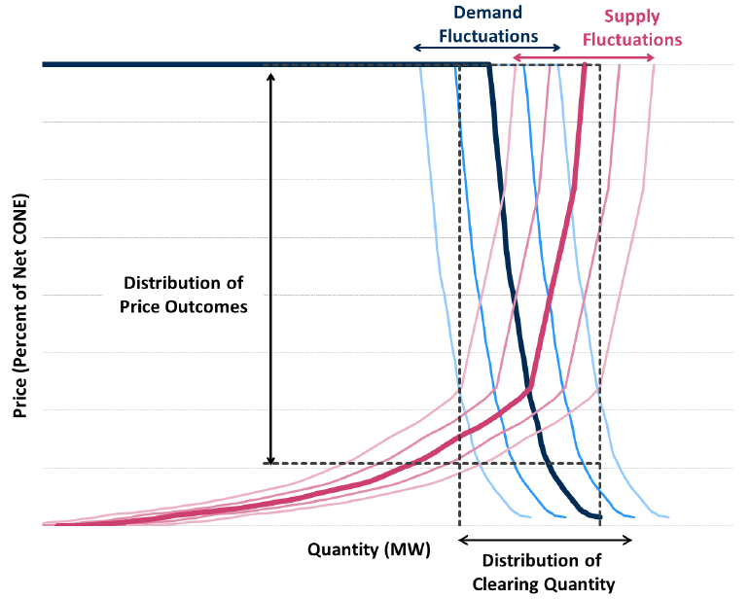

In-market supply curves consist of three (3) component pieces:
  - Price Offers: supply offers at prices above zero, shape based on historic MISO offer curves, and independent of demand curve shape.
  - Year-to-Year Variability in Supply: zero-priced supply block, quantity varies with each draw to generate variability in supply offers, and tuned to true historic availability in supply.
  - Market Entry and Exit: zero-priced annual supply block with seasonal capacity ratings proportional to a combustion turbine reference resource, quantity varies across draws so that the average of seasonal clearing prices across all seasons is equal to the annual net CONE.
- Non-Schedule 53 Seasonal Accredited Capacity (SAC) Calculations for Planning Resources
The following sets of equations establish how the SAC values (NRIS SAC, including E-NRIS SAC, and ERIS SAC) are determined for Planning Resources to account for resource performance and availability. Schedule 53 resource accreditation is outlined in Appendix Y.
H.1 Planning Resource SAC calculation for a Generation Resource, a Demand Response Resource backed by a generator, or a Behind-the-Meter Generator, with a Point of Interconnection on MISO’s Transmission System
The Seasonal Accredited Capacity (SAC) calculation is based on resource type and volume of seasonal Interconnection Service, seasonal GVTC, and seasonal forced outage rate (XEFORd).
H.1.1 Planning Year SAC Calculation for each Season
The following steps are used to calculate NRIS SAC and ERIS SAC for each Planning Resource.

Determine ICAP:

The first step is to determine the Installed Capacity (ICAP) that the Planning Resource can reliably provide, which is equal to the lesser of its GVTC or its total volume of Interconnection Service (Network Resource Interconnection Service and/or Energy Resource Interconnection Service) granted either through MISO’s Generation Interconnection Procedures or through a market transition deliverability test. The equation is shown below.

$ICAP=\left\{\begin{aligned}Total Interconnection Service, If GVTC>Total Interconnection Service \\ GVTC, &If GVTC≤Total Interconnection Service\end{aligned}\right.$

Determine Total SAC:

The next step is to convert the resultant ICAP value into a Total SAC value by applying its seasonal forced outage rate (XEFORd).

A forced outage rate class average for each Season is used if the Planning Resource has a GVTC < 10 MW and has not submitted generator availability data or does not have sufficient generator availability data to calculate a forced outage rate specific to the Planning Resource. A Planning Resource has sufficient generator availability data when it has a minimum of 12 months of generator availability data between September 1 and August 31 for the previous 3 years. The applicable class average for a Planning Resource is based on its unit size and type.

$$Total SAC=ICAP×\left(1-{XEFOR}_{d}\right)$$

If the Planning Resource has provisional Interconnection Service, then the Planning Resource will receive zero Interconnection Service and therefore the calculated Total SAC will be zero.

If the Planning Resource does not report historical outage data to GADS, its historical performance during seasonal peak hours should be provided to MISO through the Non-GADS Performance Template, which will leverage prior performance to establish seasonal GVTC values indicative of typical seasonal capabilities. In this case, XEFORd would not be used to reduce Total SAC. This process excludes Demand Response Resources.

Allocate Total SAC into NRIS SAC and ERIS SAC based on Interconnection Service:

The Resource’s Total SAC is allocated into NRIS SAC and ERIS SAC based upon its type of Interconnection Service.

$$Total SAC=NRIS SAC+ERIS SAC$$

To the extent the Planning Resource has Network Resource Interconnection Service (NRIS) or was determined to be aggregate deliverable through the market transition deliverability test, then that quantity will be allocated first to calculate the NRIS SAC.

$$NRIS SAC=\left\{\begin{aligned}ICAP*\left(1-XEFORd\right), If ICAP=NRIS \\ \left(Minimum of \left(NRIS,GVTC\right)\right)*(1-XEFORd), If &ICAP>NRIS\end{aligned}\right.$$

The remaining balance of Total SAC is allocated to ERIS SAC (i.e. ERIS SAC = Total SAC – NRIS SAC.

$$ERIS SAC=\left\{\begin{aligned} 0, If ICAP= NRIS \\ Total SAC-NRIS SAC, If &ICAP>NRIS\end{aligned}\right.$$

Eligibility of NRIS SAC and ERIS SAC Conversion into seasonal Zonal Resource Credits

The NRIS SAC represents capacity in MW that is eligible to be converted into seasonal Zonal Resource Credits.

Effective ICAP
In determining the amount of ERIS SAC eligible for conversion into seasonal ZRCs, the deliverability of any ERIS must be determined prior to ERIS SAC conversion. ERIS must be paired with firm Transmission Service that covers the entire Season to be considered deliverable. NRIS is automatically considered deliverable and does not require an additional Transmission Service Request. The full amount of ERIS SAC can be converted to ZRCs if the resource is fully deliverable to its ICAP amount.

Total SAC which can be converted into seasonal ZRCs are the summation of the Planning Resource’s NRIS SAC plus the lesser of the resource’s ERIS with firm Transmission Service.

$Total SAC Eligible for ZRC Convsersion =\left(NRIS SAC\right)+ {\left(ERIS SAC with TSR\right)}^{*}$
*Amount of TSR needed is dependent on ICAP amount
Ex | Size | NRIS | SAC | Total IS | GVTC | ICAP | Total SAC | NRIS SAC | ERIS SAC | TSR | ZRC
1 | 100 | 100 | 0 | 100 | 100 | 100 | 75.0 | 75.0 | 0.0 | 0.0 | 75.0
2 | 100 | 50 | 50 | 100 | 100 | 100 | 75.0 | 37.5 | 37.5 | 50.0 | 75.0
3 | 100 | 50 | 50 | 100 | 75 | 75 | 56.3 | 37.5 | 18.8 | 25.0 | 56.3
4 | 100 | 0 | 100 | 100 | 100 | 100 | 75.0 | 0.0 | 75.0 | 100.0 | 75.0

Examples for Illustrative Purposes

In example 3 above, a 100 MW Resource with 50 MW NRIS and 50 MW ERIS submitted a GVTC value at 75.

The ICAP will be 75 MW because the GVTC is less than the Interconnection Service of 100 MW.

Since the 50 MW NRIS is less than the Resource’s ICAP, the Total SAC value of 56.3 MW of the Resource is not fully allocatable to NRIS SAC.NRIS SAC in example 3 was determined to be 37.5 MW. The remaining Total SAC minus the NRIS SAC is allocated into the resource’s ERIS SAC. Thus, ERIS SAC level is 56.3 MW – 37.5 MW = 18.8 MW.

The resource would be credited with 56.3 MW of Total SAC which is comprised of 37.5 MW NRIS SAC + 18.8 MW ERIS SAC with firm Transmission Service for the corresponding seasonal PRA.

The resource was able to convert its entire Total SAC into seasonal ZRCs because the resource obtained full deliverability up to its ICAP, where 50 MW of NRIS plus 25 MW of firm Transmission Service is equal to its ICAP of 75 MW.

H.2 SAC calculation for a GADS-reporting External Resource that qualified as a Capacity Resource
The External Resource Capacity Resource SAC calculation is based on its seasonal GVTC and seasonal forced outage rate (XEFORd). The ERIS SAC is calculated by applying its seasonal XEFORd to its seasonal GVTC.

$$ERIS SAC=GVTC×\left(1-{XEFOR}_{d}\right)$$

A seasonal forced outage rate class average is used if the Capacity Resource has a GVTC < 10 MW and has not submitted generator availability data or does not have sufficient generator availability data to calculate a Planning Resource specific forced outage rate. A Planning Resource has sufficient generator availability data when it has a minimum of 12 months of generator availability data between September 1 and August 31 for the previous 3 years. The applicable class average for a Planning Resource is based on its unit size and type.

The ERIS SAC represents the capacity in MW that are eligible to be converted into seasonal Zonal Resource Credits with valid transmission service.
H.3 SAC calculation for a Planning Resource that is classified as Intermittent Generation and Dispatchable Intermittent Resources
For resources that don’t report outage data to GADS, MISO calculates the Total SAC based on the past historical season-specific output assessing either the median for Run-of-River Hydro or average for all other intermittent resources that are not wind resources. The calculation requires a minimum of 30 consecutive seasonal days of output for a unique seasonal accreditation value. If that is not available, a class average seasonal accreditation value will be applied to the nameplate of the resource. A capacity factor adjusted by the resource’s deliverability is applied to the resource’s Total SAC to determine the amount of Total SAC eligible to be converted into seasonal ZRCs.

For wind resources, MISO produces an annual wind capacity credit study for every Season in the upcoming Planning Year using the Effective Load Carrying Capability (ELCC) methodology, as described in Appendix A, to determine a fleet-wide SAC value to be allocated across all in-front-of-the-meter wind resources in that Season. Deterministic allocation of the total fleet-wide wind SAC across the studied wind resources is dependent on the reliability value of the entire wind fleet (as determined through probabilistic modeling) at the aggregate level and the historical performance history of the wind resources at the unit level during specific historical MISO system Coincident Peak Demand hours.
A capacity factor adjusted by the resource’s deliverability is applied to the resource’s Total SAC to determine the amount of Total SAC eligible to be converted into seasonal ZRCs.
BTMG wind Resource owners are required to submit the historical performance history of their BTMG wind Resources during specific historical MISO system Coincident Peak Demand hours for the purpose of accrediting these resources with a SAC value based on their performance during periods of MISO system seasonal peak Demand for the three prior applicable years for each Season. This results in resource-specific SAC values for each BTMG wind Resource in operation.
BTMG Wind SAC = [capacity factor over the 8 seasonal peaks over the past 3 years] * [k] * [ICAP]
Where k = [seasonal MISO Fleet ELCC] / Sum of [Fleet ICAP * PKmetric] (see BPM-011 Appendix A)
New wind Resources that do not yet have historical performance history for an entire Season would receive the class average wind capacity credit for that Season (as determined by the Wind and Solar Capacity Credit study produced every year) applied to the wind Resource’s ICAP to derive an appropriate Total SAC value. Please reference Appendix A for more details regarding the accreditation procedure for wind Resources.

The amount of SAC eligible to be converted into seasonal Zonal Resource Credits will be based on the application of a deliverability-adjusted capacity factor.
H.3.1 Intermittent Generation and Dispatchable Intermittent Resources with a Point of Interconnection on MISO’s Transmission System
The following sections establish how SAC values (NRIS SAC and ERIS SAC) are determined for Intermittent Generation and Dispatchable Intermittent Resources that have a Point of Interconnection on MISO’s Transmission System to account for resource performance and deliverability.
H.3.1.1 Planning Year SAC Calculation for Wind Resources
The first step is to determine the total installed capacity of the wind Planning Resource, which is the Installed Capacity (ICAP). It is equal to the lesser of its seasonal GVTC (Registered maximum output in the Commercial Model) or its total volume of Interconnection Service (Network Resource and Energy Resource Interconnection Service) granted either through MISO’s Generation Interconnection Procedures or through a market transition deliverability test.

$Total Interconnection UCAP=\left\{\begin{aligned}Total Capacity Tested, GVTC>Total Capacity Tested \\ GVTC, &GVTC≤Total Capacity Tested\end{aligned}\right.$$Total Interconnection UCAP=\left\{\begin{aligned}Total Capacity Tested, GVTC>Total Capacity Tested \\ GVTC, &GVTC≤Total Capacity Tested\end{aligned}\right.$The next step is to determine the resource’s total SAC. MISO determines a unit-specific seasonal wind capacity credit, by CPNode, for each Planning Resource that is fueled by wind by allocating the total fleet-wide seasonal ELCC capacity. The wind capacity credit is determined by applying the larger of two allocation methodologies, as noted in Appendix A:
- one method which includes (adds back in) megawatts for wind resources that were curtailed (applies to DIR wind resources only)
- a second method excludes (does not add back in) those same curtailed megawatts

The larger of the two results becomes the individual resource’s Total SAC.

$$Total SAC=GVTC×\left({Wind Capacity Credit}_{CPNode}\right)$$

Determining Convertible SAC based on a Deliverability Adjusted Capacity Factor
The next step is to determine how much of the total SAC is eligible to be converted into seasonal ZRCs.
The total SAC for a wind resource is distributed into two categories for the purpose of determining the amount of Capacity eligible for conversion into seasonal ZRCs, either convertible SAC or undeliverable ERIS SAC.
To calculate convertible SAC, which is eligible to be converted into seasonal ZRCs, a Deliverability Adjusted Capacity Factor is first applied. The Deliverability Adjusted Capacity Factor uses historical seasonal peak observances of an intermittent resource and is calculated by ‘capping’ historical intermittent output during seasonal peak load observances to the resource’s demonstrated deliverable amount divided by the resource’s ICAP. Whereas a peak performance capacity factor also uses the same historical seasonal peak observances divided by the resource’s ICAP but does not cap those observances.
Formula for determining Convertible SAC
$$Convertible SAC=Total SAC*\frac{Deliverability Adjusted Capacity Factor}{Peak Capacity Factor}$$
The remaining Total SAC that is left after calculating Convertible SAC is considered the undeliverable ERIS SAC.
$$ERIS SAC= \left\{\begin{aligned}0, Total Interconnection SAC= Convertible SAC \\ Total Interconnection SAC-Convertible SAC, Total Interconnection SAC>Convertible SAC\end{aligned}\right\}$$

Optionally, the classified undeliverable ERIS SAC can become eligible to be converted into seasonal ZRCs by procuring firm Transmission Service.
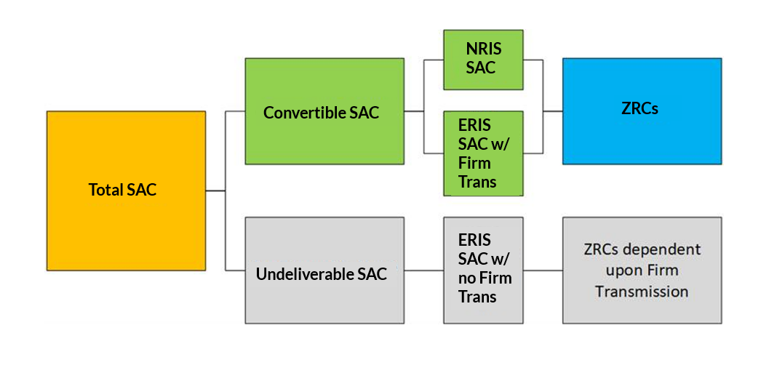
Converting ERIS SAC to Convertible SAC using the Resource’s Deliverability Adjusted Historical Performance
ERIS SAC is not generally convertible to seasonal ZRCs at a one-to-one MW ratio. Each resource will have unique conversion data generated based on its past seasonal performance and deliverability which indicates the level of firm Transmission Service necessary to be obtained to gain a given level of seasonal ZRCs.
An example and further explanation is shown in the figure below:
ZRC Deliverability Curve Chart
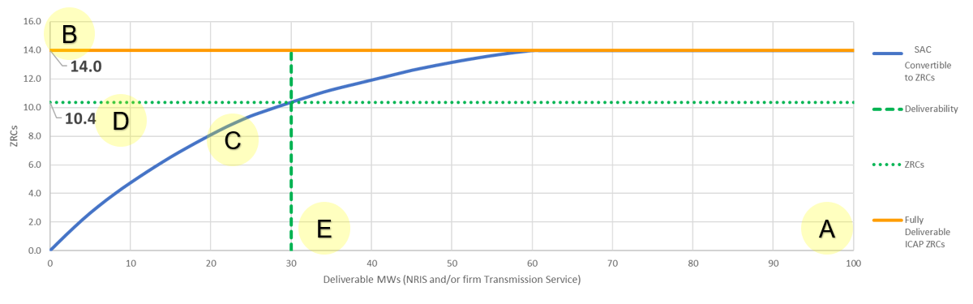
C
D
Where:
A: Equals the maximum output of resource (RMax). In this example, this resource is 100 MW.
B: Total SAC, or SAC (Max) that can potentially be converted into seasonal ZRCs. This also represents the share of the total fleet-wide seasonal ELCC capacity. This value is based on the size and performance of the resource.
C: This is the Convertible SAC function which is the resource’s Total SAC multiplied by the ratio of its Deliverability Adjusted Capacity Factor divided by its Peak Capacity Factor. Convertible SAC varies depending on the amount of Deliverability of the resource.
D: This is the resulting Convertible SAC value for a corresponding Deliverable amount in MW.
E: This is the amount of Deliverable MWs, or Deliverability. The point at which E intersects C provides the amount of seasonal ZRCs the Market Participant would obtain based on the size, performance, and deliverability of the resource.

H.3.1.2 Non-wind Intermittent Generation and Dispatchable Intermittent Resources

The first step is to determine the Total Installed Capacity that the Planning Resource can reliably provide, which is the Installed Capacity (ICAP). It is equal to the lesser of its GVTC, or its total volume of Interconnection Service (Network Resource and Energy Resource Interconnection Service) granted either through MISO’s Generation Interconnection Procedures or through a market transition deliverability test.

The next step is to allocate the Total SAC based upon its type of Interconnection Service. To the extent the Planning Resource has Network Resource Interconnection Service (NRIS) or was determined to be deliverable through the market transition deliverability test then that quantity will be allocated first to NRIS SAC. The remaining Total SAC will then be allocated to ERIS. If the Planning Resource has provisional Interconnection Service, then the Planning Resource will receive zero Interconnection Service and therefore the calculated SAC will be zero.
$Aggregate UCAP=\left\{\begin{aligned}Total Interconnection UCAP, Total Interconnection UCAP≤NRIS \\ NRIS, &Total Interconnection UCAP>NRIS\end{aligned}\right.$$Aggregate UCAP=\left\{\begin{aligned}Total Interconnection UCAP, Total Interconnection UCAP≤NRIS \\ NRIS, &Total Interconnection UCAP>NRIS\end{aligned}\right.$
$NRIS SAC=\left\{\begin{aligned}Total SAC, Total SAC≤NRIS \\ NRIS, &Total SAC>NRIS\end{aligned}\right.$
$ERIS SAC=\left\{\begin{aligned} 0, Total SAC≤NRIS \\ Total SAC-NRIS, &Total SAC>NRIS\end{aligned}\right.$

Determining Convertible SAC based on a Deliverability Adjusted Capacity Factor
The total SAC for an intermittent non-wind resource is distributed into two categories for the purpose of determining the amount of Capacity eligible for conversion into seasonal ZRCs. This would be considered Convertible SAC, either NRIS SAC or ERIS SAC coupled with firm Transmission, or undeliverable ERIS SAC (no associated firm Transmission).
To calculate convertible SAC, which is eligible to be converted into seasonal ZRCs, a Deliverability Adjusted Capacity Factor is first applied. The Deliverability Adjusted Capacity Factor uses historical summer peak observances of an intermittent non-wind resource and is calculated by ‘capping’ historical intermittent output during peak load observances to the resource’s demonstrated deliverable amount divided by the resource’s ICAP. (See Appendix V for examples)

H.3.2 Intermittent Generation and Dispatchable Intermittent Resources that does not have Point of Interconnection on MISO’s Transmission System
The following sections apply to Intermittent Generation and Dispatchable Intermittent Resources that do not have a Point of Interconnection on MISO’s Transmission System. The ERIS SAC represents the capacity in MWs that are eligible to be converted into seasonal ZRCs.

- XEFORd Calculation
XEFORd is equivalent forced outage rate Demand excluding events outside of management control (OMC). XEFORd will be calculated on a seasonal basis. A description and list of the MISO OMC events can be found in Appendix B. The MISO equation is:

$$\frac{\left(FOHd+EFDHd\right)}{\left(FOHd+SH+Synch Hours\right)}*100\%$$

where:
SH = service hours
Synch Hours = synchronous hours
RSH = reserve shutdown hours

FOH_{d} = forced outage hours Demand = f_{f} x FOH
f_{f} = full forced outage Demand factor = $\frac{(\frac{1}{r}+\frac{1}{T})}{(\frac{1}{r}+\frac{1}{T}+\frac{1}{D})}$
r = average forced outage duration = (FOH)/(# of FO occurrences)
D = average Demand time = (SH + Synch Hours)/(# of unit actual starts)
T = average reserve shutdown time = (RSH)/(# of unit attempted starts)
FOH = forced outage hours

EFDH_{d} = (f_{p} x EFDH)
AH = available hours
f_{p} = partial forced outage Demand factor = (SH + Synch Hours)/AH
EFDH = equivalent forced derated hours

Special cases are evaluated in the following order:
If reserve hours < 1, then f_{f} =1,
then if (SH + Synch hours) = 0, then f_{f} = 1,
then if (1/r + 1/T + 1/D) = 0, then f_{f} = 0,
then if # of FO occurrences = 0 or FOH = 0, then 1/r = 0,
then if RSH = 0 or # of unit attempted starts = 0, then 1/T = 0,
then if # of unit actual starts = 0 or (SH + Synch Hours) = 0, then 1/D = 0,
then if (SH + RSH + Synch Hours) = 0, then f_{p} = 0,
then if ((FOHd + SH + Synch Hours) = 0, then EFORd = 0

SH, RSH and Synch Hours are reported through the MISO Market Portal in the PowerGADS application by the users in their Performance data. The rest of the statistics are calculated by PowerGADS based on the user submitted Event data. Forced outage rates for each unit can be found in the Generator Outage Rate Program (GORP) report. The statistics used in calculating forced outage rates can be found in the Statistics Report, Performance Report, and the Seasonal XEFORd Report.

The MISO calculation is based on the EFORd equation defined in the NERC Generating Availability Data System Data Reporting Instructions Appendix and the IEEE Standard No. 762-2006 Standard Definitions for Use in Reporting Electric Generating Unit Reliability, Availability and Productivity. The MISO XEFORd calculation differs as follows:
- The NERC and IEEE EFDH formula is (Derated Hours * Size of Reduction)/Net Max Capacity while the MISO formula uses net dependable capacity rather than net max capacity and is (Derated Hours * Size of the Reduction)/Net Dependable Capacity. The size of the reduction is the Net Dependable Capacity minus the Net Available Capacity.
- MISO also includes synchronous hours in the XEFORd, average Demand time (D), and the partial Demand factor (f_{p}) calculations while NERC and IEEE do not.

Example XEFORd Calculations

Unit 3 Example XEFORd Calculation Detail

r = average forced outage duration = $\frac{FOH}{FO events}=\frac{504}{11}=$45.82 hours, then 1/r = 0.0218
T = Average reserve shutdown time = $\frac{RSH}{attempted starts}=\frac{3694}{36}$= 102.61 hours, then 1/T = 0.0097
D = average Demand time $=\frac{\left(SH+synch hours\right)}{actual starts}=\frac{3942+132}{36}=$ 113.17 hours, then 1/D = 0.0088
f_{f} = full forced outage Demand factor = $\frac{(\frac{1}{r}+\frac{1}{T})}{(\frac{1}{r}+\frac{1}{T}+\frac{1}{D})}=\frac{\left(0.0218+0.0097\right)}{\left(0.0218+0.0097+0.0088\right)}=$ 0.7816
FOHd = forced outage hours Demand = f_{f} x FOH = 0.7813 x 504 = 393.78 hours
f_{p} = partial forced outage Demand factor = $\frac{\left(SH+synchhours\right)}{AH}=$ $\frac{\left(3942+132\right)}{7768}$= 0.5245
EFDH = fp x EFDH = 0.5245 x 19.92 = 10.45 hours
XEFORd = $\frac{\left(FOHd+EFDHd\right)}{\left(FOHd+SH+synch hours\right)}*100=\frac{\left(393.78+10.45\right)}{\left(393.78+3942+132\right)}*100=$ 9.05%

Units with 12 or more consecutive months of actual data: The XEFORd of a unit in service twelve or more full calendar months prior to the calculation month will be based on the number of consecutive months that that unit has data for up to 36 months.

Units with less than 12 consecutive months of actual data: The XEFORd of a unit in service less than twelve full calendar months shall be determined by the class average rate for units of the same type and within the same range of capability. A unit will use the class average value until 12 consecutive months of data is obtained and a new Planning Year begins. The class average will be the 5-year forced outage rate from the latest Loss of Load Expectation (LOLE) Study.

Units with Low Service Hours
Units with an average of less than 20 service hours per Season and attempted starts greater than zero will have their service hours adjusted if the unit has at least 12 consecutive seasonal months of GADS data. The adjusted service hours will be based on 60 service hours (20 service hours x 3 Seasons) or a fraction of 60 if there is less than 9 consecutive seasonal months of GADS data. This adjustment will be performed in the MECT. The calculation for the adjustment is as follows:

MO = consecutive seasonal months in operation
If SH = Service Hours < (MO/9*60) and attempted starts is greater than zero, then

SH’ = seasonal adjusted low service hours = $\left[(\frac{actual starts}{atempted starts})*\left(\frac{MO}{9}*60-SH\right)\right]+SH$

External Resources
Market Participants are responsible for making sure that GADS data is submitted for the External Resources that they are seeking qualification as ZRCs. The Market Participant can submit this data to MISO’s GADS tool for the external resource or they can have the external resource submit the data. If an external resource is going to submit the GADS data, then they must receive access to the MISO Market Portal through their Local Security Administrator. If an External Resource does not have a Local Security Administrator, then it is the Market Participant’s responsibility to receive and submit this data for the External Resource.

Catastrophic Outages
Catastrophic Outages are defined as forced outages that result in a unit being unavailable for a minimum of six (6) continuous months. A catastrophic outage may be a forced full or partial (forced derating) outage. A scheduled outage (planned, planned extension, maintenance, or maintenance extension) cannot be a catastrophic outage. For an outage to be considered catastrophic, the MP must notify the MISO Resource Adequacy team in writing within 75 days of determining the outage is a Catastrophic Outage, including a description of the Catastrophic Outage, start date of outage, expected return date, etc.

If the MP chooses not to replace a Planning Resource that suffers a Catastrophic Outage, then the XEFORd will be based on actual GADS data.

If the MP chooses to replace a Planning Resource that suffers a Catastrophic Outage, the XEFORd will be based on class average when the unit returns to service. The class average value will be used until 12 consecutive months of data is obtained and a new Planning Year begins.

Resource replacement must be completed within 75 days of catastrophic outage.
Resource replacement must be in accordance with section 6.4 of this BPM.
Once the unit returns from Catastrophic Outage, Planning Resource qualification requirements still apply. Partial replacements are allowed.

If the outage is a forced derate with total or partial replacement, or a full forced outage with partial replacement, the resources XEFORd upon returning to service will be the class average for the portion of the resource replaced and the actual XEFORd for the remainder of the unit. A blended XEFORd will be calculated by MW weighting the class average and actual XEFORd values.
For Schedule 53 resources that experience a catastrophic outage and replaced the ZRCs accordingly during the time the resource was unavailable, the time it is out will be considered non-RAR and would not be counted in the SAC calculation consistent with ZRC replacement section of this BPM and Appendix Y. In situations where this leads the resource to have less than 60 days of RAR performance history during the 3-year lookback period, the Schedule 53 resource would be granted Schedule 53 class averages for the impacted seasons.

Fleet Weighted Average Forced Outage Rates
External Resources may participate using a fleet of resources. A weighted average forced outage rate is calculated using the individual unit forced outage rates and GVTC values. The resulting rate is applied to the total fleet GVTC to determine the fleet UCAP. See Appendix Q for more information regarding the Fleet XEFORd Calculation.

XEFORd for Non-GADS Electric Storage Resources (ESR)
The XEFORd for a non-GADS ESR is its Forced Unavailability and will be determined as follows.

A non-GADS ESR is forced unavailable when it is in an unplanned outage or an unplanned derating (see oranges boxes). All other states are unforced availability and include in-service (discharging or charging), reserve (not connected), planned outages, or planned deratings (see green boxes).

An available resource that is not derated is 100% available. If a resources availability changes during an hour, the Forced Availability should be pro-rated. For example, if a 10 MW resource experiences a 23-minute Unplanned Outage during the hour, its equivalent Forced Unavailability would be (23 min/60 min) * 10 MW = 3.8 MW or 38%. Similarly, for an Unplanned Derating of 2.4 MW for 47 minutes of the hour the equivalent Forced Unavailability would be (47 min/60 min) * 2.4 MW = 1.9 MW or 19%.

Additional information:
- Pumped Storage Resources submit their availability and GVTC data through the MISO PowerGADS application.
- All other ESR types must submit their availability and GVTC (Hourly Equivalent Discharge Amount) data using the Non-GADS Performance template.
  - The template provides the 8 MISO coincident peak hours per Season for the last three years.
  - The average of these 24 seasonal unforced availability values is divided by the Hourly Equivalent Discharge Amount (MW) to calculate a seasonal unavailability factor.
  - Market Participants with less than 8 availability values in a Season will be given the default unavailability factor.
- Availability Reporting is optional for resources less than 10 MW. Resources that choose not to report, will be given the default unavailability factor. Once a resource chooses to report for the first time, they will be required to report every year thereafter.

- GVTC Testing Requirements
J.1 Overview
All Generation Resources, External Resources, Behind the Meter Generation (BTMG) and Demand Response Resources backed by BTMG that intend to qualify as a Planning Resource are required to perform a real power test or provide past operational data. This test, or past operational data, shall be used to determine a planning resource’s GVTC value. GVTC data is submitted through the MISO Market Portal into MISO PowerGADS.
Each seasonal corrected net test capability is the gross output (MW) that a planning resource can sustain averaged over the test period, if there are no equipment, operating, or regulatory restrictions, less station service and process load served, corrected to MISO coincident seasonal peak conditions.
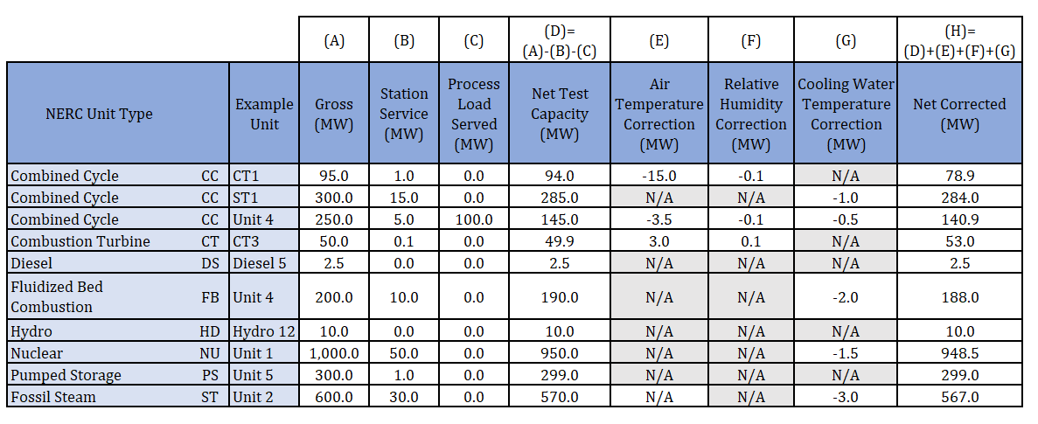GVTC Table J.1 – Examples of net corrected net test capability for different unit types. **Examples may not be representative of your situation. If you have unit specific questions, please contact Resource Adequacy.

If a Planning Resource fails to perform a real power test and report the test data to MISO’s PowerGADS byOctober 31 prior to the start of the planning year t, it will result in the Planning Resource not qualifying as a Planning Resource and will receive zero SAC MWs for the upcoming Planning Year.

J.1.1 Test Period and Reporting Deadline
The real power test shall be performed between September 1 and August 31 prior to the upcoming planning year. The test data shall be submitted no later than October 31.
Example: For the 2023-2024 planning year (June 1, 2023 through May 31, 2024), the test must be conducted between September 1, 2021 and August 31, 2022, and submitted no later than October 31, 2022 to qualify as a Planning Resource for the upcoming Planning Year.

J.2 When to Perform and Submit a Generation Verification Test Capacity
Generation Resources, External Resources, Demand Response Resources backed by behind the meter generation, or Behind the Meter Generation that qualified as Planning Resources for the current Planning Year shall submit their GVTC no later than October 31 to qualify as a Planning Resource for the upcoming Planning Year. A real power test shall be performed, or past operational data may be used, during the period between September 1 and August 31 prior to the upcoming Planning Year. In addition to performing and submitting GVTC data to qualify as a planning resource for the annual capacity auction, a planning resource must conduct a test and submit data when:
- a modification that changes, increases, or decreases, the rated capacity of a unit is completed,
- returning from a suspension,
- returning to MISO after an absence including but not limited to, catastrophic events,
- not qualifying as a Planning Resource under Module E-1
- being qualified as a Planning Resource for the first time
- or for a Planning Resources in an approved “Suspension” status.

If a Planning Resource is unable to complete a real power test, the responsible MP must include the timing and cost requirements to complete a test when requesting a facility specific reference level.
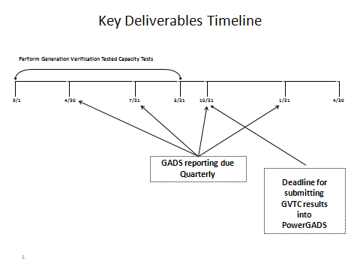
J.3 Corrections to Establish GVTC
The GVTC shall be corrected to the average conditions of the date and times of MISO’s four seasonal coincident Peaks, measured at or near the generator’s location, for the last 5 years. MISO publishes the date and time of the past 5 seasonal coincident Peaks. When local weather records are not available at the plant site, the values shall be determined from the best data available (i.e., local weather service, local airports, river authority, etc.).

The corrections required to establish the GVTC of a unit include, as appropriate for each electric generating technology, dry air temperature, relative humidity, cooling water temperature, fuels, steam heating loads, reservoir level, nuclear fuel management programs and scheduled reservoir discharge.

J.3.1 Process Load Reporting in MISO PowerGADS to Establish GVTC
The Generator Owner shall forecast the maximum process load (PL) expected to be present at the time of the upcoming MISO seasonal peaks. MISO publishes the date and time of past coincident seasonal peaks as a reference for predicting the PL that is forecasted to be present at the time of the upcoming MISO peaks.
For calculating GVTC, the PL being forecasted and reported by the Generator Owner is allocated to the underlying generating unit of the Planning Resource and deducted from a unit’s gross MW unless provisions are in place to curtail the load in the event of a MISO Capacity Emergency, or for electric load, is included in an LSE forecast. If such provisions for curtailment are in place or, for electric load, it is included in an LSE forecast, the PL is non-firm for the purpose of calculating GVTC.
Process Load can be electric load or thermal load in the case of a Combined Heat and Power (CHP) facility. Thermal PL is converted to units of MW by determining the reduction of power output caused by serving that load. Thermal loads can be PL because steam that would have otherwise been used to drive turbines to produce electricity may have been diverted to support process load, thus reducing the electrical capacity of the overall plant relative to the MISO system.
Thermal load that causes an increase in power output, as served from a back-pressure turbine for example, is not a PL for these purposes. However, the GVTC test should be performed or corrected for conditions that are a conservative expectation of the amount of thermal load that would be present coincident with MISO peak load conditions.
PL can be firm or non-firm. The following criteria should be applied to determine whether the PL is firm or non-firm:
- PL is firm if it continues to exist when one or more of the underlying generating units of the Planning Resource are derated or out of service. Such firm PL would be served by one or more of the underlying generating units of the Planning Resources at the same location or from the MISO system.
- PL is non-firm if it does not continue when the underlying generating unit of the Planning Resource is out of service.
- To the extent that PL that continues to exist when the underlying generating unit of the Planning Resource is out of service is served by resources that are not Planning Resources, such as auxiliary boilers, that portion of the PL is non-firm.
The amount of firm PL will be adjusted by multiplying by (1+PRM) and dividing by (1-XEFORd). The sum of the firm and non-firm PL will be reported in PowerGADS.

PL = (adjusted firm PL) + (non-firm PL)
Adjusted firm PL = firm PL * (1 + PRM) / (1 - XEFORd)
PL calculations are performed outside of PowerGADS and the MECT. PL is only deducted from an underlying generating unit of the Planning Resource’s gross MWs one time. PL is part of the GVTC calculation that is entered into PowerGADS. MISO performs a PowerGADS integration that retrieves the GVTC value from the PowerGADS data base and populates the MECT. A Planning Resource may be comprised of one or more underlying PowerGADS units.
The UCAP PRM is from the most recent LOLE Study Report. The XEFORd is the appropriate value for the 36-months ending on August 31 proceeding the planning year, which can be found in PowerGADS.
J.4 Generation Verification Test Capacity During a Derate
A Market Participant that performs a GVTC when a unit has a documented derate in MISO PowerGADS can request MISO to adjust its GVTC if the documented derate in MISO PowerGADS lasted a minimum of 90 consecutive days prior to the test date and generator availability data has been reported to MISO prior to any adjustments to the GVTC. The Market Participant shall contact MISO’s Resource Adequacy Department for a review of its request.
J.4.1 Interconnection Service Limitations
All Planning Resources GVTC are subject to Interconnection Service limitations to the bus to which the facility is currently or about to be connected to as verified by the Transmission Service Planning Department of MISO.
J.5 GVTC Real Power Test Requirements by NERC Unit Type
J.5.1 Fossil Steam (FS), Fluidized Bed Combustion (FB), and Nuclear (NU)
The test shall be at least two (2) continuous hours and data shall be averaged over the test period.
The impact of the observed steam turbine exhaust pressure will be corrected to the past five years average rated daily maximum circulating water temperature measured at the unit location, at the date and time of MISO’s coincident peaks.

J.5.2 Combined Cycle (CC)
The determination of the GVTC of a combined-cycle unit will depend on the structure of the unit and its components. The steam turbine and combustion turbine(s) shall adhere to the guidelines in this manual. In the case of thermally dependent components the determination of the GVTC shall require the operation of both combustion and steam turbine components simultaneously. The output of the components can be netted to determine the combined-cycle unit GVTC.

The test shall be at least two (2) continuous hours and data shall be averaged over the test period.

For each Season, the impact of the observed steam turbine exhaust pressure will be corrected to the past five years average daily maximum circulating water temperature measured at the unit location on the day of MISO’s Coincident Peak.

The impact of the observed ambient air temperature and relative humidity on combustion turbine performance will be corrected to the past five years average rated conditions experienced at the unit location measured at the date and time of MISO’s Coincident Peaks. Where inlet cooling is used to reduce inlet air temperature, the temperature at the discharge of the inlet coolers shall be the basis for ambient temperature adjustment.

J.5.3 Miscellaneous (MS)
The test shall be at least two (2) continuous hours and data shall be averaged over the test period.

The test will be seasonally corrected per J.3 Corrections to Establish GVTC.
J.5.4 Combustion Turbine (CT)
The test shall be at least one (1) continuous hour and data shall be averaged over the test period.
The impact of observed dry air temperature and relative humidity on combustion turbine performance will be corrected, for each Season, to the past five years average rated conditions experienced at the unit location measured at the date and time of MISO’s seasonal coincident peaks. Where inlet cooling is used to reduce turbine inlet air temperature, the temperature at the discharge of the Inlet coolers shall be the basis for air temperature correction.

J.5.5 Hydro (HD) and Pumped Storage (PS)
The test shall be at least one (1) continuous hour and data shall be averaged over the test period.

The GVTC established for hydroelectric plants shall recognize the head available considering environmental, operational, and regulatory restrictions and ambient conditions such as forecasted reservoir levels or water flow conditions. The test capability shall be corrected to historic median head conditions as specified below.

The seasonal historic median head shall be determined as the median of all head measurements from the most recent five (5) years up to the most recent fifteen (15) years. If 15 years of historic data is not available for this period when the 15-year time period is chosen, or is no longer relevant due to environmental, operational, regulatory or other restrictions, all available relevant data shall be used and accumulated until the 15-year requirement is met. The hours ending 1500, 1600, and 1700 EST apply to all days of the Summer (June, July, August), Fall (September, October, November), and Spring (March, April, May). The hours ending 0900, 1000, 1900, and 2000 EST apply to all days of the Winter (December, January, February).

Once the number of years and methodology is chosen and submitted as GVTC requirements, the same number of years must be submitted in future GVTC data collection.

Each hydro unit shall be verified individually.

The entire hydro plant shall be verified if the sum of individual unit capabilities is greater than the total plant capability.

MISO PowerGADS does not accept seasonal corrections for Hydro and Pumped Storage resources. If a Generation Operator (GO) elects to submit seasonal corrections they can use the Hydro and Pumped Storage GVTC Corrections template which can be found at https://www.misoenergy.org/planning/resource-adequacy/#nt=/planningdoctype:RA%20Guides%20and%20References/raguidetype:GVTC. If a GO elects to submit seasonal corrections, they must submit a test in MISO PowerGADS and the Hydro and Pumped Storage GVTC Corrections template to the MISO Help Center help.MISOEnergy.org.

J.5.6 Diesel (DS)
The test shall be at least one (1) continuous hour and data shall be averaged over the test period.
No corrections apply to this unit type.
J.5.7 Electric Storage Resources (ESR)
This section is for all ESR except Pumped Storage. For pumped storage see J.5.5.
The test shall be at least one (1) continuous hour and data shall be averaged over the test period. The test shall be conducted at the discharge rate that would be expected if the ESR were dispatched for four (4) continuous hours. The test results must be submitted in the Module E Capacity Tracking (MECT) tool (Planning Resources > Non-GADS Resource Registration) using the Non-GADS Performance Template posted on the MISO Website.
J.5.8 General Requirements
If a generating unit has not been in operation for five years, then as many years as the unit has been in operation shall be used. The GVTC for new generating units will be corrected based on estimated average daily maximum circulating water temperature measured at the date and time of MISO’s Peaks.
The unit shall be operated with the regularly available type and quality of fuel.
The Station Service shall be representative of the conditions expected to occur during MISO’s coincident peaks.
For facilities consisting of multiple units, shared station power and process load served shall be allocated to the individual units to compute unit net capability.
J.6 Reporting
The following information shall be reported to MISO’s PowerGADS as described in MISO’s Net Capability Verification Test User Manual. Certain data will be reported or calculated for each of the 4 Seasons – summer, fall, winter and spring.

CARD | Must be "90"
Utility | Required
Unit | Required
Year | Required
Test Index | Must be a "1"
REVISIONCODE | Must be "0" for initial upload, "R" to Revise, or "D" to Delete
Corrected Net - Seasonal | Calculated by PowerGADS
Test Start Date | Required
Test End Date | Required
Gross MW | Required
Station Service | Required
Process Load Served | Required
Net Test Capability | Required, Gross MW – Station Service – Process Load Served
Reactive Generation MVAR | Optional
Total Power MVA | Calculated by PowerGADS if Reactive Generation MVAR entered
Power Factor | Calculated by PowerGADS if Reactive Generation MVAR entered
Dry Air Temperature Observed - Seasonal | Required for certain unit types
Dry Air Temperature Rated - Seasonal | Required for certain unit types
Air Temperature Correction | Required, may be zero
Relative Humidity Observed - Seasonal | Required for certain unit types
Relative Humidity Rated - Seasonal | Required for certain unit types
Relative Humidity Correction | Required, may be zero
Cooling Water Temperature Observed - Seasonal | Required for certain unit types
Cooling Water Temperature Rated - Seasonal | Required for certain unit types
Cooling Water Temperature Correction | Required, may be zero
STANDARD | Must be "MISO"

- Resource Adequacy Timeline for activities for the Planning Year 2025 – 2026
Please check for the latest online version posted on the Resource Adequacy webpage of MISO’s corporate website.
Date | Process and Notes | Responsible Entity | Tariff Reference
Sep 01, 2024 | Start Cost of New Entry (CONE) calculation in coordination with IMM. | MISO/IMM | 69A.8(a)(3)
Sep 09, 2024 | MISO to publish historical monthly and seasonal Coincident Peak Load hours and LRZ seasonal coincident factors. | MISO | 69A.1.1.(c)
Oct 01, 2024 | Last day to submit outage exemption related resolution requests regarding Schedule 53 resources through the MISO Help Center. | Resource Owner
Oct 01, 2024 | MISO opens the new Planning Year in the MECT for all 4 Seasons.  (1st Business Day - October) | MISO
Oct 01, 2024 | Transmission losses by Local Balancing Authority are posted by MISO.  (1st Business Day - October) | MISO | 69A.1.1(b)
Oct 15, 2024 | MISO posts RA hours to be used for accreditation calculation | MISO
Oct 31, 2024 | Generation Verification Test Capacity (GVTC) due.  Resource Owners submit operational data or real power test for September 1 - August 31 period. | Resource Owner | 69A.3.1.a, b, & c, 69A.3.6
Oct 31, 2024 | Populated Non-GADS Performance Templates due in MECT. | Resource Owner | 69A.3.1.a(1)(d)
Oct 31, 2024 | Generator availability data due in GADS for resources required to report for Q3. Resource Owners must ensure at least 36 months of data is provided. | Resource Owner | 69A.3.1.a(1)(c)
Nov 01, 2024 | Seasonal Coincident and Non-Coincident Peak Demand forecasts by LSE/EDC, monthly peak Demand, seasonal peak Demand and energy-for-load forecast values by LSE due. No action needed by Retail Choice LSEs. | LSE, EDC | 69A.1.1(a)
Nov 01, 2024 | Loss of Load Expectation study results published by MISO. | MISO | 68A.2  68A.4  68A.5
Nov 07, 2024 | MP must request an extension from within 5 business days after October 31 deadline. | Resource Owner | 69A.3.1.a, b, & c, 69A.3.6
Nov 15, 2024 | Review list of units with conditional Interconnection Service for results of annual study. Units may have NRIS/ERIS balance re-allocated. | MISO
Dec 01, 2024 | For individual States establishing their own seasonal PRM, submission of written letter by authorized State regulatory authority representative notifying MISO. | State Regulatory Authority | 68A.1
Dec 15, 2024 | RBDC opt out adder % posted on MISO website | MISO | 69A.9.1 (l)
Dec 15, 2024 | Initial UCAP/ISAC ratio, initial Seasonal Capacity accreditation values and validation files are published by MISO.Resources that do not meet the October 31 deadline will have their initial capacity accreditation calculated using estimated capacity submitted along with GVTC extension requests. MP may begin submitting resolution requests though the MISO Help Center. | MISO
Dec 15, 2024 | PLC submissions by EDC due. EDC will send the details of the PLCs to the respective LSEs and to MISO for review. The EDC-provided PLC data will be the default value for the LSE’s Retail Choice Coincident Peak. | Retail Choice EDCs | 69A.1.1( e)
Dec 15, 2024 | Last day for MPs to submit to March Network & Commercial Model changes to qualify for ICAP Deferral. | Resource Owner
Jan 15, 2025 | LSE submit initial RBDC Opt Out Plan in MECT, including its RERRA contact | LSE | 69A.9.1 (c)
Jan 15, 2025 | Generation Verification Test Capacity (GVTC) due for generators that requested an extension. | Resource Owner | 69A.3.1.a, b, & c, 69A.3.6
Jan 15, 2025 | LSEs confirm the seasonal Retail Choice PLC in the MECT.  LSEs should have all PLC questions resolved by this date. If an LSE desires a change in their PLC value, the appropriate EDC should be contacted directly. | LSEs, Retail Choice EDC | 69A.1.1.1
Jan 15, 2025 | Evidence for seasonal HUC/ZDC hedges due. | LSE | 69A.7.7(b)
Jan 20,2025 | MISO notifies RERRA its regulating LSE’s initial plan for opting out RBDC | MISO | 69A.9.1 (d)
Jan 31, 2025 | Default technology-specific avoidable costs posted by the IMM. Resource owners may use the default costs in lieu of submitting facility specific operating costs for a facility specific Reference Level request.  (59 days prior to deadline for offers) | IMM | 64.1.4(f)(ii)
Jan 31, 2025 | Generator availability data due in GADS for resources required to report for Q4. | Resource Owner | 69A.3.1.a, b, & c, 69A.3.6
Feb 01, 2025 | Last day to submit non-exemption related resolution requests on ISAC posted for Schedule 53 resources through the MISO Help Center. | Resource Owner
`Feb 01, 2025 | Existing Load Modifying Resource, Energy Efficiency, and External Resource registrations due for prompt Planning Year. | LMR/EE/ER Owner
Feb 01, 2025 | Loss of Load Expectation study begins for next Planning Year. | MISO
Feb 01, 2025 | Evidence of Demand Resource testing due. Last day to submit evidence. DR testing or performance must take place during the calendar year prior to the upcoming Planning Year. | DR Owner | 69A.3.5
Feb 01, 2025 | Written letter from officer of company stating intention to leverage DR testing deferral provisions due. | DR Owner | 69A.3.5(l)
Feb 07, 2025 | Last day to submit a Full Responsibility Transaction.  (due the 5th business day of February) | LSE
Feb 14, 2025 | If utilizing FSRL, last day to submit request to IMM regarding Going-Forward Cost determination. Submit data for facility ZRC reference levels to IMM.  (45 days prior to close of PRA offer deadline) | Generation Owner | 64.1.4.f.iii.b
Feb 15, 2025 | Final UCAP/ISAC ratio and SAC values for Schedule 53 resources will be posted on MECT. Schedule 53 resource owners can start confirming SAC and converting SAC into ZRCs. | MISO
Feb 15, 2025 | New Load Modifying Resource, Energy Efficiency Resource, and External Resource registrations must be submitted for approval to be considered for inclusion in seasonal FRAP or RBDC Opt Out. | LSE | 69A.9(a)
Feb 15, 2025 | LSEs submit request to revise seasonal Coincident Peak Demand forecast originally submitted on November 1.  MISO will review and either approve or deny request. | LSE
Feb 15, 2025 | Written letter from officer of company stating intention to leverage ICAP Deferral provisions. | Resource Owner | 69A.7.9(a)
Feb 17, 2025 | Last day that RERRA notifies MISO if it denies any of the LSE’s plan for opting out RBDC | RERRA | 69A.9.1 (d)
Feb 28, 2025 | Capacity accreditation updated for resources granted ICAP Deferral. | MISO
Mar 01, 2025 | Seasonal Generator Verification Test Capacity and generator availability data for new resources or resources with increased capacity due for prompt Planning Year. | Generation Owner | 69A.3.1.a(d)
Mar 01, 2025 | New Load Modifying Resource, Energy Efficiency Resource, and External Resource registrations must be submitted for approval in the MECT for the prompt Planning Year. | LMR/EE/ER Owner | 69A.9(a)
Mar 01, 2025 | Deadline to satisfy credit requirements for DRs opting out of or deferring testing. Credit posting only required if DR doesn't have regulatory restrictions or contractual obligations that preclude testing. | DR Owner | 69A.3.5 (j)(2)&(l)
Mar 01, 2025 | MISO to complete its seasonal Coincident Peak Demand forecast review process. | MISO | 69A.1.1( c)
Mar 01, 2025 | Satisfy credit posting requirement for seasonal capacity accreditation issued from resources granted ICAP Deferral. | Resource Owner | 69A.7.9(b)
Mar 01, 2025 | Resource Owners submit Attachment Y requests for units scheduled for retirement/suspension between 3/30 and 5/31 to receive exemption from physical withholding. | Resource Owner | 38.2.7.a.(i)
Mar 03, 2025 | Publish seasonal Sub Regional Import Constraint (SRIC) and seasonal Sub Regional Export Constraint (SREC) for each Sub Regional Resource Zone (SRRZ) no later than first business day in March. | MISO | 68A.3.1
Mar 10, 2025 | Finalize and submit HUC registrations in the MECT. | LSE
Mar 11, 2025 | Seasonal Fixed Resource Adequacy Plan due by LSE.  (7th Business Day of March) | LSE | 69A.9(a)
Mar 11, 2025 | LSE confirms its RBDC Opt Out Plan in MECT (7th Business Day of March) | LSE | 69A.9.1(c)
Mar 14, 2025 | Last day to notify IMM of deliverable resources requesting to be excluded from offering into seasonal PRAs or included in a FRAP or RBDC Opt Out. | Generation Owner
Mar 15, 2025 | Fixed Resource Adequacy and RBDC Opt Out Plan review completed by MISO. The LSE will have until the auction offer window opens to remedy any deficiencies in their FRAP or RBDC Opt Out. | MISO(LSE) | 69A.9(a)  69A.9.1(c)
Mar 19, 2025 | Final date to update seasonal CIL and CEL values for each LRZ prior to the Planning Resource Auction. Changes due to firm capacity commitments from MISO resources to neighboring regions established prior to the PRA. | MISO | 68A.4
Mar 19, 2025 | CEL determined for each ERZ. Equal to the ZRC quantity of the External Resources registered to participate in the PRA.  (8th business day in March prior to the last business day) | MISO | 68A.4
Mar 19, 2025 | Final posting by MISO of preliminary seasonal PRA data, reflective of updated information from LSEs, Resource Owners and PJM auction results. Coincides with seasonal CIL/CEL calculations. | MISO
Mar 27, 2025 | Provide Facility Specific Resource Level(s) to MPs 5 days prior to the close of the PRA offer window. | IMM | 64.1.4.f
Mar 25, 2025 | Final day for confirming/converting SAC in MECT. | Resource Owner
Mar 26, 2025 | Planning Resource Auction offer window is opened for all Seasons. Auction Offer window is opened at 8:00 AM EPT, 3 business days prior to the last business day in March. | MISO | 69A.7.1(a)
Mar 31, 2025 | Planning Resource Auction offer window is closed for all Seasons. Auction Offer window is closed at 6:00 PM EPT on the last business day of March. | MISO | 69A.7.1(a)
Apr 01, 2025 | Iterations of seasonal auction runs with adjusted seasonal CILs and CELs may be required to ensure that a network loading is not violated. Additionally, MISO will work with the IMM to evaluate potential withholding. The reference levels are used to determine financial withholding. The mitigation of financial withholding can be expected to reduce the Auction Clearing Price.  (First 20 Business Days of April) | MISO/IMM* | 69A.7
Apr 28, 2025 | Seasonal Planning Resource Auctions results posted.  (20th Business Day of April) | MISO | 69A.7
Apr 30, 2025 | Generator availability data due in GADS for resources required to report for Q1. | Resource Owner | 69A.3.1.a, b, & c, 69A.3.6
May 01, 2025 | MISO to assess seasonal Capacity Deficiency Charges for applicable LSEs. | MISO | 69A.10(a)
May 8, 2025 | MISO sends Capacity Deficiency Charges to applicable LSEs 5 business days after assessment. | MISO
May 19, 2025 | Capacity Deficiency Charge payments distributed to MPs.  Payment made within 7 business days of receipt. | MISO
May 28, 2025 | Publish details of the seasonal ZRC offers submitted in the PRA. Market Participant IDs are not revealed.  (One month after PRA) | MISO | 69A.7.4
May 28, 2025 | MISO publishes cleared LMRs to DSRI. MISO publishes must offer performance requirements in the applicable Operations tool. | MISO
May 30, 2025 | Information due to satisfy ICAP Deferral must be submitted to MISO to avoid ICAP Deferral Non-Compliance Charge for Summer Season.  (Last business day of Planning Year) | LSE | 69A.7.9(a) (2)
May 30, 2025 | Information due to satisfy DR Deferral Notice must be submitted to MISO in order to release credit requirements and avoid LMP performance penalties. | DR Owner | 69A.3.5
Jun 01, 2025 | Summer Season in new Planning Year starts. | All | 69A.7
Jun 01, 2025 | Daily settlements for the Summer Season starts. | All
July 31, 2025 | Generator availability data due in GADS for resources required to report for Q2. | Resource Owner | 69A.3.1.a, b, & c, 69A.3.6
August 29, 2025 | Information due to satisfy ICAP Deferral must be submitted to MISO to avoid ICAP Deferral Non-Compliance Charge for Fall Season.  (Last business day) | LSE | 69A.7.9(a) (2)
Sep 01, 2025 | Fall Season in new Planning Year starts. | All | 69A.7
Sep 01, 2025 | Daily settlements for the Fall Season starts. | All
November 26, 2025 | Information due to satisfy ICAP Deferral must be submitted to MISO to avoid ICAP Deferral Non-Compliance Charge for Winter Season.  (Last business day) | LSE | 69A.7.9(a) (2)
Dec 01, 2025 | Winter Season in new Planning Year starts. | All | 69A.7
Dec 01, 2025 | Daily settlements for the Winter starts. | All
February 27, 2026 | Information due to satisfy ICAP Deferral must be submitted to MISO to avoid ICAP Deferral Non-Compliance Charge for Spring Season.  (Last business day) | LSE | 69A.7.9(a) (2)
Mar 01, 2026 | Spring Season in new Planning Year starts. | All | 69A.7
Mar 01, 2026 | Daily settlements for the Spring Season starts. | All

- Transmission Loss Calculation
The Transmission Provider will calculate the seasonal LBA Transmission loss percentages using the process described as follows:
- The Transmission Provider's State Estimator calculates transmission losses (MW) as part of the solution output process every five (5) minutes.
- The transmission losses (MW) are computed on all transmission lines and transformers by summing up real power at both ends for each transmission element (retaining the convention for flow direction) or as the difference in real power (without the sign convention for flow direction) for each State Estimator solution.
- The individual transmission losses (MW) for each element are summed to a total transmission value for each Local Balancing Authority (LBA) level.
- These LBA transmission loss values are then integrated across each hour to calculate an hourly transmission loss value (MW) for each LBA.
- The total transmission loss value (MW) for each LBA will be the hourly integrated transmission losses value (MW) for the hour of the Transmission Provider's system peak during each of the four previous Seasons.
- The LBA transmission loss percentages are calculated as the total LBA transmission losses divided by the total LBA load, at each seasonal MISO peak hour.

The seasonal LBA transmission loss percentage calculated by the Transmission Provider will apply to the LSE's applicable seasonal LBA Coincident Peak Demand forecast to determine the LSE transmission losses for the calculation of the seasonal Initial PRMR. The LBA transmission loss percentage calculated by the Transmission Provider coincident with each LRZ’s seasonal Peak Demand forecast will determine the LSE transmission losses for the calculation of LRR. Both the MISO and Zonal Transmission Losses will be posted on the MISO public website by November 1 before the upcoming Planning Year.

Initial PRMR met with Behind-the-Meter-Generation Resources that are interconnected to the Transmission System shall be treated like other Resources with respect to transmission losses. Initial PRMR met with Behind-the-Meter-Generation Resources that are not interconnected to the Transmission System shall be adjusted to account for serving load without incurring transmission losses by grossing up the MW quantity of such resources by (1.0 + the appropriate LBA transmission loss percentage).

- Auction Formulation
Planning Resource Auction Formulation with Reliability Based Demand Curves
Disclaimer
This document is prepared for informational purposes only and is intended to help the user understand how the MISO Tariff provisions relating to Resource Adequacy Requirements and Reliability-Based Demand Curves are implemented in MISO’s Planning Resource Auction (PRA). MISO may revise or terminate this document at any time at its discretion without notice. However, every effort will be made by MISO to update this document and inform its users of changes as soon as practicable. Nevertheless, it is the user’s responsibility to ensure you are using the most recent version posted on the MISO website. In the event of a conflict between this document and the Tariff, the Tariff will control, and nothing in this document shall be interpreted to contradict, amend or supersede the Tariff. MISO owns the intellectual property of this document and content.
Purpose of this document
MISO’s Resource Adequacy construct provides LSEs in the MISO footprint an ability to procure planning resources through a PRA for each Season within the Planning Year (PY). A Linear Programming (LP) based optimization tool has been developed to clear the auction and calculate Auction Clearing Prices (ACP). This document provides a detailed mathematical representation of the constrained optimization formulation that is used for clearing the seasonal PRA and explains how the zonal Auction Clearing Prices are calculated for each Season within the PY.
- Overview of Auction Clearing Process
MISO is introducing sloped demand curves in its Resource Adequacy construct through the implementation of Reliability-Based Demand Curve (RBDC) in the 2025 PRA. Specifically, MISO utilizes distinct sloped demand curves at both the systemwide and sub-regional levels: one systemwide RBDC and separate subregional RBDCs for the North/Central (N/C) and South subregions (also called planning areas). The systemwide RBDC addresses overall reliability needs across the entire system, while the subregional RBDCs capture additional reliability requirements specific to each subregion. As a result, for each season, MISO will utilize one systemwide RBDC and two sub-regional RBDCs in the PRA, totaling twelve RBDCs over the course of a Planning Year.
A subregional RBDC acknowledges the specific reliability needs of each sub-region. It is crucial to provide a price signal that reflects this regional diversity to promote efficient capacity pricing, resource planning, and grid reliability across MISO. Since MISO's footprint is divided into two subregions, each subregion will have two obligations to meet for resource adequacy: one from its share of the systemwide RBDC and the other from its own subregional RBDC. The share of systemwide RBDC is the systemwide RBDC weighted by the coincident peak demand share (with transmission losses) of the subregion. To ensure resource adequacy, the higher of these two obligations should be prioritized; meeting the higher obligation will automatically satisfy the lower one. The method for PRA clearing and pricing is outlined below.
Step 1 (RBDC identification): For each subregion, identify the RBDC curve between (i) share-of-systemwide RBDC and (ii) subregional RBDC that produces higher MW obligation in the neighborhood of the intersection of supply and demand curves.
Step 2 (Clearing and pricing): Use specific RBDCs identified in step 1 for each subregion and solve the clearing and pricing problem.
This solution methodology is summarized in Figure 1.

Figure 1. Overview of solution methodology
- Preliminaries
This section defines the notation used in the optimization problem. In cases of ambiguity, we use the superscript $SR$ to denote parameters or decision variables associated with subregional RBDC clearing, while the superscript $SYS$ is used in reference to systemwide RBDC clearing. The optimization variables are in orange font.
  - Sets
Set $DC$ = {Systemwide RBDC (SYS-RBDC), North/Central subregion RBDC (NC-RBDC), South subregion RBDC (S-RBDC)}
Set $R$ = {North/Central subregion (NC), South subregion (S)}
Set $Z$ = {All local resource zones (LRZs) in the transmission planning area}
Set $Z_{r}$ = {All local resource zones (LRZs) in the subregion $r∈R$}
Set $Z_{n}$ = {All North/Central subregion LRZs (LRZ 1 through 7)}
Set $Z_{s}$ = {All South subregion LRZs (LRZ 8 through 10)}
Set $E$ = {All external resource zones (ERZs) participating in the PRA}
Set $F$ = {All resource offers in the system including LRZs and ERZs}
Set $G$ = {All resources in LRZs}
Set $G_{k}$ = {All resources in LRZ k}
Set $G_{r}$ = {All resources in the LRZs within subregion $r∈R$}
Set $H$ = {All resources in external zones (including dual connected external zones)}
Set $H_{e}$ = {All resources in external zone e}
Set $J_{dc}$ = {All demand segments in RBDC $dc∈DC$}
Set $J_{r}$ = {All demand segments in subregional RBDC for subregion $r∈R$}
Set $MC$ = {All resources which are part of fixed resource adequacy plans (FRAPs), or self-scheduled resources ($0 offer price), or resources covered by RBDC Opt Out}

  - Parameters
The following parameters are used to set up the constrained optimization problem for the PRA:
${INITIALPRMR}_{k}$ Initial Planning Reserve Margin Requirement (PRMR) for LRZ k. Initial PRMR refers to PRMR for achieving the seasonal systemwide LOLE target (1-day-in-10 for Summer and 1-day-in-100 for other seasons)
CPDF_{k} Coincident Peak Demand Forecast (CPDF) for LRZ k
${LCR}_{k}$ Local Clearing Requirement for LRZ k
${CIL}_{k}$ Capacity Import Limit for LRZ k
${CEL}_{k}$ Capacity Export Limit for LRZ k
${CEL}_{e}$ Capacity Export Limit for external zone e
$SREC_{r}$ Subregional export constraint (SREC) for subregion $r∈R$
$SRIC_{r}$ Subregional import constraint (SRIC) for subregion $r∈R$
${ACP}_{k}$ Auction Clearing Price for Zone $k$
$OFFERPRICE_{i}$ The offer price for resource i

${CONE}_{k}$ Annualized cost of new entry (CONE) for LRZ k
${CONE}_{n}$ Average annualized CONE for LRZs in the North/Central subregion
${CONE}_{s}$ Average annualized CONE for LRZs in the South subregion
$CONE_{SYS}$ Average annualized CONE for all LRZs in MISO
${SEASONALCONE}_{k}$ Annualized CONE for LRZ k divided by number of days in the season
${SEASONALCONE}_{e}$ For dual connected ERZ $e$: maximum annualized CONE of all LRZs divided by number of days in the season. For ERZ $e$ connected to a single subregion: maximum annualized CONE of all LRZs in that subregion divided by number of days in the season.
${DAILYCONE}_{k}$ Annualized CONE for LRZ k divided by number of days in the planning year
$RBDCPRICE_{j,dc}$ RBDC Price ($/UCAP MW-day) for demand curve segment $j∈J_{dc}$ for demand curve version $dc∈DC$
$RBDCSTEP_{j,dc}$ RBDC Step Size (UCAP MW) for demand curve segment $j∈J_{dc}$ for demand curve version $dc∈DC$
$u_{r}$ Binary parameter for MISO subregion $r∈R$ indicating the RBDC selected for step 2 of the solution methodology: 0 refers to share-of-systemwide RBDC, and 1 refers to the subregional RBDC
$α_{k}^{SYS}$ CPDF share of LRZ k with respect to all the LRZs in the system given by the following equation:
$$α_{k}^{SYS}\overset{def}{=}\frac{CPDF_{k}}{\sum_{k∈Z}{CPDF_{k}} }∈[0,1]$$
$α_{r}$ CPDF share of region $r∈R$, given by:
$$α_{r}\overset{def}{=}\sum_{k∈Z_{r}}{α_{k}}∈[0,1]$$
$α_{k}^{r}$ CPDF share of LRZ k in subregion $r∈R$ with respect to all the LRZs in that subregion, given by:
$$α_{k }^{r}\overset{def}{=}\frac{α_{k}}{α_{r}}∈[0,1]$$

  - Decision Variables
The optimization variables for the two linear programs are as follows (all variables are non-negative):
${clearedMW}_{i}^{SYS}$ Cleared MW value of offer i to meet systemwide RBDC demand in step 1
${clearedMW}_{i}^{SR}$ Cleared MW value of offer i to meet systemwide RBDC demand in step 1
$clearedMW_{i}$ Cleared MW value of offer i to meet selected RBDC demand in step 2
$clearedDemand_{j,r}^{SYS}$ Cleared MW value of systemwide RBDC segment j for subregion $r∈R$
$clearedDemand_{j,r}^{SR}$ Cleared MW value of subregional RBDC segment j for subregion $r∈R$
$S_{k}^{SYS}$ MW amount by which LRZ k is short of its local clearing requirement (LCR) or initial PRMR - CIL while meeting systemwide RBDC demand in step 1
$S_{k}^{SR}$ MW amount by which LRZ k is short of its local clearing requirement (LCR) or initial PRMR - CIL while meeting subregional RBDC demand in step 1
$S_{k}$ MW amount by which LRZ k is short of its local clearing requirement (LCR) or initial PRMR - CIL in step 2
- Step 1: RBDC Identification
The objective of the RBDC identification procedure is to determine which RBDC between share-of-systemwide RBDC and subregional RBDC is producing a higher MW requirement for each subregion. The requirements are determined through a solution to a linear program.
The identification of the RBDC producing a higher requirement is challenging, a priori. This difficulty is illustrated via the two plots on the first row of Figure 2. corresponding to the summer season in the MISO N/C region and MISO South region, respectively: on the left, the subregional RBDC will always result in a higher MW requirement as compared to the share-of-systemwide RBDC for any clearing price point. However, on the right, both RBDCs are intertwined and depending on supply and demand curve intersection either systemwide or subregional RBDC could result in a higher MW requirement. This systemwide and the subregional RBDC interaction increases the complexity of the PRA clearing process. To address this, an LP based optimization approach is utilized for the determination of the correct RBDC (higher MW requirement) for each subregion in a given season; this selected RBDC is used for the optimization in step 2.
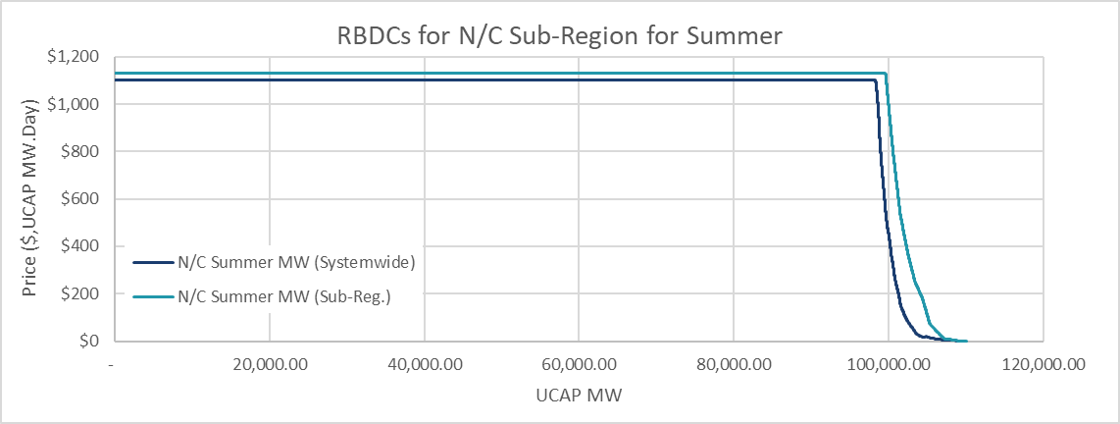 | 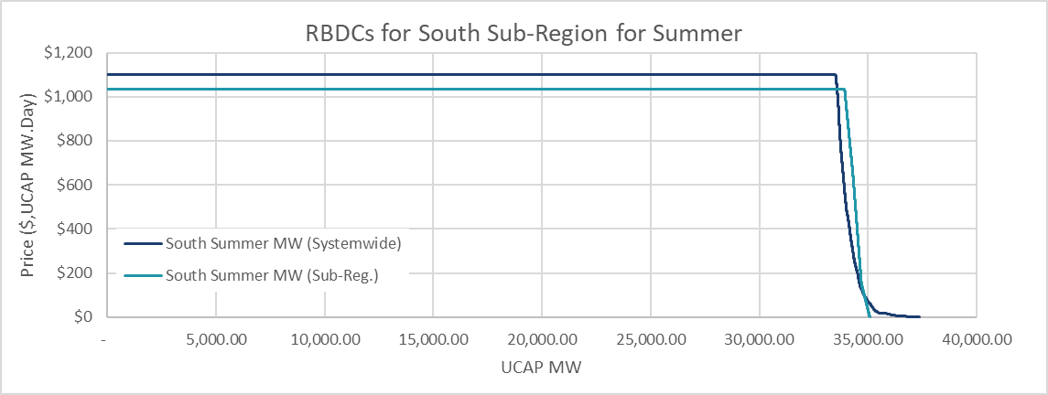
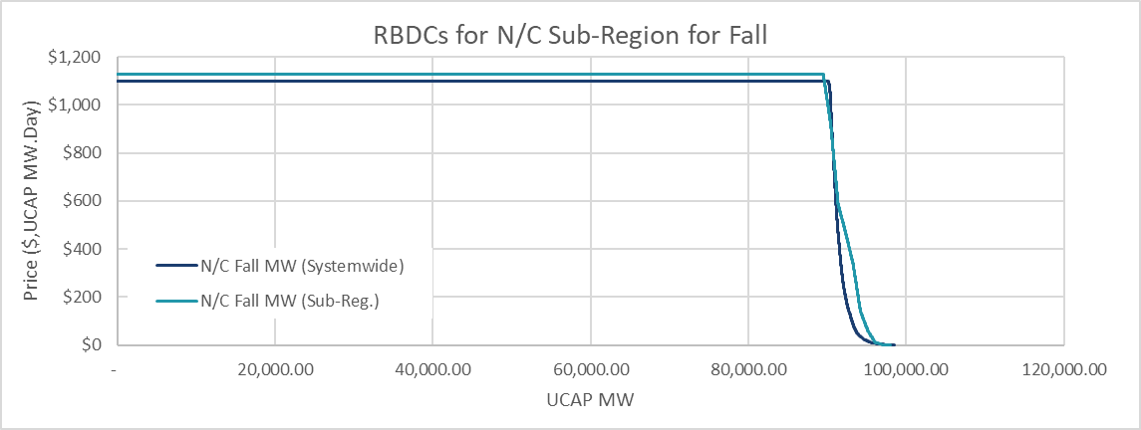 | 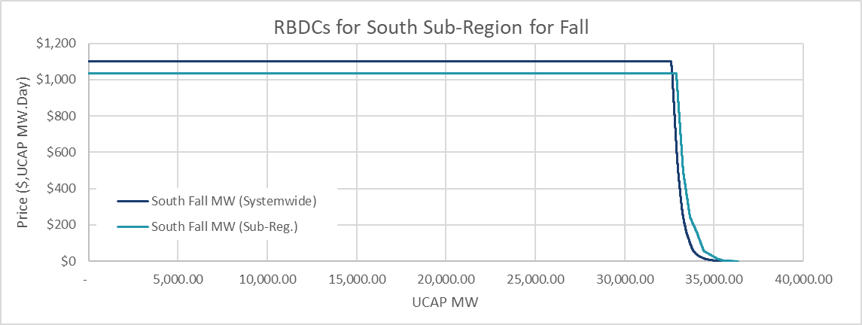
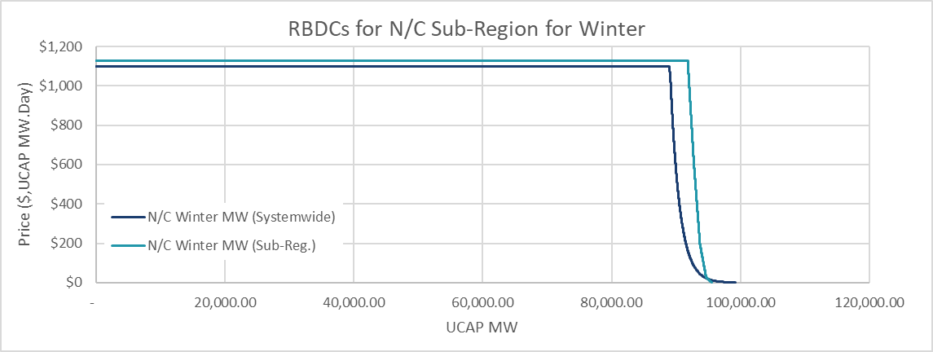 | 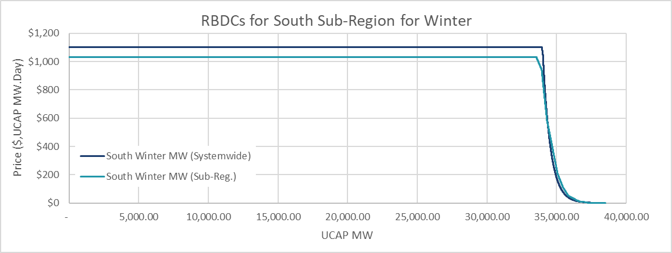
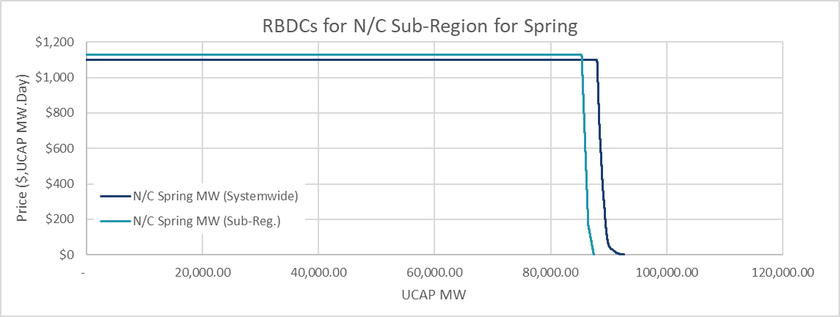 | 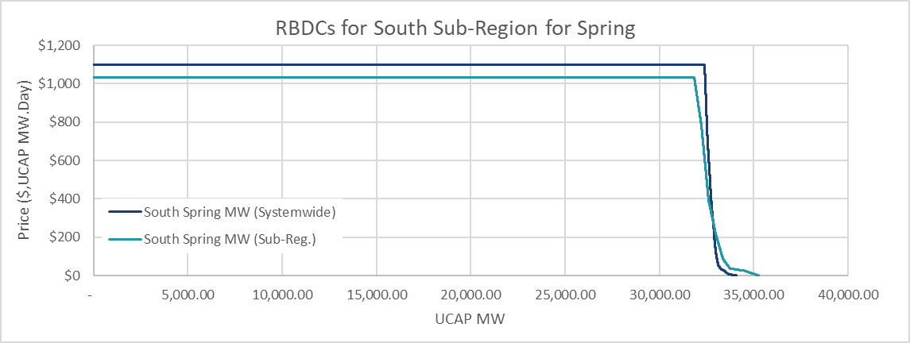
Figure 1. Indicative seasonal RBDC curves for N/C and South subregions, also showing the load-share-based projection of systemwide RBDC on to the sub-region.
  - Step 1 Formulation
The optimization problem for the RBDC identification step is posed as a linear program with the objective to minimize the cost of balancing capacity & demand for two scenarios: (i) demand is from share-of-systemwide RBDC in each subregion, and (ii) demand is from subregional RBDC in each subregion. In this formulation, these two scenarios are enforced independently. Subregional power balancing constraints and zonal clearing constraints are also enforced independently for each scenario.
After solving the LP, the demand cleared on the basis of share-of-systemwide RBDC is compared with the demand cleared on the basis of the subregional RBDC clearing for both N/C and south subregions: for each subregion, the type of RBDC (share-of-systemwide RBDC or subregional RBDC) which produces the higher MW requirement is identified and selected for use in step 2 of the clearing process. The optimization formulation for step 1 is presented in the following.
    - Objective Function
The linear minimization objective is as follows:
Minimize $f≝$ $SC-\left(SB+RB\right)+ Λ,$ (3.1.a)
with $SC$ referring to the supply cost which is the area under the offer curve, $SB$ and $RB$ referring to the reliability benefits from the systemwide and subregional RBDCs which are the areas under the systemwide RBDC and subregional RBDCs, respectively, and $Λ$ as the shortage penalty for zonal LCR shortage or initial PRMR shortage beyond the capacity import limit (CIL) of the zone. These terms are expressed as follows:
$SC≝ \sum_{i∈F}{OFFERPRICE_{i}×(}clearedMW_{i}^{SYS}+ clearedMW_{i}^{SR})$ (3.1.b) $SB≝ \sum_{j∈J_{SYS-RBDC}}{\sum_{r∈R}{α_{r}×RBDCPRICE_{j}}×}cleared{Demand}_{j,r}^{SYS}$ (3.1.c)
$RB≝ \sum_{r∈R}{\sum_{j∈J_{r}}{RBDCPRICE_{j}}×}cleared{Demand}_{j,r}^{SR}$ (3.1.d)
$Λ≝ \sum_{k∈Z}{SEASONALCONE_{k}×(}S_{k}^{SYS}+ S_{k}^{SR})$ (3.1.e)
    - Constraints
The optimization constraints are based on system, subregional, and zonal balancing requirements, in addition to bounds on resource and segment clearing. Note that all decision variables are restricted to be in the domain of non-negative real values.
      - Resource Offer Bounds
Resource clearing should not exceed the MWs offered by the resources
$clearedMW_{i}^{SYS}≤$ ${OFFERMW}_{i}, ∀i∈F$ (3.2.a)
$clearedMW_{i}^{SR} ≤$ ${OFFERMW}_{i}, ∀i∈F$ (3.2.b)
      - RBDC segment bounds
Price sensitive demand, characterized by different RBDCs, has limits based on the segments of the RBDC; MWs cleared in RBDC segments should not exceed the RBDC segment limits:
$cleared{Demand}_{j,r}^{SYS}≤$ ${RBDCSTEP}_{j}, ∀j∈J_{SYS-RBDC} , ∀r∈R$ (3.3.a)
$cleared{Demand}_{j,r}^{SR} ≤$ ${RBDCSTEP}_{j}, ∀j∈J_{r} , ∀r∈R$ (3.3.b)
      - Power balance constraints
Systemwide supply-demand balance constraints. To properly value the reliability given the clearing outcome, the supply-demand balance equations enforce the condition that cleared supply is greater than or equal to cleared demand.
In step 1, the supply-demand balance must hold for both the system and subregional RBDC curves: the cleared quantity of demand from each RBDC curve must be met by corresponding supply-side variables.
$\sum_{i∈F}{clearedMW_{i}^{SYS}}≥ \sum_{j∈J_{SYS-RBDC}}{\sum_{r∈R}{α_{r}}×}cleared{Demand}_{j,r}^{SYS}$ (3.4.a)
$\sum_{i∈F}{clearedMW_{i}^{SR}} ≥ \sum_{r∈R}{\sum_{j∈J_{r}}{cleared{Demand}_{j,r}^{SR}}}$ (3.4.b)
Subregional supply-demand balance constraints. These constraints ensure that the difference between the cleared supply available within a subregion and the cleared demand associated with the subregion is within the subregional import and export limits (SRIC and SREC, respectively). In step 1, the constraints are imposed for clearing associated with both systemwide and subregional RBDCs as follows, respectively:
$-SRIC_{r}≤ \sum_{i∈G_{r}}{clearedMW_{i}^{SYS}}+ \sum_{e∈E}{SF_{r,e}× \sum_{k∈H_{e}}{clearedMW_{k}^{SYS}}}-\sum_{j∈J_{SYS-RBDC}}{α_{r}×}cleared{Demand}_{j,r}^{SYS}≤SREC_{r}, ∀r∈R$ (3.5.a)

$-SRIC_{r}≤\sum_{i∈G_{r}}{clearedMW_{i}^{SR}}+ \sum_{e∈E}{SF_{r,e}×\sum_{k∈H_{e}}{clearedMW_{k}^{SR}}}-\sum_{j∈J_{r}}{cleared{Demand}_{j,r}^{SR}} ≤SREC_{r}, ∀r∈R$ (3.5.b)
      - Zonal Clearing Constraints
Local Clearing Requirement (LCR) and Capacity Import Limit (CIL) constraints ensure that the quantity of cleared supply in the zone must exceed the minimum of the LCR and the share of Initial PRMR that cannot be met by imports. If the quantity of cleared supply falls short of either of these limits, the shortfall variable is penalized at the zone’s seasonal CONE value in the objective function (3.1.a). In Step 1, the LCR and CIL are enforced for both the systemwide and subregional RBDC clearing outcomes. The LCR constraints are as follows:
$\sum_{i∈G_{k}}{clearedMW_{i}^{SYS}}+S_{k}^{SYS} ≥ {LCR}_{k}, ∀k∈Z$ (3.6.a)
$\sum_{i∈G_{k}}{clearedMW_{i}^{SR}}+S_{k}^{SR} ≥ {LCR}_{k}, ∀k∈Z$ (3.6.b)
The quantity of imports in the zone to meet initial PRMR requirements must be below CIL. Only the tighter of the LCR and CIL constraints will bind, so we can use the same shortage variables for both LCR and CIL constraints. The CIL constraints are as follows:
$INITIALPRMR_{k}-\sum_{i∈G_{k}}{clearedMW_{i}^{SYS}}-S_{k}^{SYS} ≤ {CIL}_{k}, ∀k∈Z$ (3.7.a)
$INITIALPRMR_{k}-\sum_{i∈G_{k}}{clearedMW_{i}^{SR}}-S_{k}^{SR} ≤ {CIL}_{k}, ∀k∈Z$ (3.7.b)
Capacity Export Limit (CEL) constraints ensure that the quantity of exports for the zone does not exceed the available transfer capabilities (CEL). The exports are the difference between the cleared supply in the LRZ and the load obligations of the LRZ. The load requirement for an LRZ is calculated based on the CPDF share of the LRZ with respect to the cleared demand in the subregion. Consequently, the LRZ obligations based on systemwide RBDC clearing and subregional RBDC clearing are given by, respectively,
$LRZ{Req}_{k}^{SYS}=$ $\sum_{j∈J_{SYS-RBDC}}{α_{k}^{SYS}×}cleared{Demand}_{j,r}^{SYS}, ∀k∈Z_{r},∀ r∈R$ (3.8.a)
$LRZ{Req}_{k}^{SR} =$ $\sum_{j∈J_{r}}{α_{k}^{r}×}cleared{Demand}_{j,r}^{SR}, ∀k∈Z_{r},∀ r∈R$ (3.8.b)
The CEL constraints for each LRZ corresponding to the systemwide RBDC and the subregional RBDCs are given by, respectively,
$\sum_{i∈G_{k}}{clearedMW_{i}^{SYS}}-LRZ{Req}_{k}^{SYS} ≤ {CEL}_{k}, ∀k∈Z$ (3.9.a)
$\sum_{i∈G_{k}}{clearedMW_{i}^{SR}}-LRZ{Req}_{k}^{SR} ≤ {CEL}_{k}, ∀k∈Z$ (3.9.b)
Since ERZs have no load obligations, their CEL constraints for systemwide RBDC and subregional RBDCs are given by, respectively,
$\sum_{i∈H_{e}}{clearedMW_{i}^{SYS}} ≤ {CEL}_{e}, ∀e∈E$ (3.9.c)
$\sum_{i∈H_{e}}{clearedMW_{i}^{SR}} ≤ {CEL}_{e}, ∀e∈E$ (3.9.d)
- Step 2: Clearing and Pricing
Following Step 1: RBDC Identification, the effective RBDCs for each subregion are established. In step 2, these identified RBDCs are used to determine resource and RBDC MW clearing along with the Auction Clearing Prices (ACPs). This clearing and pricing optimization problem is an LP problem.
In the social welfare optimization problem in step 2, for each subregion, we select the RBDC (between share-of-systemwide RBDC and subregional RBDC) that resulted in a higher requirement in that subregion. This selection is done via parameter $u_{r}$: for a given subregion $r∈R$, the parameter $u_{r}$is a binary parameter which is determined based on the clearing results of step 1. Parameter $u_{r}$ is set to 0 if share-of-systemwide RBDC resulted in a higher clearing in step 1 (i.e., share-of-systemwide RBDC is selected for step 2), while it is set to 1 if the subregional RBDC resulted in a higher clearing in step 1 (i.e., subregional RBDC selected for step 2). The parameter selection for each subregion is given by the following equation:
$u_{r}= 1 \left(\left\{\sum_{k∈Z_{r}}{L{RZReq}_{k}^{SYS}≤ \sum_{k∈Z_{r}}{LRZ{Req}_{k}^{SR}}}\right\}\right), ∀r∈R,$ (4.1)
where $1$ is the indicator function, and the LRZ clearing requirements are from step 1 as defined in (3.8).
  - Step 2: Formulation
Since we are selecting the RBDCs using the parameter $u_{r},$step 2 does not require separate supply variables or constraint equations to distinguish between systemwide RBDC and subregional RBDCs. The details of the LP formulation for the clearing-and-pricing step 2 are as follows.
    - Objective Function
The linear minimization objective is given by the following equations, with the same terminology as defined in Section 3:
Minimize $f≝$ $SC-\left(SB+RB\right)+ Λ,$ (4.2.a)
$SC≝ \sum_{i∈F}{OFFERPRICE_{i}×clearedMW_{i}}$ (4.2.b)
$SB≝ \sum_{j∈J_{SYS-RBDC}}{\sum_{r∈R}{{(1-u}_{r})×α_{r}×RBDCPRICE_{j}}×}cleared{Demand}_{j,r}^{SYS}$ (4.2.c)
$RB≝ \sum_{r∈R}{\sum_{j∈J_{r}}{u_{r}×RBDCPRICE_{j}}×}cleared{Demand}_{j,r}^{SR}$ (4.2.d)
$Λ≝ \sum_{k∈Z}{SEASONALCONE_{k}×S_{k}}$ (4.2.e)
    - Constraints
In step 2, the power balancing constraints and the segment bounds are imposed for the selected RBDC using the parameter $u_{r}$. This subsection provides expression for the constraints in the LP.
      - Resource Offer Bounds
Resource clearing should not exceed the MWs offered by the resources
$clearedMW_{i}≤$ ${OFFERMW}_{i}, ∀i∈F$ (4.3)
      - RBDC segment bounds
MWs cleared in RBDC segments should not exceed the RBDC segment limits:
$cleared{Demand}_{j,r}^{SYS}≤$ ${\left(1-u_{r}\right)×RBDCSTEP}_{j}, ∀j∈J_{SYS-RBDC} , ∀r∈R$ (4.4.a)
$cleared{Demand}_{j,r}^{SR} ≤$ $u_{r}×{RBDCSTEP}_{j}, ∀j∈J_{r} , ∀r∈R$ (4.4.b)
The multiplication involving the parameter $u_{r}$ in the above equation ensures that the segment-wise clearing variables are allowed to take non-zero values only for the selected RBDC; the segment-wise clearing variables will be zero for the non-selected RBDC.
      - Power balance constraints
The system power balance constraint is represented below: the cleared systemwide supply should exceed the total system cleared demand from the selected RBDCs.
$$\sum_{i∈F}{{clearedMW}_{i}}≥ \sum_{r∈R}{\sum_{j∈J_{r}}{u_{r}×cleared{Demand}_{j,r}^{SR}}}$$
$+ \sum_{r∈R}{\sum_{j∈J_{SYS-RBDC}}{{\left(1-u_{r}\right)×α}_{r}×}cleared{Demand}_{j,r}^{SYS}}$ (4.5)
The subregional power balancing constraints ensure that the difference between the selected RBDC cleared demand and subregion cleared supply, including external resources clearing for the subregion, respects the subregional import and export constraints, as follows:
$-SRIC_{r}≤\sum_{i∈G_{r}}{clearedMW_{i}}+\sum_{e∈E}{SF_{r,e}×\sum_{k∈H_{e}}{clearedMW_{k}}}-\sum_{j∈J_{r}}{u_{r}×cleared{Demand}_{j,r}^{SR}} -\sum_{j∈J_{SYS-RBDC}}{{\left(1-u_{r}\right)×α}_{r}×}cleared{Demand}_{j,r}^{SYS}≤SREC_{r}, ∀r∈R$ (4.6)
      - Zonal Clearing Constraints
The LCR and CIL are requirements that need to be met with local resources or penalized in cases of shortage. These constraints are represented as follows, respectively,
$\sum_{i∈G_{k}}{clearedMW_{i}}+S_{k} ≥ {LCR}_{k}, ∀k∈Z$ (4.7)
$INITIALPRMR_{k}-\sum_{i∈G_{k}}{clearedMW_{i}}-S_{k}≤ {CIL}_{k}, ∀k∈Z$ (4.8)
The CEL constraints are imposed with respect to the load obligation for each LRZ. The load obligation for LRZs is expressed as the zonal CPDF share of the cleared demand from the selected RBDC. This is given by,
$$LRZ{Req}_{k}=\sum_{j∈J_{SYS-RBDC}}{\left(1-u_{r}\right)×α_{k}^{SYS}×}cleared{Demand}_{j,r}^{SYS}$$
$+\sum_{j∈J_{r}}{u_{r}×α_{k}^{r}×}cleared{Demand}_{j,r}^{SR} , ∀k∈Z_{r},∀ r∈R$ (4.9)
The difference between the zonal cleared supply and the LRZ load requirement should be below CEL:
$\sum_{i∈G_{k}}{clearedMW_{i}}-LRZ{Req}_{k} ≤ {CEL}_{k}, ∀k∈Z$ (4.10.a)
Since ERZs do not have load obligations, their CEL constraints are given by:
$\sum_{i∈H_{e}}{clearedMW_{i}} ≤ {CEL}_{e}, ∀e∈E$ (4.10.b)
  - Verification of selected RBDC for Step 2
For a given subregion, if both the share-of-systemwide RBDC and the subregional RBDC are intertwined near the intersection of the supply and demand curves, then the RBDC producing higher requirement may be inconsistent between step 1 and step 2. Therefore, additional verification is performed to ensure that the curve selected for step 2 results in an appropriate requirement. This verification process is described below.
Verification step 1: Determine the subregional clearing price for subregion $r∈R$as the sum of the shadow prices corresponding to the system and subregional power balancing constraints, i.e., the sum of the shadow prices (which are the dual variables) for the constraints (4.5) and (4.6).
Verification step 2: For the subregional clearing price calculated in verification step 1, determine the associated UCAP MW for the share-of-systemwide RBDC and the subregional RBDC for each subregion r. Note the RBDC that results in the higher requirement.
Verification step 3: For a given subregion, if the RBDC with the higher UCAP MW as determined in verification step 2 matches with the RBDC selected via the binary parameter $u_{r}$ (0 implies selection of share-of-systemwide RBDC and 1 implies selection of subregional RBDC), then the PRA clearing solution is valid and we can proceed with the computation of clearing prices and obligations for the market participants.
If the verification fails for a given subregion, then this failure implies that the RBDC with the higher UCAP MW as determined in verification step 2 is different from the type of RBDC (share of systemwide or subregional) selected via the parameter $u_{r}$; hence, the PRA clearing solution is not valid. In such a case, the value of the parameter $u_{r}$ for the subregion is switched to its complement (0 to 1, or 1 to 0), and step 2 of the PRA clearing process is solved again with this updated parameter.
  - Auction Clearing Price calculations
Following the PRA clearing solution obtained in the step 2 optimization problem, the clearing prices are calculated for every LRZ and ERZ. This section describes the methodology for computing the auction clearing price (ACP).
    - ACP determination
The initial auction clearing price is calculated using the shadow prices (SP) of the system, subregional, and zonal power balancing constraints, which are defined below. All prices in this document are in units of $/MW-day.
$systemBalanceSP$ — Non-negative shadow price corresponding to the systemwide supply demand balancing constraint (4.5). This SP applies to all LRZs and ERZs.
$SRICSP_{r}$ — Non-negative shadow price corresponding to the subregional import constraint: left-hand side inequality of (4.6). A positive shadow price implies that the imports for subregion r are equal to the SRIC limit. The shadow price applies to all local zones in the respective subregion r. For external zones, the shadow price is assigned proportionally based on the respective subregional shift factors.
$SRECSP_{r}$ — Non-positive shadow price corresponding to the subregional export constraint: right-hand side inequality of (4.6); a negative value implies that the exports for subregion r are equal to the SREC limit. The shadow price applies to all local zones in the respective subregion r. For external zones, the shadow price is assigned proportionally based on the respective subregional shift factors.
$LCRSP_{k}$ — Non-negative SP for the LCR constraint (4.7) for LRZ $k∈Z$. This only applies to LRZs. A positive SP for the LRZ implies that the total cleared generation in LRZ k is either exactly equal to the LCR for k, or that the total generation offered in LRZ k is short of the LCR for k (in which case, seasonal CONE pricing is used as a shortage penalty).
$CILSP_{k}$ — Non-negative SP for the CIL constraint (4.8) for LRZ $k∈Z$. This only applies to LRZs. A positive SP implies that the difference between the initial PRMR and the total cleared generation in the LRZ is either exactly equal to CIL or is more than CIL in case of a shortage.
$CELSP_{k}$ — Non-positive SP for the CEL constraint (4.10) for zone $k∈Z\bigcup{E}$. This applies to both LRZs and ERZs.
The ex-ante ACP for an LRZ $k∈Z_{r}$ in subregion $r∈R,$prior to the calculation of LCR price adder is the minimum of (i) seasonal CONE of the LRZ and (ii) the sum of shadow prices corresponding to the LRZ (for zones without multi-season shortage, the ex-ante ACP will also be the ex-post ACP for the LRZ):
$ACP_{k}^{EA}= min⁡\{{SEASONALCONE}_{k},systemBalanceSP+{SRICSP}_{r}+{SRECSP}_{r}+{LCRSP}_{k}+{CILSP}_{k}+{CELSP}_{k}\}$ (4.11.a)

The ACP for an ERZ $e∈E$is the minimum of (i) the maximum seasonal CONE of all the LRZs in the subregion to which the ERZ is connected (for dual connected ERZs, this is the maximum seasonal CONE of all LRZs in the entire transmission area; and (ii) the sum of the shadow prices corresponding to the ERZ:
$ACP_{e}= min⁡\{{SEASONALCONE}_{e},systemBalanceSP+{ {CELSP}_{e}+\sum_{r}{SF_{r,e}}×( SRICSP}_{r}+{SRECSP}_{r})\}$ (4.11.b)

    - ACP under multi season LRZ shortages, or near-shortages, on local clearing requirement
When an LRZ has more than one season in any combination of ZRC shortage conditions and/or ZRC near-shortage conditions, the final Auction Clearing Price (ACP) for the LRZ will be determined as follows.
Let $\tilde{Z}$ the set of all LRZs with multi-season LCR or CIL shortage or near-shortage conditions. Let $N_{k}^{S}$denote the total number of shortage or near-shortage days for the LRZ $k∈\tilde{Z}$ across the entire planning year. Then, the LCR price adder for LRZ $k$ is given by,
${LCRPRICEADDER}_{k}= {{CONE}_{k}}/{N_{k}^{S}}$ (4.12)

The ex-post ACP for an LRZ $k$ with multi-season shortage or near-shortage is,
$ACP_{k}^{EP}=\min{\{}SEASONALCONE_{k}, systemBalanceSP+{SRICSP}_{r}+{SRECSP}_{r}+ LCRPRICEADDER_{k}\}, ∀k∈\tilde{Z}$ (4.13)
- Final Auction Clearing Quantities for LRZs
The Final PRMR of an LSE is determined based on RBDC clearing in the corresponding subregion and the LSE’s participation option (such as RBDC Opt Out, market participation, etc.) in the PRA. The detailed procedure to determine Final PRMR is presented in Section 5.6 of this Business Practice Manual.
- Examples
  - Small System Examples
Assume a system as shown in Figure 2Error! Reference source not found. below. It consists of two LRZs and two subregions. There is a limited transfer capability between the subregions, and it is reflected in the subregional power balance constraint limit (SRPBC): the SRPBC limit in the following examples is a simplified representation of the SRIC/SREC constraints included in the preceding mathematical formulation.
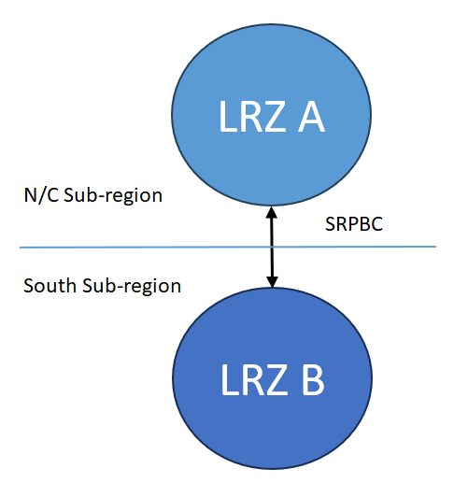
Figure 2. System setup for clearing examples: Two LRZ system with two subregions
Case 1: Regional RBDCs in both subregions are resulting in higher requirements than the share-of-systemwide RBDC, and there are no binding subregional import/export constraints. The offer and RBDC information along with the optimal clearing are shown in the following figure.
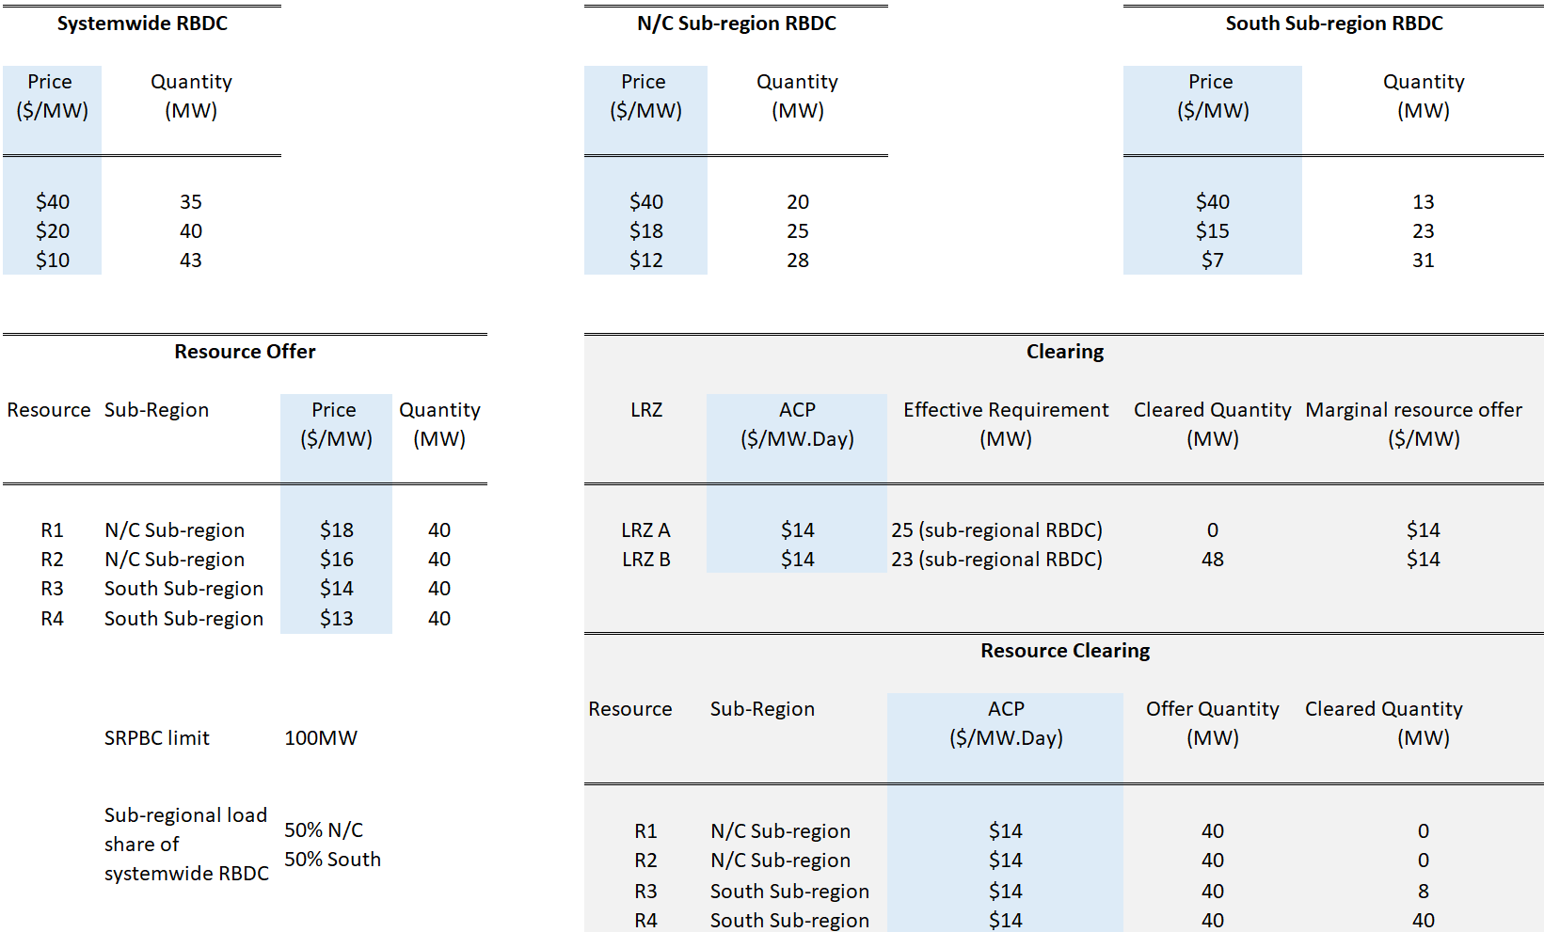
Case 2: Regional RBDCs in both subregions are resulting in higher requirements than the share-of-systemwide RBDC, and the subregional import/export constraints are binding. The offer and RBDC information along with the optimal clearing are shown in the following figure.
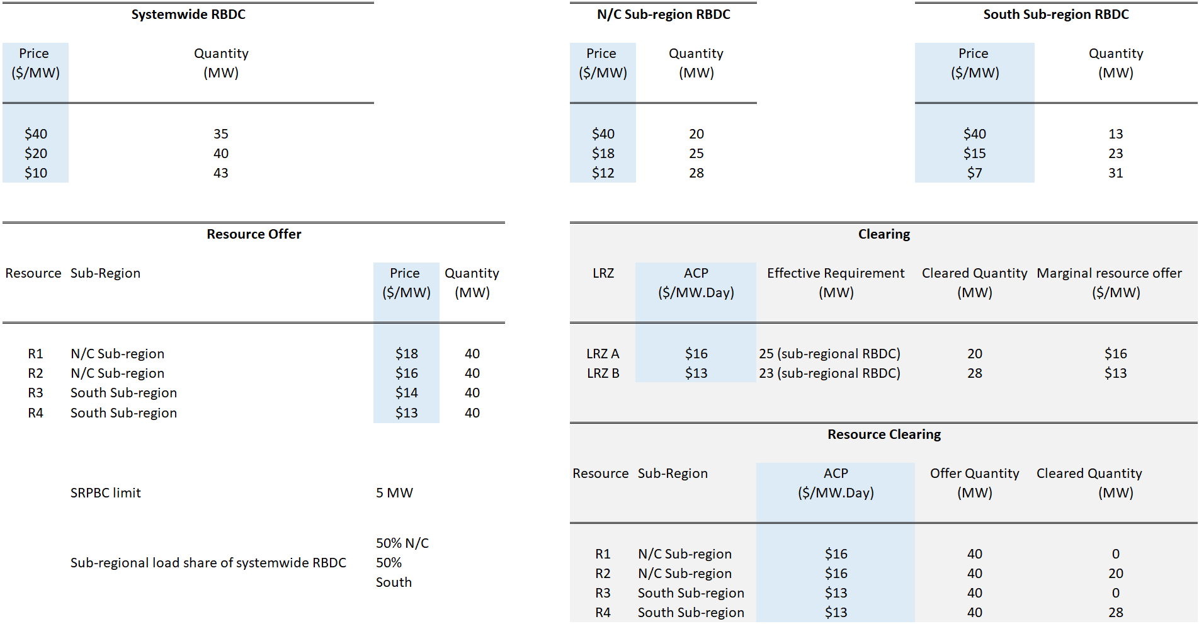
Case 3: In one subregion, share-of-systemwide RBDC is resulting in a higher requirement than subregional RBDC, while in the other subregion, the subregional RBDC results in a higher requirement as compared to the share-of-systemwide RBDC. SRIC/SREC are not binding. The offer and RBDC information along with the optimal clearing are shown in the following figure.
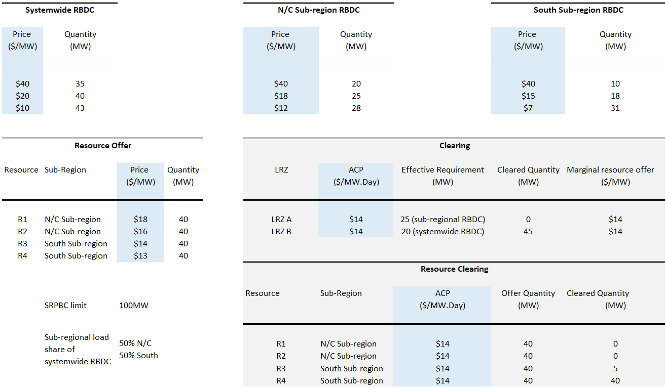
Case 4: In one subregion, share-of-systemwide RBDC is resulting in a higher requirement than subregional RBDC, while in the other subregion, the subregional RBDC results in a higher requirement as compared to the share-of-systemwide RBDC. SRIC/SREC are binding. The offer and RBDC information along with the optimal clearing are shown in the following figure.
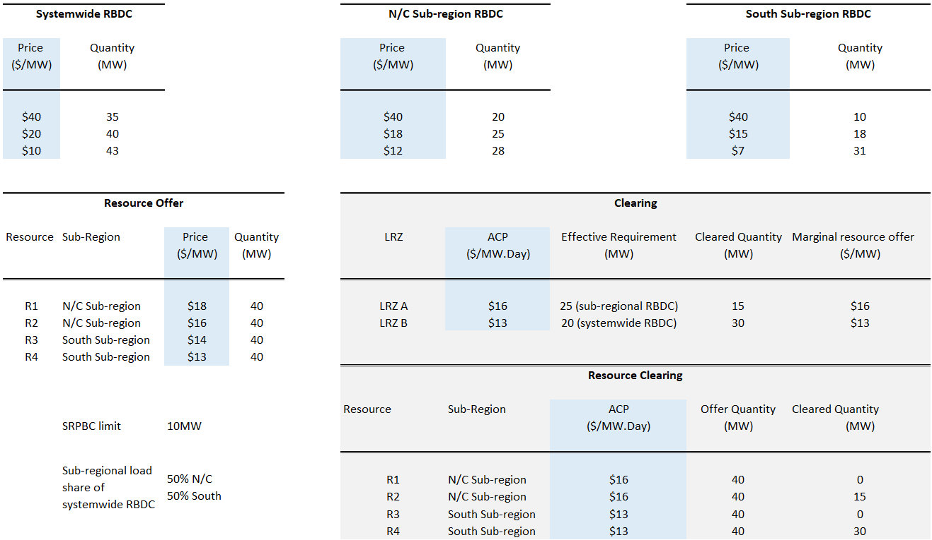
Case 5: Systemwide RBDC results in a higher requirement in both subregions, and no SRIC/SREC binding. Offer, RBDC, and clearing details are in the following figure.
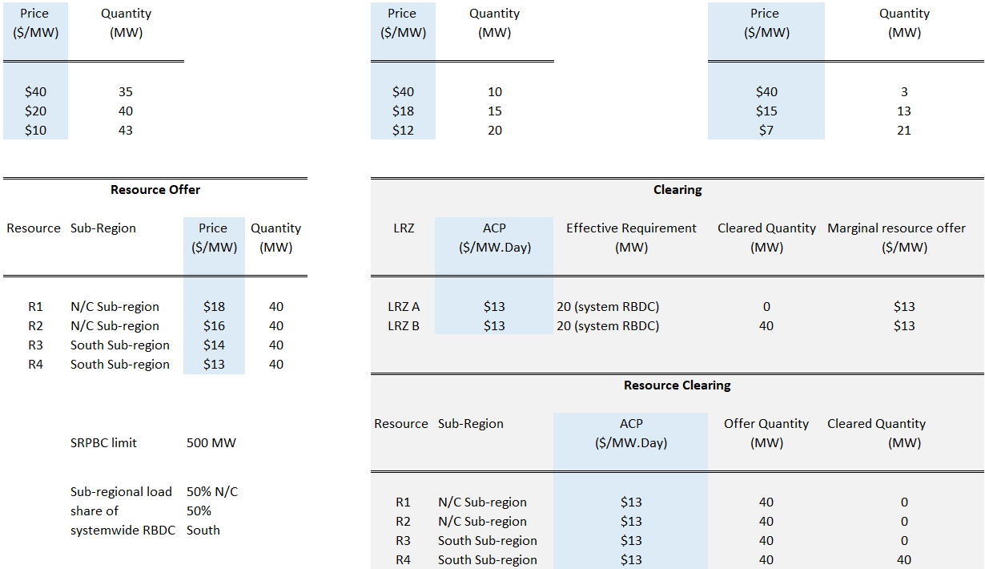

Case 6: Systemwide RBDC results in a higher requirement in both subregions, and SRIC/SREC are binding. Offer, RBDC, and clearing details are in the following figure.
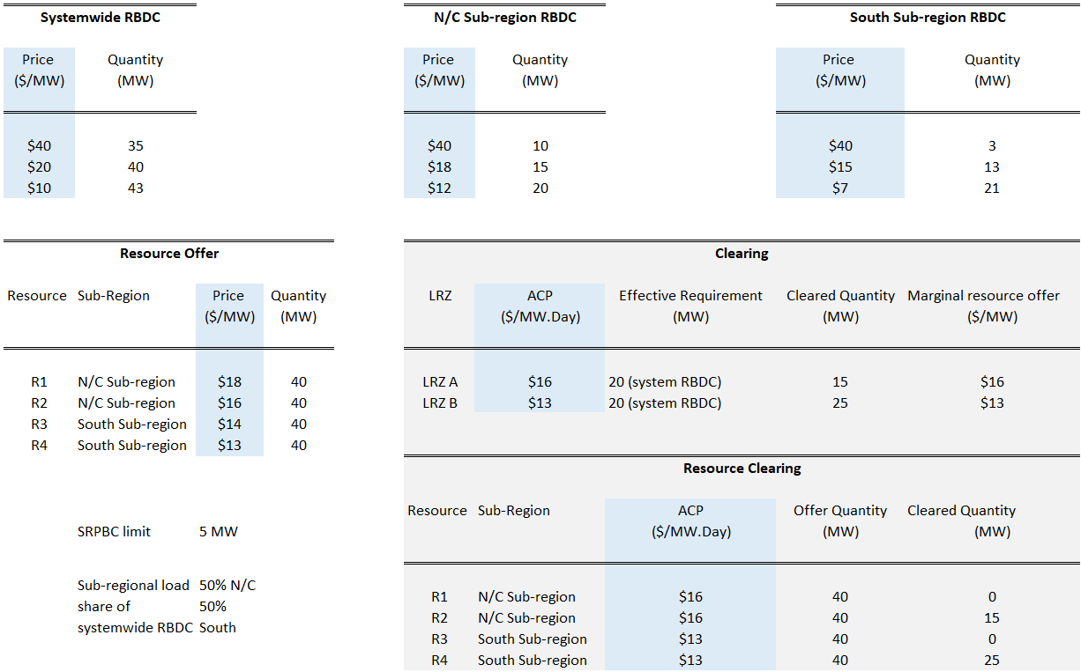
  - PRA Clearing Examples using Indicative RBDCs
This section provides an illustrative graphical representation of the auction clearing with RBDCs: the plots representing the PRA clearing outcomes with indicative RBDCs for PY 24-25 Summer Season are presented in Figure 4. The indicative RBDCs are developed based on PY 24-25 loss-of-load study and the associated models. Resource offers submitted for the PY 24-25 Summer Season are used for the supply curves. The parameters for the zonal CIL, CEL, and LCR constraints are the same as those used in the PY 2024/25 PRA. The solution to the linear programming-based formulation results in an Auction Clearing Price of about $140/MW-day with no subregional or zonal price separation. The systemwide RBDC is setting up the requirement in both subregions with a total cleared demand of 140.1GW, because the share-of-systemwide RBDCs are to the right of the subregional RBDCs in both subregions.
The SREC limit from the south subregion to the north/central subregion is 1,900 MW; the capacity exports from the south subregion to the north/central subregion are 1,581 MW as reflected in Figure 4. The RBDCs shown in the dashed lines for the exporting subregion (south) have been shifted to the right by the export quantity, while those for the importing subregion (N/C) have been shifted to the left by the same quantity. The original RBDCs are in solid lines.
The horizontal line represents the ACP, which is set at the intersection of the supply curve and import/export-shifted RBDC for each subregion (red dot in the figure). The Final PRMR for an importing subregion (N/C) is to the right of the intersection of the supply curve and the import-shifted RBDC by the import quantity (1,581 MW in the figures below). Similarly, for the exporting subregion (south), the final PRMR is to the left of the intersection of the supply curve and the export-shifted RBDC by the export quantity of 1,581 MW. The Final PRMR is shown by the dotted dark-gray vertical line passing through the intersection of the horizontal ACP line and the requirement-setting RBDC (share-of-systemwide RBDC for Summer 2024 in both subregions—plots in orange solid lines).
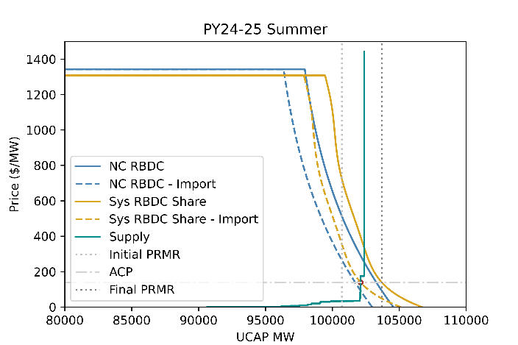 | 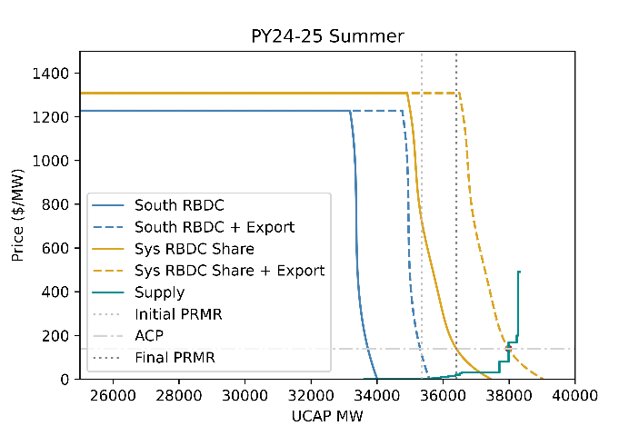
Figure 3. PRA clearing with indicative RBDCs representing PY24-25 Summer season with actual offers submitted for PY24-25 Summer season.
For completeness, the zoomed-in version of PRA clearing presented in Figure 4 is shown below in Figure 5.
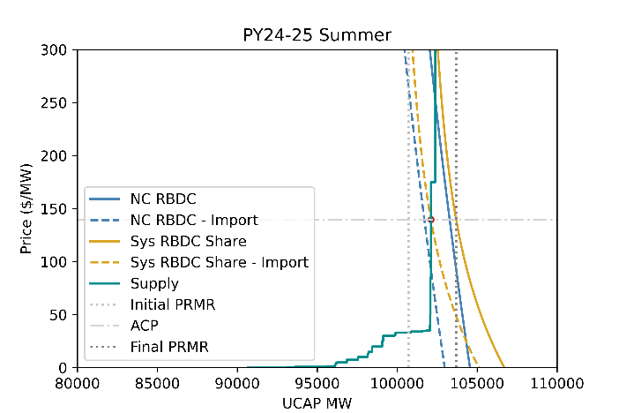 | 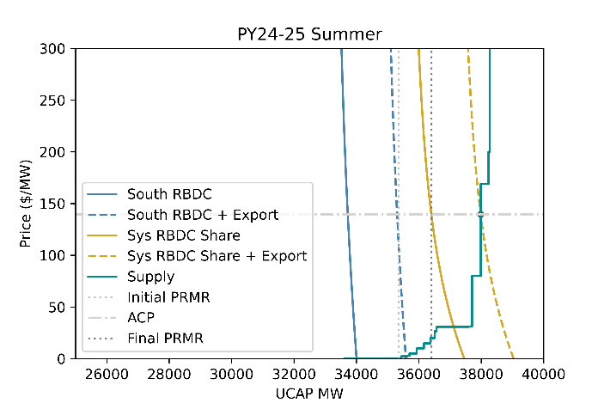
Figure 4. Zoomed in version of illustrative PY 24-25 Summer season PRA clearing.

- Seasonal Demand and Energy Forecast Characteristics
Forecast Criteria | Coincident Peak Demand and Zonal Coincident Peak Demand Forecasts | Non-Coincident  Peak Demand Forecast | Energy for Load Forecast
Includes Demand Served by Energy Efficiency Planning Resources | Yes | Yes | Yes
Includes Demand Served by Energy Efficiency Programs | No | No | No
Includes Demand Served by Demand Resources | Yes | Yes | Yes
Includes Demand Served by BTMG Planning Resources | Yes | Yes | Yes
Includes Demand Served by resources that are not qualified as Planning Resources | Yes | No | No
Includes Demand Pseudo-Tied Out of MISO BA and Included Subject to other RAR | No | Yes | Yes
Includes Transmission Losses | No | No | Yes
Coincident with reporting Load Serving Entities’ system | No | Yes | No
Demand reported at Physical LBA Location | Yes | Yes | Yes
Include Demand from Power Plant Station or Auxiliary Needs | No | No | No

- Parties Responsible for Reporting Seasonal Demand and Energy Forecasts
Data | EDC | Retail Choice LSE | Non-Retail Choice LSE
MISO Coincident Peak (Total CPF) | No | No | Yes
MISO Non-Coincident Peak (Total NCPF) | No | No | Yes
Zonal Coincident Peak (Total CPF) | No | No | Yes
RC Coincident Peak (Total CPFEDC Area) | Yes | No | No
RC Coincident Peak (Total NCPF) Load Contribution | Yes | No | No
RC Zonal Coincident Peak (Total CPFEDC Area) | Yes | No | No
Non-Coincident Peak | Yes | No | Yes
RC Non-Coincident Peak | No | Yes | No
Energy for Load | Yes | No | Yes
Retail Choice (MISO Peak) | Yes | No | No
Retail Choice (Zonal Peak) | Yes | No | No

- Zonal Deliverability Benefit Pro Rata Allocation
This Appendix is an illustrative example of the ZDB pro rata allocation methodology in the presence of Historical Unit Considerations (HUC) and Fixed Resource Adequacy Plan (FRAP) or RBDC Opt Out. The results from the Planning Resource Auction for the 2020/2021 Planning Year are used in this example to educate Market Participants. The resulting Auction Clearing Prices illustrated here are different than those settled for the 2020/2021 Planning Year. Starting in Planning Year 2023-2024, the ZDB calculation will be performed separately for each Season in which the ZDB calculation is required.

Step 1: Subtract PRMR and ZRCs associated with HUC Hedges to derive an adjusted Final PRMR (Adjusted Final PRMR) and ZRC (Adjusted ZRC). ZRCs are FRAP + RBDC Opt Out + Self-scheduled offers + cleared Non-self-scheduled offers.

RZ | ACP | Final PRMR | ZRC | HUC (MW) | ZDC Hedges (MW) | Adjusted Final PRMR | Adjusted ZRC
Z1 | $5.00 | 18,476.0 | 18,742.0 | 191.7 | 0 | 18,284.3 | 18,550.3
Z2 | $5.00 | 13,728.2 | 13,590.0 | 0 | 0 | 13,728.2 | 13,590.0
Z3 | $5.00 | 10,129.1 | 10,551.0 | 0 | 0 | 10,129.1 | 10,551.0
Z4 | $5.00 | 9,794.6 | 8,462.1 | 0 | 0 | 9,794.6 | 8,462.1
Z5 | $5.00 | 8,456.3 | 7,952.8 | 0 | 0 | 8,456.3 | 7,952.8
Z6 | $5.00 | 18,720.6 | 17,054.6 | 0 | 0 | 18,720.6 | 17,054.6
Z7 | $257.53 | 21,945.3 | 21,727.5 | 0 | 0 | 21,945.3 | 21,727.5
Z8 | $4.75 | 7,986.9 | 10,183.1 | 0 | 0 | 7,986.9 | 10,183.1
Z9 | $6.88 | 21,711.7 | 20,893.7 | 107.3 | 0 | 21,604.4 | 20,786.4
Z10 | $4.75 | 5,030.6 | 5,244.2 | 0 | 0 | 5,030.6 | 5,244.2
E20 | $4.90 | 0.0 | 347.2 | 0 | 0 | 0.0 | 347.2
E22 | $5.00 | 0.0 | 633.8 | 0 | 0 | 0.0 | 633.8
E23 | $5.00 | 0.0 | 30.1 | 0 | 0 | 0.0 | 30.1
E24 | $5.00 | 0.0 | 148.4 | 0 | 0 | 0.0 | 148.4
E26 | $4.92 | 0.0 | 24.0 | 0 | 0 | 0.0 | 24.0
E27 | $4.89 | 0.0 | 168.3 | 0 | 0 | 0.0 | 168.3
E28 | $4.90 | 0.0 | 226.5 | 0 | 0 | 0.0 | 226.5

Step 2: Create a DBZ for each group of LRZs that have equal ACPs which result from the same auction constraint. In this example, Zone 7 is a DBZ because the PRA bound on its LCR.

RZ | ACP | Adjusted Final PRMR | Adjusted ZRC | DBZ Grouping
Z1 | $5.00 | 18,284.3 | 18,550.3 | Zone A
Z2 | $5.00 | 13,728.2 | 13,590.0 | Zone A
Z3 | $5.00 | 10,129.1 | 10,551.0 | Zone A
Z4 | $5.00 | 9,794.6 | 8,462.1 | Zone A
Z5 | $5.00 | 8,456.3 | 7,952.8 | Zone A
Z6 | $5.00 | 18,720.6 | 17,054.6 | Zone A
Z7 | $257.53 | 21,945.3 | 21,727.5 | Zone B
Z8 | $4.75 | 7,986.9 | 10,183.1 | Zone D
Z9 | $6.88 | 21,604.4 | 20,786.4 | Zone C
Z10 | $4.75 | 5,030.6 | 5,244.2 | Zone D
E20 | $4.90 | 0.0 | 347.2 | Zone E
E22 | $5.00 | 0.0 | 633.8 | Zone A
E23 | $5.00 | 0.0 | 30.1 | Zone A
E24 | $5.00 | 0.0 | 148.4 | Zone A
E26 | $4.92 | 0.0 | 24.0 | Zone F
E27 | $4.89 | 0.0 | 168.3 | Zone G
E28 | $4.90 | 0.0 | 226.5 | Zone E

Step 3: For each DBZ, subtract the sum of Adjusted Final PRMR for each LRZ within the DBZ from the sum of Adjusted ZRCs for each LRZ within the DBZ. A DBZ will be considered a net importing DBZ if the sum of Adjusted Final PRMR is greater than the sum of Adjusted ZRCs. A DBZ will be considered a net exporting DBZ if the sum of the Adjusted Final PRMR is less than the sum of Adjusted ZRCs. A net exporting DBZ shall not receive any ZDB credit. A net importing DBZ shall receive a ZDB credit allocation based upon this weighted average approach.
In this example, Zones A, B, and C are net importing DBZ’s and Zones D, E, F and G are net exporting DBZs.

DBZ | Adjusted Final PRMR | Adjusted ZRC | Difference | Result
Zone A | 79,113.1 | 76,973.1 | -2140.0 | Net Importer
Zone B | 21,945.3 | 21,727.5 | -217.8 | Net Importer
Zone C | 21,711.7 | 20,893.7 | -818.0 | Net Importer
Zone D | 13,017.5 | 15,427.3 | 2,409.8 | Net Exporter
Zone E | 0.0 | 573.7 | 573.7 | Net Exporter
Zone F | 0.0 | 24.0 | 24.0 | Net Exporter
Zone G | 0.0 | 168.3 | 168.3 | Net Exporter

Step 4: Calculate the weighted average ACP of all net exporting DBZs (Weighted Average Export ACP) to determine a financial value of export capacity within the Transmission Provider region per the formula below:
$Weighted Average Export ACP=\frac{\sum{{(Net Export}_{j}×{ACP}_{j})}}{\sum{{Net Export}_{j}}}$$Weighted Average Export ACP=\frac{\sum{{(Net Export}_{j}×{ACP}_{j})}}{\sum{{Net Export}_{j}}}$$Weighted Average Export ACP=\frac{\sum{{(Net Export}_{j}×{ACP}_{j})}}{\sum{{Net Export}_{j}}}$
$\sum{\frac{Net Exports_{j}*ACP_{j}}{\sum{Net Exports_{j}} }}$Where j = Each net exporting DBZ
DBZ | Net Export | ACP | Net Export*ACP
D | 2409.8 | $4.75 | $11,446.55
E | 573.7 | $4.90 | $2,811.13
F | 24 | $4.92 | $118.08
G | 168.3 | $4.89 | $822.99
Total of Exporting Zones | 3175.8 |  | $15,198.75
Weighted Average Export ACP =(Total Net Export*ACP)/(Total Net Export) |  |  | $4.79

Step 5: Calculate the ZDB credit allocation, in dollars, for each net importing DBZ:
${ZDB Credit}_{k}={Net Import}_{k}×\left({ACP}_{k}-Weighted Average Export ACP\right)$${ZDB Credit}_{k}={Net Import}_{k}×\left({ACP}_{k}-Weighted Average Export ACP\right)$
Where k = Each net importing DBZs

DBZ | Net Import | ACP ($/MW-day) | Weighted Average Export ACP | ZDB Credit ($/day)
A | 2140.0 | $5.00 | $4.79 | $458.39
B | 217.8 | $257.53 | $4.79 | $55,047.69
C | 818.0 | $6.88 | $4.79 | $1,713.05
Total of Importing Zones | 3175.8

Step 6: Distribute the ZDB credit in each DBZk by dividing the ZDB credit by the sum of Adjusted Final PRMR of the LRZs within each DBZk. Subtract this amount from the initial ACP calculated for each LRZ from the PRA.

DBZ | ZDB Credit ($/day) | RZ | Adjusted Final PRMR | ZDB Rate ($/MW-day) | ACP | Net ACP
A | $458.39 | 1 | 18,284.3 | $0.01 | $5.00 | $4.99
A | $458.39 | 2 | 13,728.2 | $0.01 | $5.00 | $4.99
A | $458.39 | 3 | 10,129.1 | $0.01 | $5.00 | $4.99
A | $458.39 | 4 | 9,794.6 | $0.01 | $5.00 | $4.99
A | $458.39 | 5 | 8,456.3 | $0.01 | $5.00 | $4.99
A | $458.39 | 6 | 18,720.6 | $0.01 | $5.00 | $4.99
 |  | Total DBZ A | 79,113.1
B | $55,047.69 | 7 | 21,945.3 | $2.51 | $257.53 | $255.02
C | $1,713.05 | 9 | 21,604.4 | $0.08 | $6.88 | $6.80

- Fleet XEFORd Calculation
This appendix walks through the process for calculating fleet XEFORd. This process is used for External Resources that participate in the PRA as one MECT resource which represents the aggregate of a fleet of units. In order to qualify, resource owners must submit help tickets to help.misoenergy.org to let MISO know which resources to be included in your fleet by November 15, otherwise the resource will not be able to participate in the PRA. For example, an external area might have 100 units in its fleet with a total capacity of 10,000 MW of which it plans to commit 1,000 MW on an installed capacity basis to MISO. MISO will then calculate a seasonal SAC based on a seasonal weighted average forced outage rate of all units in the fleet. Intermittent and class average units are excluded from the fleet XEFORd calculation. This appendix will walk through a weighted average example calculation for a set of fleet units.

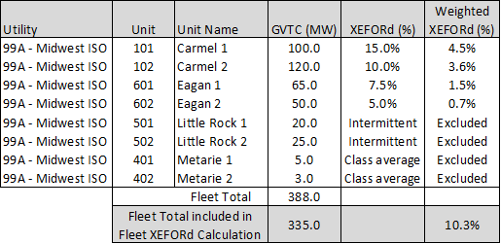
Formulas
- Unit Weighted Average XEFORd = (Unit GVTC (MW)) / (Total GVTC (MW) ) * (Unit XEFORd)
(for Carmel 1 weighted XEFORd is 100.0/335.0*15.0% = 4.5%)
- Fleet Total GVTC (MW) = Sum of GVTC (MW) for all units
(100.0 + 120.0 + 65.0 + 50.0 + 20.0 + 25.0 + 5.0 +3.0 = 388.0)
- Fleet GVTC w/ XEFORd = Sum of GVTC for all units with an XEFORd value
(100.0 + 120.0 + 65.0 + 50.0 = 335.0)
- Fleet Weighted XEFORd = Sum of Weighted XEFORd for all units
(4.5% + 3.6% + 1.5% + 0.7% = 10.3%)

- Annual CONE Calculation
MISO calculates gross Cost of New Entry (CONE) values for each LRZ for each Planning Year. This CONE value will be used for all Seasons within the entire Planning Year. MISO calculates CONE for each LRZ based upon the costs associated with an advanced combustion turbine generator (CT). MISO uses the following approach:

- MISO begins with an estimate of a CONE value not specific to an LRZ,
- MISO uses “the law of one price” where applicable (e.g., turbines that are sold competitively),
- MISO develops zonal differences to reflect different locational costs (e.g., labor, technical enhancements and others) using the most recent United States Energy Information Administration (EIA) document, and
- MISO uses the Net Present Value (NPV) algorithm to calculate CONE values for each LRZ.

MISO allows factors such as the weighted average cost of capital, escalation rates, and other factors where global competition drives prices to have no locational differences to be constant.

In order to determine the appropriate CONE value for each LRZ, MISO relies upon the most recent EIA report on “Capital Cost and Performance Characteristic Estimates for Utility Scale Electric Power Generating Technologies (EIA Report)”. The EIA Report contains detailed specifications for a hypothetical advanced CT, including information regarding the differences in project costs for an advanced CT with a nominal capacity of 237 MW, based upon the state where the facility is constructed. The report is available at:
https://www.eia.gov/analysis/studies/powerplants/capitalcost/.

MISO uses an NPV analysis to determine an appropriate CONE value for hypothetical advanced CTs located in each LRZ. In accordance with Section 69A.8.a of Module E-1, MISO considers many factors in its calculation of the CONE value, including the following: (1) physical factors (such as, the type of Generation Resource that could reasonably be constructed to provide Planning Resources, costs associated with locating the Generation Resource within the Transmission Provider Region, the estimated costs of fuel for the Generation Resource); (2) financial factors (such as, the hypothetical debt/equity ratio for the Generation Resource, the cost of capital, a reasonable return on equity, applicable taxes, interest, insurance); and (3) other costs (such as, costs related to permitting, environmental compliance, operating and maintenance expenses). MISO does not consider the anticipated net revenue from the sale of capacity, Energy or Ancillary Services.

CONE values for each Planning Year are based, in part, upon data supplied by the EIA, which are adjusted using the implicit price deflator from the Bureau of Economic analysis in order to convert EIA cost data into present value dollars. In order to produce the annualized CONE value for each LRZ from these cost numbers, for the 2023/2024 Planning Resource Auction MISO assumed: (i) a 55/45 debt to equity ratio; (ii) a 20-year project life and loan term; (iii) a 5.16 percent debt interest rate; (iv) a 2.2 percent Operation and Maintenance escalation factor; (v) a 2.2 percent GDP deflator; (vi) a 25-31 percent combined effective federal and state tax rate; (vii) property tax and insurance costs of 1.5 percent of the capital costs; (viii) a calculated weighted average cost of capital of 7.99 to 8.17 percent; (ix) and a 13.4 percent after tax internal rate of return on equity. None of these factors vary by LRZ to any significant degree that is discernible in available data. MISO will continue to examine these factors in the future to determine if any LRZ specific modifications are indicated. These factors and assumptions are comparable to those used by other RTOs in the development of CONE estimates.

Steps for calculating CONE
- Obtain latest ‘Base Project Cost $/kW’
Obtain the latest Energy Information Administration (EIA) report for EIA, Capital Cost and Performance Characteristic Estimates for Utility Scale Electric Power Generating Technologies. It provides the following data:
- Plant Capital Cost in $/kW. MISO currently uses the number for advanced CT.
- Location Based Costs Table: Location Percent Variation, Delta Cost Difference and Total Location Project Cost columns

- Use Bureau of Economic Analysis (BEA) data to calculate implicit price deflator
Use Table 1.1.9 - Implicit Price Deflators for Gross Domestic Product from NIPA data. Using the table, calculate the Escalation Rate from base year to planning year, based on historical and projected quarterly PCE deflator values. Use this Escalation Rate to calculate “Total Location Project Cost” in current year dollars.
- Calculate LRZ and Base total capital costs, adjusted by multiplying with the Escalation Rate
For LRZs - Use averages of adjusted project costs for locations (for which data is available) in each zone.
- Calculate the after-tax weighted average cost of capital (WACC)
WACC = (E * R_{e}) + (D * R_{d} * (1 – T_{c})).
Where E = Equity Fraction of Project
R_{e} = Cost of Equity. Assume as the after-tax IRR
D = Debt Fraction of Project
R_{d} = Cost of Debt (20-year BB corporate bond rate)
T_{c} = Combined effective federal and state tax rate
- Calculate estimated annualized costs for each LRZ and also for the Base.
- Calculate annualized capital costs using total capital costs, after-tax WACC and assuming the project lifespan. (Use PMT function)
- Calculate the O&M costs based on O&M data, project lifespan, WACC and US GDP Deflator (Use PMT and NPV functions)
  - Assume suitable O&M escalation factor
  - Assume/Update US GDP Deflator
- Assume insurance and property tax costs.

- Example Scenarios of “Excess BTMG"
This Appendix shares a few illustrative examples of how BTMG may change to “Excess BTMG” from one year to the next. The examples below show how some specific factors may cause BTMG to be classified as “Excess BTMG” from one year to the next. Below are four examples of “Excess BTMG”.
(All PRMR being referred in this appendix are Final PRMR cleared through PRA auction)
- Increase in BTMG and No Change to Seasonal PRMR
The chart below illustrates the scenario in which a Market Participant experiences an increase in BTMG SAC from one year to the next while PRMR remains unchanged. In Year 1, the chart shows that the BTMG SAC is 100 MW and the seasonal PRMR is 100 MW; therefore, the Market Participant has no “Excess BTMG” in Year 1. Between Year 1 and Year 2, the Market Participant experiences an increase in BTMG of 25 MW—however, seasonal PRMR remains unchanged. In Year 2, the chart shows that BTMG SAC is 125 MW and the seasonal PRMR is 100 MW; therefore, the Market Participant has 25 MW of “Excess BTMG” in Year 2.

- Increase in Demand Resources and/or Demand Response Resources and No Change to PRMR

The chart below illustrates the scenario in which a Market Participant experiences an increase in DR / DRR SAC from one year to the next while seasonal PRMR remains unchanged. In Year 1, the chart shows that the BTMG SAC is 100 MW and the seasonal PRMR is 100 MW; therefore, the Market Participant has no “Excess BTMG” in Year 1. Between Year 1 and Year 2, the Market Participant experiences an increase in DR / DRR SAC of 25 MW, however, seasonal PRMR remains unchanged. In Year 2, the chart shows that DR / DRR is 25 MW and BTMG is 100 MW and the seasonal PRMR is 100 MW. Since DR / DRR is netted against seasonal PRMR, the BTMG is stacked on top of the DR / DRR; therefore, the Market Participant has 25 MW of “Excess BTMG” in Year 2.

- No Change to BTMG and Decrease to Seasonal PRMR
The chart below illustrates the scenario in which a Market Participant experiences a decrease in seasonal PRMR from one year to the next while BTMG SAC remains unchanged. In Year 1, the chart shows that the BTMG is 100 MW and the seasonal PRMR is 100 MW; therefore, the Market Participant has no “Excess BTMG” in Year 1. Between Year 1 and Year 2, the Market Participant experiences a decrease in seasonal PRMR of 20 MW, however, BTMG SAC remains unchanged. In Year 2, the chart shows that BTMG is 100 MW the seasonal PRMR is now 80 MW; therefore, the Market Participant has 20 MW of “Excess BTMG” in Year 2.

- Equal Amount Increase in DR / DRR and Seasonal PRMR
The chart below illustrates the scenario in which a Market Participant experiences an equal increase in DR / DRR SAC and seasonal PRMR from one year to the next while BTMG SAC remains unchanged. In Year 1, the chart shows that the BTMG is 100 MW and the seasonal PRMR is 100 MW; therefore, the Market Participant has no “Excess BTMG” in Year 1. Between Year 1 and Year 2, the Market Participant experiences an equal increase in DR / DRR and seasonal PRMR of 20 MW each, however, BTMG remains unchanged. In Year 2, the chart shows that DR / DRR is 20 MW, BTMG is 100 MW and the seasonal PRMR is 120 MW. Since DR / DRR is netted against seasonal PRMR, the BTMG is stacked on top of the DR / DRR, however, due to the equal increase in DR / DRR and seasonal PRMR there is no “Excess BTMG” in Year 2.

- ICAP Deferral Notice

ICAP Deferral Notice
Midcontinent Independent System Operator
720 City Center Drive
Carmel, IN 46032-7574
Attn.: Resource Adequacy
(Delivered via email to help@misoenergy.org)

[Current Date]

[Insert Company Name] ICAP Deferral Notice – [Planning Resource Name/CPNode Name, if applicable]
Select Planning Resource being deferred:
☐Generation Resource – [Insert CPNode Name, Unit Number]
☐Dispatchable Intermittent Resource (DIR) – [Insert Name]
☐Demand Response Resource (DRR) – [Insert Name]
☐External Resource – [Insert Name]
☐Behind the Meter Generation (BTMG) – [Insert Name]

Dear Resource Adequacy,

[Insert Company Name] is providing this written notification in accordance with Section 69A.7.9 of the Midcontinent Independent System Operator (MISO) Tariff, Module E-1 Resource Adequacy regarding an Installed Capacity (ICAP) Deferral for the Planning Resource selected above. [Insert Company Name] intends to increase ICAP between March 1 and the last Business Day of the applicable Season(s) for the [Insert Planning Year] Planning Year.
[Contact Name, Phone Number and Email] | Planning Resource Type
MISO MP ID/NERC ID of Company
Planning Resource Name
Local or External Resource Zone (LRZ or ERZ) where located
Planning Resource Fuel Type
Estimated ICAP Value (MW)  Note: this is the total ICAP value not the incremental increased value from a prior ICAP | Summer
 | Fall
 | Winter
 | Spring
Check applicable deferred Season(s) | Summer [ ], Fall [ ], Winter [ ], Spring [ ]
Estimated completion date of ICAP
Reason for deferring (See Appendix U)
Please fill out the following that is applicable to the Planning Resource being deferred:
Generator Interconnection Agreement (GIA) Number and expected contract execution date Note: only necessary if deferral includes upgrades to Interconnection Service
Expected NRIS and ERIS values with Interconnection Service upgrades
Commercial Operation Date
TSR Number

Sincerely,
[Name], [Title – must be an officer], [Company Name], [Contact Information]

- ICAP Deferral Examples
- Deliverability
Example 1: Unit is capable of testing at 150 MW, but currently only has 100 MW of NRIS with MISO. The unit is in the queue to have its NRIS increased to 150 MW by the last Business Day prior to the start of a Season in the upcoming Planning Year. Although the difference is 50 MW, the MP would submit an ICAP Deferral Notice for the total ICAP amount of 150 MW. For a Schedule 53 resource, even though the ICAP will increase, SAC will not. For a non-Schedule 53 resource, both ICAP and SAC will increase.

- Increased GVTC and Deliverability
Example 1: Unit currently tested for 100 MW and has 100 MW of NRIS. The unit is in the queue to have NRIS increased to 150 MW and plans to retest after upgrades are in place. Although the difference is 50 MW, the MP would submit an ICAP Deferral Notice for the total ICAP amount of 150 MW. Please note that the current unit should already submit a GVTC test of 100 MW by October 31.

- Commercial Operation
Example 1: The unit currently is subject to an environmental regulation that prevents the unit from operating. The unit is in the process of installing additional equipment to comply with the new environmental regulation. Thus, the unit is deferring GVTC until after all necessary approvals are completed.

Example 2: A resource that is a Dispatchable Intermittent Resource (DIR) would not submit GVTC, but instead receives capacity accreditation based on past historical data. If a DIR is new and is not expected to have Commercial Operation approved until after March 1, then it would be eligible to qualify for capacity credit by submitting an ICAP Deferral for Commercial Operation if Commercial Operation is expected before the last Business Day of prior to the deferred Season.

Example 3: The unit is currently waiting for upgrades to existing Interconnection Service and the upgrades have been completed, however, the unit has yet to be declared Commercial with MISO. The resource owner needs to file an Exhibit E with MISO Resource Integration to finalize the Commercial Operation of the unit. The unit must be in the March Commercial Model prior to the start of the Planning Year. Once this has been done, the Commercial Operation deferral will be considered complete. The resource owner should assist with coordination with MISO Resource Adequacy and MISO Resource Integration throughout the process.

- Suspension of Catastrophic Outage
Example 1: A unit is planning to return from suspension in August and will submit a new GVTC for the upcoming Fall Season prior to the last Business Day of the summer Season. Units returning from suspension are required to retest. The MP may defer the retested value.

- TSR Number
Example 1: A unit is planning to participate in the upcoming Planning Year; however, the unit does not have a Transmission Service Request (TSR) or NITS Scheduling Rights (SR) on the MISO OASIS with a status of “Confirmed” by March 1 to convert the SAC to ZRC to offer into the Auction. The unit expects to have its TSR or SR Confirmed by MISO prior to the last Business Day of prior to the start of the deferred Season. Once the TSR achieves “Confirmed” status on the MISO OASIS, the MP should reach out to help.misoenergy.org. If the TSR or SR status is “Confirmed” prior to June 1, the deferral requirement has been met.

- Additional GVTC Examples
Example 1: The unit defers 100 MW and the test submitted is for 80 MW. The unit is required to replace the UCAP value of 20 ICAP MW. For example, if the XEFORd for the unit is 25%, then the deferred ZRCs is 75 and the submitted test ZRCs is 60. The MP is required to replace the difference of 15 ZRCs through Resource Replacement, Interconnection Service, Cleared Volumes, Bi-lateral ZRC transactions, etc.

- Solar and Run-of-River Hydro Accreditation
This appendix walks through examples for calculating solar and run-of-river hydro accreditation. For existing solar resources, the total Seasonal Accredited Capacity (SAC) is determined by the historical average output of the resource during the Summer, Fall, and Spring Seasons for the hours ending 15, 16, and 17 EST and for hours ending 8, 9, 19, and 20 EST for the Winter Season. Existing run-of-river hydro resources can submit up to 15 years of output data over the same hours as for solar resources, with total SAC determined by the median of that data. Market Participants will use the Non-GADS Performance Template found on the MISO website to submit the appropriate historical data for the upcoming Planning Year. The Non-GADS Performance Template can be found on the MISO website under Planning > Resource Adequacy > PRA Documents > PY (Current Plan Year). The populated template should be submitted to MISO by October 31 of each year via the Module E Capacity Tracking (MECT) tool.

For new solar resources, the maximum SAC that can be accredited is 50% for summer, fall, and spring and 5% for winter of the unit’s registered maximum output or nameplate capacity. To convert all SAC to seasonal ZRCs, the resource would need to show firm deliverability through NRIS or ERIS with a firm TSR equaling the resource’s ICAP value.

For existing solar resources, the historical performance used to calculate the resource’s total SAC for a given Season is based on their average output over the defined seasonal peak hours for the last 3 years.
- The amount of total SAC that is convertible into ZRCs is based on the amount of deliverability (NRIS or ERIS with a firm TSR)
- Convertible SAC = total SAC * (deliverability-adjusted capacity factor / peak performance capacity factor)
- Where:
  - Peak performance capacity factor is calculated is calculated by taking an average of the resource’s output and then dividing by nameplate capacity.
  - Deliverability-adjusted capacity factor is calculated by adjusting the adjusting output across the seasonal peak hours so that it is capped to the resource’s deliverability, taking an average of the resource’s output, and then dividing by nameplate capacity.

The examples below show how solar capacity credit is calculated for new resources in the Summer Season only—however, the examples may also be applied to run-of-river hydro resources as well. For the purposes of the examples, the following information will be used in each:

Solar Nameplate = 10 MW
Transmission Losses (vary by LBA) = 5%
Solar Class Average Summer Capacity Credit = 50%
Year 1 Average Historical Summer Output = 6.5 MW (Year 1 data only)
Year 2 Average Historical Summer Output = 7.0 MW (Average of Years 1 and 2 data)

Example 1: New solar (or run-of-river hydro) resources with less than 30 consecutive Summer days or no Summer data
In this example, the new solar resource does not have any historical Summer performance data to submit. Thus, the solar resource will receive the solar class average accreditation for the initial Summer Season in the Planning Year. In Year 2, the resource will use the average (run-of-river hydro resources use a median value) historical Summer performance from Year 1 to determine the accredited amount. In Year 3, the resource will use the average historical Summer performance from Years 1 and 2. In Year 4, the resource will use the average historical Summer performance from Years 1, 2, and 3. In Year 5, the average historical Summer performance from Year 1 will be replaced by Year 4 and the cycle will continue to repeat year-over-year using the 3 most recent years of average historical Summer performance. Below are examples of how both BTMG and CPNode solar resources will be accredited.

BTMG
Year 1 à SAC_{BTMG} = Nameplate capacity * seasonal class credit * (1 + Transmission Losses)
à SAC_{BTMG} = 10 * 50% * (1 + 5%)
à SAC_{BTMG} = 5.25

Year 2 à SAC_{BTMG} = 10 * (65%) (1 + 5%)
à SAC_{BTMG} = 6.8 (rounded to tenth decimal place)

Year 3 à SAC_{BTMG} = 10 * (70%) (1 + 5%)
à SAC_{BTMG} = 7.4 (rounded to tenth decimal place)

CPNode
Year 1 à Total SAC_{CPNode} = Nameplate capacity * seasonal class credit
à Total SAC_{CPNode} = 10 * (50%)
à Total SAC_{CPNode} = 5.0

Year 2 à Total SAC_{CPNode} = 10 * (65%) = 6.5

Year 3 à Total SAC_{CPNode} = 10 * (70%) = 7.0

Example 2: New solar resource with at least 30 consecutive Summer days
In this example, the new solar resource has at least 30 consecutive Summer days of performance. Thus, the solar resource will not receive the solar class average for the initial Planning Year. In Year 1, the average historical Summer performance from Commercial Operation data will be used to determine the accredited amount. In Year 2, the resource will use the average historical Summer performance from Year 1 and 2. In Year 3, the resource will use the average historical Summer performance from Years 1, 2, and 3. In Year 4, the average historical Summer performance from Year 1 will be replaced by Year 4 and the cycle will continue to repeat year-over-year using the 3 most recent years of average historical Summer performance.
BTMG
Year 1 à SAC_{BTMG} = Nameplate capacity * seasonal class credit * (1+ Transmission Losses)
à SAC_{BTMG} = 10 * (65%) * (1 + 5%)
à SAC_{BTMG} = 6.8 (rounded to tenth decimal place)

Year 2 à SAC_{BTMG} = 10 * (70%) * (1 + 5%)
à SAC_{BTMG} = 7.4 (rounded to tenth decimal place)

CPNode
Year 1 à Total SAC_{CPNode} = Nameplate capacity * seasonal class credit
à Total SAC_{CPNode} = 10 * (65%)
à Total SAC_{CPNode} = 6.5

Year 2 à Total SAC_{CPNode} = 10 * (70%)
à Total SAC_{CPNode} = 7.0

Once the total SAC value for a resource has been determined, it is compared with the Interconnection Service assigned to that resource. Resources that are fully deliverable are eligible to convert all of their total SAC to ZRCs with no further action needed.
For resources that are not fully deliverable, having either partial or no deliverability, the following steps would be used:
- MISO calculates a deliverability-adjusted capacity factor for the resource.

- For SAC not considered convertible, the Market Participant may choose to obtain firm Transmission service in some level to convert some or all of the undeliverable SAC to Convertible. MISO supplies documentation to the MP on the MECT tool that can be used to determine the level of SAC that can be converted given some level of firm Transmission obtained.

- Subsequently, the MP uses the Confirm SAC function to move the desired Convertible SAC amount to the Convert SAC MECT page. Once there, the associated firm Transmission information is entered after selecting the ERIS SAC value.

- After MISO approval of the firm Transmission data that was entered by the MP, the SAC may then be converted to ZRCs for use in the PRA.

SAC is allocated by type of Interconnection Service (NRIS or ERIS with a TSR). SAC associated with ERIS may be converted into Zonal Resource Credits for use in the PRA with an approved Transmission Service Request.

- Hybrid and Co-Located Resource Accreditation
This appendix describes the accreditation process for Hybrid Resources and Co-Located Resources. A Hybrid Resource is defined as a resource that is comprised of two or more separate Electric Facilities that share a single Point of Interconnection and that provides a single energy offer in the MISO DA/RT Energy Markets. A Co-Located Resource is defined as a resource that is comprised of two or more separate Electric Facilities that share a single Point of Interconnection where each separate Electric Facility provides separate energy offers in the MISO DA/RT Energy Markets.
Hybrid Resources and Co-Located Resources will be accredited in one of two phases depending on how much operating data is available. The Phase I – Sum of Parts approach will apply default class accreditation values for each separate Electric Facility comprising the Hybrid Resource or Co-Located Resource. The Phase II – Availability-based approach will consist of tracking the historic availability of each separate Electric Facility of the Hybrid Resource or Co-Located Resource. A Hybrid Resource or Co-Located can be Phase I for a Season and then get Phase II for a subsequent Season that it has operational data for. Once a Hybrid Resource begins receiving Phase II availability-based accreditation, the resource will continue to receive Phase II availability-based accreditation.
For Co-Located Resources, allocation of total Interconnection Service at the shared Point of Interconnection among the separate Electric Facilities must be provided to MISO Resource Adequacy staff by the incumbent Asset Owner, or the Market Participant(s) representing the incumbent Asset Owner, prior to conversion of Seasonal Accredited Capacity (SAC) to Zonal Resource Credits (ZRCs).
Phase I – Sum of Parts
Each Hybrid Resource or Co-Located Resource may be operating in very different ways from other Hybrid Resources or Co-Located Resources with a similar configuration depending on the goals of the resource owner and operator. Until historical operating data exists, default class accreditation values for each separate Electric Facility comprising the Hybrid Resource or Co-Located Resource will be applied. Co-Located Resource owners must inform MISO how the total Interconnection Service granted at the shared Point of Interconnection should be allocated among each separate Electric Facility for conversion purposes. Phase I accreditation will apply for each Season until a minimum of 30 consecutive historical days of operation for the corresponding Season have been observed.
For Phase I, Market Participants must submit a populated Non-GADS Performance Template to MISO through the MECT for each separate Electric Facility that includes the nameplate capacity (or registered maximum output from the Commercial Model) and resource type of each Electric Facility, unless the Electric Facility qualifies as a Schedule 53 resource.
Phase II – Availability-based
Phase II accreditation will apply after a Hybrid Resource or Co-Located Resource has sufficient operating history to determine a resource-specific seasonal accreditation value.
Availability is measured as historical net output (exception for ESR below) and will be determined in the following ways:
- For Hybrid Resources, the combined historical net output of each Electric Facility, provided via a single populated Non-GADS Performance Template.
- For Co-Located Resources, the separate historical net output of each Electric Facility, provided via several populated Non-GADS Performance Templates.
- For the ESR component of a Hybrid Resource or Co-Located Resource, availability for a given hour will be measured as the maximum of the net output or the output potential on that hour. Output potential should be determined as the minimum of the Hourly Equivalent Discharge Amount or the state of charge minus the Emergency Minimum Energy Storage Limit for a given hour.

Market Participants must submit Non-GADS Performance Templates to MISO through the MECT. In addition to historical operating performance, populated Non-GADS Performance Templates must include nameplate capacity (or registered maximum output from the Commercial Model) and resource type.

- SAC Calculations for Schedule 53 Resources
This appendix describes the process of calculating Seasonal Accredited Capacity (SAC) for Schedule 53 Resources.
- Identification of Resource Adequacy Hours
Resource Adequacy (RA) Hours represent the periods of highest risk and greatest need during a Season and throughout the year. They include Emergency Declaration periods and the hours when the operating margin, a measure of available supply capacity above Demand and reserve requirements, is at its lowest. RA Hours are determined seasonally and at a subregional level (North/Central and South) based on emergency events, the tightest operating margin hours (65 hours per Season), and a maximum operating margin threshold established at 25 percent.
RA Hours will be used to determine each resources’ availability for calculating its seasonal accreditation. The number of RA Hours in a Season can exceed the target when a high number of hours during declared system or subregional emergencies occurs.
Provisions also ensure Seasons have a minimum target number of RA Hours by supplementing any deficient hours with Annual Average Offered Capacity (AAOC) over all RA hours across the year. The RA Hours used for determining the AAOC (or AAOC Hours) are the hours with emergency events and the tightest 3 percent of operating margin hours below the 25% threshold for each year, up to 260 hours per year. The AAOC Hours are determined on a sub-regional (North/Central and South) basis. Not all AAOC Hours are RA hours.
  - Definition and Identification of RA Hours
RA Hours are defined over the three most recent historical years from September - August, based on declared MaxGen alert, warning and event hours supplemented by the tightest 3 percent of hours per Season where the realized operating margin for the region is at or below the threshold of 25 percent.
    - Hourly Operating Margin Calculation
The Operating Margin is determined using historical information to identify RA Hours and AAOC Hours within the three (3) most recent periods beginning September 1 and ending August 31.
We first express the power balance between load and supply, where:
$Load=Thermal Resource Energy+Renewable Energy+Net Scheduled Interchange$ (1)
$Supply=Thermal Resource EmergencyMax+Renewable Energy+Net Scheduled Interchange-Operating Reserve$ ______________ (2)
Substituting (1) into (2), we have
$$Margin\left(MW\right)=\left[Thermal EmergencyMax+Renewable Energy+Net Scheduled Interchange \left(NSI\right)\right]-\left[Thermal Energy+Renewable Energy+Net Scheduled Interchange\right]-Operating Reserve=Thermal Resource EmergencyMax-Thermal Resource Energy-Operating Reserve$$
The power balance between equation (1) and (2) suggests the renewable Energy and net-scheduled interchange have been implicitly reflected in the margin calculation but has no impact on the overall margin calculation used for RA hour identification as in the steps below.
By re-arranging the $Margin\left(MW\right)$ and broken down to online and offline components, we re-express the Operating Margin Equation as below
$${Operating Margin (\%)}_{j}=\frac{{Online margin (MW)}_{j}+{offline margin (12 hour leadtime)(MW)}_{j}}{{Real Time \left(RT\right)Load (MW)}_{j}}$$
Where:
$${Online margin (MW)}_{j}=\sum_{unit i in region j}{({EmergencyMax}_{i}-{EnergyMW}_{i}-{cleared operating reserve}_{i})}$$
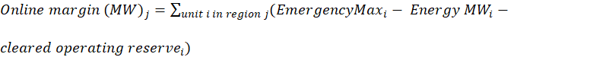for all Resources that are online and under normal dispatch control; and
$${Offline margin (MW)}_{j}=\sum_{unit i in region j}{({EmergencyMax}_{i}-{cleared offline supplement reserve}_{i})}$$
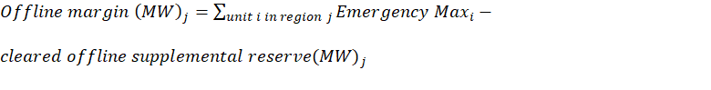for Resources where all of the following is true: (i) Resource is Offline; (ii) its cold-start lead-time is less than or equal to 12 hours; and (iii) it is not on outage.
Load Modifying Resource (LMR), and Emergency Demand Response (EDR) are excluded in the Online margin (MW) and Offline margin (MW) calculations because they require emergency declarations in order to access.
    - Selection of RA Hours
Hours during which MaxGen declarations are in effect automatically become RA Hours, including all MaxGen Alert, Warning, or Event hours declared in each Season within each of the three (3) most recent September-August periods.
For non-MaxGen declaration hours in each of the 12 Seasons of the past three-year period, additional RA Hours with the tightest margin will be identified until reaching the (65 hours) for each Season; if a Season already has more than 65 hours because of MaxGen declaration, this step will be skipped.
Finally, a maximum margin threshold is applied to exclude hours with an operating margin greater than 25 percent.
Going through the steps above, some Seasons will have more than 65 hours because of MaxGen declarations, while some other Seasons may have less than 65 hours if there are hours excluded based on the 25 percent maximum margin threshold criterion and a low number of hours with MaxGen declarations, reflecting underlying Demand, supply and weather conditions. The deficiency from the 65 target hours leads to the need for AAOC Hour as described in the next section.
Additionally, each individual resource will have its own set of RA hours that are dependent on outage exemptions and whether it was designated for Resource Adequacy Requirements (RAR) in previous year’s seasonal auctions. Like the system-wide RA hours, if a resource has deficient RA hours in a Season, that resource’s AAOC will be supplemented for the deficient hours.
Non-RAR resources are not subject to SAC calculation using seasonal RA and AAOC hours.
If the unit was designated as RAR within the 3-year lookback period, the following logic will apply.
- When a unit is RAR and has 60 days or more during the 3-year lookback period of that particular Season’s operational data, for that Season SAC will be calculated with that historical operational data. Operating days that a unit was in full outage will be excluded from the statistics.
- If the unit has less than 60 days of data designated as a RAR for that Season over the 3-year lookback period they will receive Schedule 53 seasonal class average SAC accreditation. Operating days that a unit was in full outage will be excluded from the statistics.
- For resources that have a generation capacity change due to upgrades or seasonalization that had a non-zero offer historically, the RT EmerMax will be prorated based on the capacity change/ICAP% of the historical offers, capped at the new GVTC of the resource.
- For resources that have a generation increase due to upgrades or seasonalization, that have zero historical offer information, will receive Schedule 53 seasonal class average SAC accreditation for that Season
- In the case where a schedule 53 generator was derated due to transmission limitations imposed by the incumbent Transmission Operator, the MP can work with MISO to determine if any exemptions for those hours can be granted
- Exemption status for a unit’s outage should be validated and resolved with MISO if needed, per timeline defined in BPM-008 (Business Manual -- Outage Operations)
    - Selection of AAOC RA Hour
Hours where MaxGen declarations are in effect automatically become AAOC RA Hours, including all MaxGen Alert, Warning, or Event hours declared in each Season within the three (3) most recent periods.
For the rest of non-MaxGen declaration hours in each year of the past three-year periods, additional AAOC RA Hours with the tightest margin will be identified until reaching the (260 hours) for each year. For a unit to receive exemption for an AAOC hour they must have Tier 2 exemption during that hour.
    - Illustration of Selected RA Hour
The figure below, using South region as example, illustrates the variation of hourly Margin (%) between September 1, 2020, and August 31, 2021, and labels the selected RA Hour / AAOC Hour. In this example, there are 65 RA Hours identified in each of the four Seasons, hence the AAOC Hour will not be needed for backfilling any deficiency hour.
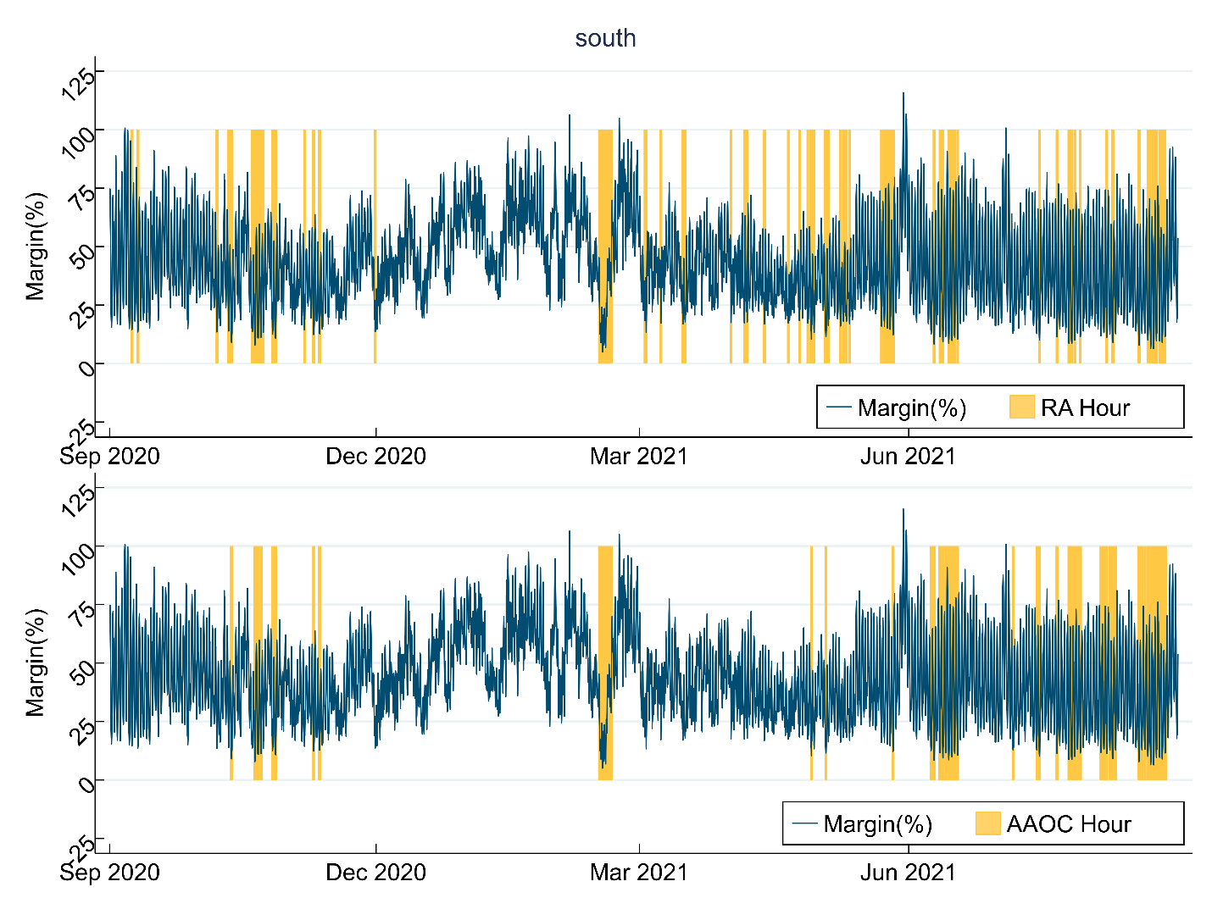

  - Seasonal Accredited Capacity Calculation
Resource Accreditation should reflect the anticipated capability and availability of Planning Resources during times when they are most needed. The following sections illustrate the two-tiered weighting structure to calculate Intermediate Seasonal Accredited Capacity (ISAC) reflecting general availability while emphasizing availability during times of greatest need. Each Resource will have its ISAC determined based on its Real-Time offered availability (Emergency Maximum Limit) during seasonal RA Hours (Tier 2) as described in Section 1.1 and Non-RA Hours (Tier 1).
    - Prepare Hourly Real-Time Offered Availability Dataset
The first step is to prepare the hourly Real-Time Offered Availability dataset for a Resource, including (1) hourly timestamp (EST); (2) offered Real-Time availability (EmerMax MW); (3) lead time(Start up time + Start up notification time) (in hours); (4) binary indicator if a resource is in outage from either the commit status or from records in Control Room Operations Window (CROW) Outage Scheduler; (5) binary identifier indicating if a Resource is online.; (6) ICAP (MW); and (7) binary indicator if a resource has received outage exemption.
Figure below provides a sample screenshot of the dataset, using a sample Resource located in Central/North region. If a Resource is in Derated status but not in outage, its offered availability already accounts for the impact of derates.
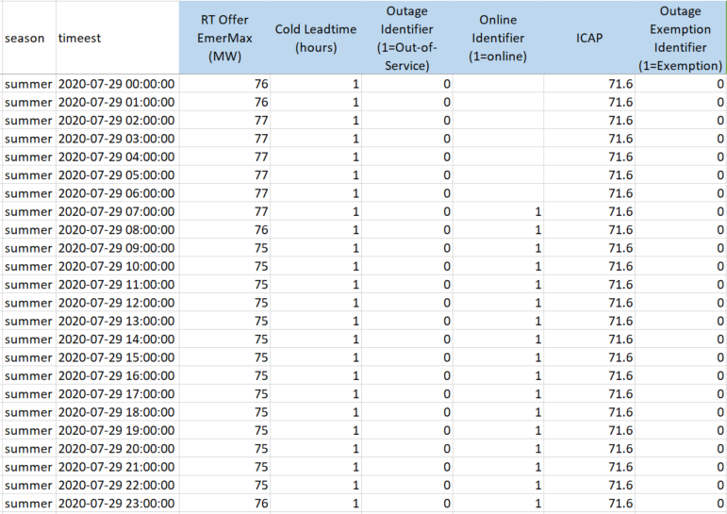
In sample data above, the outage indicator is set to 1 (outage) either if there is a valid full outage ticket in CROW or the unit was offered as outaged in real time for the specific hour. The online indicator is based on unit’s control mode from ICCP data as described in 2.4.7 in BPM-031 (ICCP Data Requirement).
    - Prepare Calculation for Annual Average Offered Capacity (AAOC)
If a Resource does not have 65 RA hours in a Season, AAOC is needed for backfilling the availability during deficiency hours in later steps. To calculate AAOC, the RT Offer EmerMax data is paired with AAOC hours by timestamp. Availability (MW) during AAOC hour is then generated through these following steps:
(1) Set availability = Min (ICAP, Real-Time Offer EmerMax) during AAOC hour; this step caps RT Offer EmerMax at ICAP;
(2) Set availability = zero if a Resource is in outage (based on outage identifier) during AAOC Hour;
(3) Set availability = zero if a Resource is not online and not in outage and has lead time (Start up time + Start up notification time) greater than 24 hours during AAOC Hour.
(4) Set availability = NULL if a Resource has been granted outage exemption during AAOC Hour.
Figure below shows the sample dataset fragment after generating the availability (MW) during AAOC hour through the steps described above.
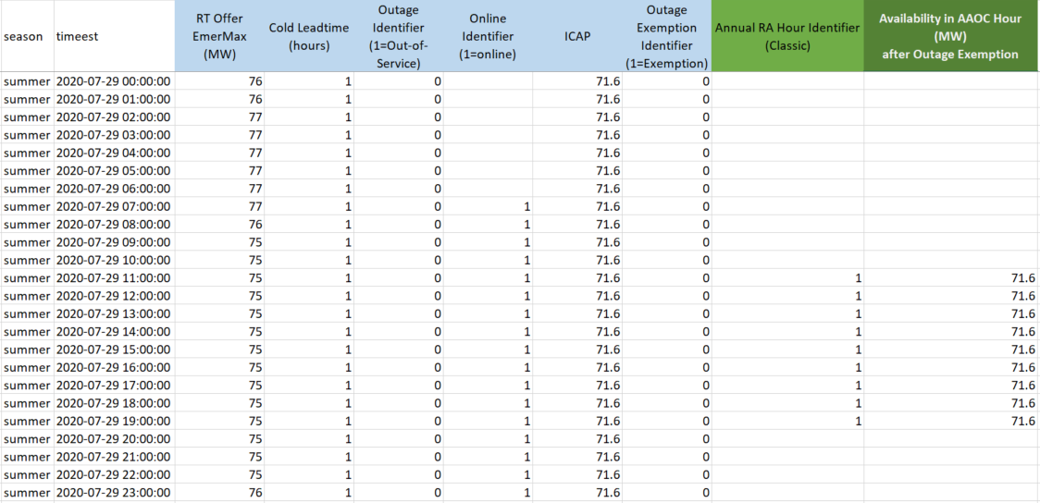
    - Prepare Calculation for Intermediate Seasonal Accredited Capacity (ISAC)
To calculate SAC, the RT Offer EmerMax data is paired with RA Hour by timestamp. Availability (MW) during RA Hour is then generated through these following steps:
For availability during Tier 1 Non-RA Hour:
(1) Set availability = Min (ICAP, Real-Time Offer EmerMax) during Tier 1 Non-RA hour; this step caps RT Offer at ICAP;
(2) Set availability = zero if a Resource is in outage (based on outage identifier) during Tier 1 Non-RA Hour;
(3) Set availability = NULL if a Resource has been granted outage exemption during Tier 1 Non-RA Hour.
For availability during Tier 2 RA Hour:
(1) Set availability = Min (ICAP, Real-Time Offer EmerMax) during Tier 2 RA hour; this step caps RT Offer at ICAP;
(2) Set availability = zero if a Resource is in outage (based on outage identifier) during Tier 2 RA Hour;
(3) Set availability = zero if a Resource is not online and not in out-of-service outage and has lead time (start up time + Start up notification time) greater than 24 hours during Tier 2 RA Hour;
(4) Set availability = NULL if a Resource has been granted outage exemption during Tier 2 RA Hour.
Figure below shows the sample dataset fragment after generating the availability (MW) during seasonal Tier 1 and Tier 2 RA hour through the steps described above.
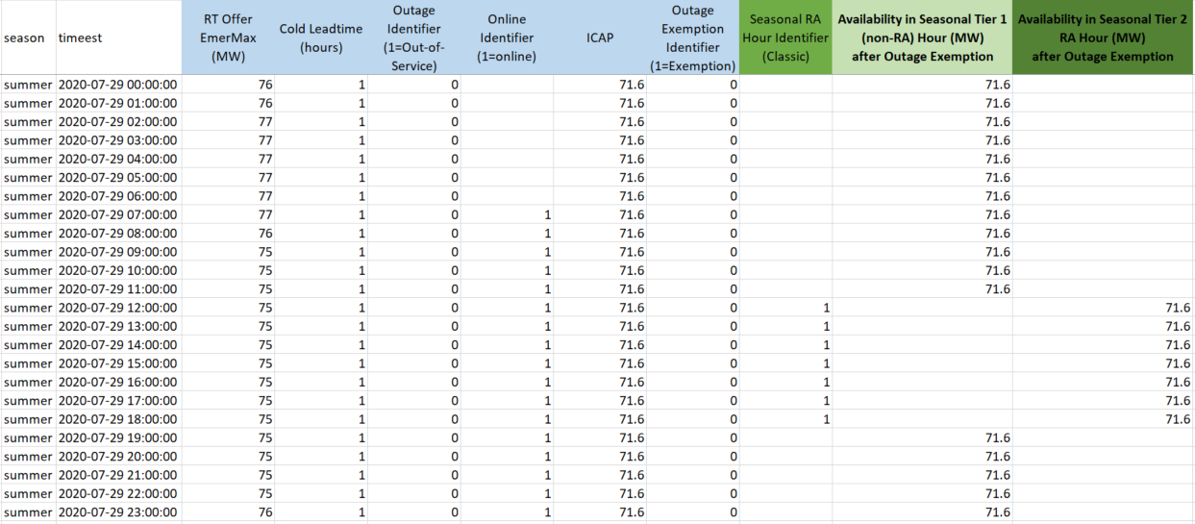
    - Calculation of Annual Average Offered Capacity (AAOC)
For each of the past three years, the AAOC is calculated as the sum of availability over AAOC hours, divided by the total number of AAOC hours (excluding outage exemption hours) in each year, as shown in the table below for a sample resource.
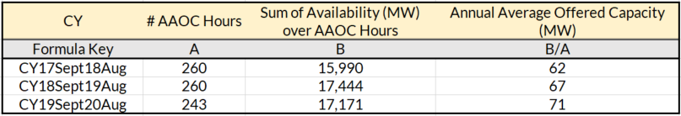
    - Calculation of Intermediate Seasonal Accredited Capacity (ISAC)
For Non-RA Hours (Tier 1), Intermediate Seasonal Accredited Capacity is calculated as the sum of availability over seasonal Tier 1 Non-RA hours, divided by the total number of seasonal Tier 1 Non-RA hours across the past three years.
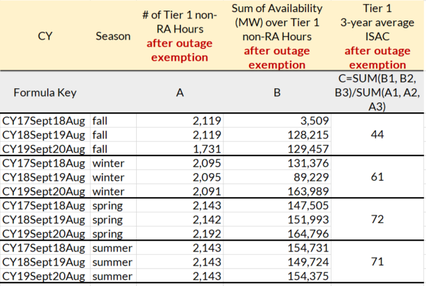
For RA Hour (Tier 2), its Intermediate Seasonal Accredited Capacity is calculated as the sum of availability over seasonal RA hours and AAOC multiplied by the deficient RA hours, then averaged over total number of Tier 2 RA hours across the past three years. A particular Season will be excluded from a unit’s tier 1 and tier 2 ISAC calculation if either condition is met: 1) a unit has not been designated as RAR for the Season or 2) it has not been offering into Real-Time market due to an exempt outage for the whole Season.
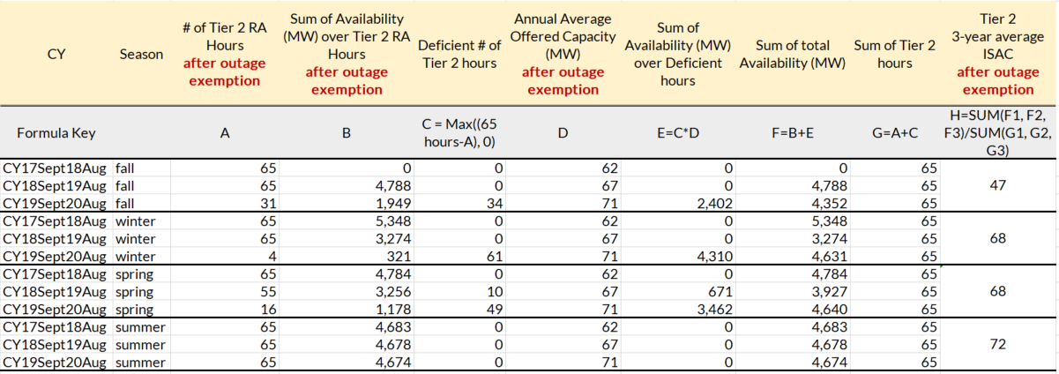
    - Tier Weighting of ISAC
The final Intermediate Seasonal Accredited Capacity (ISAC) value is the weighted averaged over its values from two tiers as calculated from steps above. The corresponding tier weightings are:
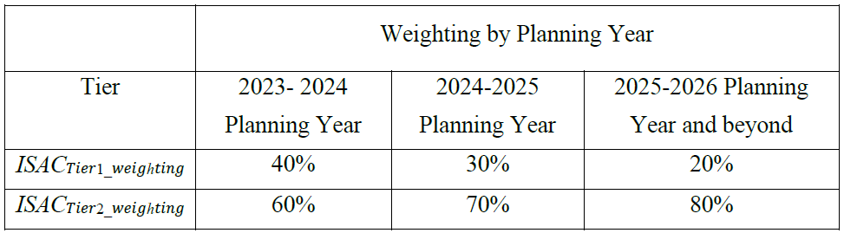
$${ISAC={ISAC}_{Tier 1 MW}×ISAC}_{Tier 1 weighting}+{ISAC}_{Tier 2 MW}×{ISAC}_{Tier 2 weighting}$$
The table below illustrates the ISAC of a sample resource.
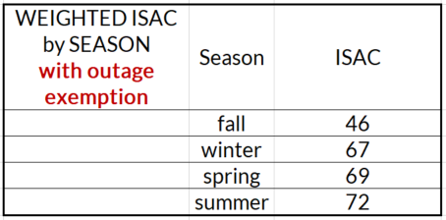
    - Final conversion to SAC
Lastly, the ISAC is converted back to SAC in UCAP term using the formula and as illustrated in the sample table below. The Conversion Ratio is calculated for each Season on a system-wide basis for all Schedule 53 resources.
$$SAC=ISAC×{Conversion Ratio}_{UCAP/ISAC}$$
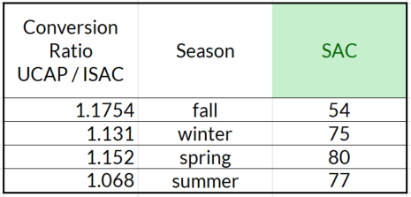

The following rules are applied for determining units to be included/excluded in ratio calculations.
1. Only resources are included in both LOLE study and SAC calculations for the same Season of planning year are included in the UCAP/ISAC ratio calculation.2. Resources that are granted with a class average for one or multiple Seasons, are not included in ratio calculation for the Season(s)
    - SAC calculation for Combined Cycle (CC)units
Due to complicated nature of modeling and market participation options for combined cycle units, MISO will calculate their ISAC/SAC values based on how they are modeled and historically been offered into the Real-Time market, and how the combined cycle units submit their test capacity (GVTC) data in MISO GADS data:
1. If the owner of combined cycle unit submits GVTC data on the parent CP node only, MISO will calculate the SAC value on the parent node, by combining the Real-Time children’s offer data if needed and capped at the latest GVTC. MISO will only provide planned outage exemptions for the SAC calculation, if all of the children units are fully outaged with valid exempt outage requests.
2.If the owner of combined cycle unit submits GVTC data on the children’s CP nodes, or submits GVTC data on the parent node, but with specified % split of each children node, MISO will calculate SAC values for each children CP node. MISO may need to split the Real-Time offer (Emergency Max) based on the % ratios of all the children’s GVTC data, if needed. In this scenario, each children’s exempt outage will be reflected in their own SAC calculations.
    - SAC calculation for Jointly Owned Units (JOU)
Jointly Owned Units (JOUs) SAC values will be calculated the same way as regular units as long as the owners submit their separate GVTC data in the MISO GADS system. For units that have experienced ownership and/or share percentage changes within the last 3 years where Real-Time offer data is used, MISO may need to combine all the owner’s Real-Time offers, capped by their total GVTC and then split again based on the latest GVTC ratios among ownerships before calculating each owner’s SAC values.
  - Class Average based SAC calculation
New Schedule 53 Resources or existing Resources that do not have at least 60 days of Real-Time offered availability when designated for RAR over the last three (3) years for each Season (Summer, Fall, Winter, Spring) will have a SAC based on the class average SAC to ICAP Ratio for its Resource type. MISO will calculate Schedule 53 class averages based on existing GADS fuel type categories from the existing MISO Schedule 53 fleet.

Per MISO’s discretion and agreement with the resource owner, MISO may grant the unit class average, if a unit’s operation and offer history no longer represents its future economical and physical characteristics.
Class averages (% values) are calculated based on units with sufficient Real-Time offer in each resource type by dividing their total seasonal ISAC values divided by total effective ICAP (lesser of GVTC or interconnection service):
$${Class Average \%}_{type of resource}={\sum_{type of resource}{ISAC}}/{\sum_{type of resource}{Effective ICAP}}$$

For units whose SAC is calculated based on a class average, their class average %
is applied to the unit’s ICAP (lesser of GVTC or Interconnection Service) to determine the ISAC. The UCAP/ISAC ratio per Season will then be applied to identify the final SAC for the Season

  - SAC conversion to ZRC

    - Allocate Total SAC into NRIS SAC and ERIS SAC based on Interconnection Service
Schedule 53 Resource’s Total SAC is allocated into NRIS SAC and ERIS SAC based upon its type of Interconnection Service.

$$Total SAC=NRIS SAC+ERIS SAC$$

To the extent the Planning Resource has Network Resource Interconnection Service (NRIS) or was determined to be aggregate deliverable through the market transition deliverability test, then that quantity will be allocated first to calculate the NRIS SAC as defined in Module E 69A.4.5

$$NRIS SAC=\min\left(NRIS, ICAP\right)×\frac{Total SAC}{ICAP}$$

The remaining balance of Total SAC is allocated to ERIS SAC with following formula:

$$ERIS SAC=\max\left(0,\left(ICAP-NRIS\right)\right)×\frac{Total SAC}{ICAP}$$
    - Eligibility of NRIS SAC and ERIS SAC Conversion into seasonal Zonal Resource Credits
The NRIS SAC represents capacity in MW that is eligible to be converted into seasonal Zonal Resource Credits.

In determining the amount of ERIS SAC eligible for conversion into seasonal ZRCs, the deliverability of any ERIS must be determined prior to ERIS SAC conversion. ERIS must be paired with firm Transmission Service that covers the entire Season to be considered deliverable. NRIS is automatically considered deliverable and does not require an additional Transmission Service Request. The full amount of ERIS SAC can be converted to ZRCs if the resource is fully deliverable to its ICAP amount.

Total SAC which can be converted into seasonal ZRCs are the summation of the Planning Resource’s NRIS SAC plus the lesser of the resource’s ERIS with firm Transmission Service.

This means a Demand Resource must have responded to a Scheduling Instruction on or after January 1, 2023 to qualify for this waiver provision in the 2026 / 2027 Planning Year.
This provision means that a Demand Resource that does not meet this waiver provision with the asset(s) being disaggregated does not meet the waiver requirements even after the asset(s) have been disaggregated.
This means a residential program may not be required to perform a real power test if the program grows by 15% (by household) from one year to the next, but if this program grows by another 15% and more than 20% of the original households are replaced in the program by the 2nd year, the aggregation must perform a real power test.
Additional details can be found in MISO’s Qualifying Facilities White Papers on the MISO website. Markets and Operations-> Markets and Operations-> Whitepapers.
In this document, a resource can offer only one price. Multiple price segments are treated as multiple resources.

