
1

Stakeholder Governance Guide
Effective 09.18.24

Table of Contents
Introduction 4
Definition of Terms 5
POLICY Document
- Leadership 7
  - Entity Leadership Selection 7
    - Soliciting Leadership Nominations for Non-Advisory Committee Entities 7
  - Electing the Chair and Vice Chair 7
  - Liaison and Stakeholder Relations Selection 8
  - Monitoring and Removal of Leadership 8
- Stakeholder Sectors and Voting Rights 9
- Voting 10
  - Assessing a Quorum 10
  - Voting by Proxy 10
  - Voting Eligibility and Voting Process 10
  - Reporting Results 10
  - Advisory Committee Voting 11
  - Roll Call Vote 11
  - Email Voting 11
- Issues 13
  - Issue Administration and Issue Selection Process 13
  - Strategic Prioritization 13
  - Issue Selection, Agenda Creation, and Addressing Issues 14
- Entity Formation, Suspension and Retirement 15
  - Requesting New Entities 15
  - Suspension of an Entity 15
1

  - Retirement of an Entity 15
  - Review of Subcommittees, Working Groups, Task Forces 15
- Steering Committee 15
  - Steering Committee 15
- MISO Meetings of Entities 17
  - Current Expectations for the Communication of Meeting Information: 17
  - Agenda Item/Late Motion 17
  - Determining Eligible Voters and Maintaining Voting List Accuracy 17
  - Stakeholder Representation and Participation 18
- Parliamentary Authority, Training and Amendments 19
  - Robert’s Rules of Order Newly Revised 19
  - Stakeholder Governance Training 19
- Amending the Governance Guide 20
PROCEDURES Document 21
- Leadership 21
  - Entity Leadership Selection for the Advisory Committee 21
  - Entity Leadership Selection for Non-Advisory Committee 21
- Stakeholder Sectors and Voting Rights… 22
  - Advisory Committee 22
    - Advisory Committee Voting Examples 22
- Issues 23
  - Issue Assignment 23
  - Issue Selection, Agenda Creation, and Addressing Issues 23
  - On-going Monitoring and Management 24
  - Issues Tracking Process Purpose 24
  - Entity Formation, Suspension and Retirement 25
    - Approval of a Proposed Entity 25
    - Denial of a Proposed Entity 25
    - Monitoring Entities… 25
    - Suspension of an Entity 25
    - Retiring an Entity 26
- Structure of Entities 28
- Advisory Committee Agenda Development
  - Advisory Committee Agenda Development Guidelines 29
- Meetings of Entities 30
  - Meeting Schedules 30
  - Posting requirement examples 30
  - Meeting Preparation 30
  - Addressing Motions on the Agenda 30
- Stakeholder Governance Guide Review Process
- Stakeholder Governance Training 33
Appendix 1 – Public Meeting Announcement 34
Appendix 2 – Leadership Roles and Responsibilities 35
Appendix 3 – Issue Debate Process 36
Appendix 4 – Charter Template 37
Appendix 5 – Management Plan Template 38
Appendix 6 – Proposal for a New Entity Template 39
Appendix 7 – Subordinate Entity Status Report Template 40
Appendix 8 – Main Parent Entity Status Report to the BOD/AC/SC 41

Appendix 9 – Issue Submission Web Form 42
Appendix 10 – Issue Submission Presentation to the Main Parent Entity Template. 43
Appendix 11 – Business Practice Manual Responsibility Matrix 44
Appendix 12 – MISO Code of Conduct ……………………………………………………………………..45

Introduction

The purpose of this Governance Guide is to provide the Midcontinent Independent System Operator, Inc. (or “MISO”) Stakeholders an overview of the structure and operation of committees, subcommittees, working groups, and task forces. All of these Stakeholder Entities shall follow the rules and processes contained herein, which are based on Robert’s Rules of Order Newly Revised, 12th ed.

MISO has made a commitment to its Stakeholders that all major policy topics will be introduced to the Stakeholders with sufficient time for debate prior to decision and implementation. Both Stakeholders and the MISO acknowledge there may be exceptions to this rule due to either time constraints or emergency conditions.

With the exception of individual sector meetings and meetings discussing confidential or proprietary information, MISO Stakeholder meetings are open to all interested participants.

This Guide is divided into two sections. The first is the Policy section which contains the higher-level rules. The second section is the Procedures section and contains recommendations, administrative topics, guidelines and forms. The Advisory Committee (AC) shall approve changes to the Stakeholder Governance Guide with a majority vote.

In the event of a conflict between this document and the Agreement of Transmission Facilities Owners to organize the Midcontinent Independent System Operator, Inc., a Delaware Non-Stock Corporation (Transmission Owners’ Agreement, or TOA), the TOA will control, and nothing in this document shall be interpreted to contradict, amend or supersede the TOA.

Definition of Terms:

Advisory Committee: A permanent committee to the MISO Board of Directors consisting of representatives from Stakeholder sectors as defined in the Transmission Owners’ Agreement.

Business Day: Any day except Saturday, Sunday, and MISO recognized holidays, as observed. (New Year’s Day, Martin Luther King Day, President’s Day, Memorial Day, Independence Day, Labor Day, Thanksgiving and the day after, Christmas Eve and Christmas Day)

Charter: Describes the mission statement and specific functions and responsibilities of each Entity.

Committee: Advisory Committee, Planning Advisory Committee, and/or Steering Committee

Common Issue: An topic with impact across two or more business areas as appropriately designated by the Steering Committee.

Entity: Any Committee, Subcommittee, Working Group, or Task Force formed under the governance of the Advisory Committee.

Entity Leadership: The Chair, Vice Chair, and Liaison of an Entity.

Issue: A topic of dispute or debate or a suggested enhancement that is significant enough to necessitate examination through an open forum and that may warrant change to a MISO business process. Presented Issues are formally tracked on the MISO Dashboard.

Liaison: A member of MISO Management appointed by the MISO Officer Team to serve as a member of the leadership of an Entity.

Main Parent Entity: Market Subcommittee, Reliability Subcommittee, Resource Adequacy Subcommittee, Planning Advisory Committee; Regional Expansion Criteria and Benefits Working Group.

Market Participant: A legal entity as defined in the MISO Tariff. A Market Participant is qualified pursuant to procedures established by MISO to submit bilateral transaction schedules to MISO; submit bids to purchase, and /or offers to supply electricity in the Day-Ahead and/or Real-Time energy markets; hold Financial Transmission Rights (FTRs) and submit bids to purchase, and/or offers to sell such rights; and settle all payments and charges with MISO.

Parent Entity: The higher-ranking Entity to whom a Committee, Subcommittee, Working Group, Task Force or Task Team reports.

Roll Call: A counting of a motion vote whereby each Voting Member is required to state their corporate identity and vote or abstain on the motion.

Stakeholder: A person or group that has an investment, share, or interest in MISO, as a business or industry.

Subcommittee: A permanent Entity responsible for the detailed work across many functions and Entities (analysis, formation of recommendations, study, implementation, etc.) on behalf of the committee it reports to. A Subcommittee may have both Working Groups and Task Forces reporting to it.

Task Force: A temporary Entity established to address, study, and make recommendations on a specific topic. A Task Force can be created by a Committee, Subcommittee, or Working Group. All Task Forces are expected to have specific work objectives and a sunset date.

Task Team: An ad hoc group formed at the direction of a Subcommittee, Working Group, or Task Force established to vet a specific topic. It is not an Entity as defined in the Stakeholder Governance Guide and is not required to follow the guidelines. A Task Team has a limited scope of work and a short life expectancy. The Parent Entity must review the Task Team’s progress at every meeting or as needed. If the topic being vetted by the task team cannot be completed within six months, the Parent Entity shall refer the topic to the Steering Committee to determine if the task team should remain in existence or be reformed as a Task Force or Working Group. That decision will be reported to the Steering Committee upon completion of the topic or on a six-month basis.

User Group: An ad hoc group that meets regularly to work on efforts that do not directly impact MISO policy. It is not an Entity as defined in the Stakeholder Governance Guide and is not required to follow the guidelines stated in this Governance Guide. A Liaison is assigned, and Stakeholder leadership is encouraged but not required. The group reports to the Entity that created it, or any other Entity as needed or requested.

Voting Member: 1) A Member as defined in the Agreement of Transmission Facilities Owners to organize the Midcontinent Independent System Operator, Inc., A Delaware Non-Stock Corporation (TOA); or 2) a state regulatory authority eligible for representation on the Advisory Committee pursuant to Article Two, Section VI, Paragraph A.2.c of the TOA; or 3) a recognized public consumer group, an environmental group, or another organization having an interest in the activities of MISO and certified by the MISO Board of Directors as eligible to participate in the selection of representatives to the Advisory Committee pursuant to Article Two, Section VI, Paragraph A.2.d of the TOA. As defined here, a Voting Member may vote on Entity motions as governed by the Stakeholder Governance Guide. NOTE: Multiple Members that are affiliates of a common parent corporation have one collective vote

Working Group: An Entity responsible for a specific subject area in addressing MISO practice and policy options. This Entity affords a deep, focused discussion of relevant topics and recommendations. Working Groups report directly to a Main Parent Entity or Subcommittee and are expected to generate formal proposals regarding process, policy and IT revisions. These formal proposals should include potential motions for consideration by the Parent Entity, while outlining the pros and cons of the proposals at hand.

Policy Document

Leadership
There are three defined leadership roles within the Stakeholder governance environment: Chair, Vice Chair, and Liaison. Chair or Vice Chair positions must be held by a Stakeholder unless the Stakeholders request a MISO employee to hold the position.
If it has been determined by the Steering Committee and Advisory Committee that a new Entity is to be formed, or in the event that both the Chair and Vice Chair of an existing Entity relinquish their positions and there are no nominations for the position of Chair, the Liaison shall report back to the Steering Committee that there have been no nominations for the position of Chair. The Steering Committee shall then review the original request for the Entity and if appropriate, assign the topic to an existing Entity, or dismiss the topic on the grounds of lack of interest.

Entity Leadership Selection
    - Soliciting Leadership Nominations for Advisory Committee
The Advisory Committee will organize a nominating committee (“NC”) to solicit nominees for the Chair and Vice Chair position. The NC will report their findings and recommendations to the Advisory Committee. The Chair and Vice Chair of the Advisory Committee must be members of the Advisory Committee during the period that they will be serving in the leadership role.
Furthermore, the NC must submit its report at the penultimate meeting of the current term. The ballot will be finalized at the penultimate meeting each year.
    - Soliciting Leadership Nominations for Non-Advisory Committee Entities
In the case of a new Entity, leadership positions (Chair and Vice Chair) are established in the form of a request for nominations. Candidates must be Stakeholders (unless Stakeholders request a MISO employee serve as Chair).
For established Entities, nominations for leadership positions (Chair and Vice Chair) are solicited by the Chair or the Liaison in the form of a request for nominations.
Candidates must be Stakeholders (unless Stakeholders request a MISO employee serve as Chair).

Electing the Chair and Vice Chair
    - The elections of Chair and Vice Chair for each MISO Stakeholder Entity will be conducted simultaneously via electronic ballot.
    - Elections are decided by plurality. Stakeholders may run for Chair or Vice Chair for a single Entity. In the event of a tie vote for a position, a second vote will be taken with the top two candidates accumulating the most votes for that position on the second ballot.
    - The results of the election are effective and implemented at the start of the next meeting after the close of the election.
    - The Chair and Vice Chair shall serve for a one-year term unless removed per the process below or otherwise leave office. They are eligible for re-election.

Liaison and Stakeholder Relations Selection
MISO Leadership shall appoint Liaisons and Stakeholder Relations for all Entities, with the consent of the individuals.

Monitoring and Removal of Leadership
It is the responsibility of the Entity to monitor and, if necessary, remove the Chair and/or Vice Chair. Removal of leadership can be initiated by a stakeholder and/or MISO for one or more of the following reasons, but not limited to:
- Not being available on multiple occasions for Entity meetings or otherwise not fulfilling the obligations of the leadership role.
- Not observing governance rules or protocols.
- Whether through own or others’ actions, demonstrating, condoning or otherwise not managing unprofessional behavior during meetings.
Following initiation by a stakeholder and/or MISO, the removal can occur by way of one of three possible mechanisms:
    - Removal may take the form of a motion from the floor, a second, floor debate, and then a closed ballot vote.
    - A motion may also be submitted to the Liaison and Stakeholder Relations for that Entity and seconded confidentially.
      - Such voting for the removal of the Chair and/or Vice Chair shall be by confidential ballot and requires a 2/3 majority of the of the votes cast during such vote. Removal of the Chair or Vice Chair of the Advisory Committee requires a 2/3 majority of all sitting members of the Advisory Committee. Upon removal of the Chair, the Vice Chair will serve as temporary Chair until a new election process is completed. Upon removal of the Vice Chair, the Chair shall assume the responsibilities of the Vice Chair until a new election process is completed. Upon removal of both the Chair and Vice Chair, the Liaison shall serve as temporary Chair until a new election process is completed.
      - The Liaison will send an electronic ballot using the Entity’s email distribution list maintained by MISO. The completed ballot must be emailed or faxed to the Liaison and the Stakeholder Relations within five business days following the motion for removal. Stakeholder Relations will subsequently announce electronically the results of the vote.
      - Any Entity may recommend removal of a Liaison by a valid motion and a 2/3 majority of the votes cast over which the Liaison resides. Stakeholder Sectors and Voting Rights.

1.5. Respectful Conduct in Stakeholder Meetings
The MISO Stakeholder Process is intended to provide fair, open, and inclusive discussion of the wide range of complex issues that are before MISO stakeholders. This requires a foundation of mutual respect, professionalism, fair debate and dialogue; participants are expected to maintain decorum during meetings and communications.

There is a zero-tolerance policy for disruptive or disrespectful behavior, including, but not limited to:

    - Name-calling or personal attacks
    - Dismissive, sarcastic, or demeaning remarks toward presenters or participants
    - Repeated interruptions or speaking out of turn
    - Any conduct that obstructs the orderly flow of discussion or intimidates others

While spirited debate is welcome, disrespect is not. To that end, the Chair and Vice Chair are required to act in response to disruptive conduct. These actions include, but are not limited to:

    - Call the participant to order immediately upon a breach of decorum
    - Warn the individual explicitly that continued disruption will lead to consequences
    - Refuse to recognize the participant until order is restored
    - Direct the participant to leave the meeting for the remainder of the session
    - Initiate disciplinary procedures, which may include formal censure, suspension, or removal from the stakeholder group, subject to governing documents

These rules exist, not to silence disagreement, but to preserve a space where all voices can be heard without hostility or harassment.

Stakeholder Sectors and Voting Rights
An organization must declare its sector affiliation. The member will belong to this sector for the calendar year and may change sectors annually by providing written notice to the MISO Legal Department. In accordance with the TOA, MISO Stakeholders are organized into eleven (11) sectors, with the following seats and votes on the Advisory Committee and Planning Advisory Committee as noted:

ADVISORY COMMITTEE

 | Sectors | Assigned Seat and Vote
 | IPP/EWG | 3
 | Transmission Owners | 3
 | TDU2 | 3
 | Power Marketers | 3
 | Public Consumer Advocates | 2
 | State Regulatory Authorities | 4
 | Environmental | 2
 | Eligible End- Use Customers | 3
 | Coordinating Members | 1
 | Transmission Developers | 1
 | Affiliates | 1

PLANNING ADVISORY COMMITTEE:

Sectors | Assigned Seat and Vote
IPP/EW G3 | 1
Transmission Owners | 1
TDU4 | 1
Power Marketers | 1
Public Consumer Advocates | 1
State Regulatory Authorities | 1
Environmental | 1
Eligible End- Use Customers | 1
Coordinating Members | 1
Transmission Developers | 1
Affiliates | 1

2 Municipals, Cooperatives, and Transmission Dependent Utilities
3 Independent Power Producers and Exempt Wholesale Generators
4 Municipals, Cooperatives, and Transmission Dependent Utilities

Voting

Assessing a Quorum:
The quorum for the Advisory Committee shall consist of representation by six of the eleven sectors (with at least one duly recognized Stakeholder from each of the six sectors present) for a group meeting to officially conduct business. Quorum requirements for other Entities shall be detailed in their Charter.

Voting by Proxy
A proxy is a means for a Voting Member to be represented by another person. A proxy assignment may be for a specific topic, single meeting, and/or vote, or standing in force until the assignor declares the proxy void.
    - Notification of proxy assignments must be in writing (e-mail is acceptable). A proxy may be used in two forms:
      - For a specific topic, single meeting, and or vote:
Notification shall be in writing to the Entity Chair, Liaison, and Stakeholder Relations in advance of the motion being placed on the floor.
      - Standing in force until the assignor declares the proxy void:
Notification shall be in writing to Stakeholder Relations, and shall indicate:
        - If proxy is given for all or specified Entities (if specified, then list)
          - Effective date (if no date is specified, it will be effective immediately)
        - Expiration date (if no date is specified, will be effective until the designator declares void)
      - Advance notification need not be provided for designated Advisory Committee Alternates (those provided in advance to Stakeholder Relations and listed on the Advisory Committee roster) to vote on their sector’s behalf.
      - Stakeholder Relations shall forward standing proxies to current Entity Leadership and shall post on the Stakeholder Entities and Workshops page under the Engage tab on the MISO website.

Voting Eligibility and Voting Process
    - Each Entity has the discretion to determine its voting eligibility and process as either 1) straight voting (one vote per eligible Voting Member) or 2) weighted sector voting. The method of voting shall be documented in the Entity’s Charter.
    - Any Voting Member can request at any time a counted vote (see Section 3.6) i.e. Number of Yes, No, Abstentions are recorded.

Reporting Results
    - All motions that have been approved or defeated by a margin of 60/40 percent or closer, excluding abstentions, must be forwarded by the Entity’s leadership to the leadership of its Parent Entity, Stakeholder Relations, the Steering Committee, and the Advisory Committee within five business days of the Entity’s meeting adjournment.

Advisory Committee Voting
The Advisory Committee uses weighted sector voting, which calls for the following:
- Fix weights by sector according to existing seat allocations;
- All votes within a sector are tabulated by weighted percent for, weighted percent against, and number of abstentions. Percent for and percent against are normalized (for abstentions) for reporting purposes;
- Voting tabulation detail will be available to MISO staff, the Board of Directors and Stakeholders through meeting minutes. Current Stakeholder Governance policy states all votes and voting details are a matter of public record (except for selection or removal of committee chairs and vice chair);
- A motion made with proper notice, passes based on a majority of the normalized weighted vote tabulation. (See the Procedures Document 101.1 for additional voting examples). For a motion to be brought to the floor one Sector must move a motion and a different Sector must second the motion. Motions made without proper notice require a 2/3 vote to be heard by the Advisory Committee.

Roll Call Vote
Roll Call Voting shall be used, when requested by two or more Voting Members, to count how each Voting Member cast their ballot. Results, including each individual Voting Members ballot, will be released with the ballot result announcement. The request for a roll call vote must be made prior to the close of the debate period. Once a vote has been cast, the ability to request a roll call vote is lost. Request for a roll call vote after the voting process has begun is out of order and shall be denied.

Email Voting
    - Leadership
All elections of Stakeholder Leadership shall be conducted via an email ballot, following these guidelines:
      - Ballot sent via email when more than one nominee or results needed prior to next meeting;
      - Nominees with bios will be posted five days prior to meeting;
      - Ballots shall be open for five business days;
      - Reminder will be sent the morning of the deadline;
      - All ballots will be acknowledged via email receipt;
      - Ballots may be received via email. Results are tallied, individual responses private;
      - Results will be provided within two business days;
      - Announcements of results will be made by the Entity leadership in compliance with the Governance Guide.
    - Policy Voting:
Motions driving a policy decision may be requested to be conducted via email. Email votes on policy motions shall follow these guidelines:
      - An email vote shall be used when requested by two Voting Members;
      - Ballots will be distributed via email to the Entity’s email distribution list and posted to the MISO website with the meeting materials;
      - All timely submitted motions will be posted with and included on the agenda.
      - Motions will be posted five business days prior to the meeting. Motions not properly noticed will require a 2/3 majority of votes cast during such vote to be placed on the floor for email voting;
      - Only those proxies valid for that meeting will be honored;
      - Ballots should be open for a minimum of five business days with a specific deadline stated in the email;
      - Reminder will be sent the morning of the deadline;
      - No ballots will be accepted after the stated deadline;
      - All ballots will be acknowledged via email receipt;
      - All ballots and comments will be kept anonymous unless a roll call vote is formally requested as detailed in Section 2.3 above. If a roll call vote is used and the Voting Member does not want their comments identified, it must be communicated to Stakeholder Relations prior to the close of the ballot period;
      - Votes and comments of non-roll call votes will remain anonymous unless the Voting Member specifically requests otherwise;
      - Turnaround time for posting and announcing results will be determined based on complexity of ballot and will be stated in the ballot email;
      - Announcements of results will be made by the Entity leadership in compliance with the Governance Guide.

Issue Administration and Oversight

Issue Sources

Issues may arise from the following sources:
      - MISO Board, officers, management or staff;
      - Independent Market Monitor;
      - Stakeholder Entities, or
      - Individual Stakeholders.

4.2 Initiating the Issues Submission Form

The Issue submission form is submitted to Stakeholder Relations via the public website. Proposed Issues directly aligned with a Main Parent Entity Charter could be introduced directly to that Main Parent Entity. The Steering Committee review of an issue submission form may take 45 business days.
New topics, open Issues with significant and substantial changes, and previously closed Issues require the completion of an Issue submission form.

The assigned Entity is responsible to report to the Steering Committee when a proposed Issue has been accepted or closed.
See Appendix 10. Issue Submission Form

4.3 Issue Assignment and Acceptance

Issues may take two paths for assignment: Steering Committee or Main Parent Entity.

4.3.1 Steering Committee
The Steering Committee has the following options when reviewing an issue submission:
      - Referral to a specific Main Parent Entity: If the proposed Issue has a clear business area impact, the Steering Committee may assign it to the relevant Main Parent Entity.
      - Identify as a Common Issue: If the proposed Issue impacts two or more Main Parent Entities, the Steering Committee may identify it as a Common Issue. Approaches include:
        - Workshop/Training: Some cross-business area topics may be more appropriate for a workshop or training, rather than requiring vetting by a specific entity. This determination would be made by the Steering Committee with MISO’s support. A workshop provides a baseline of understanding on a particular topic.
        - Proposed Issues that cross more than one MPE could be managed by:
          - Assign the Issue to MPEs in order best suited for work to begin, with follow up assignment to other MPE(s)
          - Split the Issue into components that allow work to advance simultaneously
      - Request for More Information: The Steering Committee has the authority to request additional information on a proposed Issue, as necessary to properly determine the appropriate next steps.
      - Inactive – The Steering Committee may identify a proposed Issue better suited for future consideration.
      - No Action: the Steering Committee will not take any action on issue submissions that are deemed not appropriate for further discussion and the proposed Issue will be closed on the MISO Dashboard. The requestor has the option of escalating the issue to the Advisory Committee.

The SC Status Report will communicate the proposed Issue assignment to the Main Parent Entity.

4.3.2 Main Parent Entity
Proposed Issues that are considered by the Main Parent Entity are added to an upcoming agenda for consideration. The Main Parent Entity has the following options when considering a proposed Issue:
- Accept and place on the management plan
- Accept and delegate to a subordinate Entity
- Accept and place in inactive status
- Deny acceptance– closed status

For Issue review, the Issue submitter shall use the recommended template (Appendix 10)

Disposition of a proposed Issue is decided by consensus. In the event consensus is not met, a motion may be brought to the floor, and action may be taken on the motion as detailed in Section 105.5 of the Procedure Document.

Issues assigned by the Main Parent Entity to a Subordinate Entity do not require a formal acceptance process.

The MPE Chair will report the outcome to the Steering Committee at the next scheduled Steering Committee meeting. A Stakeholder may escalate an MPE’s disposition of a proposed Issue to the Steering Committee.

Voting Members may bring up new issues during the “New Business” portion of Entity meetings.

4.4Issue Status

      - Updates on priority Issues will be provided through the status report templates (Appendices 7 and 8).
      - Issue status is decided by consensus in the Entity.
4.5Ongoing Monitoring and Management
      - Issues will be tracked on the MISO Dashboard and updates will be included on Entity management plans as available.

Entity Formation, Suspension and Retirement

Requesting New Entities
    - Submit Justification
To request a new Entity, a Stakeholder or MISO employee must complete Appendix 7: Entity Formation and Retirement and submit the completed form to the Steering Committee.
    - Approval of a Proposed Entity
If the Steering Committee approves formation of the new Entity, it will be placed on the Advisory Committee’s next agenda for vote. Upon approval of the Advisory Committee, the new Entity will begin operation in accordance with the information submitted with the Appendix 7 form.
    - Denial of a Proposed Entity
If the Steering Committee denies the proposal for a new Entity, the Steering Committee Leadership will refer the proposal back to the requester with reason(s) for denial or, if warranted, comments for reconsideration and resubmission. If not resolved to the requester's satisfaction, the requester may request the Advisory Committee consider the proposal

Suspension of an Entity
Any Entity reporting to the Advisory Committee or Planning Advisory Committee may be suspended. Suspension requires a motion be made, seconded and approved by a majority vote of the eligible Voting Members within the Entity in question. The request for suspension shall be reviewed and approved or denied by the Parent Entity. If denied, the Parent Entity shall provide direction to the requesting Entity on next steps. The suspended Entity may be resumed at the direction of the Chair or Parent Entity.

Retirement of an Entity
Any Entity reporting to the Advisory Committee or Planning Advisory Committee may be retired based upon the determination they have completed their assigned task, or such other reason as detailed in Section 3.5 of the Procedures Document contained within this guide. Main Parent Entities
and Steering Committee Members should be diligent in the review and management of Entity sunset dates. Retirement requires that a motion be made, seconded and approved by a majority vote of the Voting Members. This act ion should originate in the Entity
considering retirement. The request for retirement shall be voted on by the Main Parent Entity. If approved, the motion is escalated to the Steering Committee. If approved by the Steering Committee the decision is reported to the Advisory Committee. The Advisory Committee shall retain the right to hold a final vote. If at any point in the process the request for retirement is denied, the denying Entity shall provide direction on next steps.

5.4 Review of Subcommittees, Working Groups and Task Forces
On an annual basis or 30 business days prior to the Entity’s sunset provision date, every Entity’s Charter and Entity Management Plan must be reviewed and approved by the Main Parent Entity. The Main Parent Entity shall rigorously review and manage all sunset dates. The Main Parent Entity shall consider whether Task Forces with ongoing work should be delegated to another Entity or changed to Working Groups or Subcommittees.
Upon approval of the charter of an Entity reporting to it, the Main Parent Entity shall present the Charter to the Steering Committee for review and approval. The Steering Committee is
charged to review and manage sunset dates i f applicable. The Advisory Committee shall retain the right to review and/or change any Charter or management plan.
In the event a Task Force cannot complete the specific work objectives with which it is charged before the sunset date in its charter, the Task Force shall inform the Main Parent Entity 90 days prior to the sunset date. The Task Force shall include in its notice: (i) outstanding tasks; (ii) anticipated time needed to complete those tasks; and (iii) whether the Main Parent Entity should consider delegating tasks to another Entity or change the Task Force to a Working Group or Subcommittee. The Main Parent Entity will present the recommendation to the Steering Committee for consideration and approval. The Advisory Committee shall retain the right to discuss and vote to uphold or modify the recommendation from the Steering Committee.

Steering Committee

Steering Committee
The Steering Committee consists of the Advisory Committee Leadership and the Chairs and Liaisons of the Entities reporting directly to the Advisory Committee and/or the Steering Committee.
The Vice Chair of the Advisory Committee shall serve as Chair of the Steering Committee. The Chair of the Advisory Committee shall serve as the Vice Chair of the Steering Committee.
    - Primary Duties of the Steering Committee
      - Issues management:
Identify and coordinate Issues. Work directly with Stakeholder Relations to monitor and provide guidance and direction on managing and resolving Issues. Determines and assigns Issues to the responsible Entities, eliminates duplication of efforts and inefficiencies by coordinating Issues handling through oversight of the Stakeholder process.
      - Agenda development:
Provide advice, direction and recommendations to the rotating agenda team of the Advisory Committee regarding Advisory Committee agendas and to the Advisory Committee regarding strategic plans (including the annual plan).
Communicate with Entities to ensure all major Issues are captured.
      - Information source:
The Steering Committee will provide an update on its primary duties when requested by the Advisory Committee.
      - Governance responsibilities:
Ensure that the Stakeholder Governance Guide is reviewed at least annually by the Stakeholder Governance Working Group.
Coordinate with MISO to ensure that the responsibilities, authorities, limitations and accountability of the Entities under the Advisory Committee are enforced. Ensure all Entities are following the specifications of the Stakeholder Governance Guide. This includes the systematic review of Charters, sunset provisions, meeting notes, action items and status reporting.
Provide training for Stakeholders on MISO Stakeholder process and procedures as described in the Stakeholder Governance guide, among other governance related topics.
6.1.1.5. Provide stakeholders a forum to request posting data on the public website.
    - Reporting Structure
The Steering Committee reports directly to the Advisory Committee.
    - Voting
Steering Committee Voting Members are the Chairs of each Entity reporting directly to the Advisory Committee. Each Chair will have one vote per Entity. In the event a MISO employee serves as Chair of an Entity, the Entity shall appoint a Stakeholder representative.
    - Meeting Schedule
The Steering Committee will meet as required to accomplish their primary duties, but no less than six times per calendar year.

MISO Meetings of Entities

Current Expectations for the Communication of Meeting Information:
    - Logistics, Agenda, and Announcement
Meeting announcements, logistics (who, what, when, where,) and a proposed agenda, including the actual language of any motions to be voted upon, shall be posted by Stakeholder Relations by 5:00 PM (Eastern Time) five business days in advance of the meetings. All items must be submitted to the Stakeholder Relations by 4:00 PM ET five business days prior to the meeting to allow posting by the 5:00 PM ET deadline. Five business days is exclusive of the meeting day.
    - Meeting Materials
Meeting materials shall be posted by the Stakeholder Relations by 5:00 PM ET three business days in advance of meetings. All meeting materials must be submitted to the Stakeholder Relations by 4:00 PM ET three business days prior to the meeting day to allow posting by the 5:00 PM ET deadline.
Three business days is exclusive of the meeting day.
    - Meeting Minutes
Entity votes serve as recommendations to the Parent Entity and must be so recorded in meeting minutes (and status reports, see templates in Appendices 7 and 8).
Meeting minutes for all Entities shall be posted by the Stakeholder Relations no later than 5:00 PM ET five business days after the meeting.

Agenda Items
7.2.1 Advisory Committee
The Advisory Committee will provide policy input related to topics such as FERC filings, Board requests, Tariff changes, etc.
The Advisory Committee should consider for its agenda decisions at lower Entity levels if they involve the following:
      - Items approved or defeated by a vote closer than 60/40 percent, including a tie vote, excluding abstentions.
      - Decisions impacting policy, market design or strategic priorities.
      - Minority positions submitted to the Advisory Committee.
    - Main Parent Entities
The Main Parent Entity should consider for its agenda any motion voted on by a subordinate Entity.
Minority positions may be submitted to the Main Parent Entity;
7.2.3 Late Motion
If motions are not provided to Voting Members within the prescribed time frames, action may be taken on the motion during the meeting after securing an affirmative 2/3 majority of votes cast vote to take up the motion.

Determining Eligible Voters and Maintaining Voting List Accuracy
Attending Stakeholders include those attending in person, via web or telephone.
The Chair and Vice Chair are entitled to vote provided that they are Voting Members. Note: Members that are affiliates of a common parent corporation have one collective vote.
    - Eligibility for non-Advisory Committee Entities
      - Voting is limited to one vote per Voting Member. A parent company is considered to be the Voting Member, though it may have subsidiaries that are separately registered as MISO members (e.g., a parent company with a transmission function that is registered as a Transmission Owner and an energy marketing function that is registered as a Power Marketer have one vote). Likewise, if two or more companies have been MISO Voting Members and merge under one parent company, that parent company would have one vote.
      - Eligibility Exceptions
Exceptions are permitted if stated in an Entity Charter and the Charter has Steering Committee approval.
      - Eligibility List
MISO staff will maintain a list of Voting Members and post it on the MISO website for reference on the Stakeholder Entities page under the Stakeholder Engagement tab.
      - Revoked Eligibility
Voting Members affiliated with one or more Market Participants that are in default or have had services suspended by MISO will not have the ability to vote in the Stakeholder process until their status has been reconciled with MISO.
    - Eligibility for the Advisory Committee
The Advisory Committee Chair will provide its members with material on voting items for review. The Advisory Committee may then:
- Accept the decision of the Entity;
- Debate and decide the Issue at the Advisory Committee; or
- Remit the Issue back to the Entity with comments for a second review and possible vote.

  - Stakeholder Representation and Participation
Pursuant To Article Six of the TOA to organize The Midcontinent Independent System Operator, Inc., A Delaware Non-Stock Corporation (“MISO Agreement”),
    - “All Entities eligible for membership in the MISO shall pay an initial membership fee of $15,000 in order to become Members. All such fees are nonrefundable and may be adjusted from time-to-time, as may be appropriate by the Board.”
    - “If the applicant consists of several Entities or individuals who wish to share a membership, the
$15,000 membership fee will cover the group’s membership. The group will be entitled to one (1) vote.”
    - To ensure transparency about company and Sector affiliation, when participating in a stakeholder meeting, the following information is required:
      - Attending via Webex
When signing into Webex or other electronic meeting systems, stakeholders are required to provide their full first and last name.
      - Participation Requirements
When participating on the phone or in person, each time a participant speaks they will state the following:
Full name.
Company. Specific requirements for Consultants include the following:
For Consultants or others for who a company name does not indicate a Sector affiliation, either the identity of their client on whose behalf they are speaking or, if that is not possible due to an NDA or other requirement, the Sector with which the specific client is or would be affiliated.
Consultants are required to identify the client or clients only the first time they speak in the meeting or if they switch client representation.
Consultants with Registered Proxies as posted on the Governance page of the MISO Website may refer to that list if they are representing all those clients in their comments. If they are representing a subset, the Consultant should identify the specific client or the Sector to which the client is or would be affiliated.
The requirements above do not apply when they serve on the Advisory Committee because, in that role, they are representing the Sector.

7.5 Stakeholder Feedback
MISO maintains a feedback tool, at https://www.misoenergy.org/engage/stakeholder-feedback/, to facilitate collection of comments relevant to discussion in the stakeholder process. MISO or stakeholders may request formal feedback via the feedback tool on information presented in stakeholder meetings.

MISO’s feedback tool allows commenters to request that comments be either viewable by all tool users or kept confidential and viewable only by MISO.

MISO also creates a separate annual Informal Feedback request, for which feedback can be submitted on topics other those that are the subject of formal, stakeholder-group-specific feedback requests. MISO will review Informal Feedback submissions and direct them to the appropriate internal subject-matter expert(s).

Parliamentary Authority, Training and Amendments

Robert’s Rules of Order Newly Revised
The rules contained in the current edition of Robert’s Rules of Order Newly Revised shall govern in all cases to which they are applicable and are consistent with the Stakeholder Governance Guide and special rules of order the organization may adopt.
When a meeting has an operator assisted call, there should be a process to immediately interrupt a meeting in accordance with Robert Rules of Order or to stop discussions of non-public transmission information or which may violate or appear to violate anti-trust laws.

Stakeholder Governance Training
Newly elected Chairs and Vice Chairs, as well as newly appointed Liaisons and Stakeholder Relations, should complete the MISO Stakeholder Governance Entity Leadership Training Level 300 on-line or in person training prior to assuming their respective roles. Failure to complete such training within a two-month period may result in removal from the leadership position and a call for a new election. Parliamentary t raining should be taken at the earliest available date.
Chairs, Vice Chairs, Liaisons, and Stakeholder Relations who have already received the Entity Leadership and Stakeholder Governance training are strongly encouraged to take refresher training every two years if they desire to continue in leadership roles in the Stakeholder process.
AC Members are strongly encouraged to take both Stakeholder Governance and Advisory Committee training and take refresher training every two years.
All MISO Stakeholders are strongly encouraged to take Stakeholder Governance training and are strongly encouraged to take refresher training every two years. This training will provide a stronger understanding of the MISO Stakeholder process and proper meeting etiquette and procedures.

Amending the Governance Guide
Requests for amendments or changes to the Stakeholder Governance Guide shall be directed to the Steering Committee Entity Leadership a minimum of 10 business days prior to the next scheduled Steering Committee meeting. The request for changes will be assigned to and reviewed by the Stakeholder Governance Working Group (SGWG). Any edits to the Stakeholder Governance Guide recommended by the SGWG will be presented to the Steering Committee. Edits will be reviewed and if recommended by a majority of Steering Committee members, will be sent to the Advisory Committee for final approval.
The Stakeholder Governance Guide may be amended by a majority vote of the Advisory Committee.

Procedures Document

Leadership
The Chair and Vice Chair are expected to share joint responsibility on all Entity matters including process, planning work, facilitating research, ensuring accountability for action items, and producing work product in preparation for meetings. Leaders are expected to commit a minimum 10- 15 hours per month for a 1-year term.
Leaders will be held accountable by the members of the Entity, Advisory Committee and/or Steering Committee. Individual Entity participants are encouraged to bring concerns first to Committee Entity leaders. If the Entity is unable to resolve concerns, they are encouraged to talk to the Advisory Committee Chair who will designate a member of the Steering Committee to counsel leaders who have not met expectations or facilitate discussion to resolve.

Entity Leadership Selection for the Advisory Committee
The nominating committee (NC), established in October, will convene in person or by conference call to discuss candidates for the positions of Chair and Vice Chair. Stakeholder Relations will send a request to the AC email distribution list soliciting nominations and bios, to be submitted directly to the nominating committee. The NC’s report may be in the form of a verbal or written summary of deliberations and recommendation for Chair and Vice Chair positions. A majority vote is required to reopen the slate of Chair nominees.

Entity Leadership Selection for Non-Advisory Committee Entities
In the case of a new Entity, leadership positions (Chair and Vice Chair) are established in the form of a request for nominations. Candidates must be Stakeholders (unless Stakeholders request a MISO employee serve as Chair). Candidates may run for Chair or Vice Chair.
For established Entities, nominations for leadership positions (Chair and Vice Chair) are solicited by the Chair or the Liaison in the form of a request for nominations. Candidates must be Stakeholders (unless Stakeholders request a MISO employee serve as Chair).
The current Chair announces nominations for Chair and Vice Chair and solicits additional nominations from the floor. After accepting all nominations from the floor and asking for and receiving no further nominations, the Chair solicits a motion to close nominations and puts the motion to a vote. A majority vote is required to reopen the slate of Chair and/or Vice Chair nominees.
All elections shall be conducted simultaneously using electronic voting. Individuals casting electronic ballots must identify the Voting Member organization they represent on their ballots. The Liaison will send out an electronic ballot using the Entity’s email distribution list maintained by MISO. The completed ballot must be emailed or faxed to the Liaison and the Stakeholder Relations within five
(5) business days following the close of nominations. The Liaison will subsequently announce electronically the results of the vote.
Plurality vote means the candidate for a particular position with the most votes wins that position. In the event of a tie the voting process will be repeated with the top two candidates until the tie is broken.
A “contested” ballot refers to any instance when there is more than one candidate for a position. The purpose of the closed ballot voting is to preserve anonymity of Stakeholders during the voting process for Chair and Vice Chair.
In the event of an uncontested election for a position, the Liaison will announce during the meeting in which the election was to be conducted that the sole candidate will take that position.
The results of the election are effective and implemented at the start of the next meeting after the close of the election. A debriefing by the retiring leadership and MISO staff will be completed with the new leadership.

Stakeholder Sectors and Voting Rights

Advisory Committee
The Advisory Committee uses weighted sector voting. Guidelines for their use:
- Each Sector is responsible for determining their process for allocation of their weighted sector vote. Such determination shall be detailed in the Sector’s Charter;
- Total numbers tabulated for each decision:
- Abstentions (null) votes are not counted and do not impact the voting tabulation;
- Results are rounded two decimal places;
    - Advisory Committee Voting Examples

Example A
Each of the 25 Advisory Committee representatives casts a vote, but not all votes are a “definitive vote.” More specifically, 12 representatives vote “for,” 10 vote “against,” and 1 representative votes to abstain (i.e., there are two votes that are not definitive).
Applying Robert’s Rules of Order Newly Revised, the abstention does not count. The effect is as though only 22 Advisory Committee representatives cast a vote.
The results of this vote are as follows:
- 12/22 voted in the affirmative (54.5%);
- 10/22 voted in the negative (45.5%).
The motion passes because the majority (more than 50%) of the votes cast is in the affirmative.

Example B
In this example, 22 Advisory Committee representatives are present to cast a vote and the one missing representative has not submitted a proxy. Of the 22 Advisory Committee representatives present, 12 Advisory Committee representatives vote in the affirmative and 10 vote in the negative.
If we determine “no shows” do not count in our calculations, then the results are as follows:
- 12/22 voted in the affirmative (54.5%) 10/22 voted in the negative (45.5%).
The motion passes because the majority (i.e., more than 50%) of the votes cast is in the affirmative.

- Issues

Issue Assignment Notification
Any Issue recommended to a Main Parent Entity or proposed Issues from the Steering Committee will be communicated by MISO, on behalf of the Steering Committee to the leadership of the applicable Entity(ies).

102.2Working through an Issue after acceptance
The Stakeholder process for working through an issue should generally use the following steps, including: (i) a clear problem statement/definition; (ii) education/background on the issue and Stakeholder perspectives; (iii) exploration of a range of options to solve the problem (before a straw proposal is introduced); and (iv) narrowing of options and development of a single proposal/recommendation, if possible.

102.3Issues Tracking Process Purpose
The Issue tracking process is intended to ensure that all Entity Issues are captured and their progress is being monitored. The MISO Dashboard will serve as a central repository of all Issues and provide a mechanism to track when and at which Entity(ies) Issues were discussed from acceptance to closure.
102.3.1Process
The Issue will be added to MISO Dashboard and include a description, original documentation, and proposed timeline.
After an Issue is accepted by a Main Parent Entity, the Issue will be assigned an ID that identifies the MPE, year of origin, and an Issue number.
.
Stakeholder Relations will maintain each Issue on the Dashboard, posting related documents, updates, and linking related pages on the MISO website to the Issue.
Inactive Issues will be reviewed by the assigned MPE biennially. MISO will provide recommended status updates for any inactive Issues. Status recommendations may include:
- Remain Inactive
- Close
- Complete
- Active
The MPE has the following options when conducting the biennial review of Inactive Issues:
- Accept MISO’s recommendation
- Propose alternative recommendation
.
When an Issue has been closed, re-opening the issue requires the completion of a new issue submission form..

Issue status is decided by consensus. In the event consensus is not met, a motion can be brought to the floor and requires a simple majority to pass.

103 Entity Formation, Suspension and Retirement
Justification shall be submitted using the proposal format found in Appendix 1. A completed proposal shall be forwarded to Stakeholder Relations and the Chair and Vice Chair of the Steering Committee for consideration in advance of the next scheduled Steering Committee meeting.
103.1Approval of a Proposed Entity
If the proposal is approved by the Steering Committee, the Steering Committee shall forward the recommendation to the Advisory Committee. If approved by the Advisory Committee:
- A Liaison will be assigned by MISO.
- The Steering Committee will determine which Entity the new Entity will report and the expected scope of the Charter. Stakeholder Relations will communicate this information to the Liaison.
- The Liaison will be directed to convene the first meeting within one month of the Advisory Committee’s approval. The Liaison will announce, through the use of the Main Parent Entity’s email distribution list, the formation of the new Entity and the process to join the new distribution list.
- Prior to the first meeting, the Liaison shall solicit Stakeholder nominees for Chair and Vice Chair. After nominations are received, the Liaison shall conduct an electronic election for the position of Chair and Vice Chair. Results of the election shall be announced prior to the first meeting.
- By the conclusion of the third meeting the new Entity shall complete a Charter (A Charter template and sample Charter is provided in Appendix 5.a). The draft Charter shall be forwarded for approval to the Entity’s Main Parent Entity. On approval, the Main Parent Entity shall present the charter to the Steering Committee for review and approval. The Advisory Committee shall approve the Charter of a new Entity.
- Entity leadership shall work in conjunction with Stakeholder Relations to establish a site to maintain documents on MISO’s public website.
103.2Denial of a Proposed Entity
If the Steering Committee determines the proposed Entity’s goals are valid, but does not believe a new Entity is warranted, the Steering Committee must address how the needs of the proposal will be addressed and Stakeholder Relations will forward this information to the sponsor of the proposal.
103.3Monitoring Entities
The Steering Committee, Stakeholder Relations, MISO Officers, and the Advisory Committee are responsible for monitoring the progress of all MISO Entities.
- Group leadership must monitor its own Entity.
- Stakeholder Relations shall be the point of contact for information and discussion surrounding the progress of Entities.
103.4Suspension of an Entity
Making a recommendation an Entity be suspended.
Recommendations must be in writing and be addressed to the Chair of the Entity in question. A copy shall be sent to the Chair of the Steering Committee, Advisory Committee and Stakeholder Relations.
103.4.1Recommending a Suspension
Recommendations to suspend an Entity may come from any member of the Advisory Committee, the Steering Committee, MISO Officers, or the Entity in question.
Recommendations to suspend must include:
- Reason for the recommendation;
- Expected start of the suspension of the Entity;
- Expected reactivation of the Entity.
The Entity in question must fully vet the proposal and have voted as an Entity. If successful in voting for a suspension, the recommendation for suspension shall be taken to the Main Parent Entity.
103.4.2Justification for Suspending an Entity
Common reasons for suspending an Entity include:
- Waiting on external entities (such as FERC, NERC or MISO);
- Awaiting legal opinion on topic;
- Resource limitations.
103.4.3Debate on Suspending an Entity
The Entity suspension recommendation will be placed on the agenda of the next Parent Entity meeting.
- The Chair will facilitate the debate.
- The Chair of the Entity in question shall be granted 10 minutes to address the Parent Entity during the debate.
- A majority vote of the Parent Entity is required to suspend an Entity.
103.4.4Administration for a Suspended Entity
- The decision of the Parent Entity shall be effective at a time specified in the motion offered to suspend the Entity.
- The Chair and Liaison of the suspended Entity will meet with Stakeholder Relations to debrief the Entity’s progress and, if applicable, address open items.
- The Chair of the suspended Entity, or the Chair of the Parent Entity, may reactivate the suspended Entity.
103.4.5Retaining an Entity
If it is determined by the Parent Entity that an Entity should not be suspended, the Parent Entity’s minutes shall reflect this and should closely monitor the Entity.
- Stakeholder Relations and the Liaison shall meet with Entity leadership to discuss any improvements to procedure, efficiency, productivity, or other group requirements.

103.5.Retiring an Entity
103.5.1Making a Recommendation to Retire and Entity
Recommendations must be in writing to the Chair of the Entity and Parent Entity in question. A copy shall be sent to the Chair of the Advisory Committee, Steering Committee and Stakeholder Relations.
Recommendations to retire an Entity may come from any member of the Advisory Committee, Steering Committee, Main Parent Entity, MISO Officers, or the Entity in question. Recommendations to retire must include justification.
- Yes/No on whether the mission or purpose of the Entity has been achieved; and
- If no, how the mission will be achieved without the Entity.
103.5.2Justification for Retiring an Entity
Common reasons for retiring an Entity may include:
- Mission complete;
- Lack of results;
- Infrequent or inefficient meetings;
- Overlap with other Entities;
- Resource limitations; or
- Business change/Entity obsolete.
103.5.3Debate on Retiring an Entity
The Entity retirement recommendation will be placed on the agenda of one of the next two Advisory Committee meetings at the Chair’s discretion.
- The Chair of the Entity in question shall be granted 10 minutes to address the Advisory Committee during the debate;
- The Advisory Committee shall vote (majority) pursuant to the guidelines set forth in this guide.
103.5.4Administration for a Retiring Entity
The decision of the Advisory Committee shall be effective at a time specified in the motion offered to retire the Entity.
- If other action is necessary to continue the work of the Entity, the Advisory Committee minutes and status report must convey how this will be accomplished.
- The Chair and Liaison of the Entity will meet with the Stakeholder Relations to debrief the Entity’s progress and, if applicable, address open items.
- The Liaison of the Entity will transfer all records, including group minutes, task force reports, and ad hoc reports to Stakeholder Relations for document retention purposes.
103.5.5Retaining an Entity
If it is determined by the Advisory Committee that an Entity should not be retired, the Advisory Committee minutes shall reflect this and the Advisory Committee should closely monitor the Entity and revisit the retirement topic within six months of the retirement request.
Stakeholder Relations and Liaison shall meet with Entity leadership to discuss any improvements to procedure, efficiency, productivity, or other group requirements.

104Structure of Entities
MISO Committee Information
Please refer to the Stakeholder Entities and WorkshopsPage on the MISO website (www.misoenergy.org) to access current Charters and management plans for each active Entity.
Review of Subcommittees, Working Groups and Task Forces will be discussed including the frequency of meetings, Stakeholders attendance, the effectiveness of the Entity, the ability for the Entity to be combined with another Stakeholder forum and the current Charter and Stakeholder requirements for the Entity going forward.

105Advisory Committee Agenda Development

105.1Rotating Agenda Team
The Advisory Committee has a rotating agenda team. (See 5.1 Advisory Committee Agenda Development Guidelines) that is responsible for selecting the agenda items being mindful of priority and time frame considerations indicated by the Steering Committee, including:
- Financial deadlines;
- Filing deadlines;
- Business deadlines.

The Advisory Committee will utilize a rotating agenda team to develop meeting agendas consistent with its Management Plan and to address any administrative items. The rotating agenda team shall include:
- Five Advisory Committee members from five different sectors
- The Advisory Committee Chair and Vice Chair
- The Advisory Committee Liaison

The rotating agenda team will have the agenda development responsibilities set forth below and will refrain from taking on additional responsibilities or decisional authority unless directed by the full Advisory Committee.

105.2 Rotating Agenda Team Conference Calls:
Stakeholder relations will post a yearly conference call schedule of the rotating agenda team to the Advisory Committee page on the MISO website. Stakeholder Relations shall arrange the conference calls for the rotating agenda team.

The Advisory Committee Chair will preside over the conference call. In the Chair’s absence, the Vice Chair will preside.

In addition to the rotating agenda team, the following may participate in the Rotating Agenda Team conference calls:
- Main Parent Entity Chairs (if the Chair is unavailable, the Vice Chair may participate);
- Stakeholder Relations;

105.3 Agenda Development Guidelines
Prior to each rotating agenda team conference call, Stakeholder Relations will forward a draft agenda based on the items within the Management Plan for that meeting. .
- The rotating agenda team will review the draft agenda to ensure consistency with the Management Plan and sufficient time allotment for each agenda item.
- In the event the rotating agenda team cannot agree on an agenda item, the Advisory Committee Leadership will propose a resolution and seek concurrence. If the team still cannot agree, the AC Leadership’s proposed resolution will move forward. The Chair shall notify the full Advisory Committee of the disagreement and the AC Leadership’s resolution.
  - Members of each rotating agenda team are encouraged to review the Advisory Committee Management Plan and reach out to other members of the Advisory Committee to resolve potential conflicts prior to the conference call.
- During the call, Stakeholder Relations shall take notes of the discussion and any topics that require the attention of the full Advisory Committee.
- In the event the draft agenda cannot accommodate every item on the management plan for that meeting, the management plan posted for the next Advisory Committee meeting will reflect moving those items to a future meeting.
- With the direction of the AC Leadership, Stakeholder Relations will prepare the final agenda.
- Stakeholder Relations shall post the final agenda five business days prior to the scheduled Advisory Committee meeting.
- If an Advisory Committee member is unable to participate on the rotating agenda team during their scheduled rotation, they shall exchange dates or delegate someone within their sector to take his or her place and notify Stakeholder Relations of the change.

106Meetings of Entities

106.1Meeting Schedules
MISO will annually post a meeting schedule of all Entities. In person meetings should be scheduled at least 30 days in advance if possible.
Frequency of meetings is determined by each Entity to get work done. Entities are assumed to meet eight times per year on a six-week cadence unless workload indicates otherwise. .
Meeting dates should be established well in advance and should not be changed without adequate notice. Stakeholder leadership, working with MISO, can schedule or cancel a meeting as deemed appropriate. Previously scheduled meetings that are being cancelled or changed should give as much advance notice as possible.

106.2Posting Requirement Examples
A meeting scheduled to be held on a Friday, five business days prior would be the immediately preceding Friday, and for a meeting on a Wednesday, five business days prior would be the immediately preceding Wednesday.
A meeting scheduled to be held on a Friday, three business days prior would be the immediately preceding Tuesday, and for a meeting on a Wednesday, three business days prior would be the immediately preceding Friday.
The minutes for a Monday meeting shall be posted by the immediately following Monday.

106.3Meeting Preparation
The Chair may receive a majority of information and assignments pertaining to the group through the MISO Dashboard Issue tracking tool. New topics may come from a variety of forums and it is the discretion of the Chair or agenda team to place such topics on the agenda.
The Advisory Committee has established a rotating agenda team to develop its agenda. Otherwise Entity Leadership creates the agenda, sets the meeting date and time, and ensures these details are published at least five (5) business days in advance of the meeting on the MISO web site calendar.

106.4Managing Stakeholder Participation
The Entity Chair shall encourage all stakeholders that participate remotely to sign in with credentials that allow identification of the stakeholder. The Entity Chair shall remind stakeholders that when speaking, they shall follow the identification policy as detailed in Section 7.4.3. In cases of noncompliance, the Entity Chair shall remind stakeholders of their obligations per the Stakeholder Governance Guide and use discretion to facilitate the meeting productively.

106.5Addressing Motions on the Agenda

Reporting of Advisory Committee
Advisory Committee decisions on referred motions and topics shall be communicated by Advisory Committee Leadership, facilitated by Stakeholder Relations, to the requester, applicable Entity, and Steering Committee.

106.5.2Debate Preparation
Debate shall be executed according to the Issue Debate Process, found in Appendix 2.
106.5.2.1Information Provided by the Chair
The Chair reminds the group of the context and the implications of a y es or no vote. The Chair informs the group of any additional relevant information .
106.5.2.2Questions are to be solicited by the Chair and must be general in nature and not state a position. Questions received in writing from absent Stakeholders are to be read by the Stakeholder Relations, Liaison, or Chair.
106.5.2.3Debate Participants
The Chair will identify those individuals who wish to speak prior to the commencement of debate. Individuals shall indicate their interest by responding to the Chair’s request with either a show of hands or, if participating by phone, a brief verbal statement of intent. The Stakeholder Relations or Liaison will record the names of those who wish to speak..
106.5.2.4Scheduled Time
Knowing how many people wish to speak, the Chair shall set the limits of debate, dividing time equally among all speakers.
Voting Members may make a motion to extend or limit the debate. The motion requires a simple majority to pass.
106.5.5 Motions
Per Robert’s Rules of Order Newly Revised motions are used to introduce business during meetings. Robert’s Rules describes two general types of motions: main and secondary motions. A main motion is a proposal for a given action to be taken or an opinion to be expressed by an Entity, and motions to be voted on generally must be properly noticed or proposed on the floor, which requires a 2/3 vote to be brought to the floor. A secondary motion is one that is made while a main motion is on the floor and before the main motion has been voted on.
Motions can be presented by Stakeholders, Market Participants, Voting Members, Chairs, Vice Chairs, or even MISO.
106.5.6 Amending a Motion
Amendments are one form of a secondary motion. Amendments generally change the wording of a motion to make it more clear or complete, or more acceptable before the motion is voted upon. An amendment must be germane to – or related to – the motion on the floor. An amendment that enhances and strengthens the original motion requires a simple majority vote to pass. An amendment that gives a different meaning to a motion and may defeat the intent of a motion requires a two-thirds vote to amend. The determination that an amendment enhances or gives different meaning to a motion shall be at the discretion of the Chair. Adoption of an amendment does not adopt the motion on the floor – it changes the motion and the motion may be further amended. If an amendment is defeated, the motion on the floor remains as it was originally worded.
Moreover, an amendment may be amended.
106.5.7 Voting Process and Voting Lists
Voting by voice or ballot takes place after debate closes.

106.5.7.1 For Eligible Voters for all entities other than the Advisory Committee, Steering Committee and Planning Advisory Committee, voting is limited to one vote per Voting Member. Only Voting Members can move, second, or vote on motions.
106.5.7.2Updating the Voting list
The list of Voting Members maintained by MISO will be updated no later than five (5) business days following the Board of Directors meeting as membership changes occur and will be published to the Stakeholder Engagement page on the MISO public website. When needed, the Member Voting List will be updated more frequently (i.e. service suspension, withdrawal, etc.). MISO will notify Chairs and Vice Chairs of changes to the Voting List.
Stakeholders will notify MISO of changes of corporation name, ownership, etc., that has material impact on the voting process, no later than five business days following the change. Stakeholders will notify MISO Legal with changes.
106.5.7.3Eligible Voters for the Advisory Committee Entities
Voting Member List may be found in the Stakeholder Center by clicking Advisory Committee then click 20XX Advisory Committee Members in the related documents box
106.5.7.3.1Steering Committee
Voting Member List may be found in the Stakeholder Center by clicking Steering Committee then 20XX Steering Committee Members in the related documents box.
106.5.7.3.2Planning Advisory Committee
Voting Member List may be found in the Stakeholder Center by clicking Planning Advisory Committee then 20XX Committee Members in the related documents box.
106.5.8Tabulating the Vote
- The Chair is responsible to tabulate and announce the voting results.
- If the Chair believes that the “yes” or “no” votes have clearly won, he or she may announce what he or she believes is the result e.g., “It appears the yeses have it.”
- If the Chair is not sure which has more votes, he or she should call for a counted vote (by show of hands or by rising), with telephone voice responses supplementing as necessary.
- Any Voting Member may request a Counted vote.
- In the event of a Counted vote, the Chair shall require each individual to separately indicate “yes” or “no.” The Stakeholder Relations or Liaison will then count the votes for each side and inform the Chair of the results.
- Most votes will be decided by majority rule. Votes to remove elected leadership or to alter the format, rules or purpose of a group must be decided by a 2/3 majority of votes cast.
- Items that were not listed on the meeting agenda distributed prior to the meeting shall require a 2/3 majority of votes cast in order to be placed on the agenda.
106.5.9Announcing the Results
- The Chair must announce the results of the vote to the Entity.
- The Stakeholder Relations or Liaison must record the motion, type of ballot and the results in the minutes.
106.5.9.1 Advisory Committee Review of Issues
For Entities reporting directly to the Advisory Committee:
- The items below must be forwarded by the Entity’s Leadership, facilitated by Stakeholder Relations, to the Leadership of the Advisory Committee and the Steering Committee within five business days of the Entity’s meeting adjournment.
  - All motions (as amended, if amended);
  - Stakeholder number of “yes’ and “no” votes, and abstentions;
  - Supporting materials (whitepapers, presentations);
  - Specific action, if any, the Entity is seeking from the Advisory Committee;
  - If Advisory Committee voting action is desired, a motion must be provided by the Entity including document(s) describing the majority and minority positions.

      - Minority Positions
A minority position may be submitted to the Advisory Committee to address any concern not covered in the details provided in the report to the Advisory Committee. Such a minority position may be accomplished by:
          - Providing a written minority position to Stakeholder Relations;
          - Must be submitted before the next scheduled Advisory Committee materials posting date following the vote or decision;
          - Must copy leadership of the relevant Entity.

106.5.10 Escalating Topics
- Any motion approved or defeated by a margin closer than a margin of 60/40, excluding abstentions, at an Entity must be reported to the Parent Entity by the Entity Leadership

  - Reporting of Subcommittees, Working Groups and Task Forces

106.6.1 Preparing Meeting Minutes
Stakeholder Relations, or a designee, of an Entity is responsible for recording meeting minutes and posting them to the website.
The minutes shall be written according to the guidelines in Robert’s Rules. The minutes are intended to reflect conclusions and not points of debate.
106.6.2 Distributing and Finalizing Meeting Minutes
106.6.2.1 Stakeholder Relations, or a designee, must post draft minutes within five (5) business days after a meeting. Stakeholder Relations, or a designee, must incorporate revisions provided by Stakeholders.
106.6.2.2 Minutes must be reviewed by Voting Members
106.6.2.3 Stakeholder Relations, or a designee, must post final meeting minutes on the MISO Website within five (5) business days after review
    - Status Reports
The Main Parent Entities prepare status reports prior to each Advisory Committee and Steering Committee, as applicable, focusing on priority Issues (see the template in Appendix 8). The remaining subordinate Entities prepare status reports prior to each meeting of their Parent Entity, as applicable (see the template in Appendix 7). In addition, the Steering Committee will recommend agenda items for the next Advisory Committee meeting as appropriate..
      - Review of Issues
For Entities not reporting directly to the Advisory Committee:
The items below must be forwarded by the Entity’s Leadership, facilitated by Stakeholder Relations, to the Leadership of the Parent Entity and the Steering Committee within five business days of the Entity’s meeting adjournment. Items to be forwarded include:
- All motions (as amended, if amended);
- Stakeholder Number of “yes” and “no” votes, and abstentions;
- Supporting materials (whitepapers, presentations);
- Specific action, the Entity is seeking;
- If Parent Entity voting action is desired, a motion must be provided by the requesting Entity including document(s) describing both the majority and minority positions.

Stakeholder Governance Guide Review Process
107.1Governance Guide Edits
107.1.1Annual Review
The Steering Committee will ensure an annual Stakeholder Governance Guide review has been conducted by the Stakeholder Governance Working Group. Once proposed redline edits from the annual review have been compiled, the Stakeholder Governance Working Group will post the redlines edits for review at its next regularly scheduled meeting. Accepted redlines will be forwarded to the Steering Committee for review and consideration.
      - The Stakeholder Governance Guide review will be open for all Stakeholders to participate.
      - Final redline changes will be reviewed and approved by the Steering Committee at the next scheduling meeting. Once approved the final redline version will be brought to the Advisory Committee for final approval and adoption.
    - Urgent Issues and Substantive Modifications
      - Stakeholders should bring urgent governance issues or other substantive modifications to the Steering Committee or the Stakeholder Governance Working Group as soon as they are identified. The Steering Committee will address the concern and propose Governance Guide edits. The Steering Committee members will approve the edits and the final redline version will be brought to the Advisory Committee and the next scheduled meeting for final approval and adoption.
      - The Steering Committee may create a task team to address proposed edits if necessary.
      - If an issue should arise that requires a determination prior to the next scheduled Steering Committee. The Chair will discuss the issue with the voting members of the Steering Committee via email or teleconference.
    - Minor Updates and Edits
      - Minor edits such as formatting, grammatical errors, or reconciliation of procedures to approved policy changes will be administered by Stakeholder Relations and approved as needed by the Steering Committee.

Stakeholder Governance Training
Stakeholder Governance t raining is offered online through the MISO Learning Management System (LMS). MISO will track completion of Stakeholder Governance t raining. Stakeholder Relations can assist in obtaining access to the online Stakeholder Governance t raining module.

Appendix 1 – Public Meeting Announcement
misoenergy.org>Engage>Stakeholder Entities and Workshops>Public Meeting Notice https://cdn.misoenergy.org//Public%20Meeting%20Announcement67938.pdf

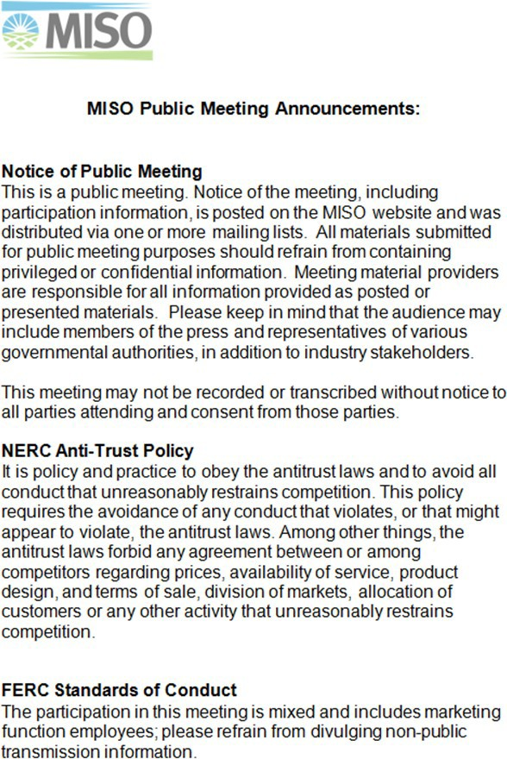

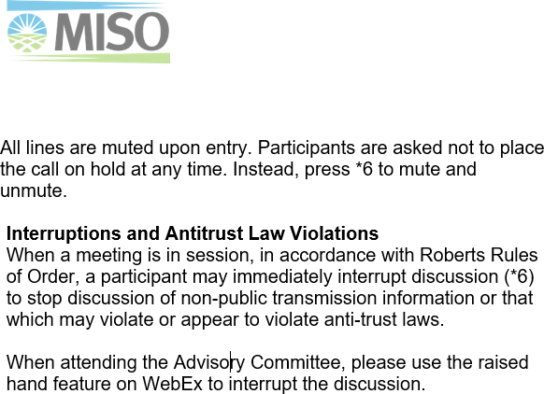

Appendix 2 – Leadership Roles and Responsibilities

Topic | Chair | Vice Chair | Liaison | Stakeholder Relations
Responsibilities | - Agenda development  - Manage meeting conduct in accordance with this guide and Robert Rules of Order.  - Clarify motions, type of vote and results of vote  - Attend Advisory Committee and Steering Committee Meetings  - Complete and maintain an Entity Management Plan.  - Provide notification to Liaison, Vice Chair and MPE (when applicable) of unavailability | - Agenda development  - Fill-in when chair is absent.  - Attend Advisory Committee and Steering Committee meetings (in the event the Chair cannot attend).  - Provide notification to Liaison and Chair of unavailability | - Agenda development  - Ensure action items and discussions are addressed by MISO and follow up as needed.  - Attend Advisory Committee and Steering Committee Meetings  - Provide objective information and expertise as requested. | - Agenda Development  - Meeting Minutes  - Coordinate and post materials  - Robert’s Rules of Order Expert  - Stakeholder Governance Guide Expert  - Coordinate Entity communication  - Make meeting arrangements  - Attend AC and SC meetings  - Maintain Issue Tracking Tool  - Maintain Stakeholder Feedback Tool  - Track leadership terms
Authorities | - Time and floor allocations during debate. |  | - Delegation of action items to MISO staff
Voting Rights | - May vote  - Votes last  - Cannot vote when held by a facilitator or MISO staff. | - Votes before Chair.  - Cannot vote when held by a facilitator or MISO staff. | - Does not vote | - Does not vote
Debate | - Must appear impartial  - Must relinquish the Chair position in order to advocate for a position. The Chair may resume its role upon closure of the issue. | - May participate in discussion and debate unless acting as Chair. Se Chair responsibilities. | - Cannot vote.  - Cannot debate; however, can provide input upon request from Stakeholders. | - Cannot vote  - Cannot debate; however, can provide input upon request from Stakeholders.
Impeachment | - Can be removed at any time by a valid motion and 2/3 majority of votes cast by the Entity over which the Chair resides. Chair may also be removed by a valid motion and a 2/3 majority of votes cast by the Entity with direct authority. | - Vice Chair can be removed at any time by a valid motion and 2/3 majority of votes cast by the Entity over which the Vice Chair resides. Vice Chair may also be removed by a valid motion and a 2/3 majority of votes cast by the  Entity with direct | - Any Entity can recommend removal of a Liaison by a valid motion and a 2/3 majority of votes cast by the Entity over which the Liaison presides. | - Any Entity can recommend removal of a Stakeholder Relations by a valid motion and a 2/3 majority of votes cast by the Entity with which the Stakeholder Relations works

Appendix 3 – Issue Debate Process

- Soliciting Motions
  - The maker of a motion subject to debate has the right to make the first statement.
  - The Chair must identify speakers in advance.
  - The Chair shall set the limits of debate.
  - The Chair shall recognize each speaker in turn and shall maintain order. Interruptions from other Stakeholders during debate are prohibited.
  - Each member that has been identified to speak will be able to do so before debate is closed.
  - Individuals may speak only once on a specific debate item until all previously identified speakers have had a chance to speak.
  - The Chair shall recognize individuals who are participating via telephone.
  - The job of the Chair is to facilitate debate. The Chair must not advocate a position or dominate the debate. If desiring to advocate a position, the Chair must relinquish the Chair position. The Chair must then be recognized during any ensuing debate.
  - Each speaker shall have an opportunity for rebuttal after all statements have been heard. The Chair shall have discretion to set limits on rebuttal time, including not having rebuttal time if the schedule does not permit it.
  - The Liaison (or Chair) will summarize any written comments received from absent Stakeholders at the close of the debate.
- Closing Debate
  - After the expiration of the debate and rebuttal time limits, the Chair shall announce the debate closed.
  - The Chair may entertain motions to postpone an issue after debate and before a vote

Appendix 4 – Charter Template
Templates and examples are available from Stakeholder Relations.

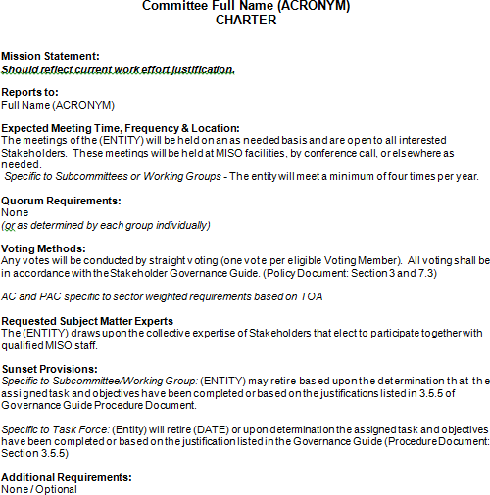

Appendix 5 - Entity Management Plan Template
Templates and examples are available from Stakeholder Relations.
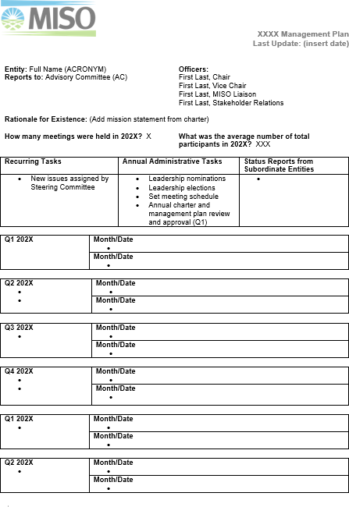

Appendix 6 - Proposal for New Entity Template
Templates and examples are available from Stakeholder Relations.

PROPOSAL FOR
Insert Subcommittee, Working Group or Task Force Name

    - What: (Purpose of the new Entity)

    - Why: (Business drivers behind the request for a new Entity)

    - Rationale: (for a separate Entity)

    - How: (Projected goals of the Entity)

    - Type of Entity Requested: (Subcommittee, Working Group or Task Force)

    - When: (Estimated duration of the Entity)

    - Recommendation of Entity name and Main Parent Entity (MPE)

Appendix 7 – Subordinate Entity Status Report
Templates and examples are available from Stakeholder Relations.

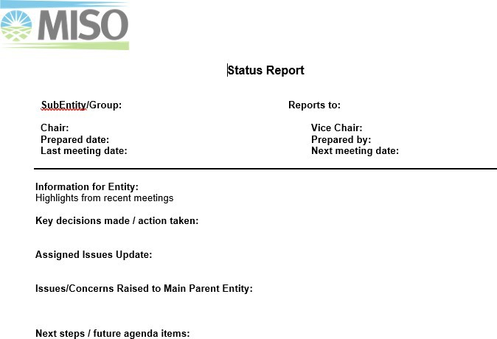

Appendix 8 – Main Parent Entity Status Report to the Board of Directors (BOD)/ Advisory Committee (AC)/ Steering Committee (SC)
Templates and examples are available from Stakeholder Relations.

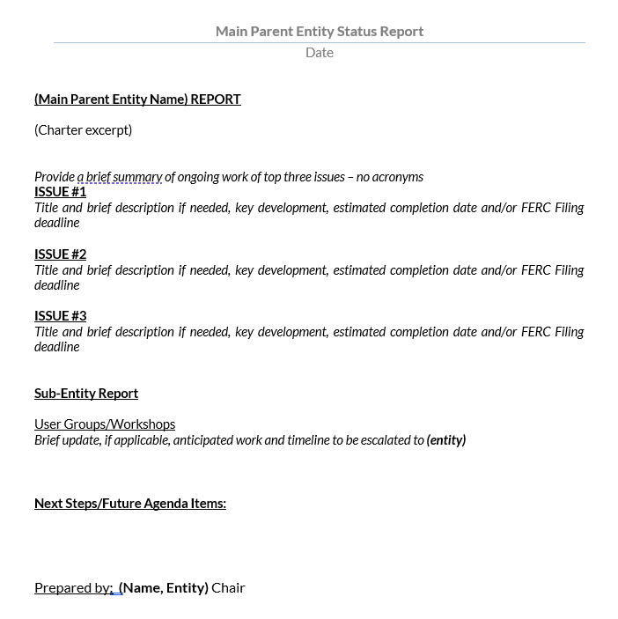

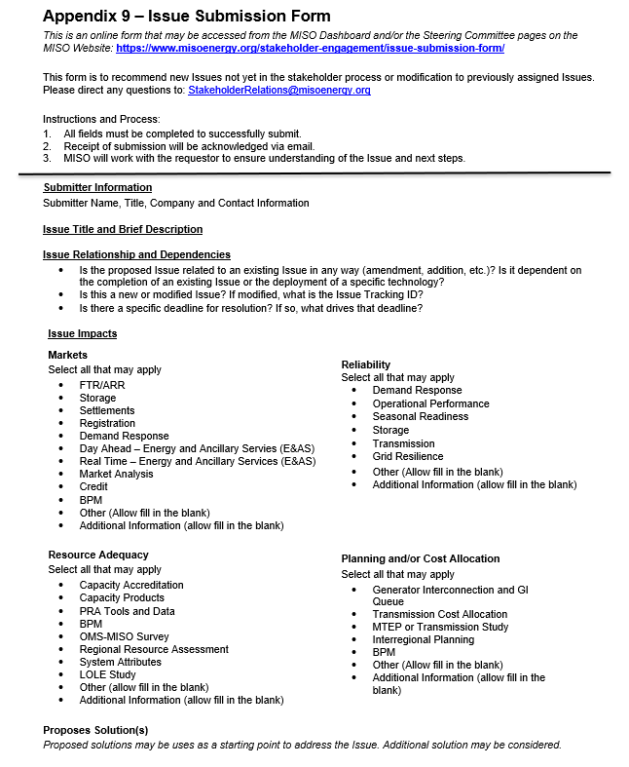

Appendix 10 – Issue Submission Presentation to MPE Template
Templates and examples are available from Stakeholder Relations.

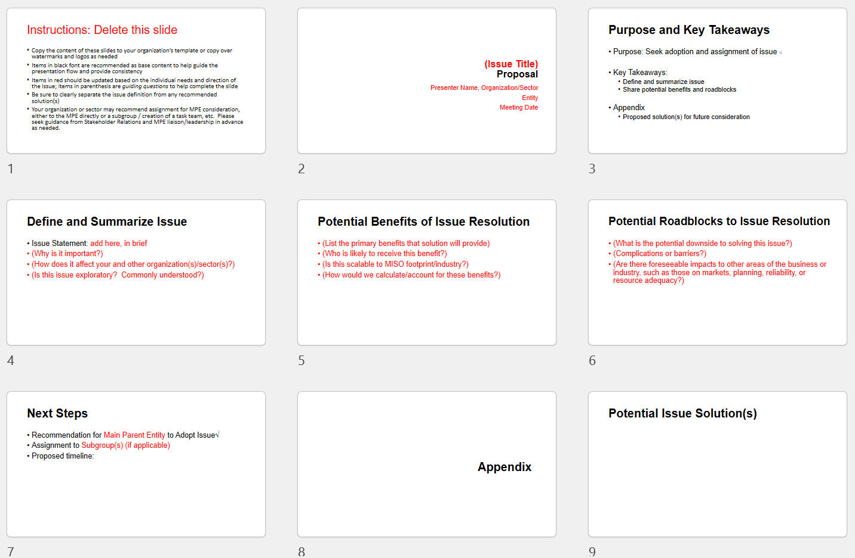

Appendix 11 – Business Practices Manual (BPM) Responsibility Matrix

Manual Number | Document Number | Document Title | Entity | Subgroup | Related Tariff Modules
1 | BPM-001 | Market Registration | MSC |  | A, C
2 | BPM-002 | Energy and Operating Reserve Markets | MSC, RSC |  | A, C
4 | BPM-004 | Financial Transmission Rights (FTR) and Auction Revenue Rights (ARR) | MSC |  | A, C
5 | BPM-005 | Market Settlements | MSC |  | A, C
7 | BPM-007 | Physical Scheduling | MSC, RSC |  | A, B, C
8 | BPM-008 | Outage Operations | RSC |  | A, C
9 | BPM-009 | Market Monitoring and Mitigation | MSC |  | A, D
10 | BPM-010 | Network and Commercial Models | MSC, RSC |  | A,
11 | BPM-011 | Resource Adequacy | RASC |  | A, E
12 | BPM-012 | Transmission Settlements | MSC |  | A, B
13 | BPM-013 | Module B (NITS and Point- to-Point)Transmission Service | PAC |  | A, B
14 | BPM-014 | Station Power | MSC |  | A
15 | BPM-015 | Generator Interconnection | PAC | PSC/IPWG | A
17 | BPM-017 | Transmission Settlements Billing Dispute Resolution | MSC |  | A, B
18 | BPM-018 | Voltage and Reactive Power Management | RSC |  | A
19 | BPM-019 | Monthly Transmission Billing, Cash Clearing and Revenue Distributing | MSC |  | A
20 | BPM-020 | Transmission Planning | PAC, RECBWG |  | A, B
21 | BPM-021 | Transmission Pricing | MSC |  | A, B
22 | BPM-022 | Blackstart Service | RSC |  | A
23 | BPM-023 | Alternative Dispute Resolution | ADRC |  | A
25 | BPM-025 | Operational Forecasting | MSC, RSC |  | A, C
26 | BPM-026 | Demand Response | MSC |  | A, C, E
27 | BPM-027 | Competitive Transmission Process | PAC |  | Attachment FF
28 | BPM-028 | Transmission Determination Process for Prospective or Existing Unregulated Transmission Owner’s | PAC
29 | BPM-029 | Minimum Project Requirements for Competitive Transmission Projects | PAC
30 | BPM-030 | Dynamic Transfers: Pseudo-ties and Dynamic Interchange Schedules | MSC |  | A, C
31 | BPM-031 | ICCP Data Requirements | RSC, PAC | MUG | C, F; Att. FF-1, FFF-2, M; Sched. 5, 6, 8

Appendix 12 – MISO Code of Conduct

