Expedited Resource Addition Study

An overview of how the Expedited Resource Addition Study (ERAS) process will be implemented
and the requirements for completing an ERAS application.

What is ERAS?
The Expedited Resource Addition Study (ERAS) is the temporary process for expediting the study and approval of interconnection projects needed for resource adequacy and/or reliability needs.

MISO has proposed the Expedited Resource Addition Study process to expedite the approval of new generation needed to address the region’s resource adequacy and reliability needs. It is a short-term solution with strict eligibility requirements. MISO filed the refined ERAS proposal on June 6, 2025. FERC issued its Order accepting MISO’s refined ERAS filing on June 21, 2025.

Timing
- ERAS will commence on the requested effective date of August 6, 2025.
  - MISO will begin accepting ERAS application submittals in the online application portal on August 6, 2025, at 8:00:00 AM EST (9:00:00 EDT / 8:00:00 CDT). Applications received any time before 8:00:00 AM EST will not be automatically rejected but will be moved back to "Initiated" status manually. Once the application is moved back into "Initiated" status, it may be submitted again by the IC. This could affect the application's placement in the ERAS queue.

- ERAS will sunset on the earlier of the completion of the 68th Interconnection Request (IR) ERAS study or on August 31, 2027.

Inherent Access Limitations
- Localized resource adequacy needs and the generator’s ability to meet that need

- Strict eligibility requirements due at the time of ERAS application submittal, along with all other requirements applicable to IRs processed through the queue, include: 100% generator and Interconnection Customer Interconnection Facility (ICIF) site control, Relevant Electric Retail Rate Authority (RERRA) verification, off-take agreement, a non-refundable $100,000 entry D1 application fee, full Network Resource Interconnection Service (NRIS), a Commercial Operation Date (COD) no later than three years from submission date, and the Generating Facility must be within the same LRZ as the identified need (unless an exception is submitted). Additionally, the requested interconnection service must not exceed 150% of the identified MW need.

ERAS Application Submission Overview
ERAS applicants must submit the following items and information at the time of application submission. Unless marked recommended, an application missing one of these items will be deemed deficient.
- Completed Appendix 1
  - Section 4s must include:
    - Requested carve out (if applicable)
    - Transfer project declaration (if applicable)
    - Description of resource adequacy or reliability need
    - Information pertaining to the LRZ requirement
    - Information pertaining to the size requirement

- RERRA Verification (for projects not serving retail load)

- Off-take agreement

- Payment (D1, D2, M2)

- PSCAD models (recommended)

- Proof of initiated Market Participant registration (recommended) for applicants in JTIQ region

ERAS Cycles, Caps, Carve Outs, & Application Deadlines
ERAS Interconnection Requests can be submitted and compiled for study after the effective date. Projects are studied on a first-come, first-served basis. Kickoff for each project is determined by submission time.

ERAS Project Cap and Carve Outs
- MISO will study no more than 68 ERAS projects total until the sunset date of August 31, 2027.
  - Of the 68 projects, MISO has carved out a maximum of 8 ERAS IRs to serve retail choice load.
    - These projects must address retail choice load, which is currently located in Illinois and approximately 10% of Michigan.
  - Of the 68 projects, MISO has carved out 10 ERAS IRs for Independent Power Producers (IPPs) with agreements with entities other than Load Serving Entities (LSEs).
    - Any ERAS IRs submitted by IPPs that do not involve an LSE will be counted towards the 10 ERAS IRs cap for IPPs.
  - ERAS applicants must indicate in Section 4.s of Appendix 1 that they are requesting a carve out, if applicable.

ERAS Study Cycles
- There are four ERAS study periods in each year with the following start and end dates:
  - Quarter 1: The first business day of March through the last business day of May
  - Quarter 2: The first business day of June through the last business day of August
  - Quarter 3: The first business day of September through the last business day of November
  - Quarter 4: The first business day of December through the last business day of February

- MISO will study no more than 15 projects per ERAS quarterly study period.
  - Each quarter could include, but is not guaranteed to include, projects from each carve out.
  - Projects will be studied on a first-come, first-served basis, taking into consideration their application review results, which involves ensuring the projects meet the ERAS requirements and are not located within the same geographic area as another project submitted for the same study period.
    - The study order is determined by the time stamp on their application in the online application tool and if their application is accepted during that ERAS study period review.
    - If more than 15 ERAS IRs are submitted for one ERAS study period, those surpassing the limit will be deferred to be studied in a future study cycle in the order in which they were submitted.
  - If multiple ERAS IRs are submitted during the same study period and within a similar geographic area – such that they affect the same constraint(s) – the application submitted first will be processed in the upcoming quarterly cycle and the second will be deferred to a future study cycle.
  - If multiple projects are proposed to address the same load, those projects will be distributed across future ERAS study periods in the order in which they were submitted.

- MISO will queue IRs by their submission time. If, during the application review, one of the 15 selected projects is found to be ineligible for study, MISO will select the next queued project for review, taking into consideration the requested carve out and whether it is in the same geographic location as a project currently in the study period.
  - If one of the 15 projects in an ERAS study cycle drops out after kickoff, MISO will not screen another project to take its place in that cycle.

ERAS Application Deadlines
- Applications for each quarter will be due no later than 15 business days prior to study kickoff for the quarter.
  - Application deadlines and kickoff dates will be publicized on the MISO website under the Expedited Resource Addition Study (ERAS) tab.
  - The application portal will not close.
  - The first quarterly study will kick off on September 2, 2025; therefore, applications for the first quarterly study period must be received by August 11, 2025.
  - The final application deadline for the ERAS process is May 10, 2027.

- If on August 31, 2027, MISO has received more than 68 ERAS IRs, then the projects that came in over the cap will go through the standard withdrawal process. Each applicant will lose their D1 payment (non-refundable application fee of $100,000) and be refunded the remainder of their D2 and M2 deposits.

ERAS Application Summary Information
- All ERAS IRs, including the Interconnection Customer (IC), megawatt (MW) range, location (county/parish and state), description of the need being met (e.g., solar project serving a Request for Proposal), and which carve out was requested (if applicable) will be made public on the MISO public website.
  - A field in the online application portal will prompt applicants to provide a Non-Confidential Summary. This is where applicants should provide the description of the need being met for public consumption.

- MISO will also post the study results of the ERAS IRs every cycle on the Extranet.

- To be considered a valid ERAS request and accepted into a cycle, an IR must meet all ERAS requirements listed in the sections below prior to the cycle kickoff date.

- MISO will communicate any ERAS application deficiencies to the applicants via the application portal. This notification will start the 10 BD cure period.
  - If deficiencies are not cured by study kickoff, the project will be deferred to a following study cycle.
  - Applicants will only have one opportunity to cure deficiencies. If after the cure period the application is not complete, the application will be withdrawn.

- No changes can be made to the ERAS IR after submission other than to address any application deficiencies.

Application Submission Timeline
- MISO’s new online application portal is expected to be updated to allow ERAS applications by July 29th. This portal can be accessed via the MISO Help Center (Generation Interconnection). Customers will be able to set up their Generator Interconnection user type access in the MISO Help Center starting July 12, 2025.

- MISO will begin accepting ERAS application submittals in the online application portal on August 6, 2025, at 8:00:00 AM EST. Applications received any time before 8:00:00 AM EST will not be automatically rejected but will be moved back to "Initiated" status manually. Once the application is moved back into "Initiated" status, it may be submitted again by the IC. This could affect the application's placement in the ERAS queue.

- ICs are encouraged to fill out and upload the necessary ERAS documentation prior to the August 6, 2025, effective date.

- A training module will be made available to ICs prior to the application portal’s go live date. It can be found in the MISO Learning Center.

ERAS Eligibility Requirements
All requirements (documentation, technical information, financial commitments, etc.) are due at the time of application submittal. MISO has 15 business days to review applications and identify deficiencies. Applicants are allowed 10 days to cure any deficiencies; however, if the application is not complete by study kickoff, the project will be deferred to a following ERAS study period.

Eligible Applicants
- New capacity additions (including replacement projects seeking additional capacity) submitted by Load Serving Entities (LSEs) or Independent Power Producers (IPPs), meeting all other criteria, will qualify for ERAS.
  - Replacement projects must have received an executed Generation Interconnection Agreement (GIA) through the replacement process prior to submitting new capacity for study through ERAS.

Transferring DPP to ERAS
- ERAS applicants must indicate in Section 4.s of Appendix 1that they are submitting a transfer project, if applicable.

- Active projects currently in the 2022, 2023, or later cycles that have not reached Decision Point 2 (DP 2) may apply to transfer into the ERAS process.

- The DPP project may remain in the queue while awaiting the review of its ERAS application.

- The specifications of the Generating Facility on the ERAS application do not have to match those on the DPP application. To be considered a transfer project, the facilities must share the same site control.

- Once a project’s ERAS application has been accepted as valid, it must withdraw one of its applications from either the DPP queue or the ERAS process to ensure that the project is not being studied in both processes.
  - The applicant must notify MISO via email which process it wishes to proceed with. If selecting to proceed with ERAS, notification must be completed prior to the kickoff of the ERAS study period.
    - The applicant must then send MISO a request to withdraw their DPP application.
  - If found deficient from ERAS, these applications will follow the same deficiency procedures outlined above.

- All projects withdrawing from the DPP process and entering ERAS will be subject to all existing DPP penalties and harm calculations as outlined in the Tariff (Attachment X, Sections 7.6.2.1.1 and 7.8).
  - Site Control for the generating facility itself will be used to confirm that the DPP project has not passed DP2.

- Any DPP projects that drop out to enter ERAS will not be allowed back into their previous queue position if later withdrawn from ERAS.

Simultaneous Applications
- Projects in the 2025 cycle and beyond may simultaneously apply for the DPP and ERAS processes.
  - The application portal is open now for the 2025 DPP cycle

- Like transfer projects, once a project’s ERAS application has been accepted as valid, it must withdraw one of its applications from either the DPP process or the ERAS process.
  - Site control details will be utilized to ensure that projects are not in multiple study processes.

RERRA Verification to MISO
ERAS projects serving non-retail choice load
- MISO requires that the IR be accompanied by a written verification from the RERRA (or its documented representative) where the load to be served by the Generating Facility is located, subject to the procedures or methods the RERRA requires.

- This verifies that either:

  - The new, incremental load addition claimed by the IC is valid and not otherwise included in a resource plan or other processes in the RERRA’s purview.
    - The RERRA (or its representative) may provide the written verification in conjunction with another state or municipal agency or official (e.g. economic development authority or governor’s office) to verify the new load.
or
  - The Generating Facility proposed by the IC will address a resource adequacy deficiency as determined by the RERRA, State, LSE, or IC. This determination can be supported by:
    - A state energy forecast, or other forward-looking forecast;
    - Commencement of a state proceeding;
    - Review of a RERRA, LSE, or other state resource plan or document, which may include, but is not limited to: integrated resource plans, procurement plans, or other plan or study types;
    - Response to a Request for Proposals (RFP); or
    - Other process, or delegation of authority, as determined by the RERRA or RERRA regulations (including in retail choice states).

ERAS projects serving retail choice load
- If an IC’s new Generating Facility will address an RA deficiency and will either:

  - Serve retail choice load located in a state that limits the amount of load that can select retail choice to a percentage of the electric utility’s average weather-adjusted retail sales,
or
  - Serve load in a retail choice state and will be located in a retail choice state other than one that limits the amount of load that can select retail choice to a percentage of the electric utility’s average weather adjusted retail sales,
    - MISO requires the IC to indicate the specific load on the IR in Section 4.s of Appendix 1 and provide evidence of one of the following:
      - A state energy forecast, or other forward-looking forecast;
      - Commencement of a state proceeding;
      - Review of a RERRA, LSE, or other state resource plan or document, which may include, but is not limited to: integrated resource plans, procurement plans, or other plan or study types;
      - Response to a Request for Proposals (RFP); or
      - Other process, or delegation of authority, as determined by the RERRA or RERRA regulations (including in retail choice states).
          - However, the IC will not be required to include a written verification from a RERRA.
    - MISO will notify the respective RERRA that an IR for a new Generating Facility has been submitted requesting processing through the ERAS process and transmit a copy of the IR to the respective RERRA.
    - The RERRA has 10 Business Days (BDs) from the date of the MISO’s notification and the simultaneous transmittal of the copy of the IR to notify the MISO that the IR should not be considered in the ERAS process.
    - If no such notice is received at the end of 10 BDs or if the RERRA notifies MISO of its non-opposition prior to the end of the 10 Business Days, the IR shall be studied through the ERAS process provided it meets all other requirements.

General Project Information
- If the written verification (or written notification of opposition/non-opposition from RERRA’s in retail choice states) is supplied by a RERRA’s documented representative, then the verification must include evidence from the RERRA of that representation or evidence of how they are so authorized by statute, regulation, or similar.
  - It is insufficient for the representative to simply state they are representing the RERRA without proof of official representation.
  - Evidence of authorization may include an email or letter from the RERRA stating that it is delegating its authority to a specific person or entity.

- The RERRA’s written verification does not constitute a final determination of need or suitability for the resource by the RERRA or the state.

- MISO has provided sample templates that may be used for the RERRA verification, but use of these templates is not required.

Off-Take Agreement
- All ERAS applications must be accompanied by an executed agreement evidencing that the project submitted for ERAS processing is intended to be used by the entity with the claimed resource adequacy and/or reliability need.

- Agreements can take one of the following forms:
  - LSE acknowledgement to self-supply;
  - Power Purchase Agreement (PPA) or similar off-take agreement between the IC submitting the project for ERAS consideration and the entity with the load to be served (including, but not limited to, an Alternative Retail Electric Supplier or its LSE);
  - An agreement that calls for the IC to develop the Generating Facility described in the IR and subsequently transfer ownership or control of such Generating Facility to the LSE or entity with the load to be served (Build-Own-Transfer Agreement); or
  - Any other agreement between the entity submitting the IR, including the RERRA verification letter as appropriate, and the entity with the load to be served (including, but not limited to, an Alternative Retail Electric Supplier or its LSE), stating that the ERAS project will be used to meet an identified RA deficiency.
    - Agreements that are not generally legally binding, such as Letters of Intent, Memorandums of Understanding, or Term Sheets, will not be considered sufficient to meet the off-take agreement requirement. Please see the Offtake Agreement Documentation guide for more information.

Resource Adequacy / Reliability Need Description
- Every IC seeking processing through ERAS must identify, in 4s of Appendix 1, the resource adequacy and/or reliability need that Generating Facility claims to address.

- ICs must report the location of the claimed resource adequacy or reliability need (i.e. the county and state, the electrical bus location(s), and the Local Resource Zone (LRZ)) of any load to be served via the off-take agreement. This is to ensure that the project meets the LRZ requirement described below.

- ICs must report the peak demand for electricity over any one-hour period in MWs. This is to ensure that projects meet the size requirement described below.

Local Resource Zone Requirement
- The ERAS Generating Facility must be located in the same LRZ as the identified need, unless the reliability or resource adequacy need has been included in a resource filing submitted to the RERRA providing project verification.
  - Examples of an acceptable resource filing include an Integrated Resource Plan (IRP), Request for Proposal (RFP), or State Energy Plan.

Size Requirement
- ERAS participants may request Interconnection Service up to, but not surpassing, 150% of the identified MW need.

- This is calculated by multiplying the peak demand for electricity expected over any one hour period in MWs by 150%.

Commercial Operation Date
- All ERAS projects must have a COD no more than 3 years from submission date.

Site Control
- Projects entering ERAS must have 100% site control (generator site and Point of Interconnection (POI)).
  - The Transmission Owner’s Interconnection Facility (TCIF) follows standard site control requirement and is submitted with the GIA site control review.

- ERAS projects cannot utilize financial security to demonstrate 100% site control.

Service Type
- All ERAS projects must request and are studied for Network Resource Interconnection Service (NRIS) (which includes Energy Resource Interconnection Service (ERIS) by default) in the amount of the requested net injection at the POI.

Financial Commitments
- Non–refundable application fee D1 = $100,000
  - Paid by ACH/wire payment only

- D2 Study Deposits
  - Paid by ACH/wire payment only

Amount of new Interconnection Service and/or Interconnection Rights requested (MW) | Study Deposit (D2)
< 6 MW | $50,000
20 ≥ MW ≥ 6 | $120,000
50 ≥ MW > 20 | $180,000
100 ≥ MW > 50 | $270,000
200 ≥ MW > 100 | $320,000
500 ≥ MW > 200 | $420,000
1000 > MW > 500 | $530,000
MW ≥ 1000 | $640,000

- Milestone M2 = $24,000/MW
  - Paid by ACH/wire payment or Irrevocable Letter of Credit

- Applicants transferring from Generation Interconnection Queue (GIQ) are permitted to apply any remaining DPP process funds toward the ERAS required payments (if both projects are submitted by the same entity) only after the DPP project withdraws to apply for ERAS.

ERAS Withdrawal Penalties
- There are no withdrawal penalties for ERAS projects that do not sign an Expedited GIA (EGIA).

- In the event that an IC terminates its EGIA after executions (or after it has been filed unexecuted), the IC will be liable for all Network Upgrades, including upgrades arising from the Affected System Study Process (AFS).

ERAS Models & Studies
ERAS projects are studied on a serial basis. MISO uses reasonable efforts to complete all studies within 60 days of study kickoff for every ERAS IR.

- ERAS projects are subject to all studies done in the DPP process.
  - These studies include the following:
    - System impact study
      - Steady state studies (thermal and voltage)
      - Short circuit analysis
      - Stability study
    - Facility studies as necessary
    - FERC 827 analysis
    - Transmission Owner Local Planning Criteria (where applicable)

- All ERAS projects are subject to the standard AFS process, including screening for participation in the Joint Targeted Interconnection Queue (JTIQ).
  - AFS queue priority is based on the system impact study commencement unless MISO and the affected system have an agreement that provides an alternative queue priority.
  - ERAS participants must agree to all AFS network upgrades upon execution of their EGIA, even if the network upgrades are not yet available.

- ERAS projects are studied using the latest MISO Transmission Expansion Plan (MTEP) model, incorporating approved Expedited Project Reviews (EPRs).
  - Long Range Transmission Plan (LRTP) Tranches 1 and 2.1 and the JTIQ portfolio are in the base case for ERAS studies.
  - ERAS projects will not be added to the base models for DPP cycles once they have kicked off. However, approved upgrades associated with ERAS projects can be used as mitigation in the DPP process per Business Practice Manual (BPM) 015, Section 6.1.1.1.
  - Once a DPP cycle has concluded, the output from the process, and any approved ERAS and EPR projects will be used to populate a new MTEP base case. Any transmission issues identified in the reconciliation process will be addressed through the existing MTEP process.

- MISO recommends that the PSCAD model be provided with its application. It must be available prior to ERAS study kickoff for projects where the Transmission Owner (TO) will be performing an Electromagnetic Transient (EMT) analysis. A PSCAD model must be provided before GIA execution.

GIA Drafting & Negotiations
JTIQ Participation Preparation
- Participants in the Joint Targeted Interconnection Queue (JTIQ) region that could screen into JTIQ participation are encouraged to provide evidence that they have initiated Market Participant (MP) registration with their ERAS application.
  - New MPs can be added to the Commercial Model in both the non-topology and topology change cycles.

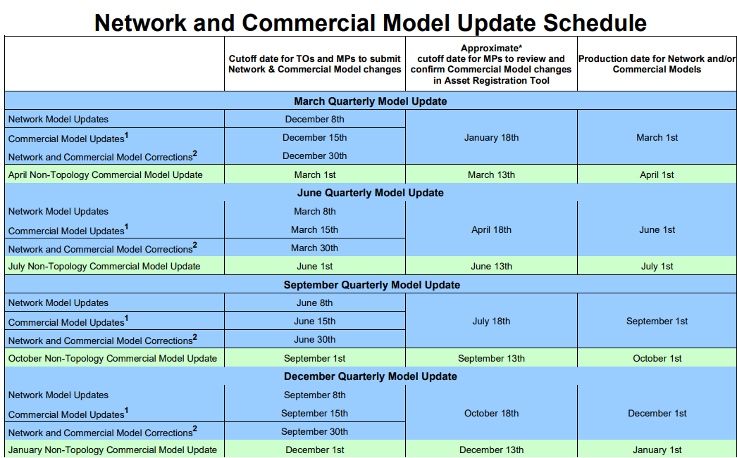

- MISO will inform the ERAS participant of their JTIQ screening results after each ERAS application deadline has passed and the 15 projects for the cycle have been identified.

- ICs that screen into JTIQ must complete the MP application prior to GIA negotiation. The participant has an additional 30 Calendar Days to complete MP registration after execution of the GIA.

- The security payment made to MISO during MP registration must be completed prior to GIA negotiations as it is used to calculate the JTIQ security agreement.

Negotiation Timeline
- ERAS ICs and TOs have 20 BDs from notice to proceed for GIA negotiations.
  - MISO has 10 BDs maximum from the end of the negotiation period to provide the ERAS participant with the final EGIA.
  - The ERAS IC and TO have 10 BDs maximum from the tender of the final EGIA to execute the EGIA or ask MISO in writing to file it unexecuted.
  - MISO then has 10 BDs maximum to execute and/or file an unexecuted EGIA with FERC.

ERAS Timeline
ERAS studies will be completed and GIAs will be issued in 3 calendar months.

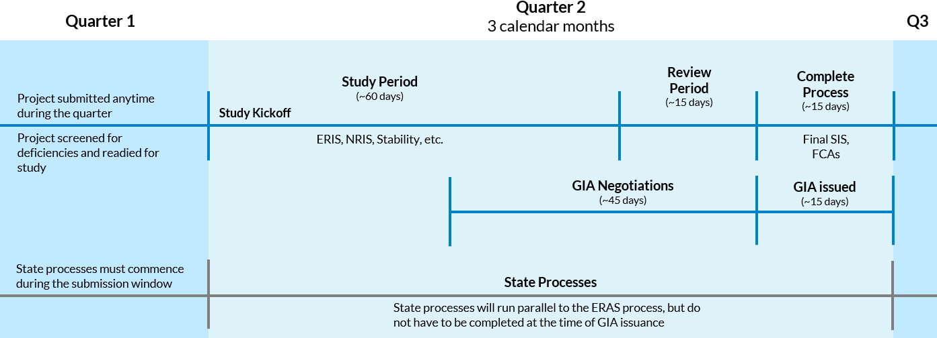

The ERAS process will kick off quarterly starting September 2025 and will integrate with existing processes without negatively impacting those ongoing studies.

