Application To Provide Station Power Service Under Schedule 20

This form documents that _______________________ (hereinafter “Generation Owner”), _________________ (NERC ID) elects to provide Station Power service pursuant to Schedule 20 of the Midcontinent ISO Open Access Transmission and Energy Markets Tariff for the Facility identified below.

By completing this form, Generation Owner is hereby certifying that:

1. It is a registered Market Participant of the Midcontinent ISO.

2. It is eligible to provide Station Power consistent with Schedule 20 and applicable FERC precedent.

3. It will provide to the Midcontinent ISO, in a timely manner, sufficient information to allow the Midcontinent ISO to implement Schedule 20.

4. It will submit accurate, complete, and timely metering information to the Midcontinent ISO. The Midcontinent ISO shall have the right to audit such metering information submissions. Generation Owner certifies that it has resolved metering arrangements with the relevant Transmission Owner.

5. In the event of Remote Self-Supply from facilities located outside the Midcontinent ISO region, the generating facility will in fact run and the Generation Owner will reserve firm transmission service and schedule delivery of the energy from such resource in advance into the Midcontinent ISO region. The Generation Owner will provide evidence of these arrangements at the Midcontinent ISO’s request.

A. Description of Generation Owner

Entity Legal Name, Description, and NERC ID:

Mailing Address:

Contact Name:

Phone:

E-mail:

B. Description of Facility

Name and Description (including geographic location):

Mailing Address:

Contact name:

Phone:

E-mail:

C. Intended Station Power Option

Indicate whether Generation Owner intends to provide Station Power on an ongoing monthly basis via On-Site Self-Supply, Remote Self-Supply, or Third-Party supply. Additional details shall be provided in the Station Power Application Information Worksheet included with the application packet.

If the local service provider where a Facility is located asserts its right to serve the station power needs of the Facility under an applicable retail rate or tariff, the Facility must register as Third-Party Supply. Schedule 20 cannot supersede the applicable jurisdiction of a state regulatory commission.

If a Facility, such as a wind farm, spans multiple service territories and any of those service providers assert their right to serve the station power needs of the Facility under an applicable retail rate or tariff, the Facility must register as Third-Party Supply.

Select the option for providing Station Power to the Facility:

On-Site Self-Supply

Remote Self-Supply

Third-Party Supply

D. Third-Party Supplier

If Generation Owner intends to provide Station Power via Third-Party Supply (where permitted), provide information regarding the third-party supplier.

Generation Owner shall provide information regarding the applicable Load Serving Entity (LSE) that will provide Third-Party Supply in the event On-Site Self-Supply or Remote Self-Supply are not adequate.

Entity Name and Description (including NERC ID):

Mailing Address:

Contact name:

Phone:

E-mail:

If the Third-Party Supplier’s applicable retail rate or tariff includes charges for Transmission Service, the Generation Owner will not incur any additional charges for Transmission Service when Third-Party Supply is used to provide Station Power.

Does the Third-Party Supplier’s applicable retail rate or tariff include charges for Transmission Service?
Yes No

Alternative means for covering Transmission Service charges:

Does the Generation Owner have other permissible transmission arrangements with the Transmission Owner?
Yes No

Does the Generation Owner have existing rights to use ITC’s facilities?
Yes No

E. Local Balancing Authority

Please provide information regarding the Local Balancing Authority:

Entity Name and Description (including NERC ID):

Mailing Address:

Contact name:

Phone:

E-mail:

F. Other Information

1. Attach single line diagram of the Facility to this application and provide description as indicated below.

2. In the Station Power Application Information Worksheet, identify the Commercial Pricing Nodes associated with provision of Station Power for the Facility, if applicable.

a. In instances of On-Site Self-Supply, designate Commercial Pricing Node(s) to be aggregated for purposes of calculating Net Output of the Facility.

b. For instances of Remote Self-Supply, designate Commercial Pricing Node(s) that comprise the Facility and designate remote Commercial Pricing Node(s) to be aggregated for purposes of calculating Net Output and possible Transmission charges in the instance of Remote Self-Supply.

c. In instances of Third-Party Supply, designate Commercial Pricing Node(s) to be aggregated for purposes of calculating Net Output of the Facility.

d. For Facilities where gross and Station Power load have separate Commercial Pricing Nodes, identify both nodes in the Facility definition.

3. Metering Arrangements

- Describe Station Power metering arrangements.

4. Questions or clarification please contact your Customer Relations Representative.

G. Certification

By signing below, the Generation Owner hereby certifies that it will promptly notify the Midcontinent ISO of any material changes in any of the above responses as soon as it becomes aware of any such changes.

Under penalty of perjury, I hereby acknowledge that I am an employee of Generation Owner who has sufficient authority to execute this document on behalf of the Generation Owner and I further certify that the foregoing responses are true and correct to the best of my knowledge.

________________________
[Signature]

________________________
[Printed Name]

________________________
[Company Name]

________________________
[NERC ID]

________________________
[Title]

________________________
[Date]

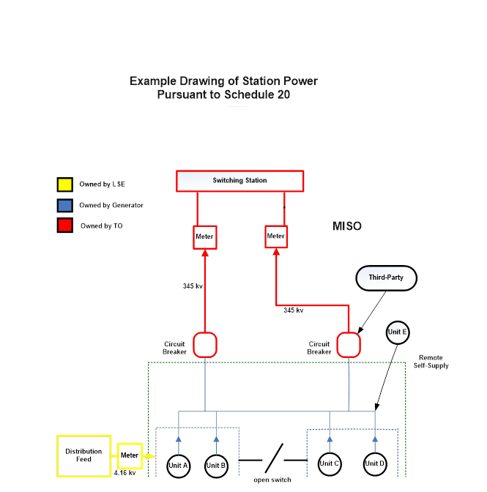
Examples of Station Power Pursuant to Schedule 20
(see drawing)

On-Site Self-Supply

Generation Owner designates the Commercial Pricing Nodes associated with Units A, B, C, D to be aggregated for purposes of calculating Net Output. Generation Owner provides information regarding the appropriate entity that will provide Third-Party Supply in the event of negative Net Output.

Generation Owner is responsible for ensuring that meter information is provided to Midcontinent ISO.

If Net Output of the aggregation of Units A, B, C, D is positive, there are no transmission charges and energy injected and consumed at Nodes A, B, C, D is settled at the respective nodal LMP.

Remote Self-Supply

Generation Owner designates the Commercial Pricing Nodes associated with Units A, B, C, D, and E to be aggregated for purposes of calculating Net Output. Generation Owner indicates that Unit E is in a different Local Balancing Authority. Generation Owner provides information regarding the appropriate entity that will provide Third-Party Supply in the event of negative Net Output.

Generation Owner is responsible for ensuring that meter information is provided to Midcontinent ISO.

If the Net Output of Units A, B, C, and D is negative but the aggregation of Units A, B, C, D, and E is positive, the Facility has used Remote Self-Supply to provide its Station Power. The energy injected and consumed at Nodes A, B, C, D and E is settled at the respective nodal LMP. Transmission charges (Schedule 8 Non-Firm Point-to-Point Transmission Service) or transmission charges for “other arrangements” (i.e., Schedule 7 Long-Term Firm and Short-Term Firm Point-to-Pont Transmission Service or Schedule 9 Network Integration Transmission Service) will apply for the negative Net Output of the Facility that was covered by the positive Net Output from Unit E.

In the instance of Remote Self-Supply from a unit outside of the Midcontinent ISO Region, Unit F, the Generation Owner must reserve transmission service and schedule delivery from such resource in advance into the Midcontinent ISO Region. In addition, the Generation Owner must be able to provide evidence that it has made these arrangements and that Unit F ran during the month.

Third-Party Supply

Generation Owner designates the Commercial Pricing Nodes associated with Units A, B, C, and D to be aggregated for purposes of calculating Net Output. Generation Owner designates the Third-Party Supplier from which it will obtain Station Power (where permitted). Retail energy and transmission charges apply, pursuant to applicable tariff provisions or other agreement.

